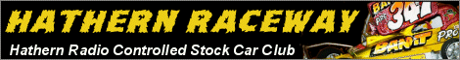
are proud to hold the

2009 British Open for 1:12 Stockcars
Sponsored by #91 Tony Smith and the BRCA 1/12th Oval Section


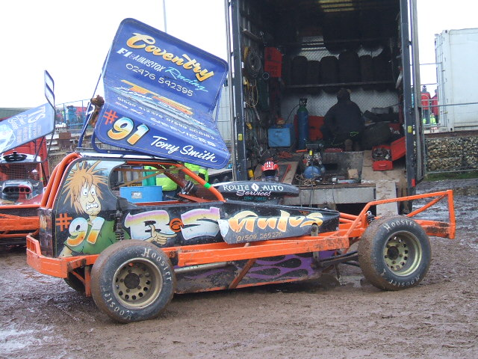
On Sunday 13th December 2009
At Charnwood Social Club,
Shelthorpe Avenue, Loughborough LE11 2ND
For detailed directions go to our website www.hathernraceway.co.uk

Please note this event is for stockcars only
Entry Fees £8 Seniors £6 Juniors
Entries (including payment) to:

Hathern Raceway, 31 Pearce Drive, Beechdale, Nottingham, NG8 3FN
please make cheques payable to H.R.C.S.C.

Closing date for entry: Saturday 5th December 2009
Absolutely No entries will be accepted after this date.
Doors open at 10am (no earlier) Heats start at 11am
Food Available throughout the Day

The venue has many mains power points but please bring own extension leads
Trophies for Finalists, Grade Awards, Best Junior and Concourse
Due to strict Health and Safety rules and the close proximity of the track to both the drivers and pit area, the BRCA wish to inform all drivers that excessively rough driving cannot be allowed, offenders may be asked to remove their cars from the track immediately

Name: ……………….….... Race No: ……... BRCA No: ….….…. Roof Grade: ……..

Frequencies (minimum of 3 please) Junior Yes/No Club:………………….………

1st Choice: ………….. 2nd Choice: ………….. 3rd Choice: …………...

Contact phone number …………………………………………………………..….….….

Email Address:………………..……………………………………………….….………...
Please remember to enclose the entry fee.

Directions From M1 to Charnwood Social Club,

Shelthorpe Avenue, Loughborough LE11 2ND
Take the A512 exit, EXIT 23, on the LEFT toward LOUGHBORO'/ASHBY.

Enter next roundabout and take 1st exit onto A512. Go through 1 roundabout.

Enter next roundabout and take 2nd exit onto EPINAL WAY/A6004. Go through 2 roundabouts.

Enter next roundabout and take 1st exit onto A6004.

Turn RIGHT onto SHELTHORPE AVENUE.

We are right at the top of the Avenue.
