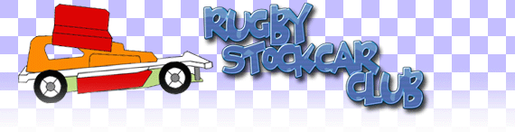

Round 2 of the 2010 season, and we are at the Rugby Raceway, the “Contact Capital” as they like to be known.

With 32 Drivers booked in for the day (slightly up from 2009), and drivers coming down from Scotland and across from Holland and Switzerland, another days hard Stock car racing was expected.

Again the main protagonists were in attendance, Ben Harding (current World, Dutch Open and National Points Champion), Maikel Rutten (European and British Open Champion), and Clive Buckler (Rugby Points Champion), along with several other club champions and past National points champions.

There would be 4 qualifying rounds of 4 heats, with a drivers best 3 lap scores to count.
The day started with a practice round, where the drivers could use the 5 minutes of their heat to tune the cars to the track conditions, followed by the drivers briefing and concourse event.

Round 1

Heat 1 saw four Rugby drivers, two Urmston drivers and a Hathern and a East Fife driver represented, local driver Clive Buckler taking the honours on a very tighly contested heat with 77 laps from Gary Osbourne on 75, Cal Baker and Gary James on 74.
Heat 2 Had the father and son combination of Alan and Ben Harding.
Ben taking the win with a 89 from Blue top, Loz Collins and Jon Cutts, both on 81.

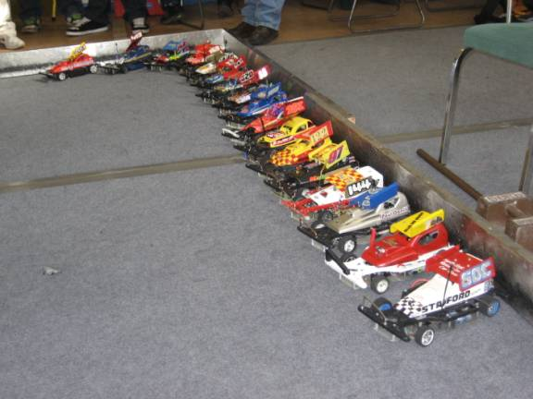

Heat 3, included the Dutch racer, Maikel Rutten, however it was Paul Jenkinson from Urmston that dominated the heat for a win with 85 laps, from Rob Teuke on 81 and junior racer Stuart Clarke on 79.
Heat 4 had the Swiss resident Matt Bennett, returning to his local club. The heat was won with a 87, by Matt showing that even though he hadn’t raced regularly since emigrating, he still knew his way round the track, followed by Rich Harding with a 85 in second.

Round 2

Heat 5 and Clive Buckler takes his 2nd win of the day with a 80, again from Gary Osbourne on 78 and Allan Inness on 76.
Heat 6 and Ben Harding moves up a gear with a 92, beating his brother Rich on 81, and Jon Cutts also on 81.
Heat 7 Matt Bennet getting into the swing of it with a 92, ahead of Paul Jenkinson on 91 and Jim Burkett on 85.
Heat 8 was a battle of attrition, with cars leaving the track for repairs, however Anthony Wyper won through with a 89, from Rob Teuke on 85 and Jamie Collins putting in a good effort with 76.
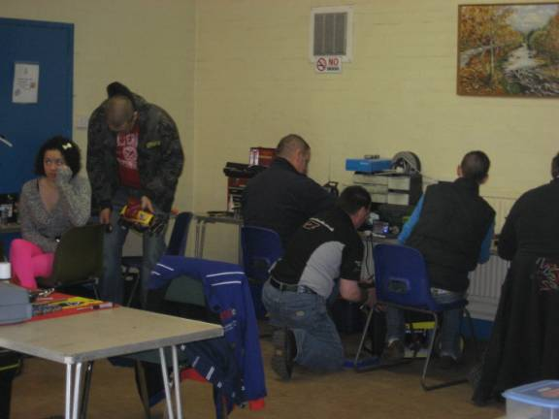

Round 3

Heat 9 and again Clive Buckler wins with an 83, from Jon Cutts on 81, and Loz Collins on 75.
Heat 10 turned in to a very fast heat after 2 cars dropped out early, with Ben Harding posting a 93 (the highest of the day) from Anthony Wyper also on 93, and Stuart Clarke on 86.
Heat 11 had Paul Jenkinson take the win on 81 from Matt Bennett on 80 and Pete Clarke on 77.
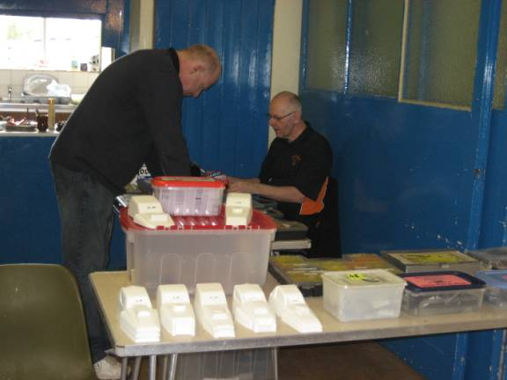

Heat 12 is the final heat before the lunch break, and Rob Teuke 86 beat and improving Gary James 81 and Paul Riddell finally finding some form on 79.

Round 4

Heat and finally Clive Buckler is beaten to the win by Anthony Wyper, winning by a single lap on 91, with Jon Cutts in third on 85.
Heat 14 and another win for Matt Bennett,on 90, from Ben Harding with 88 and Stuart Clarke on 81.
Heat 15 and Rich Harding takes another win with a 87, from Paul Jenkinson on 86, and Rob Teuke on 84.

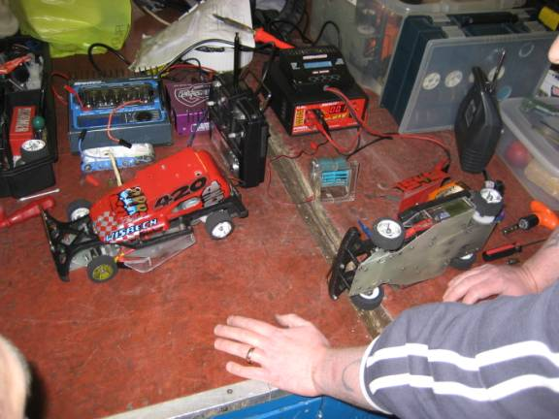

Heat 16 the final heat of the day, and several drivers still needing a good score to progress, turned into a crashfest, won by Pete Riddell on 77 from Loz Collins on 75 and Gary James on 74.

A full breakdown of the heats can be seen here.

Qualifiers

Looking at last years qualifiers, a total of 249, would have been good enough for the Final, with Matt Bennett as top scorer on 265.

Below is a list of qualifiers and their qualifying lap scores

Consolation Final
1 Jim Burkett 249 1 Ben Harding 274
2 Jon Cutts 247 2 Anthony Wyper 273
3 Stuart Clarke 247 3 Matt Bennett 269
4 Carl Baker 244 4 Paul Jenkinson 262
5 Miklos Szabados 240 5 Rich Harding 255
6 Pete Clarke 232 6 Rob Teuke 255
7 Gary Osbourne 231 7 Clive Buckler 251
8 Loz Collins 230

Again for the 2nd national running Allan Inness missed out on qualifying for the consolation by a lap.

The Consolation

Again in the last chance race, for the remaining spot in the final, it became clear right form the start that no one was going to be able to pull away from the rest, and a few scores were to be settled. Stuart Clarke seemed to make a break, but then spent what seemed like 2 laps on his roof, as his car got smashed around the track. Miklos Szabados, (the only one running an electronic speed controller) ground to a halt after 33 laps. After 5 minutes the remaining 7 cars were only separated by 4 laps with Carl baker taking the win on 83.

Carl was then promoted to the eighth place slot for the Final.

All-Comers races

While Carl got his car ready for the final, 2 All-comers races were held. A chance for a bit of fun and retribution on anyone daring enough to take part. The first race, started with 8 cars, but soon dropped down to 6 as 2 cars died under the attack, followed by a third one losing teeth on a gear, but continuing. Maikel Rutten took the win with 73 laps and a lot of big hits.
The 2nd race started with 7, but were soon joined by one of race 1’s early retiree’s. This was a more civil affair, with 5 cars chasing the total set by Maikel in race 1, however the other 3 were not going to make it easy on them. At the end it was Pete Clarke on 75, for the win.

The final

A steady start, followed by the inevitable crash, with Carl Baker and Rich Harding becoming tangled. The race settled down into the usually Rugby close racing, with local driver Ben Harding showing the rest how to slip through the traffic, not that he was having it all his own way, but experience on this track certainly helps Paul Jenkinson, pulled out halfway through, leaving just 7 cars. And this is how it continued.
At the buzzer it was a clear win for Ben Harding (by 3 laps), from Rich Harding and Clive Buckler.

Results

1st Ben Harding 88
2nd Rich Harding 85
3rd Clive Buckler 84
4th Matt Bennett 84
5th Cal Baker 82
6th Rob Teuke 80
7th Anthony Wyper 79
8th Paul Jenkinson 47

other awards on the day went to the following drivers:-

Concourse – Loz Collins
Best Yellow Top – Jamie Collins
Best Blue Top – Loz Collins
Best Junior – Stuart Clarke

And a huge thank you goes to Jon Cutts, Pete Clarke and Stuart Clarke, for running race control.

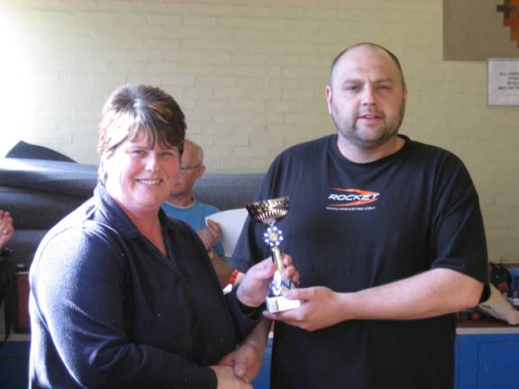

The video of the final can be found on youtube :-

http://www.youtube.com/watch?v=Zp_CyekvjWI

and the points are on the Hathern Website. :-

www.hathernraceway.co.uk

Race report by Allan Inness

