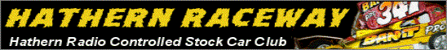

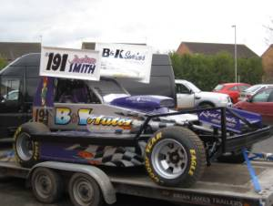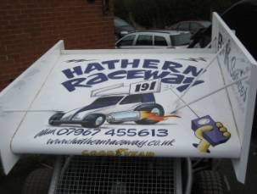

Well the new 2010 season is upon us, and with what has become somewhat of a tradition, Hathern hold the first national of the year. Having held the Stock Car British Open back in December 2009, it feels like only yesterday since we were in the Charnwood Social Club, Loughborough.

With 46 Drivers booked in for the day, and drivers coming down from Scotland and across from Holland, it was always going to be a good demonstration of hard stock car racing.

As per the BRCA 1/12th Oval section rules, there are 4 qualifying rounds of 8 heats, with a drivers best 3 lap scores to count for their total, so skill, reliability and consistency would be a must for a good score.

Arriving at the venue at 8:30am, we found the Scottish drivers already waiting outside. They had set off at 10pm the previous evening, arriving at 3:30am – obviously very keen !!!

Doors opened at 9am, and the track was quickly laid out for the days racing – a huge thanks top all those who helped. Free practice started at 9:30am, with the majority of drivers taking the opportunity to setup their cars for the uniquely shaped “coffin” track

The day started with a concourse event, with the cars lined up on the track and the landlord of the club choosing which car looked the best, shortly followed by the first round at 10:30am
Round 1

Heat 1 saw three Hathern drivers, two Urmston drivers and a rugby driver represented, local driver Phil Chadbourne taking the honours with 92 laps from Anthony Wyper on 90.
Heat 2 featured Hathern regulars Ben and Rich Harding, with Rich taking the honours from his brother with a 95.
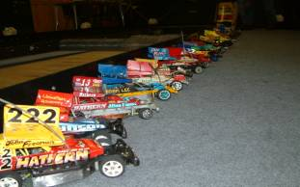

Due to a little problem with the number of competitors in the heat, Heat 3, was re-run later in the round, in between heats 6 and 7

Heat 4 included the Dutch racer, Maikel Rutten – the European and British Open champion, but he was beaten to the win by Hotrod World Champion Sam Gray with a score of 88.
Heat 5 and MarK Cooper took the win with 95 from Dannielle Chadbourne, one of only 2 lady racers on the day.
Heat 6 local driver Ian Johnson sets the mark with a 97, from Nick Cooper the current Junior World Champion
The re-run of Heat 3 now took place, with John Gould on 86 leading home Allan Inness in a closely fought heat.
Heat 7 had Paul Jenkinson, returning to Stock car racing from 1/12th circuit, and taking the win with 94 from Jim Burkett on 91.
Heat 8 brought the round to a close with Duncan Stott taking the win with a 90, and the days youngest driver, Tommy Johnson, scoring a very respectable 71.

Round 2

Heat 9 had newly graded blue top Adam Lee taking the win with a personal best of 85 followed closely by Dannielle Chadbourne.
Heat 10 and Fordham racer Jim Burkett, takes the heat win on 91 from John Gould on 90.
Heat 11 saw Ben Harding starting his winning ways with a 90.
Heat 12 was a particularly hard heat with David Nesbitt winning on 78, a good result for this Rugby blue top driver.
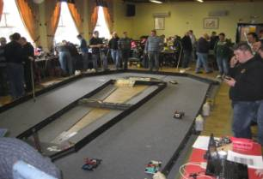

Heat 13 and another convincing win for Mark Cooper with a 91, from Paul Jenkinson on 88
Heat 14 Scottish driver Pete Riddell shows his form with a 88 for the heat win, with Both Maikel Rutten and Miklos Szabados on 87
Heat 15 and another win for Ian Johnson with 95 from Sam Gray on 94
Heat 16 Rich Harding raising the bar with a 98 from Anthony Wyper and Phil Chadbourne on 93.

Before the next round there was a short lunch break to allow everyone to refuel, change setup and fix damage.

Round 3

Heat 17 and new F1 driver Josh Smith (who’s F1 Stock car was proudly on display outside) took the win with a 83, from Tom Collins on 82
Halfway through Heat 18 and all hell breaks loose, as the computer crashes. Race to be re-run after Heat 22.
Heat 19 Anthony Wyper getting faster with a 97, from Rich Harding on 95
Heat 20 and an easy win for Sam Gray on 87.
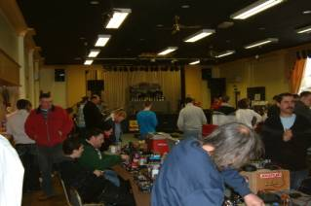

Heat 21 had Paul Jenkinson take the win on a split from Mark Cooper, both with 92
Heat 22 saw another win for Ben Harding with a 96, he seemed to be slowly getting faster

The rerun of Heat 18 and Nick Cooper with a 91, 9 laps clear of john Gould
Heat 23 3rd win of the day for Ian Johnson with a 92

Round 4

Heat 25 had Mark Cooper on 90, 14 laps clear of the opposition.
Heat 26 and Ian Johnson makes it 4 wins from 4 with a 91. He was the only one to win all his heats
Heat 27 and Anthony Wyper blows everyone away with a 100. No one has been near this for many years, not since the carpet was new and well before the club moved to the new venue.
Disaster strikes, with the lap counting laptop crashing (again) during Heat 28, and no matter how race control tried, it wouldn’t reboot.

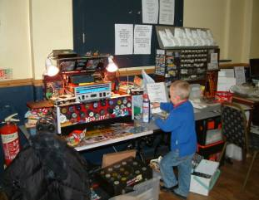

Thankfully an old laptop from 8 years ago was found in the back room, it had the lap counting software on, and after a short delay the heat was restarted.

Once Heat 28 finally got underway, 2 cars dropped out early, leaving Pete Riddell on 88 from Miklos Szabados on 85.
Heat 29 Rich Harding wins the heat on 95, from Allan Inness holding up the chasing Scottish drivers Neil Ritchie and Gary Riddell.
Heat 30 Phil Chadbourne gets another win with 94, from Nick cooper on 93
Heat 31 and lady racer Jane Osbourne, took a convincing win with 82
Heat 32 and the last heat of the day….. Sam Gray on 95 from fellow club racer Jim Burkett on 84.

A full breakdown of the heats can be seen here.

Qualifiers

Looking at last years qualifiers, a total of 266, would have been good enough for the Final, with Ben Harding as top scorer on 282.

Below is a list of qualifiers and their qualifying lap scores

Consolation Final
1 Nick Cooper 274 1 Anthony Wyper 290
2 Paul Jenkinson 274 2 Rich Harding 288
3 Jim Burkett 271 3 Ian Johnson 284
4 Josh Smith 267 4 Ben Harding 282
5 Pete Riddell 264 5 Phil Chadbourne 281
6 Dannielle Chadbourne 261 6 Mark Cooper 277
7 John Gould 261 7 Sam Gray 277
8 Maikel Rutten 259

Unluckiest driver was Allan Inness who also qualified with 259 laps but was beaten on split by Maikel Rutten for last place in the consolation.

The Consolation

With this being the last do or die race, made up with drivers that usually grace themselves in the final, it was going to be a tough race, but the pressure increased when the first start failed to count some of the transponders. This was quickly rectified and they lined up for the restart. From the restart, it became clear that no one was going to pull away from the rest, and by half way 3 drivers were fighting for the lead on the same laps. The lead continued to swap between Dannielle Chadbourne, Paul Jenkinson and Jim Burkett, for the remainder of the race, with Paul Jenkinson just winning by less than 0.2s from Dannielle Chadbourne. 3rd was Jim Burkett, followed by Maikel Rutten, then Nick Cooper, Paul Riddell, John Gould and Josh Smith.

Paul was then promoted to the eight place slot for the Final.

The final

After a clean getaway, the race settled down into a steady procession, with hardly anyone making mistakes, First to leave the track was ian Johnson, who duly marshalled himself back in. By the 3rd minute it was clear to the racers who was in contention and who wasn’t, and so a few old scores were settled. Rich Harding making big hits on multiple cars at the tight end of the track, while Phil Chadbourne seemed to be getting stuck into Paul Jenkinson. At the buzzer it was a clear win for Ben Harding, from Anthony Wyper and MarK Cooper.

Results

1st Ben Harding
2nd Anthony Wyper
3rd Mark Cooper
4th Ian Johnson
5th Sam Gray
6th Rich Harding
7th Paul Jenkinson
8th Phil Chadbourne

other awards on the day went to the following drivers:-

Concourse – Ade Eaglen
Best Yellow Top – Alan Harding
Best Blue Top – Josh Smith
Best Junior – Dannielle Chadbourne

And a huge thank you goes to Beka Montague, for running race control.

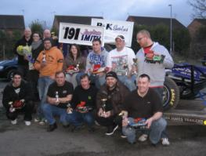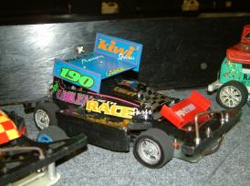

The video of the final can be found on youtube :-

http://www.youtube.com/watch?v=Zp_CyekvjWI

and the points are on the Hathern Website. :-

www.hathernraceway.co.uk

ps – the laptop is now fixed and working fine !!!!

Race report by Allan Inness

