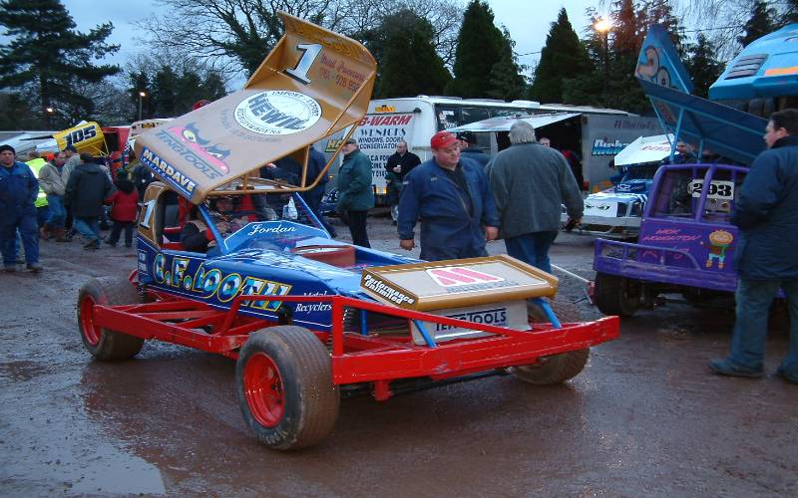

Urmston 28th Anniversary Meeting

Saturday 10th November

2007

What an achievement in our fickle world, a club that has been based at the same venue for a consecutive 28 years along with the same promoter! I hope there are big plans in place for when the club reaches the 30 year mark.
Anyone who knows about the oval section will know what an extremely difficult year it has been, we have seen a rapid decline in numbers at race meetings, more so at nationals than at club level, so it is a credit to Alan Crossland’s popularity that twenty six racers have supported this meeting, and looking around the room it is nice to see so many visitors making an appearance with quite a few clubs being represented, there was Colin Eardly from the Biddulph Moor club, Alan Inness and the Chadbourn’s from the Hathern club, we also had Ben and Pop Harding along with Clive Buckler from the Rugby club and representing the Stoney Stanton club were Mark and Nicholas Cooper.
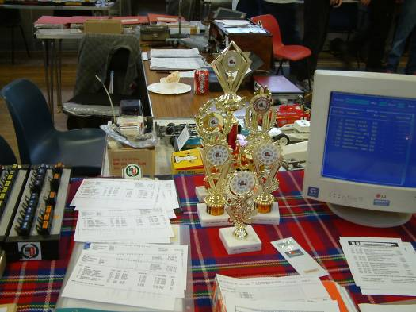
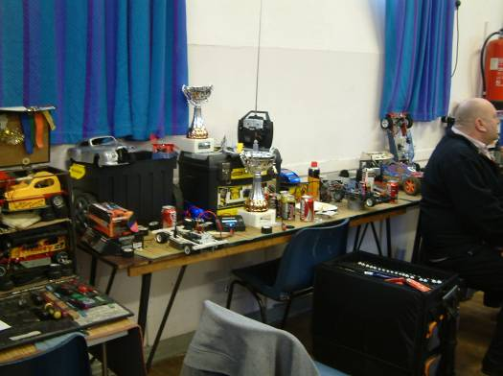
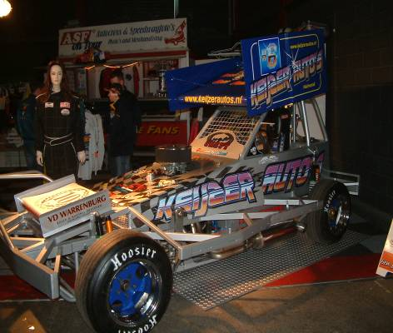
As it has been a while since my last visit to the Urmston club with a Stockcar it was interesting to see an alteration to the track as there had been two extra sections added to the infield to make it longer, this has had two effects to the racing, the first one being obvious of a longer racing line around the oval, however this has also made it a slightly faster down the straights as they are now longer, but the downside to this is the narrowing of the track area on the bends, I found that you now have to be a bit more precise about where you shut off the throttle and turn in for the bends this trade off showed up on the lap times, yes the cars in effect were going quicker down the straights but the loss of speed on the corners meant that the lap times were slower compared to the old times before the track was altered, I asked Alan why there had been changes to the track and he said that the cars were getting so fast around a single lap they were getting close to what the computer could handle i.e. lap time plus a delay, so adding the extra bits to the infield has made a big difference, this will show up in the highest lap scores from today’s meeting, looking back to the national meeting in 2005 Ben Harding took the FTD in round four with 90 laps.

The format for today’s meeting was like a club meeting, you would stay in the same heat all day and all of your race scores would count towards qualifying, the top six would go straight into the final and the next eight would contest a consolation race with the top two from this going into the final to make it an eight car final.
The meeting started on time as there were no late arrivals, the first heat of round one was underway at 09:50 and the first heat winner of the days racing was Matthew Bennett with 81 laps ( it was interesting to see that Matthew was using his new short wheelbase self build car that he has been having a lot of success with although this success is not normally on a bumpy track ) in second place with 78 laps was Martin Riley with 78 followed by Colin Eardly with 75 behind Colin in fourth place with 69 laps was Urmston club member Gary Osborne and the minor places were filled by Ian Warman with 66 and Sean Warman with 60 laps, interestingly the fastest lap time from this race was set by Martin Riley with a time of 3.250 seconds. In race two it was Clive Buckler that took the heat win with 80 laps he was chased by Peter Ayriss who finished in second place with 78 and third place went to Rugby club member Alan Harding with 75, in fourth place we had Phil Chadbourne with 73 laps, Alan Inness had completed the race distance although he had been off track for some minor repairs which accounts for his low lap score of 49 and Jim Wilson had only completed 3/5ths of the race distance to record his 48 laps. The fastest lap time was achieved by the race winner with a time of 3.280 seconds.
Race three was won by a home club racer as Stewart Smith took the chequered flag with 81 laps from Carl Baker with 75, third place went to Nicholas Cooper with 74 this was achieved with a car loaned from his dad, the fourth and fifth places were separated by a split time after Oliver Elliot and Daniell Chadbourne had recorded 73 laps each, the computer showed that Oliver crossed the finish line 1.100 seconds ahead of Daniell, interestingly both of these racers had the same fastest lap time of 3.440 seconds, behind these two in sixth place was Adam Lyons with 70 laps and David Smith using a brand new Skint type of car that had only just been put together prior to the race start posted a promising 63 laps in seventh place. The fastest lap time from this one was set by Stewart Smith with a time of 3.290 seconds. Race four was won with 82 laps by Ben Harding, worth noting here was the car Ben had chose to use a self built short wheelbase car similar to the car that Matthew Bennett has been racing, second place went to Mark Cooper with 80 laps and third place went to Anthony Wyper with 78, Terry Crowley came home in fourth place with 74 followed by Craig Howard with 56 laps in fifth place and Lynette Yarwood with 53 in sixth and just behind in seventh place with 50 laps was Robert Willshire. Interestingly the fastest lap was achieved by Lynette Yarwood with a time of 3.140 seconds this compared to Anthony Wypers fastest of 3.220.

Round Two.
Matthew Bennett collected his second win with 79 laps two down on his previous score in round one, second place went to Martin Riley with 76 and third place went to fellow Urmston club member Gary Osborne with 71, fourth and fifth places were separated by a single lap and was the battle of the Warman’s, at the finish it was Ian Warman with 64 laps followed by Sean Warman with 63 and the unlucky Colin Eardley collected 55 laps this was due to his motor going pop, just to show how well he was going he went out of the race after 3 and a ½ minutes so if he had kept on going at the rate he was I think he would have had an 80 + lap score! The fastest lap time in this race was set by Martin Riley with a time of 3.340. Race two was won with 82 laps by Clive Buckler from Peter Ayriss in second place with 79, Phil Chadbourne improved on his previous lap score with his 77 laps in third place behind him in the fourth and fifth places were Alan Harding and Jim Wilson with 73 laps each although Alan was ahead of Jim by 3 seconds as they crossed the finish line and I guess Alan Inness was having another one of those days as he finished the race in sixth place with 66 laps. The fastest lap went to Phil Chadbourne with a lap completed in 3.300 seconds. Heat three saw a different winner as Carl Baker took the chequered flag with a winning 78 laps, and right behind him was Stewart Smith with 77 laps in second place, things were very close behind these two as the next four places were separated by a single lap as David Smith improved on his first ever lap score from round one with his new car by collecting third place with 72 laps just over one second ahead of Oliver Elliot who also finished the race with 72 laps next across the finish line was Nicholas Cooper with 71 laps this in a race distance time of 4.46.440 seconds and Daniell Chadbourne also finished the race with 71 laps in sixth place and seventh place went to Adam Lyons with his 65 lap score. The fastest lap was achieved by Stewart Smith with a time of 3.340. Race four was won with an impressive 84 laps by Anthony Wyper it took a mighty effort from Anthony to keep Ben Harding behind him as Ben recorded 82 laps in second place and Terry Crowley posted 80 laps in third place with Mark Cooper right behind him in fourth place with 79 laps fifth place went to Robert Willshire with 68 laps, Lynette Yarwood posted 47 laps in sixth place and Craig Howard had 33 laps to his credit as he only completed half of the race distance. Ben Harding had the satisfaction of setting the fastest lap time in this one his time was 3.200.

Round Three.
Colin Eardly shows what might have been as he collects a win in round three his winning lap score was 81 which was just one lap ahead of the previously unbeaten Matthew Bennett in second place and martin Riley was also right up there in contention with his 79 laps in third place, these three were well ahead of the rest as Sean Warman finished with 64 laps in fourth place he was followed over the finish line by Ian Warman with 62 laps and the unlucky Gary Osborne completed just 6 laps in sixth place, the fastest single lap was completed by Mattthew Bennett in a time of 3.270 seconds. In race two Clive Buckler remained unbeaten as he collected win number three with 81 laps behind him in second place was Peter Ayriss with 75 laps followed by Phil Chadbourne with 74 and Jim Wilson in fourth place with 71, Alan Harding finished the race with 67 laps to his credit and Allan Inness completed a miserable days racing with 64 laps in sixth place, the fastest lap was set by Jim Wilson with a time of 3.300 seconds. Carl Baker collected his second race win with a winning lap score of 80 laps in race three, right behind him in second place was Elliot Oliver with 79 and Nicholas Cooper was a further lap behind in third place as was David Smith in fourth place with his 77 laps, Daniell Chadbourne came home in fifth place with 73 laps and Adam Lyons completed his days racing with 69 laps in sixth place and the unlucky Stewart Smith completed 37 laps before he retired from the race and out of contention for the consolation and final. It would have been of little consolation to Stewart to have set the fastest lap time in this one with a lap completed in 3.250 seconds. The last race from the heats was won by Anthony Wyper with 81, the second and third places were separated by a split time after Terry Crowley and Ben Harding had both recorded 78 laps the computer showed that Ben Harding was ahead of Terry by 2.510 seconds, Mark Cooper was a little bit unlucky as he had collected another car coming the other way around the track which had dislodged his motor from the drive gear however a quick fix allowed him to complete the race with 73 laps in fourth place behind him came Robert Willshire with 66 laps and both Lynette Yarwood and Craig Howard recorded 61 laps with Lynette a mere 0.400 of a second ahead of Craig. The fastest single lap was completed by Terry Crowley in a time of 3.300 seconds.
With the completion of the heats we now had some idea of who had qualified for what, however it was a hard luck story for Stewart Smith, Colin Eardly and Allan Inness who for whatever reason had all failed to reach either the consolation or final and David Smith had the handicap of debuting a brand new untried car, once Alan had done the maths we knew for sure who had qualified for what, so here is the line up for the consolation race,

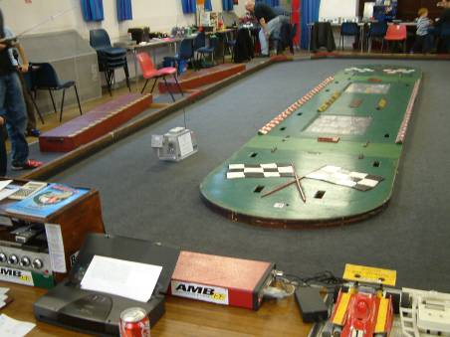
1. Mark Cooper 80 79 73
2. Terry Crowley 74 80 78
3. Pete Ayriss 78 79 75
4. Elliot Oliver 73 72 79
5. Phil Chadbourne 73 77 74
6. Nicholas Cooper 74 71 78
7. Daniell Chadbourne 73 71 73
8. Alan Harding 75 73 67

Consolation races are never easy to predict as to who will win, this one is slightly different as it is the first two that will progress forward into the final, for a racer this makes it slightly easier as the odds of going through from this are 2 to 8 compared to a national meeting consolation where the odds are 1 to 8, right from the start it became clear that Mark Cooper was the one to catch the big question was who else was going to follow him into the final barring any mechanical breakdowns, one sure fact it was going to be close as every place was being fought for tooth and nail, at the end of the race it indeed was Mark Cooper who ran out a clear winner with 80 laps, but behind him it went right down to wire as both Pete Ayriss and Nicholas Cooper finished the race with 77 laps, the all important second place however went to Nicholas as his split time was just better than Pete’s by a slender 1.270 seconds, so it would be the Father and Son duo that progressed through to the final, the remaining places went to Terry Crowley in fourth place with 72 laps he was followed by Phil Chadbourne in fifth place with 70 laps and Daniell Chadbourne also finished the race with 70 laps although behind Phil (her dad) by 3.150 seconds, Alan Harding was just behind these two with 69 laps to his credit and Elliot Oliver trailed in last with 67 laps, the fastest lap was achieved by Terry Crowley his fastest lap of the race was achieved in 3.330 seconds.

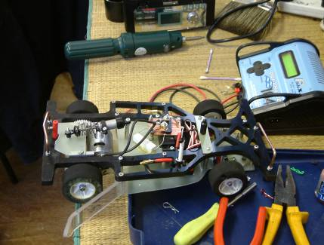
The line up for this final was a rather distinguished one indeed with some notable performers included in the line up, in order of qualification here are the qualifiers,

1. Anthony Wyper 78 84 81
2. Clive Buckler 80 82 81
3. Ben Harding 82 82 78
4. Matthew Bennett 81 79 80
5. Carl Baker 75 78 80
6. Martin Riley 78 76 79
7. Mark Cooper Consolation Qualifier
8. Nicholas Cooper Consolation Qualifier

It’s not easy to comment about a race that you were in! However it would appear that only the winner had a trouble free race and cruised to an easy win well on paper that’s how it looked and that’s what the record books will show as Anthony Wyper took the win with an untroubled 84 laps, and what a result for the home club as Martin Riley finished in second place with 79 laps, somehow I managed to claw my way back up the grid from a poor start and loosing time when my car became wedged on the centre so a third place finish for me was rather pleasing as I crossed the finish line first in a train of three racers with 78 laps, Clive Buckler was just 1.600 seconds behind in fourth place and Matthew Bennett a further 1.320 behind Clive to finish in fifth place, Nicholas Cooper can be well pleased with a healthy sixth place finish with 75 laps and behind him in the seventh and eight places were both Carl Baker and Ben Harding with 63 laps each, seventh place going to Carl by a split time of 1.640 seconds, Ben was rather unfortunate to loose time as his rear wheel nut’s had became loose during the race and a quick pit stop to tighten them up explains why for a change Ben had finished in last place in a final although he posted the fastest lap in the final with a lap completed in 3.250 seconds.

A big thank you must go to Alan Crossland for organising and running the meeting along with the Urmston club members for making us visitors welcome, and the very biggest thank you must be saved for Jean and the rest of the ladies in the kitchen, in my opinion this is one of the major attractions to visiting the Urmston club, great grub, five star coffee and tea all served with a hearty smile, I will defiantly see you all at next year’s 29th Anniversary meeting if not before.

Race report by Mark Cooper.

