Rugby Raceway

The 1/12th Electric Stockcars
For Round 2 of the BRCA National Championship

Not a lot has changed at the club from our last visit, so here is some information about the club, race nights are held on Friday evenings start time 8.00pm, they hold two championships every year, one on a specially adapted track to make it into a “Longtrack” this was won by Samantha Eaglen in 2005, the Longtrack is run with a handicap system for the lower grades and the other championship is the Kiwi Cup, this was won by Ben Harding in 2005, one meeting every month is held for each with the top points scorers going forward into semi-finals & finals, these are usually held in December, there is alsotrophies awarded at the end of the year for the points champion along with the racer with the most number of final wins, and the same is done for the racer with the top number of consolation wins. Unlike most other clubs, their grading period is every month, so there can be a lot of movement up and down the grades, as the competition is fierce; one bad meeting can easily move you down a grade. There is a web-site for the club, this is maintained by Karl Spencer and can be found at www.rugbyscc.freehosting.net , the best lap score around the oval in a five minuet race stands at 94 laps, so expect the laps to be in the high 80’s and into the 90’s today.
The number of racers booked in for today’s meeting totalled 44, although three did not arrive which left us with the same number of racers as we had at the first national meeting of the year at the Hathern club. Everything ran smoothly before the meeting, all the cars met with the requirements of the scrutineer, and practice was hectic to say the least although everyone seemed happy, I say that with caution as Jackie was extremely busy serving breakfasts and hot drinks which was appreciated by everyone. And as there were no late arrivals the meeting started right on time after Jon had done the drivers briefing, so enough of the waffling and onto the meeting.

Round 1, Heat 1
Heat one looked very busy as there were a full eight cars in this heat which might explain the low winning lap score of 79 laps by Karl Spencer, he was chased by Urmston club member Mathew Brown with 77 and Nicholas Cooper with 75 in third place a good result for him as he finished the race ahead of Alastair Needham who finished with 73 laps in fourth place. Heat two was won by the reigning World Champion Ian Johnson with 79 laps, he had Carl Baker right behind him on 78 and Roy Calver was a further lap behind Carl in third place. Heat three threw up a real surprise as young Aron Eaglen raced the race of his life to finish with a wining lap score of 84 and in doing so he pushed Ben Harding into second position as Ben finished the heat with 83 laps, behind these two came Jamie Burkett with 81 laps and High Wycombe racer Steve Brown finished with 79. Heat four was won by Rugby racer Clive Buckler with 83 laps from Rich Harding with 82 and James Blower with 81. Heat five was a low lap scoring race, all of the racers were evenly matched and the win could have gone to anyone of them, at the finish it was Paul Riddel standing tall with 75 laps in first place he was just ahead of Alan Harding who finished with 74, then we had both Phil Chadbourne and Danielle Chadbourne finishing with 73 laps (Dad was ahead of Danielle just!) and Chris Blower was a further lap behind these two in fifth place. Heat six was won with the highest lap score of the round, this was achieved by Anthony Wyper with 88 laps, Matthew Bennett came home in second place with 87, and just behind these two was Laurence Collins with 80 laps a great result for the Rugby Yellow grade racer, these three racers finished well ahead of the rest of the racers in this heat.

Round 2, Heat 1
It looks like Alastair Needham has worked some magic on his car as he wins heat one with 86 laps, Roy Calver also improved on his first round outing with 83 laps he was followed over the finish line by Jason Reed with 77. Heat two had Ian Johnson collect win number two with 84 from Jamie Burkett with 81 and just behind Jamie came Bryan Lee with 79 laps he was followed by Carl Baker with 75. Heat three saw Ben Harding make amends for round one as he won heat three with a healthy 87 laps from James Blower with 83, behind these two there was a good tussle going on for third place, this little battle was won by Allan Inness with 78 laps from round one heat winner Aron Eaglen who finished a single lap behind Allan with Martin Riley a further two laps behind in fifth place. Heat four produced the highest lap score of the round so far as Clive Buckler posted a high score of 89 laps, chasing him all the way to the finish line was Mark Cooper with 86 and Rich Harding with 83 laps in third place, Danielle Chadbourne was just behind Rich with 82 and both Gerry Fordham and Steve Brown finished the race with 77 laps. Heat five had a race long battle between Karl Spencer and Phil Chadbourne, at the finish it was Phil who crossed the finish line in first place with 86 laps with Karl right behind him on the same lap, third place went to Chris Blower with 80 laps from Alan Harding who also recorded 80 laps in fourth place. Heat six had the first racer to break into the 90 lap area as Matthew Bennett won heat six with 90 laps, two racers with the same lap score behind Matthew were Anthony Wyper and Mark Foster with 86 laps each, Anthony was ahead of Mark at the end of the heat, behind these two with another solid result was Laurence Collins with 78 laps in fourth place.

Round 3. Heat 1
We can add another name to the list of distinguished heat winners after Derek Cayzer wins heat one of round three with 79 laps, behind him came a train of racers all one lap behind each other, in second place we had Bryan Lee with 78 then it was Nicholas Cooper with 77 followed by Alastair Needham with 76 and Carl Baker with 75. Heat two went to the reigning national points champion Ben Harding with 89 laps, in second place we had the previously unbeaten Ian Johnson with 85, and young Thomas Collins finished in third place with 80 laps. Heat three saw another name added to the list of heat winners, achieving this with 87 laps was Mark Cooper with Mark Foster a close second with 85 laps, and Urmston racer Martin Riley finished with 80 laps in third place. Heat four was won with 86 laps by Clive Buckler, this was Clive’s third win of the meeting! the only racer to remain unbeaten, second place went to James Blower with 82 he was followed by Jamie Burkett with 79 and Chris Blower with 78. Heat five was won by Karl Spencer with 87 in an extremely busy race! Karl was chased by Paul Riddell with 81 laps in second place and Rich Harding with 80 then we had Phil Chadbourne on 77 in fourth place. Heat six was a scorcher as Matthew Bennett set the FTQ with 91 laps as he collected another heat win, just behind him in second place with 89 was Anthony Wyper then we had a big gap in the number of laps back to Alan Greig who finished the heat in third place with 77 he was closely followed over the finish line by Laurence Collins with 76 laps.

Round 4. Heat 1
Ben Harding equals the 91 lap score of Matthew Bennett form the previous round by winning heat one, unfortunately for Ben it failed to take the FTQ from Matthew as his split time was slower than Matthew’s, coming home in second place with 86 laps was Aron Eaglen then we had two racers with 82 laps they were Nicholas Cooper in third place and Carl Baker just behind in fourth. Heat two had Ian Johnson collect his third heat win with 87 laps he was made to work for it though as Alastair Needham was only one lap behind him in second place, coming home in third place with his highest lap score of the rounds was Allan Inness with 84 he was followed by Mathew Brown with 82. Heat three was won with 88 laps by James Blower, there was a great race going on behind him as three racers were disputing the second place, at the finish it went down to the wire as all three finished on the same lap, in order of crossing the finish line they were Alan Harding, Mark Foster and Jamie Burkett all on 85 laps. Heat four saw the only unbeaten racer remain that way as Clive Buckler collected his fourth win with 83 laps from a subdued Karl Spencer with 78 and Roy Calver with 74. Heat five was won with a low lap score of 78 laps by Derek Cayzer from Phil Chadbourne with 77 and Danielle Chadbourne not far behind with 74. The final heat of the rounds was won by Matthew Bennett with 85, Laurence Collins took a great second place in this heat with 74 and not to be outdone Alan Greig came home in third place with 71.

For some reason this national always throws up a variety of winning lap scores, the highest was 91 laps by Matthew Bennett and Ben Harding, and the lowest was that of Paul Riddell in round one, and who would have thought that 75 would be enough to take a heat win! so nothing can be taken for granted about qualification, as the adding up of the race scores were being done it became clear that some big names had not gone straight into the final and some that you thought might not had! With that in mind let’s take a look at the qualifiers for the consolation and final.

Let’s start with the consolation race. This race is made up from the list qualifiers, and features those racers that had finished in eight place down to fifteenth place, as the top seven go straight through into the final, and only the winner of the consolation joins them.

1. Karl Spencer 252
2. Mark Cooper 248
3. Alastair Needham 248
4. Jamie Burkett 247
5. Aron Eaglen 247
6. Rich Harding 245
7. Alan Inness 241
8. Phil Chadbourne 240

Looking at the list of qualifiers for this race, some top names were in for disappointment, at the end of the race it came as no real surprise that Rugby track specialist Karl Spencer had won and gone through to the final, he produced a great race to win with 88 laps from Mark Cooper in second with 83 and Alan Inness with 82 in third place, Alastair Needham was next with 81 in fourth position, he was followed by Jamie Burkett with 79 and Rich Harding in sixth place with 72, and who would have thought that the first national final winner of the year Phil Chadbourne would have finished in seventh place in the consolation race at the very next national meeting with 68 laps and the unfortunate Aron Eaglen was eight with 42 after stripping his drive gear early on in the race.

The Grand Final.
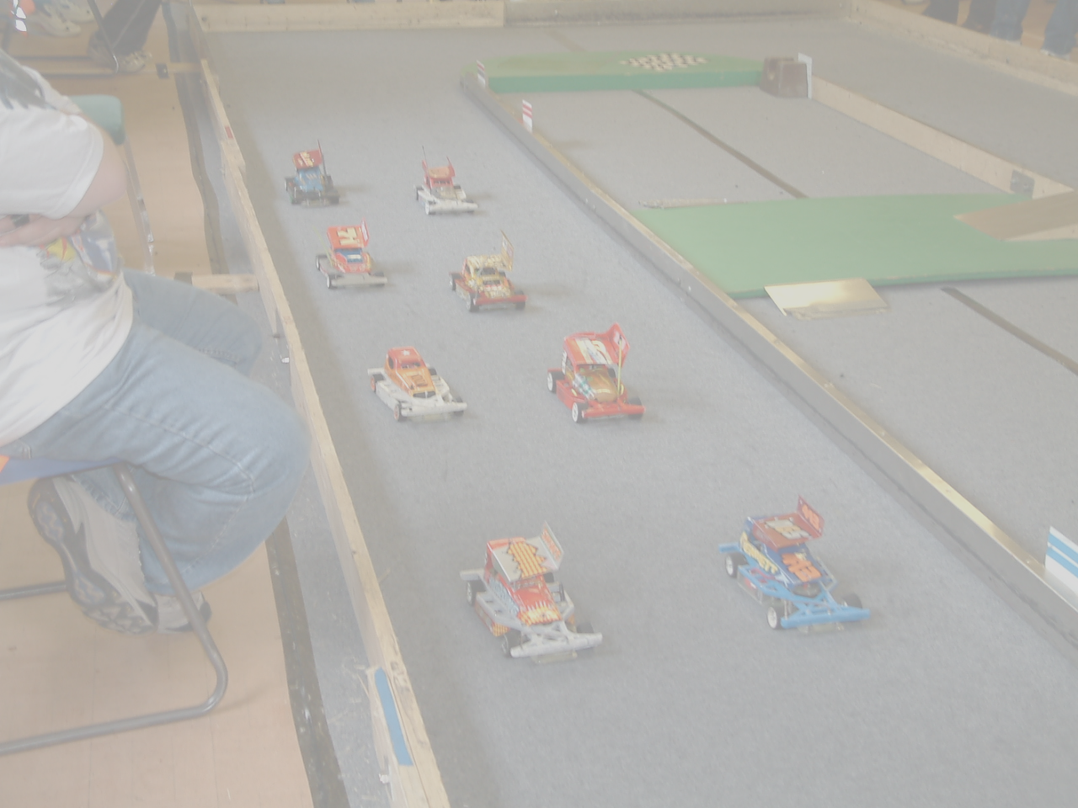
We are now down to the main event, and I am sure we will be treated to a top class race as there were no easy passages into the final, all of the racers had qualified by right to be here, so here are the racers along with their qualifying totals and their home clubs, in the order that they will start the final.

1. Matthew Bennett 268 Rugby
2. Ben Harding 267 Rugby
3. Anthony Wyper 263 Urmston
4. Clive Buckler 258 Rugby
5. Ian Johnson 256 Hathern
6. Mark Foster 256 Urmston
7. James Blower 253 Fordham
8. Karl Spencer Consolation Winner

It’s nice to get things right with my prediction as the racers did not disappoint me, the speed and the quality of racing was superb! and how close it was at the finish, we had an incredible three racers finish on the same lap, it was down to the computer with the split time’s to give us the order of the top three, they were 1st. Ben Harding, 2nd. Clive Buckler and 3rd. Karl Spencer all on 85 laps, then we had another two racers finishing on the same lap in the fourth and fifth places, they were Ian Johnson in fourth and Matthew Bennett in fifth with 83, and just behind them came James Blower with 82 laps in sixth place, Anthony Wyper finished with 79 laps in seventh place and Mark Foster had 75 in eight place.

We ended the day with the trophy presentations to all of the finalists along with the Concourse winner Jason Reed,the grade awards went to Miklos Szabados as the best White, Laurence Collins best Yellow, Aron Eaglen picked up the Blue award and Nicholas Cooper took the Junior award, and there was an extra trophy for the top trier of the day, this was presented to young Stuart Clark.

Name | F/Tyre  Inside | R/Tyre  Outside | R/Tyre  Inside | R/Tyre  Outside | Gear  Ratio | Speed  Board | Charger  Type | Car  Type | Chassis  Make | Cells | Club | Grade | Qualify  Position | Final
Anthony  Wyper | Yellow | Orange | Pink | Pink | 12/51 | 2 speed | Apex | Bandit Pro | Mardave | 3600 | Urmston | S/S | 3 | 7
Ian  Johnson | Jap Med | 46 shore | SE | Pink | 11/53 | 2 speed | Pro  Trak | Bandit  Pro | Mardave | 3700 | Hathern | World  Champ | 5 | 4
James  Blower | SE | 52 shore | SE | Se | 10/53 | 2 speed | Apex | Bandit | Mardave | 3700 | Fordham | Red | 7 | 6
Matthew  Bennett | Jap | Jap | Pink | Pink | 12/50 | 2 speed | Durax | Lecatt 2 | Lecatt | 3700 | Rugby | Red | 1 | 5
Ben  Harding | Jap Med | 812 | Pink | Pink | 12/50 | Mk 1  mardave | Pro  Trak | Skint | Anderton | 3800 | Rugby | Silver | 2 | 1
Mark  Foster | 50 shore | 50 shore | Pink | Pink | 12/50 | 2 speed | Pro  Trak | Baker | Baker | 2000 | Urmston | Red | 6 | 8
Karl  Spencer | Jap | Yellow | Pink | Pink | 12/51 | Mk 1  mardave | Apex | Elite | Anderton | 3700 | Rugby | S/S | 8 | 3
Clive  Buckler | 05 | Orange | Pink | Pink | 12/50 | 2 speed | Durabar | Shminka | Anderton | 3300 | Rugby | S/S | 4 | 2
Here is a chart with the finalists set ups.

Race report prepared by Mark Cooper.

