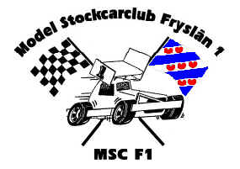
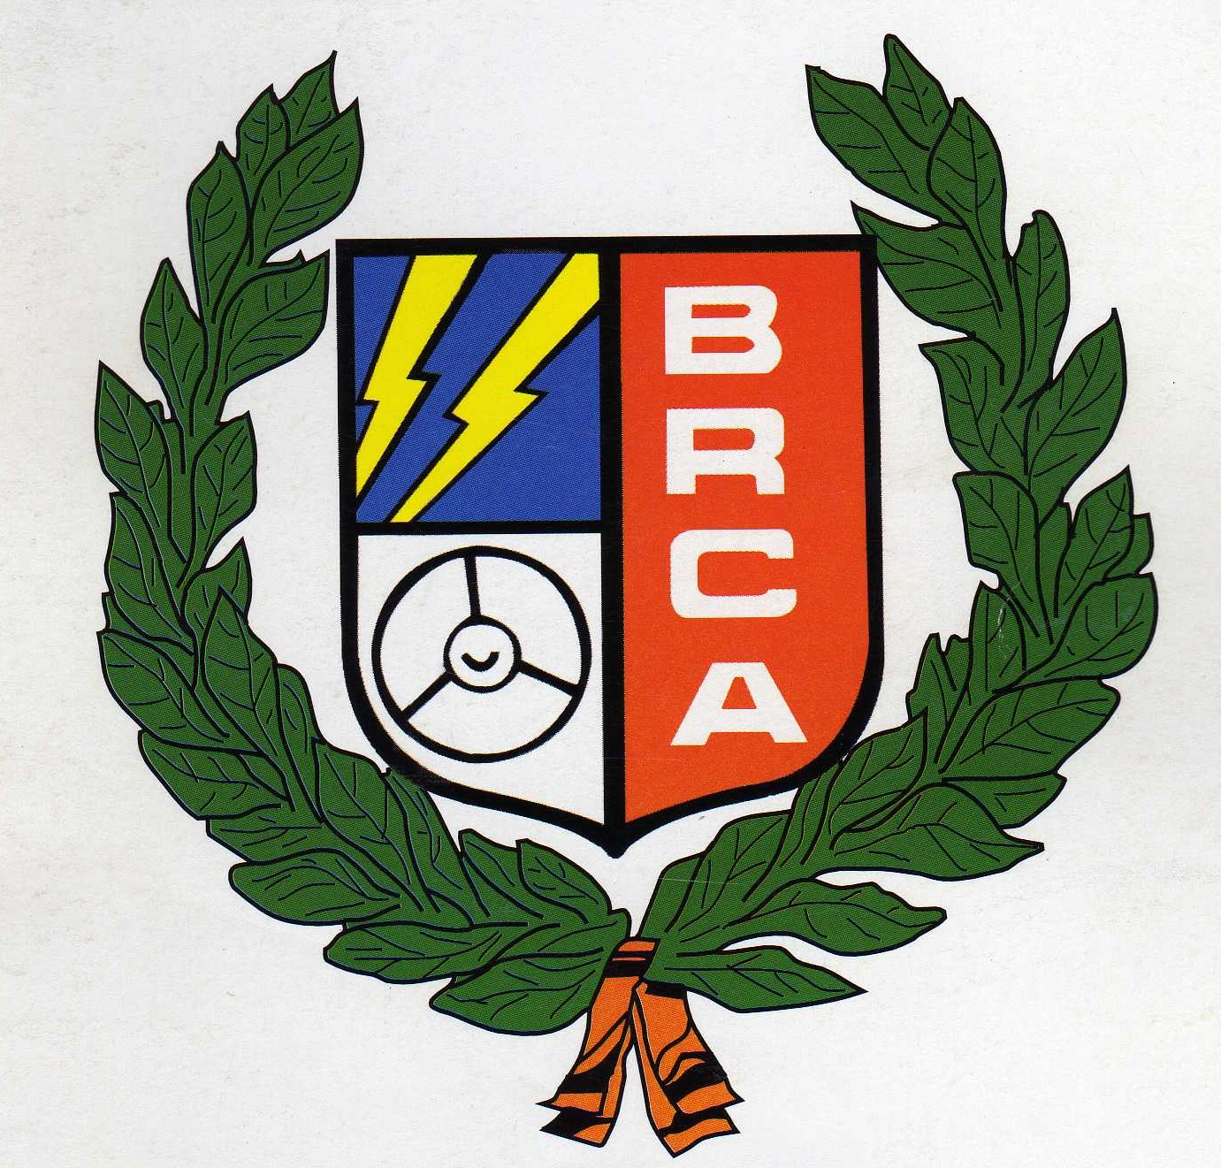


It is hard to imagine how twelve months has passed by from the last time we visited the Expo show, and the plans were set in motion for this trip, maybe it was a little too early as the organiser of the show had originally given me a date for the previous weekend, so plans were made for that date, unfortunately it was not until a later date we discovered that this was now the wrong date, so hastily things were changed for those that could do so, unfortunately this was too late for Karl Spencer as he had booked his flights and hotel in advance, and had major problems in arranging time off work to attend the championship’s on the new date although he had took advantage of the previous date for a romantic weekend break in Amsterdam. This late change in dates also caused me a lot of problems as a coach had been booked from Swift Valley Coaches to take us to Holland, and a lot of racers that had said they would come with us on the original date, had now found out they could not make it for the new date, so a mountain we had to climb, and with the begging bowl out and a marginal number of racers on the coach we were finally on our way at 06.15am on the Friday morning of January 27th, and what a difference the comfort of the coach was, compared to the cramped conditions of the mini bus on previous years, for me it was all worth the effort in the end along with less toilet stops for Fudgy Murray as we had a toilet on board! and after a slight detour en-route we arrived at our destination of the Het Grauuwe Paard at around 10.00pm Europe time! The good news was that all of the other racers that had chosen to fly had all arrived, except for Karl Spencer and he was not far behind us as he was stuck in traffic, and as 4.00 am approached it looked like we were in for our usual program of drinking, followed by minimal sleep and breakfast, followed by plenty of racing and socialising with the Dutch, then the routine would start over once again! And as we were still fresh into our weekend the alarm call at 07.30 am was not too much of a problem for most, although one or two wished they had had a little more sleep, although our coach driver Iain did look a little more alive after his nights sleep, and his continental breakfast was greatly received along with numerous mugs of coffee, and once we were outside the rest of us were soon wide awake as the temperature was around -5 with a wind chill of -10, Iain commented on the conditions and said that he had never known the coach to freeze up before. As we only had a relative short journey to the Racing Expo Show at Franeker, warm clothing was a must as the coach temperature inside was just above freezing and this was by the time we had arrived at our destination! Our usual place in the hall had changed, we were now just inside of the hall to the right, and what greeted us was the sight of a grandstand along side of the track, and also the track was looking in pristine condition, since our last visit the infield had now been covered, which made the track feel more of a track and larger than it had before, all psychological in the sense that the track was still the same size as before, so once all of the gear had been unloaded from the coach a suitable parking spot could be found the serious business of racing could begin, unfortunately this took a little longer than expected due to some problems with the P.A equipment, so there could be no excuses for not having the car setup ready for the first round, eventually the heats of racing could start and by know we were into the afternoon! In total there were forty- six competitors, and due to their being only six transponders there were eight heat’s, once again I do not have all of the details to give you a comprehensive report on all of the heat details, also the format of qualifying had changed slightly due to the lengthy start to the proceedings, so the plan was for the best five from six to count towards the qualifying score, and on the Sunday morning we would go straight into qualifying with there being no practice round, the aim was to finish in the top twenty-four along with a place in the quarter finals, there were some that appeared to be going well and some that were not, this was due I think to being in a challenging heat compared to others, as they are not shuffled over here, although things would start to unravel themselves at the quarter final’s, there were some good performances during the heats with Allan Inness showing potential as was Carl Baker, Phil Chadbourn was also going well, Anthony Wyper and Alastair Needham were some way down the order due to their heat being one of the roughest, one of the most vivid memories of the heats came when Nicholas Cooper won one of them and nearly repeated this only to loose out by one lap at the finish, at the top of the pile it was Mark Cooper that posted a new four minuet track record of 85 laps which was equalled by Ben Harding in a later round, the computer was predicting an 86-87 lap race was possible in the four minuets, and a quick calculation showed this would be up to 106 to 107 laps over a five minuet race distance, a considerable jump on last years final winning 99 laps by Karl Spencer! At the end of qualifying it was Ben Harding at the top with a total of 409 followed by Matthew Bennett with 403 and Mark Cooper with 402, placed at number six and seven in the list of qualifiers were the top two Dutch racers, they were Daniel Wissman in sixth with 389 and Thijs De Vries in seventh with 387, the final qualification place was filled by Reinder Visser with 349 in twenty fourth place, which meant there would be no quarter final qualification for Nicholas Cooper who finished in twenty sixth place with 345 just one place ahead of Pete Ayriss with 341 in twenty seventh, and rather surprising was the failure of Shayne Moorcroft, he finished thirty first of the forty six competitors with a total of 331 which was two less than Danielle Chadbourne had in thirtieth place, and Paul Brooks was content with posting an impressive 62 and an 60 in his heats of qualifying, his total of 272 placed him down in thirty ninth place.
The quarter finals.
The first of the quarter finals featured the top qualifier Ben Harding, along with Dave Gwilliam as the eight of the qualifiers, and Carl Baker as the ninth, then we had the sixteenth qualifier Alastair Needham along with Arnold Terpstra as the number seventeen qualifier and the final place on the grid went to the twenty fourth qualifier Reinder Visser.
The race distance was now up to four and a half minuets, and the first of the qualifiers through into the semi-finals was Ben Harding with ninety-one laps, then it was the Urmston club duo of Alastair Neeham and Carl Baker in second and third place with eighty eight and eighty seven laps respectively that go through to the semi-finals at the expense of the newly crowned Coventry Champion Dave Gwilliam, who had a bad start to the race and was unable to pull the missing laps back, his eighty five laps only good enough to take fourth place, behind him in fifth place with eighty laps was Arnold Terpstra followed by Reinder Visser with 62.
The second of the quarter finals featured the consistent Matthew Bennett as the number two qualifier, then we had Thijs De Vries as the seventh qualifier another Dutch racer to qualify was the number ten qualifier Tjepke De Vries, and coming in as the number fifteen qualifier was Anthony Wyper, then we had the current Junior World Champion Koen Middelkoop as the number eighteen qualifier, and the final place was filled by the twenty third qualifier Michel Berendsen.
No surprise that the winner of this quarter final was Matthew Bennett his winning lap score was the same as the first quarter final, that of ninety one laps, second place and with a pleasing eighty nine laps was Mr Explosive Anthony Wyper and the final qualification place went to Koen Middelkoop with eighty six laps, which meant no qualification for Michel Berendsen with eighty two laps in fourth or Thijs De Vries with eighty laps and Tjepke De Vries in sixth place with sixty five.
The line up for the third of the quarter finals was Mark Cooper as the number three qualifier, then we had the sixth qualifier Daniel Wissman, the third place in this quarter final was filled by the number eleven qualifier Hidde de Jong, another of the strong Dutch contingent featured as the fourth qualifier for quarter final three, coming in as the fourteenth qualifier was Evert Jacob Klok, then we had last years surprise finalist who pushed Karl Spencer all the way to the finish flag, coming in as the number nineteen qualifier was Patrick Lievens and the final racer into the quarter was Alan Inness who qualified as the twenty second qualifier.
Negotiating a safe passage into the semi finals as the race winner was Mark Cooper with ninety two laps, finishing in second place with eighty eight laps was Patrick Lievens, and what a surprise was waiting in the third qualification place, after both Allan Inness and Hidde De Jong had finished with eighty six laps the result was down to a split time which went by the narrowest of margins to Allan Inness, so no place for Hidde in the semi finals this was a real shock! Just behind these two was Daniel Wisssman with eighty five and the final place in this quarter final was filled by Evert Jackob Klok who had retired when in a commanding position after completing forty seven laps.
The line up for the last of the quarter finals had the number four qualifier Phil Chadbourne along side of the number five qualifier Karl Spencer, next into the race was the twelfth qualifier Scott Williamson, then we had the current Lobith Superstar racer Niek Middelkoop as the thirteenth qualifier, another of last years finalist’s had made it through as the number twenty qualifier no mean achievement this for Paul Riddell who must rate this as his favourite trak, and the final contestant for the quarter finals was Jelle Bijlsma coming in as the twenty first qualifier.
No real shocks in the first two places as Karl Spencer was first with ninety two laps and Phil Chadbourne came home second with ninety one laps, then things got interesting after both Niek Middelkoop and Paul Riddell had finished with eighty five laps each, the final qualification place was decided by a split time once again with the verdict going to Paul, a somewhat off the pace Jelle Biljsma finished in fifth place with eighty two laps and Scott Williamson was accredited with sixth place with eighty one laps.
The Semi-Finals
So the question was who would face who in the semi-finals, and the answer to that question was, in semi one the line up consisted of qualifiers 1, 4, 5, 8, 9 and 12 and semi two would feature 2, 3, 6, 7, 10 and 11. Put some names to that and they looked like this,
Semi one,
Mark Cooper, Phil Chadbourne, Ben Harding, Patrick Lievens, Carl Baker and Paul Riddell
Semi two,
Karl Spencer, Matthew Bennett, Anthony Wyper, Alastair Needham, Allan Inness and Koen Middelkoop
Both semi finals represented formidable opponents, and it was not going to be an easy task to predict who would come through, on paper both looked as tough as each other, so with the battle lines drawn semi one was soon underway, and it seemed that the racers were more worried about a safe passage through to the final rather than trying to win, at the finish it was a win for Mark Cooper with ninety one laps although Ben Harding also finished with ninety one in second place, and the all important third place finish went to Phil Chadbourne with ninety laps, behind these three came Patrick Lievens with eighty one laps in fourth place, fifth was Paul Riddell with seventy nine and the final place went to Carl Baker with seventy six.
Semi two was a complete contrast to the first semi, although it was a different proposition as Allan Inness suffered all sorts of problems with his pinion and soon dropped out of the race, this meant that it was going to be a very fast race as they were down to just five cars, at the finish it was the pre race favourite Karl Spencer that took the win with a very high ninety seven laps from Matthew Bennett with ninety four in second place and Anthony Wyper with ninety three in third, behind these three qualifiers for the final was Alastair Needham in fourth with ninety one and Koen Middelkoop finishing in fifth place with eighty six.

The European Final.
So it was to be an all British final, as the last of the Dutch had fallen at the semi final stage of the meeting, the line up for the final would be,
- Karl Spencer
- Mark Cooper
- Matthew Bennett
- Ben Harding
- Anthony Wyper
- Phil Chadbourne
It is not easy to take notes as you race in preparation of a race report, although I did note that this was not the cleanest of finals, it would appear that most of the racers were equal in terms of car handling, although some appeared to be faster than others, at the finish of the final it was a relieved Ben Harding that would be crowned the 2006 European Champion with a winning ninety three laps from Karl Spencer in second place with ninety two, and the final rostrum place was filled by Matthew Bennett with ninety one laps on a split time from Anthony Wyper after Anthony had also finished with ninety one, in fifth place we find Phil Chadbourne with ninety laps and the final place was taken by Mark Cooper with eighty nine, so it was close one with just four laps separating first and sixth place, afterwards a relieved Ben Harding declared that that was a lucky one as I was the slowest out there and I had to do what I had to do to win!
The European Junior Final
We were going to be in new territory with this final, the usual format for the final is the top six juniors from qualifying contest the Junior final, because the Dutch organisation had made a mistake and had omitted someone from the final that should have been in it, the decision was made to hold a nine car final, so that all of the juniors that were at the meeting would be in it, so taking to the track were Koen Middelkoop the current Junior World Champion, Jelle Bijlsma a former European Junior Champion, Niels Derksen, Roy Derksen, Arnauld Laverman, Simon Litjen, Foppe Minnema all from Holland, and two racers from the UK, Nicholas Cooper and Danielle Chadbourne.
Considering there were nine cars on track, the race was surprisingly clean, and it was clear that some racers were more concerned about others on track, and it was clear that they had already made up their minds as to who the main opposition was going to be, but surprisingly we had a very clear winner in the form of Nicholas Cooper who had a peach of a race and had ran out a convincing winner with eighty nine laps, finishing in second place with eighty laps was Koen Middelkoop and Jelle Bijlsma was placed third with seventy eight laps on a split time from Niels Derksen who also finished with seventy eight laps, Danielle Chadbourne came home in fifth place with seventy five laps and Arnauld Laverman finished with sixty seven laps in sixth place, the minor places went to Foppe Minnema with forty eight, Simon Lijten with forty six and Roy Derksen with fifteen laps.

Here is a technical chart of the European Senior Final.
Name | F/Tyre  In | F/Tyre  Out | R/Tyre  In | R/Tyre  Out | Gear  Ratio | Speed  Board | Charger | Car  Type | Chassi | Cells | Club | Grade | Qualif | Final
Karl  Spencer | Jap | Yellow | Pink | Pink | 12/51 | Mardave | Apex | Elite | Anderton | 3700 | Rugby | S/S | 1 | 2
Ben  Harding | Jap | 812 | Pink | Pink | 12/50 | Mardave | Apex | Skint | Anderton | 2000 | Rugby | Silver | 5 | 1
Matthew  Bennett | SE | Jap | Pink | Pink | 12/50 | Mardave | Duratrax | Lecatt  2 | Lecatt | 3700 | Rugby | Red | 2 | 3
Phil  Chadbourne | Pink | 812 | SE | Pink | 12/51 | Mardave | LRP | Bandit  Pro | Mardave | 2000 | Hathern | S/S | 6 | 5
Anthony  Wyper | Orange | Yellow | SE | Pink | 12/53 | Mardave | Apex | Bandit  Pro | Mardave | 3000 | Urmston | S/S | 3 | 4
Mark  Cooper | Jap  40 | Old  812 | Pink | Pink | 12/50 | 2  Speed | Pro  Trak | Lecatt  2 | Anderton | IB  3800 | Stoney  Stanton | Red | 4 | 6

Here is the technical chart from the Junior Final.
Name | F/Tyre  In | F/Tyre  Out | R/Tyre  In | R/Tyre  Out | Gear  Ratio | Speed  Board | Charger | Car  Type | Chassi | Cells | Club | Grade | Final
Koen  Middelkoop | 45 | 45 | 25 | 25 | 13/50 | Tamiya  3 step | TLP  Robbe | Mk1 Bandit | Mardave | Sanyo  1700 | Lobith | Junior  World  Champ | 2
Niels  Derksen | 36 | 45 | 30 | 36 | 12/52 | Tamiya  3 step | Robbe | Mk 1  Bandit | Mardave | Sanyo  2400 | Lobith | White | 4
Roy  Derksen | 40 | 45 | 36 | 36 | 12/52 | Tamiya  3 step | Robbe | Mk 1  Bandit | Mardave | Sanyo  2400 | Lobith | White | 9
Simon  Lijten | 40 | 45 | 36 | 36 | 11/52 | Tamiya  3 step | TLP | Mk 1  Bandit | Skint | 5 cell  2000 | Lobith | White | 8
Jelle  Bijlsma | SE | Orange | 36 | 40 | 11/52 | Tamiya  3 step | Power  Peak 3 | Mk 1  Bandit | Joop | Sanyo  1700 | MSCF | Red | 3
Arnauld  Laverman | Corally  Gold | 40 | Corally  Gold | Corally  Gold | 12/52 | Tamiya  3 step | Power  Peak 3 | Bandit | Joop | Sanyo  1700 | MSCF | Yellow | 6
Danielle  Chadbourne | Yellow | Orange | SE | Pink | 11/52 | Mardave | LRP | Bandit | Mardave | 2400 | Hathern | Yellow | 5
Nicholas  Cooper | Super  40 | Orange | Pink | Pink | 12/51 | 2 speed | Pro  Trak | Lecatt  2 | Lecatt | GP  3300 | Rugby | Yellow | 1

So another of our great adventures is over for another year, some things have been slightly different this time as we had travelled in style aboard a thirty three seat coach from Swift Valley Coaches, and for the first time we crossed above the channel and not under it, the sightseeing trip was annoying rather than entertaining on the journey up to Frysland, and yes it made a change to stop at a Burger King instead of a McDonalds, and watching the video of only fools and horses was a treat and not a chore, as for the temperature inside of our sleeping quarters on the first night might explain why so many decided to stay in the warm of the bar. As Swift Valley Coaches have a strict dress code of white shirt and maroon tie and jumper, our poor driver Iain took a lot of stick from the lads as this was all that Iain wore over the weekend, so when he eventually took off his tie late Saturday evening, and somehow it found its way over to Brooksy, who had great delight in wearing his new addition to his uniform of green and white rugger shirt, well we all thought we had gone too far when Iain did not even crack a smile when he saw where his tie was, and it was a full five minuets before he even raised a smile. Saturday evening was also different as some of us was still going strong in the bar, to be joined by some that had had a few hours sleep and were now ready to party, and what can you say about a full tray of sausage and chips arriving at the table around 1.15am in the morning to be joined by another at 1.30 am and another at 1.50am, just like a kebab on the way home from a session without the middle man, and what about Anthony Wyper giving the light above our table a good header, how he never knocked himself out I will never know, must have been the antiseptic of alcohol that saved him! Sunday morning was a real revelation, as Fudgy got his new hair-do, he swears it was done on the Saturday evening, although we know it was Sunday morning, just the same as when Evert Jacob Klok received his new orange highlights at breakfast, and as there was no chance of getting Fudgy out of bed it was decided to leave him there, although getting Anthony Wyper up after less then one hours kip was a challenge in its self although the kids did enjoy battering him with cardboard tubes, but I think it was the cold floor outside of the toilets and the cold water that eventually woke him up, and talking of Anthony Wyper the new TNT man of Manchester, he brought the whole of the Racing Expo Show to a standstill as he decided to blow up a set of his cells, along with a big hole in his pit box, another of the weekends highlights came on the Sunday evening when we presented our driver Iain with a Fryslan medal from the European event as a token of our appreciation, along with a new addition to his uniform, a Fryslan national flag bow tie, and to his credit it was worn with pride, as for what the British customs said to him at Calais was priceless. We did not even have one quiet night for around 2.30 am on the last night someone said who is going to turn out the lights, with this Nicholas ambled across the room to turn out the lights, we all thought that Scott Williamson was dead to the world, until he turned into a venus fly trap and took Nicholas’s legs clean from under him, the hysterics were then set in for the rest of the night or what was left of it as we were due to be up at 5.00am, and can I make a suggestion that Fudgy is no longer allowed to bring his mobile phone with him, an alarm call throughout the night is no fun, and once again Pete Ayriss is crowned party animal of the year, as he was escorted from the bar by Alka at around 06.30 for some much needed sleep, so there you have it all the details from another great event, see you all at the next one.

Mark Cooper.

