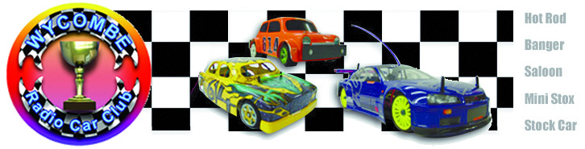

The dawn of the new era at the club in High Wycombe has been a success, Wycombe Radio Car Club was officially formed in April 2005 when they received the keys to the building, with an uncertain future ahead of them and many challenges to meet the club have acquitted themselves extremely well, yes there have been some problems along the way, with some of the formulas that were raced in the beginning not being very well supported by their members, so a few things have changed on their schedule of race meetings which I believe have now given the club a firm footing and promises a strong future , and so far this quote has been a very true one and become the very meaning of the club, WRCC has been born and it became us, the members of WRCC, our own club for the very first time, with open doors for everyone to come and enjoy our excellent facilities. In charge of the proceedings for today’s meeting we say hello to Jim Harrington, if there should be any problems arise there are plenty of additional Wycombe committee members on hand, and not forgetting the BRCA officials that are also in attendance at today’s meeting. The meeting last year attracted thirty-two competitors in the Stockcar class and there were twenty-three for the Bangers, so it was pleasing to see that the Stockcar entrée had increased this year to thirty-six, and the good news was that the Banger class had also had a slight increase in competitors too, it might be only two more than last year but it is going the right way!
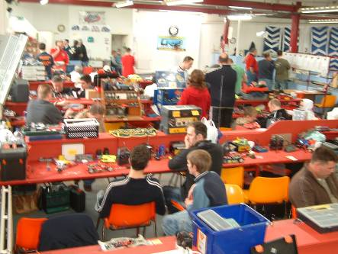
We had some problems at the meeting last year when the lap counting equipment could not keep up with the cars, this caused us to have to switch tracks, as Wycombe have this luxury, from their small oval onto their larger oval, the good news for us racers that do not like the bigger ovals is all of the problems from last year have been resolved and the meeting today will be on the small oval. So with the formalities of a drivers briefing out of the way, the meeting got underway right on the scheduled start time.
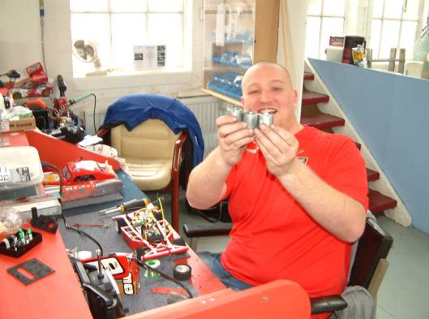
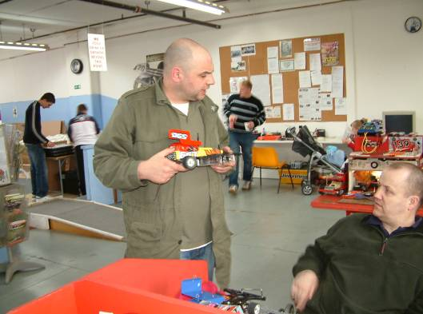

Round 1- Stockcars.
Karl Spencer opened his account by winning the first race of the meeting with 92 laps, somehow Mark Cooper had finished in second place with 88 laps, I say this as Mark had travelled overnight from Florida arriving back in Manchester in the small hours, than a race down the M6 from Manchester to home to drop the wife off and collect our racing gear it was straight on to High Wycombe, unfortunately arriving too late for practice, so after no sleep for 30+ hours and no practice this was quite an achievement! finishing behind Mark in third place with 82 laps was Phil Chadbourne followed by Wycombe club member Bryan Lee with 81. Heat two saw a rare win for the Urmston club racer Carl Baker with 84 laps, on paper this looked an easy win although I am sure that he will tell you different, there was a tremendous race behind him between a number of racers, remarkably the next four racers all finished the race on the same lap score of 74, in the order that they finished the race they were Gerry Fordham, Stewart Smith, Alan Harding and Miklos Szabados, there was just 4.44 seconds separating them! Heat three was won by Paul Jenkinson with a healthy 90 laps, making him work for it was Jim Burkett in second place with 89 laps he was followed by Dave Gwilliam with 84 and Sam Gray with 81. Heat four went to Rugby club racer Matthew Bennett with a high 96 laps, second place went to Alastair Needham with 91 and third place was decided by a split time after Anthony Wyper and James Blower had both recorded 89 laps, Anthony took third place by a mere 0.30 of a second. Heat five saw a quiet start to the meeting for Ben Harding, I say this as his winning lap score was below par with 89 (compared to Matthews 96) behind him in second place was Mark Steel with 81 followed by the Hathern club racer Allan Inness with 78 and young Christopher Blower with 75.
Bangers – Round 1.
Allan Inness makes a fantastic start to the days racing in the Banger class, he collected a rare win with 59 laps in heat one, Roy Calver was placed second after he had finished with the same number of laps as Allan however the computer showed that he was 5.22 seconds behind Allan, third place in this heat went to Michael Richardson with 56 followed by Paul Jenkinson with 51. Heat two was won by Paul Towers with 61, the second and third places were decided by a split time after Rob Forbs and Anthony Wyper had both recorded 59 laps, the split time was in favour of Anthony as he had completed his laps in 284.13 seconds compared to Rob’s time of 302.35, they were followed by Martin Riley with 52 laps and Robert Coles with48. Heat three saw a great race long battle between Mark Cooper and Mark Steel, at the finish it was Mark Steel that secured the win with 64 laps with Mark Cooper just one lap behind in second place with 63, third place went to Jim Harrington with 55 and Graham Coles was placed in fourth with his 50 laps.

Round 2-Stockcars
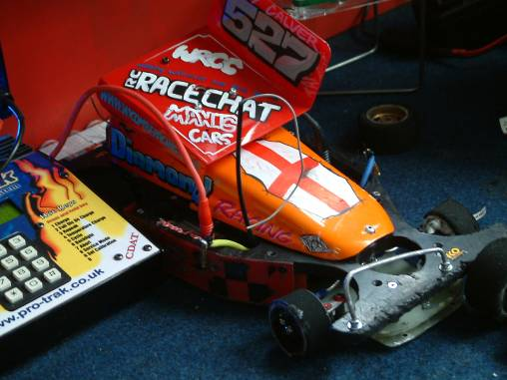
.Phil Chadbourn gets into the winning grove in heat one with his 88 laps good enough to secure the win from Jim Burkett in second place with 86 with James Blower a further lap behind on 85. Heat two had Karl Spencer increase his personal best lap score by 4 laps as he took the heat win with 96 laps, Alastair Needham came home in second place with his lap score of 89, he was followed by young Christopher Blower with 86 and Gerry Fordham with 80. Heat three and you have to ask yourself “where did that come from” after Stewart Smith had won the heat with 91 laps, as his previous race score from round one was 74! trying hard to keep with him in second place was Paul Jenkinson with 89 laps to his credit behind Paul in third place but some way behind was Matthew Brown with his 78 laps. Heat four was won by a High Wycombe club member “hooray” well done Roy Calver his winning lap score was 85, we had the next two racers finishing on the same lap of 81 so it was down to the computer to tell who took second place, and by a slender 0.12 of a second it was Michael Fryett who was just ahead of young Nicholas Cooper, and right behind these two was Allan Inness with 80. It is not very often we see lap scores this high, simply scintillating, and what an achievement as Ben Harding records a heat win with 100 laps in heat five, he was chased by both Matthew Bennett and Dave Gwilliam with 92 laps, the split time showed that Matthew was ahead by 2.85 seconds, this was a very high lap scoring race indeed as Robert Llewelyn – Jones recorded 87 laps in fourth place and Carl Baker clocked up 86 in fifth place.

Bangers – Round 2.
Mark Cooper goes one better in round two by recording a win in heat one with 58 laps, behind him in second place was Dan Martin with 55 and Michael Richardson was just one lap behind him in third place with 54 he was followed by Matt Shirley with 50. Heat two was won with a mind blowing 77 lap by Anthony Wyper, trailing in his wake was Mark Steel with 71 he was followed by Robert Coles with 66 laps in third place and Roy Calver finished in fourth with his 56. Heat three had another High Wycombe club member securing a heat win the winning lap score was 65 by Paul Towers who just edged out the on form Allan Inness who was just one lap behind at the finish of the heat, third place was secured with 58 laps by Jim Burkett and just like the first and second places in this heat, the third and fourth places were also separated by a single lap as Graham Coles crossed the finish line on 57 laps, another racer into the 50 lap mark was Stephen Blower in fifth place with 53.

Round 3- Stockcars
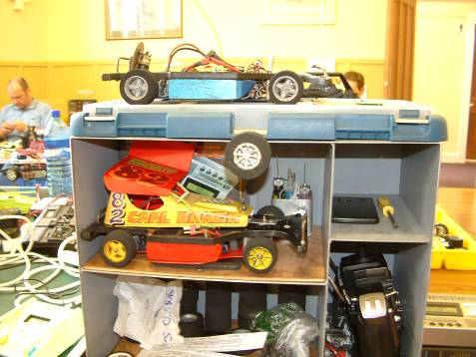
Matthew Bennett records a heat win with 85 laps in heat one of round three then we had Mathew Brown in second place with 80 and Phil Chadbourne with a poor result for him with 78 laps in third place, then in fourth we had Steve Brown with 72. Heat two had small track specialist Roy Calver taking a heat win on his home track his winning lap score was a respectable 88, not far behind in second place was Dave Gwilliam with 85 and Gerry Fordham was a further lap back on 84 in third place, they were followed by Mark Steel with his 80 laps. Karl Spencer continues with his good run of form by winning heat three with a mighty 95 laps he was chased by Paul Jenkinson with his 92 laps securing second place from James Blower with 91, this was an extremely high lap scoring race as the fourth placed racer Carl Baker recorded 89 laps which would have won some of the heats, Allan Inness posted a respectable 85 laps in fifth place with Mark cooper a further lap behind Allan. Heat four went to Stewart Smith with a high 95 lap score, the second and third places were separated by a split time after Jim Burkett and Christopher Blower had both finished the heat with 86 laps, the computer showed that Christopher was ahead by 2.38 seconds, trailing behind these two in fourth place was Anthony Wyper with 81. Amazingly Alastair Needham lowered the colours of Ben Harding as he recorded a heat win over the reigning national points champion, his winning lap score from heat five was 92 with Ben a further 2 laps behind on 90, finishing in third place with a good result was Alan Harding with 84 laps and third place was taken by Ian Rolph with 78.

Bangers – Round 3.
Heat one of round three was won by Dan Martin with 61, behind him came a train of racers that were all one lap apart at the finish heading the train in second place was Stephen Blower with 59 followed by Rob Forbs with 58 and Mark cooper with his 57 laps, fifth place went to Robert Coles with 55 and young Nicholas Cooper had 47 laps to his credit in sixth place. Heat two was won with an impressive 73 laps by Mark Steel the only other racer that was near him in this heat was Michael Richardson with 64 laps in second place although I am sure that Jim Harrington will be pleased with his third place finish with 48 laps with John Twiggs a further lap behind in fourth place. Heat three was won with a healthy 65 laps by Roy Calver, second place in this heat went to Martin Riley with 57, the third and fourth places were decided by a split time after Karl Mills and Graham Coles had recorded 47 laps each, the split times showed that Karl was ahead of Graham by 7.40 seconds, behind these two came two of the futures stars as Bradley Bircher claimed fifth place with 43 and Jack Gwilliam recorded 42 laps in sixth place.

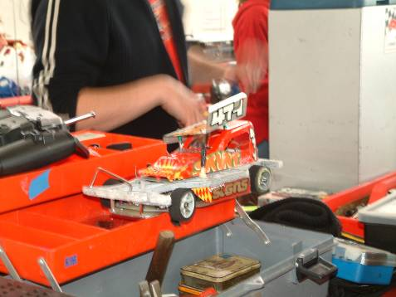
Round 4 - Stockcars
Phil Chadbourn clicks back into top gear by winning heat one of round four with a high 88 laps he had Sam Grey in close attendance in second place with 86, third place went to Christopher Blower with 80, both Brian Seymore and Carl Baker recorded 77 laps in the fourth and fifth places with Brian ahead by 0.49 of a second. Heat two was won by the impressive Matthew Bennett with 89 laps, second placed Jim Burkett was some eight laps behind Matthew he was followed by Gerry Fordham with 78 laps to his name in third place, we then had Bryan Lee and Allan Inness finishing the heat with 74 laps, the split time showed that Bryan was ahead of Allan by 2.49 seconds. Paul Jenkinson registered a heat win with 94 laps in heat three he was pursued right to the finish line by Alastair Needham who finished the race with 91 coming home in third place with 85 laps was Jordan Home and in the battle of the juniors Nicholas Cooper recorded 74 laps in fourth place and Martin Riley finished with 72 laps in fifth place. Mark Cooper must have gotten a second wind as he won heat four with 93 laps right behind him in second place was Karl Spencer with 91 and Dave Gwilliam had a good race to finish in third place with 88. The final heat of the qualifying rounds was won by Ben Harding with 97 laps, he was followed over the finish line by Stewart Smith with 88 laps and Roy Calver was just one lap behind him in third place, two other racers posting a score into the 80 lap bracket in this heat were James Blower with 84 along with Ian Rolph with 82.

Bangers – Round 4.
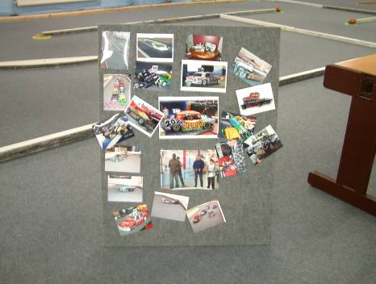
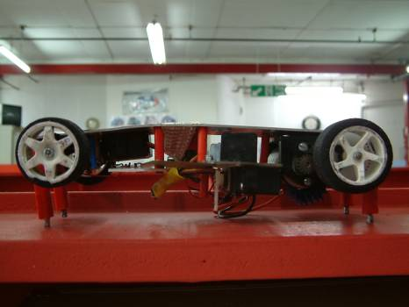
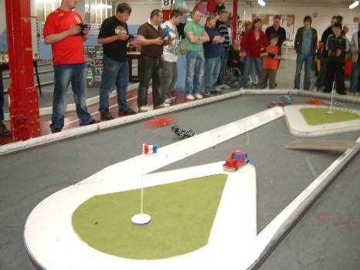
Roy Calver claimed his second successive heat win with a winning 66 laps in heat one, Stephen Blower recorded 60 laps behind him in second place and Paul Jenkinson finished with 51 just one lap ahead of Karl Mills in fourth place with 50, Alastair Needham completed a miserable day with 41 laps in fifth place and this was with the aid of a split time after Nicholas Cooper had also recorded 41 laps in sixth place the split time between them was 50 + seconds. Heat two was won with a healthy 67 laps by Paul Towers, finishing the heat with 61 laps was Rob Forbes in second place he followed by Anthony Wyper with 59 and Jim Burkett with his 52 laps, we then had both Martin Riley and Bradley Bircher completing the race on 50 laps, the split time was in favour of Martin by 1.59 seconds. The last heat of bangers was won by Mark Steel with 66 laps he was chased by High Wycombe club member Dan Martin who recorded 60 laps in second place he was followed by Jim Harrington with 53 and Graham Coles with 52.
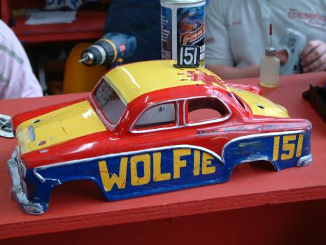
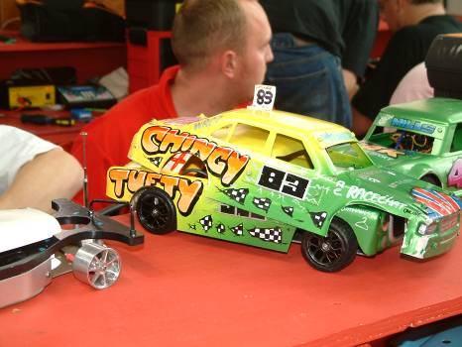
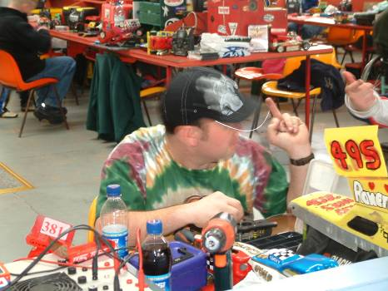

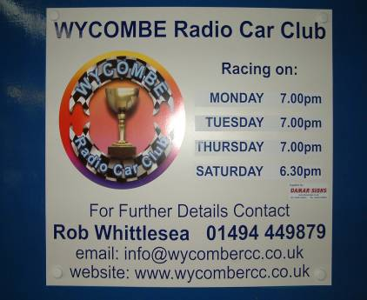
All of the heats of racing from the qualifying rounds was now finished, so now it was time to find out who would be racing in what, the usual format of qualifying means it would be the top seven qualifiers straight through to the Stockcar final followed by the next eight into a consolation race, with the winner of that through to join the seven already in the final, in the Banger class it would only be the top ten straight through to the final, although there would be a best of the rest race for the non qualifiers with no national points on offer but there would be a trophy for the winner, the first race to take to the track would be the Stockcar consolation race as the winner has to re-charge the cells and get ready for the final, so the racers that had qualified for this were :-
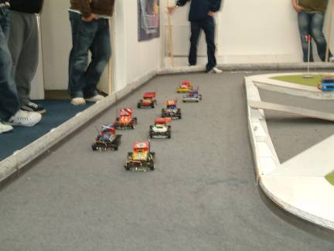
1. Mark Cooper 265
2. Dave Gwilliam 265
3. Jim Burkett 261
4. Roy Calver 260
5. Carl Baker 259
6. Phil Chadbourne 258
7. Allan Inness 256
8. Christopher Blower 252

Never easy to predict the outcome of these races, as there are so many variables involved when you are racing on a small track with a total of eight cars all vying for the one place that was available in today’s final and the only way to get there was by winning this race, on a small track like this contact is inevitable so a break down is possible, looking at the line up you had a home track specialist in Roy Calver, there was unpredictability in the shape of Jim Burkett and Christopher Blower, add to this the two small track experts Phil Chadbourne and Allan Inness (Hathern) then you also had experienced seasoned veterans like Mark Cooper, Dave Gwilliam and Carl Baker to add to the mix. And I can tell you as it was me (Mark Cooper) that won the race with 88 laps that it was experience that helped me win, finishing in second place was the second qualifier Dave Gwilliam with 83 laps and the third place was taken by Carl baker with 80, behind these three came the home track specialist Roy Calver with 77 laps in fourth, the fifth and sixth places were separated by a split time after Jim Burkett and Christopher Blower had both recorded 76 laps, the split time showed that it was Christopher that had taken fifth place by 0.47 of a second, behind these two came Allan Inness with 66 and Phil Chadbourne was just one lap behind Allan with 65.

The Banger Final
The question here was who had qualified, as with the Stockcars unpredictability was the key, we already know that Alastair Needham had not qualified and I am guessing that some of the big track speed merchants had also fell by the way side, so lets take a look at the list of qualifiers to find out, and remember that it is only the top ten qualifiers that will be in the final as there is no consolation race in the banger class, although there is a D/D later.
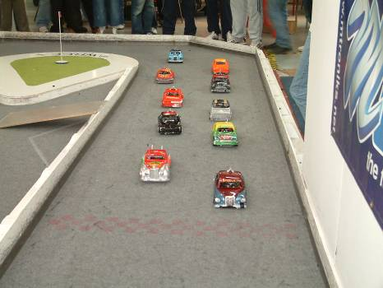
1. Mark Steel 210
2 Anthony Wyper 195
3. Paul Towers 193
4. Roy Calver 190
5. Rob Forbs 178
6. Mark Cooper 178
7. Dan Martin 176
8. Michael Richardson 174
9. Stephen Blower 172
10. Robert Coles 169

So the big names that you would expect to be in the final but were not were home club racers Jim and James Harrington, then there was the current British Open champion Paul Jenkinson, seasoned veteran Allan Inness had also fell by the way-side too as had Ian Rolph.
With all that said let’s take a look at the final result from those that had raced the final, and what a one sided result it proved to be as Anthony Wyper seemed to be untouchable as he made the rest of us look pretty ordinary with his winning 73 laps will testify when you look at the second placed racer Michael Richardson a great result although it was with a lap score of some 9 laps behind the winner he was followed over the finish line by Dan Martin with 61, things we then very close between Paul Towers, Mark Cooper and Robert Coles for the fourth, fifth and sixth places, all three racers finished with the same lap score of 59 as each other, so it was down to the split time to see who had finished where, and as Mark Cooper had the fastest split time it was he who took the fourth place followed by Paul Towers who was 2.39 second behind in fifth place and Robert took sixth place as he was just 0.02 behind Paul, we then had a further two racers finishing with a tied lap score, they were Mark Steel and Stephen Blower with 55 laps the split time showed that Mark was ahead of Stephen by a considerable 53 seconds as Mark had not completed the full race distance, ninth place in the final went to Roy Calver with 38 and tenth and last in the final was Rob Forbs with 37.

The Stockcar Final
The line up of racers for the final looked like this,
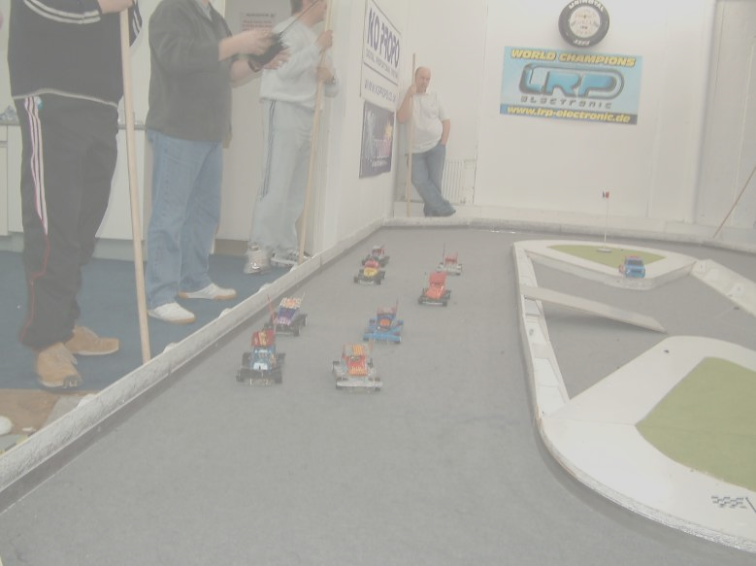
1. Ben Harding 287

2. Karl Spencer 283

3. Matthew Bennett 277

4. Paul Jenkinson 276

5. Alastair Needham 274

6. Stewart Smith 274

7. James Blower 265

8. Mark Cooper consolation winner

Well the form book was certainly turned up side down, as the red-hot favourite Ben Harding was defeated, the racer inflicting this rare event was Karl Spencer with a final winning lap score of 97, Ben could still hold his head high as he finished in second place with 94, he was pursued by Matthew Bennett in third with 91, behind these three we had another three racers finishing with 88 laps each, we had to rely on the computers split times to separate them and it showed that James Blower had taken fourth place from Mark Cooper by a slender 0.13 of a second and Mark was ahead of Paul Jenkinson by 1.08 seconds, behind these three in seventh place was Alastair Needham with 84 he was followed by Stewart Smith with 83.

There was also a further race prior to the D/D for the Bangers, this was called the best of the rest for the next ten qualifiers from the bangers that had not qualified for the final, this was won by Martin Riley with 61 laps, Jim Burkett came second with 56 and Graham Coles recorded 46 in the third place position he was followed by Nicholas Cooper with 44 and James Harrington with 41, they were chased by Allan Inness in sixth place with 40 laps to his credit we then had a big gap in laps to Matthew Shirley with 23 in seventh place he was followed by Karl Mills with 19 and Paul Jenkinson with 11. The winner of this race received a trophy along with all of the final winners along with grade awards from both classes of racing, the winners were
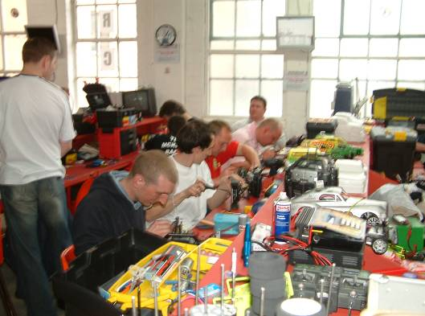
Stockcars,
Yellow – Sam Gray
Blue – Gerry Fordham
Junior – Christopher Blower
Concourse – Roy Calver

Bangers,
White – Jack Gwilliam
Yellow – Jim Harrington
Blue – Jim Burkett
Junior – Robert Coles
Concourse – John Twiggs

This meeting report was written by Mark cooper.

