Stoney Stanton Oval Raceway

Presents Round 6 for the Stockcars

& Round 5 for the Bangers

For the BRCA National Points Championship 2006
Sunday September 17th

I mentioned in the report of this national meeting from last year, that I felt that the Stoney Stanton club was going through a transitional period, this has proved to have been a right prediction as the reigns of the club were handed over to Brandon Snell early on in the year the official announcement was released on the Stoney Stanton web site on the 7/4/2006, Andy Cattell felt it better if someone else took over the running of the club as the 1/5th scale was taking up an increasing amount of his time, we wish him well and thank him for his hard work during the five and a half years that he has been in charge of the club, and getting the club established to where it is now. The news from Brandon is that he intends to take the club onto new and better things, he hopes to have a club hire car available soon, and if funds allow there will be a Stockcar and a Banger available to race on a club night, there will also be a Stoney Stanton Banger race team also, the first outing for this team has already taken place at the High Wycombe club with varying amounts of success, there will also be more end of year trophy’s for those that have supported the club throughout the year, and a new championship is in the offing as Brandon is thinking of running a D/D championship, there is also plans to make some improvements to the track, and if this is not enough Brandon also has a new web site for the club, this can be found at :-
www.ssorwracing.piczo.com
Looking back to the meeting last year there were 37 racers in the Stockcar class and 23 for the bangers, today’s meeting has attracted a slightly disappointing 29 for the Stockcars and the Bangers has attracted 22 just one less than the previous year! It was Ben Harding that won the final last year with an astonishing 92 laps, 2 laps better than his FTD of 90 laps, two other racers also recorded 90 laps during the meeting they were Matthew Bennett and Mark Steel.

Stockcars. Round 1.

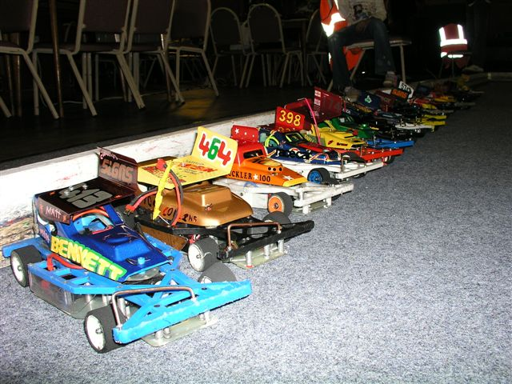
Opening his account with a heat win was the 2006 Stoney Stanton club champion Clive Buckler with 81 laps with James Blower in second place also recording 81 laps he was just 0.860 of a second behind Clive at the finish, behind these two came another pair of racers on the same lap at the finish of the race they were Martin Riley and Ben Harding with 79 laps, Martin was ahead of Ben by 1.590 seconds, and Gerry Fordham was another lap behind in fifth place with 78. Heat two was won by Alistair Needham with 86 from Mark Cooper in second place with 82, third place went to Derek Cayzer with 79 laps followed by Nicholas Cooper with 75. Heat three was won by Jon Cutts with 84 laps, he was just ahead of both Dave Gwilliam and Rich Harding who both finished with 83 laps, Dave was ahead of Rich by 1.730 seconds, coming home in a fine fourth place was Thomas Collins with 79 laps to his credit. Heat four was won with a split time after both Matthew Brown and Matthew Bennett had finished with 84 laps apiece although the win was accredited to Matthew Brown by a split of 5.00.200 compared to Matthew Bennett’s slit of 5.01.830, finishing behind these two in third place was Angela Yarwood with 81 followed by Alan Harding with 78.

Round 2.
You sometimes wonder just where the sudden improvement in laps comes from when the highest lap score from the previous round was the 86 by Alistair Needham and Ben Harding puts in an 91 to win heat one (one more than last years FTQ) behind him in second place was Alistair Needham with 87 laps, these two were well clear of the rest in this heat, Allan Inness took third place with a split from Nicholas Cooper after both racers had recorded 78 laps, one lap behind these two was Derek Cayzer with 77 and Chris Blower and Jim Burkett were just one lap further behind in sixth and seventh places and Thomas Collins was just one more lap behind these two in eighth place. Heat two was won by Rich Harding with 86 laps from Dave Gwilliam in second place with 85, Gerry Fordham finished with 80 laps in third place ahead of Darren Grace who had 78 laps to his credit in fourth place.

Heat three was won by James Blower on a split time from Matthew Bennett after they had both recorded 87 laps, the winning margin was a mere 0.180 of a second, third place was taken by Clive Buckler with 85 and both Jon Cutts and Matthew Brown finished with 83 laps each in fourth and fifth places. Heat four saw a different heat winner in the form of Sam Gray with a handsome 87 laps from Mark Cooper a close second with 86 and Angela Yarwood was giving Mark a hard race as her lap score of 85 in third place will testify, and young Martin Riley was not far behind with 83 laps in fourth place.

Round 3.

Success at last for Matthew Bennett as he wins heat one of round three with 87 laps, he had Rich Harding in close company in second place just one lap behind with 86, behind him in the third and fourth places with 84 laps each were Clive Buckler and Chris Blower, just over one second separated these two at the finish, then we had another two racers finishing with the same lap score, they were Jon Cutts and Angela Yarwood with 82, the margin between them at the finish was 0.610 with Jon taking the fifth place. Heat two went to Ben Harding with a winning lap score of 86, behind him came Sam Gray with 83 in second place and Gerry Fordham with 77 in third place just one lap ahead of Jim Burkett in fourth with 76, and worth a mention in fifth place was our long distance traveller Neil Ritchie with 73 laps. Heat three was won by Alistair Needham with 84 from Matthew Brown with 81 and Allan Inness in third place with 79. Heat four was won with a split time after James Blower and Mark Cooper were tied with 81 laps each the computer showed James to be ahead of Mark by 0.580 of a second, third place went to Dave Gwilliam with 79 laps followed by Pete Clarke with 77.

Round 4.

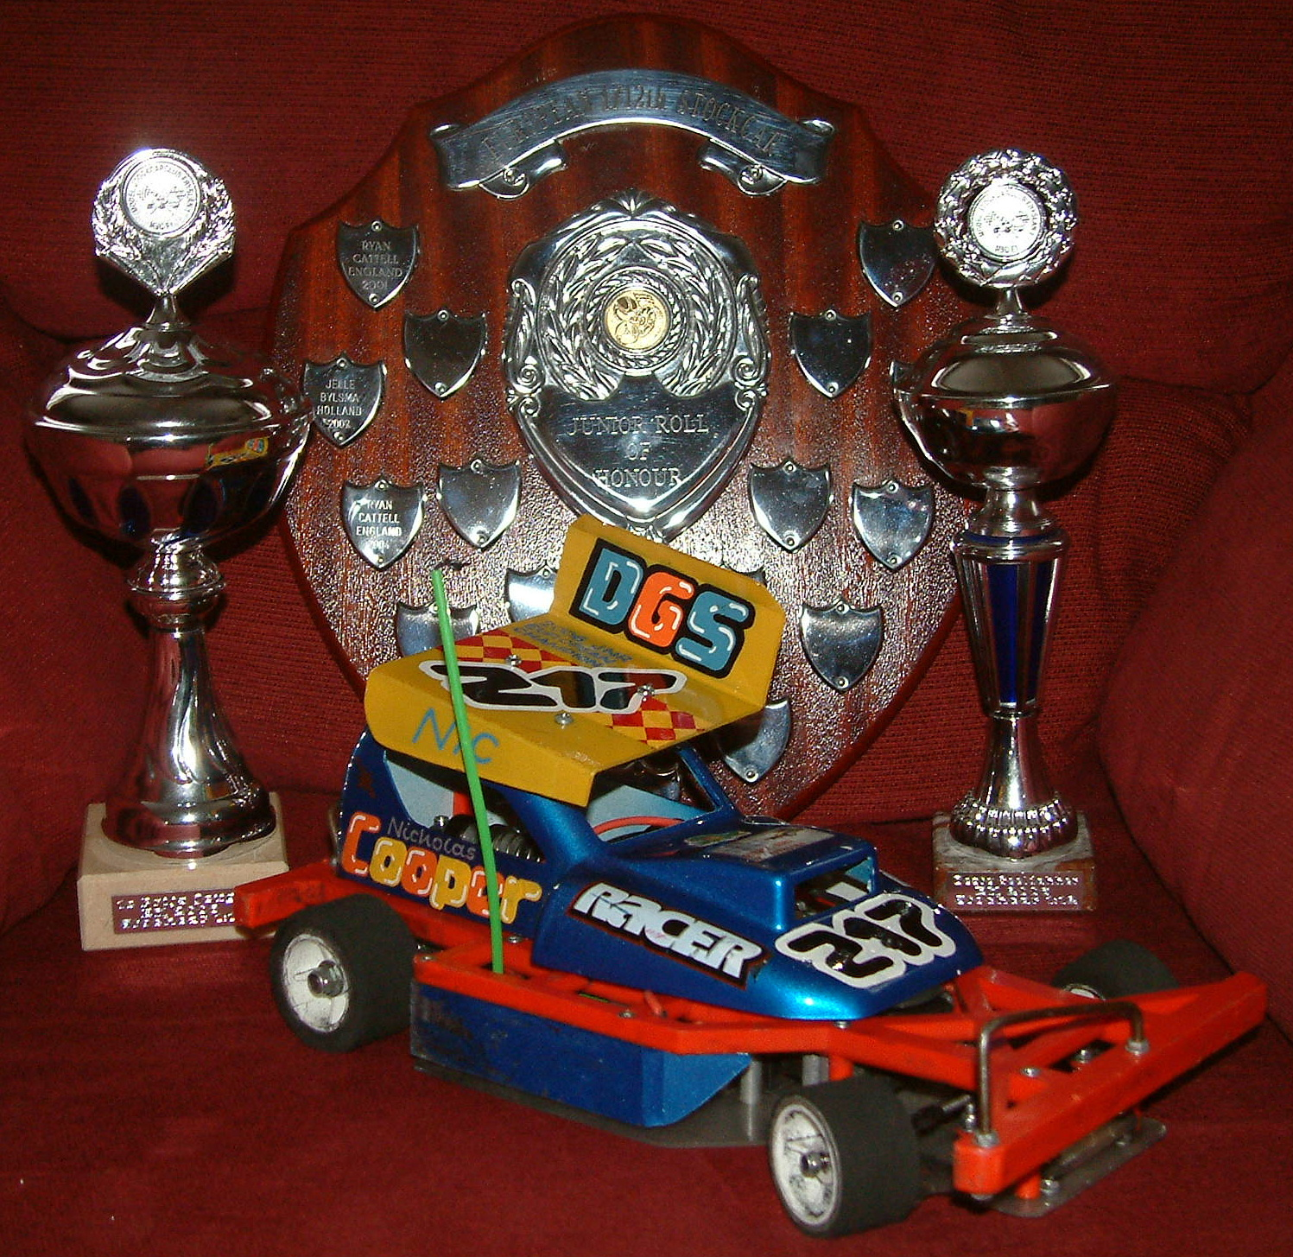
Heat one of round four was won with 90 laps by Clive Buckler he was chased by James Blower with 85 in second place and Allan Inness in third with 83 on a split time from Derek Cayzer who also finished with 83, the margin between them at the finish was just 0.590 of a second, behind these two came Rugby racer Pete Clarke with 81 laps. Heat two was unbelievable as Ben Harding set a new FTQ and new track record with 94 laps finishing in second place behind him was Sam Gray with 89, third and fourth places were separated by a split time after Matthew Brown and Dave Gwilliam finished the race with 88 laps, the computer showed Matthew was ahead by a slender 0.170 of a second, Chris Blower came home in fifth place with 82 laps ahead of Nicholas Cooper with 80 and to complete a high lap scoring race Miklos Szabados recorded 78 laps in seventh place. Heat three was a close race between three racers, at the finish Rich Harding was adjudged to be the winner by a split time after he and Angela Yarwood had recorded 89 laps each, the winning margin was 2.879 seconds, just behind these two came Mark Cooper with 88 laps in third place and Jim Burkett finished the heat with 85 in fourth place. Heat four the final heat of qualifying was won by Alistair Needham with 85 laps from Jon Cutts with 84 in second place and Gerry Fordham took third place with 79 and Alan Harding closed his account with 76 lap in fourth place.

Bangers. Round 1.

It was close at the end of heat one between three racers, but the eventual winner was Mark Cooper with 48 laps followed by the Stoney club champion Clive Buckler with 47 laps on a split time as Darren Grace also finished with 47 in third place these three were well ahead of Jim Burkett in fourth place with 21 laps. The winner of heat two also wore the biggest smile of the day, as a heat win for Alan Inness is quite a rare event his winning lap score was 39 laps just one ahead of Sandy Bissett in second place with 38, he was chased by Neil Ritchie with 32 laps in third place, it was close for the fourth spot between Nicholas Cooper and Amanda Snell at the finish it was Amanda ahead of Nicholas by one lap as Amanda posted 26 compared to Nicholas with 25 and for good measure Brandon Snell was just one lap behind Nicholas at the finish! Heat three was won by Martin Riley with 40 laps from Alastair Needham with 39, Stephen Blower came home in third place with 36 followed by Derek Cayzer with 33 and Kayleigh Cooper with 28 laps in fifth place.

Round 2.

Martin Riley collected a second heat win in round two with 48 laps he was pursued by Jim Burkett with 40 and Allan Inness in third place with 39, also posting a respectable score was Stoney Red top racer Wendy Snell with 36 laps in fourth place. Heat two saw Clive Buckler gain revenge over Mark Cooper although it could have gone either way, however Clive took the win over Mark with a split time after both racers had recorded 43 laps, Clive’s wining margin was nearly 8 seconds! third place went to Darren Grace with 39 laps and fourth was taken by Brandon Snell with 33 laps. Allan Stewart won heat three with 45 laps, he was chased by Sandy Bissett who came home in second place with 40 laps followed by Dean Ritchie with 35 and Charlotte Yarwood with 31 in fourth place.

Round 3.

Stoney Stanton club champion Clive Buckler collected his second heat win with 46 laps in heat one of round three, behind him in second place was Stephen Blower with 41 and Wendy Snell took third place with 31 laps. Heat two was won by Allan Stewart with 44 laps, this was Allan’s second heat win of the rounds, behind him in second place was Martin Riley with 35 and Nicholas Cooper was just behind Martin with 34 laps and club promoter Brandon Snell took fourth place with 21. Heat three was arguably the best race of the meeting so far, the winner of the heat was an ecstatic Derek Cayzer with 48 laps over the reigning national champion Alastair Needham in second place with 46, just behind these two was Jim Burkett with 43 laps followed by Allan Inness with 40, the fifth place finisher Sandy Bissett was not far behind Allan with 36 and Darren Grace was a further three laps behind Sandy in sixth place, and Mark Coopers race came to an abrupt end after 2 minuets and 56 seconds of the race after completing 27 laps which placed him in seventh place

Round 4.

Amazingly it was not until round four that Alastair Needham recorded a heat win, this was put right in heat one with a winning 46 laps, both Jim Burkett and Sandy Bissett recorded 35 laps each in second and third places, Jim was ahead by 2.950 seconds, and just behind these two in fourth place was Wendy Snell with 34 followed by Allan Stewart with 29. Heat two saw Mark Cooper collect another heat win with 47 laps from Darren Grace with 39 in second place, third place went to Neil Ritchie with 36 and Amanda Snell finished in fourth place with 33. Heat three was a cracking race, at the finish less than a second separated Clive Buckler and Derek Cayzer after they had both crossed the finish line with 49 laps, Clive took the win by 0.580 of a second, Martin Riley came home in third place with 45 laps and young Jack Gwilliam took fourth place with 21 laps.

That’s the end of the qualifying races, and for seven of the racers in the Stockcar class it would be the end of the meeting for them as the consolation features eight racers and the final has seven, which is made up to eight with the winner of the consolation, so fifteen of the twenty two will race on in the meeting, in the Banger class it is only the top ten that will contest the final, so we are saying goodbye to twelve racers at this stage of the meeting although they are eligible to take part in the last event of the day’s proceedings the D/D.
Here are the lists of the qualifiers for today’s finals along with their best three laps scores added together to make up their qualifying total :-

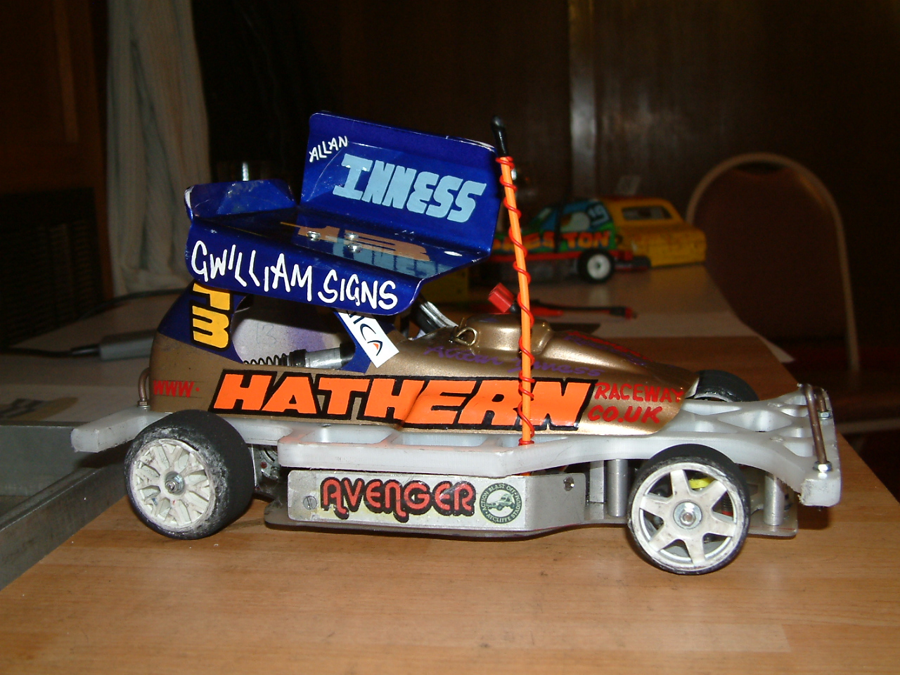
Stockcar Consolation.

1. Mark Cooper 256
2. Dave Gwilliam 256
3. Matthew Brown 255
4. James Blower 253
5. Jon Cutts 251
6. Chris Blower 242
7. Allan Inness 240
8. Derek Cayzer 239

Stockcar Final.
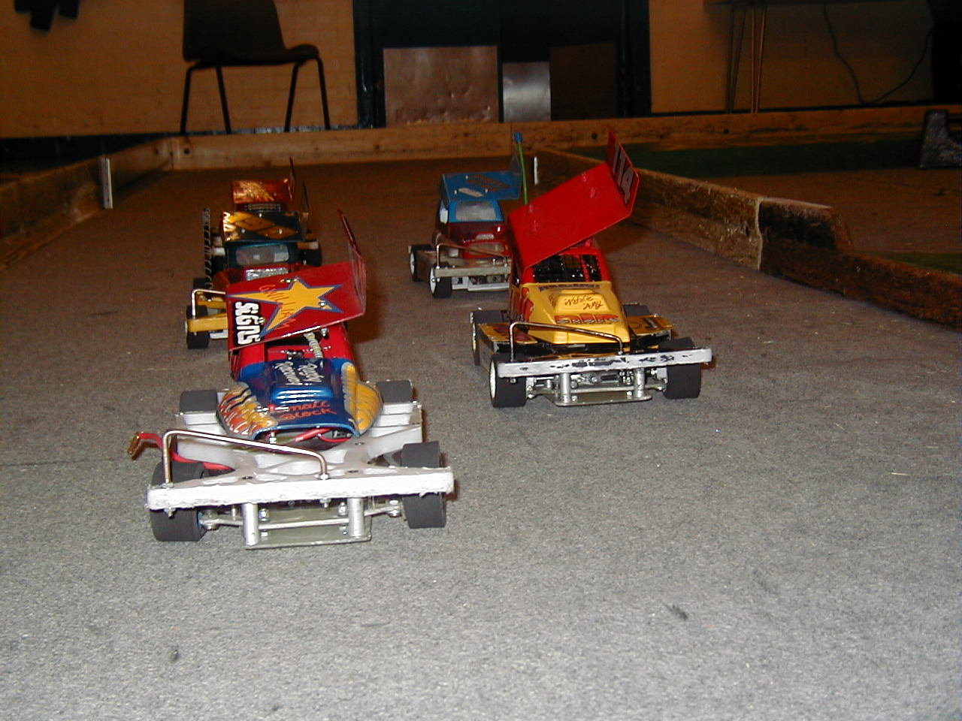
1. Ben Harding 271
2. Richard Harding 261
3. Clive Buckler 259
4. Sam Gray 259
5. Alistair Needham 258
6. Matthew Bennett 258
7. Angela Yarwood 256
8. Consolation winner

Banger Final.

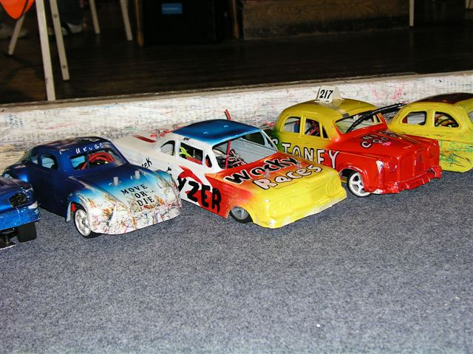
1. Clive Buckler 142
2. Mark Cooper 138
3. Martin Riley 133
4. Alistair Needham 131
5. Derek Cayzer 130
6. Darren Grace 125
7. Allan Stewart 118
8. Jim Burkett 118
9. Allan Inness 118
10.Sandy Bissett 114

The first of the finals to be run was the stockcar consolation race, which looking at the result could have gone to a number of racers as it was that close, the lead was constantly changing throughout the race, the eventual winner of the race was Jon Cutts with 85 laps and will now join the seven qualifiers for the stockcar final, just missing out in second place was Mark Cooper with 84 and James Blower was just one lap behind Mark with 83, the current Coventry regional champion Dave Gwilliam finished in fourth place with 82 laps to his credit, Matthew Brown from the Urmston club came home in fifth place with 80 followed by Allan Inness with 77, Fordham club racer Chris Blower posted 75 laps in seventh place and Derek Cayzer finished in eighth place with 71 laps. The next race out on track was the Banger Final.

Considering that this is a ten car race around a figure of eight track with cars meeting at the crossover point every lap, and then you also have a ramp to go over as well it is surprising how close the end result of the final was between the top two qualifiers from the heats, some how they had managed to break free from the chasing pack and develop their own personal battle, at the finish it was the reigning Stoney Stanton club champion Clive Buckler that took the win with an astonishing 50 laps from Mark Cooper in second place with 49 laps, behind these two in third place was Sandy Bissett with 41 he was chased by Allan Stewart in fourth place with 38, Derek Cayzer posted a creditable 36 laps in fifth place he was followed by Allan Inness with 35 laps in sixth place, Martin Riley was the last of the racers to complete the full race distance of five minuets as he crossed the finish line with 27 laps which placed him in seventh place, incredibly Darren Grace completed 26 laps in two minuets and fifty seven seconds which gave him eighth place, Jim Burkett completed 25 laps in ninth place and Alastair Needham had 10 laps to his credit in tenth place.

The Stockcar Final.

If you were there to watch this race as I was you wondered just how Ben Harding made it look so easy, considering the quality of racers that he was racing against, and to me it looked like he had got a bit more in reserve had he needed it!
His winning margin was five laps as he won the final with a massive 93 laps from Both Matthew Bennett and Alastair Needham with 88 laps each, the computer showed Matthew ahead of Alastair by 1.120 seconds, fourth place went to Clive Buckler with 85 laps the same lap score as Richard Harding recorded in fifth place, he was behind Clive by 1.880 seconds at the finish of the race, sixth and seventh places were also decided by a split time after Jon Cutts and Angela Yarwood had both recorded 83 laps, the computer showed Jon to be ahead by 1.050 seconds, and eighth place went to Sam Gray with 54 laps.

Tech chart of the Stockcar finalist’s.

Name | F/Tyre  In | F/Tyre  Out | R/Tyre  In | R/Tyre  Out | Gear  Ratio | Speed  Board | Charger | Car  Type | Chassis | Cells | Club | Grade | Qualify | Final
Ben  Harding | Jap  Med | 812 | Pink | Pink | 12/50 | Mardave  Mk 1 | Pro  Trak | Skint | Anderton | 4200 | Rugby | Silver | 1 | 1
Richard  Harding | Jap  Med | Mo  05 | Pink | Pink | 12/50 | Mardave  Mk 1 | Pro  Trak | Skint | Anderton | 3600 | Rugby | Red | 2 | 5
Clive  Buckler | Jap | Orange | Pink | Pink | 12/50 | Mardave  3 speed | Quasar | Shminka | Anderton | 3300 | Rugby | Red | 3 | 4
Sam  Gray | SC | Orange | Pink | Pink | 12/52 | Mardave | C.D.C. | Lewcatt  2 | Lecatt | 2000 | March | Yellow | 4 | 8
Alastair  Needham | 44 shore | 52 shore | Pink | Pink | 12/51 | Mardave  2 speed | Pro  Trak | Baker | Anderton | 3700 | Urmston | S/S | 5 | 3
Matthew  Bennett | Jap | new  812 | Pink | Pink | 12/50 | Mardave  2 speed | Duratrax | Lecatt  2 | Lecatt | 3600 | Rugby | Red | 6 | 2
Angela  Yarwood | 44 shore | 50 shore | Pink | Pink | 12/48 | Mardave  2 speed | Orion | Baker | Mardave | 2600 | Urmston | Red | 7 | 7
Jon  Cutts | 812 | Jap | Pink | Pink | 12/51 | Mardave | Apex | Skint | Anderton | 3300 | Rugby | Red | 8 | 6

The last event of the days proceedings was the Banger D/D, with the last car moving on the track being declared the winner, and for this achievement the winner receives one national point, and after a long battle which lasted over fifteen minuets Martin Riley was adjudged to be the winner.
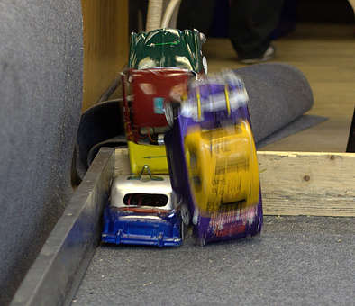
At the end of the meeting all of the Finalists received a trophy for their efforts, along with various grade awards and concourse trophies, these went to :-

Banger awards,
Concourse – Derek Cayzer
White – Jack Gwilliam
Yellow – Amanda Snell
Blue – Miklos Szabados
Junior – Stephen Blower
D/D winner – Martin Riley
Top Lady – Wendy Snell

Stockcar awards,
Concourse – Chris Blower
White – Amanda Snell
Yellow – Alan Harding
Blue – Nicholas Cooper
Junior – Chris Blower

Meeting report by Mark Cooper.

