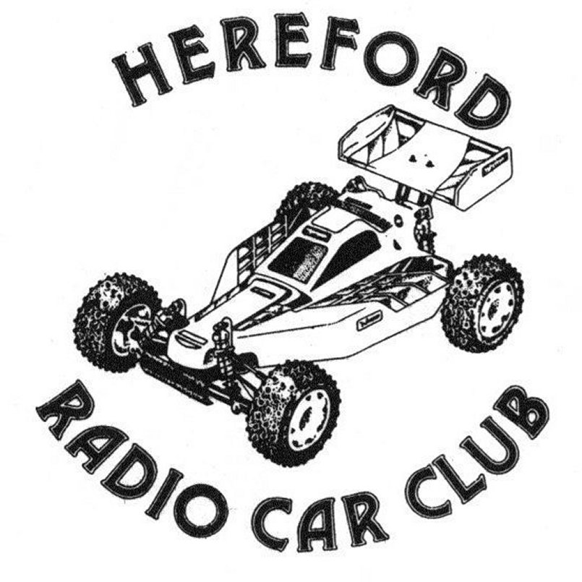

Presents
Round 5 for the Stockcars & Round 4 for the Bangers
Sunday September 3rd 2006
Held at the Bridge Street Sport’s Centre, Leominster.

How to find the club.
As the name might suggest a look at the map to find Hereford would give you a good idea of where the club is located, when in-fact the club is based in Leominster, a small town some fifteen miles north of Hereford, for me the journey was up the A46 towards Stratford, just after Stratford you stay on the old road that used to take you towards Evesham – the A435 briefly between Islands ( not down the new bypass) then you turn off just before Ragley Hall onto the A422 and headed towards Worcester, at Worcester I got onto the A44 which took me straight towards Leominster. From other parts of the country North or South get onto the M5 and leave the motorway at J7 (Worcester south) and join the A44 to Leominster, once you arrive at the large roundabout turn right proceed on to the next roundabout and turn left, continue until you have gone over a level crossing, just after this you come to mini roundabout go to the right and the venue is approximately 300 meters straight ahead then the Bridge Street Sports Centre is on your left, the journey for me from home just outside of Coventry was 78 miles.

The meeting today has attracted 19 Stockcars and 20 Bangers, this might seem a low number but as the club does not normally run the Stockcar and Banger class I think this is a reasonable turnout considering the 1/8th I.C. Stockcar World final was being held on this weekend, and the actual F1 Brisca World final was held on the Saturday prior to this meeting followed by a meeting at Northampton Stadium on the same day as this national, I think that all of this accounted for some of our usual racers, also the youngsters from the March club were let down with their travel arrangements so they were unable to attend the meeting. I hope that this does not put the club off from hosting a National meeting next year, as this is a well organised club and deserves a lot more from our section in terms of support in the number of racers for the meeting, so how hard can it be to arrange a meeting that does not clash with another section, and it does not have to cost a fortune to travel if you share a lift with someone else!
Looking around the hall it was very noticeable that the club has a smart rostrum to race from, they had one last year that was approximately two-foot high, for this one you have to go up a flight of stairs, it was certainly different, and made the cars appear slow down the straights, I think this was because you were looking down on the cars.

Round one.
Bangers.
The first race of the meeting was won by Mark Cooper with 64 laps from Alastair Needham with 63 in second place and just behind Alastair with 62 was Jamie Burkett, these three were well ahead of the rest as Jamie McLoughlin came home in fourth place with 48 and Nicholas Cooper finished in fifth with 40. Heat two went to a fast Sam Gray with 67 laps from Kyle Bouston with 63 and Chris Bottle in third place with 60, Oliver Batchelor took fourth place with 57 although he did not complete the full race distance, behind him in fifth place was Robert Llewelyn-Jones with 54, another racer with 54 laps in this heat was Stephen Blower in sixth place, fifth place went to Robert as his lap score was in a time of 4.57.124 compared to Stephens 5.00.309, behind these two was Allan Inness with 44 laps which was achieved in 3minuets and 42 seconds. Heat three saw Darren Grace post the fastest time so far, did his car have wings as he registered 70 laps in 5.02.955, behind him in second place was Martin Llewelyn-Jones with 65 laps and Chris Green was a further lap behind Martin in third place, Brandon Snell came home in fourth with 51 and Kayleigh Cooper registered 20 laps in fifth place after completing only half of the race distance.

Stockcars.
Mark Cooper posted a great result as he took first place with 79 laps in heat one with Ben Harding in second place with 77, young Martin Riley was a further lap behind Ben in third place with 76 and Matthew Brown was just behind Martin with 75 laps, then we had a smiling Brandon Snell (as he had completed a race) with 66 laps in fifth place. Heat two was won by James Blower with 80 laps from Alastair Needham with 78 and Sam Gray in third with 76, Darren Grace posted 73 laps in fourth and Gerry Fordham was just one lap behind Darren with his 72 laps, then we had Rich Harding with 68 in sixth place followed by Kayleigh Cooper with 51. Heat three had a race long battle which went right down to the wire as Angela Yarwood and Jamie Burkett fought long and hard and were both on the same lap of 80 at the finish, the win went to Jamie by 3.363 seconds, third place was taken by Miklos Szabados with 76, we then had another two racers finishing on the same lap, they were Christopher Blower and Allan Inness with 74 laps, Christopher was ahead of Allan by 0.506 of a second, behind these two came Nicholas Cooper with 71.

Round two.
Bangers
Chris Bottle storms to a heat win with an amazing 71 laps, the highest yet in the Bangers, not far behind him in second place was Robert Llewelyn-Jones with 69, previous heat winner Mark Cooper finished with 61 laps in third place and Stephen Blower was right behind him with 60 laps and the only other racer to complete the race distance was Philip Price with 55 laps in fifth place. Not to be outdone the current national points champion Alastair Needham also post’s a lap score of 71 by winning heat two, and for good measure it was in a faster time than Chris’s 71, behind Alastair was Chris Green with 68 and Martin Llewelyn-Jones with 63, amazingly Allan Inness took fourth place with 35 laps although he only completed 2 minuets and 53 seconds of the race against the 35 laps by Nicholas Cooper who completed the race distance, and just behind these two came Oliver Batchelor with 32. Anything is possible as Darren Grace proved by winning heat three with a fantastic 73 laps! (the same as his first stockcar heat lap score) behind him in second place was Martin Riley with 68 followed by Jamie Burkett with 66, not far behind him with 61 laps was young Sam Gray, these four racers were the only one’s from this heat to complete the race distance, so the minor places were taken by Jamie McLoughlin with 25 laps and Kayleigh Cooper with 24 followed by Thomas Bottle who completed just 5 laps.

Stockcars.
It doesn’t get better than this, what a race heat one of round two produced as no less than three racers finished on the same lap, they were Rich Harding in first place by 0.971 of a second from Angela Yarwood in second place and Jamie Burkett was a further 0.268 behind Angela in the third position and for good measure Sam Gray was only a lap behind these three in fourth place, and what about Brandon Snell completing another race, this time he finished with 61 laps in fifth place followed by Darren Grace with 43 and Kayleigh Cooper with 40. Heat two saw Ben Harding make up for his round one defeat with a winning lap score of 82 from James Blower in second place with 81, they were a comfortable distance ahead of Christopher Blower in third place with 76, Nicholas Cooper was right behind him with 75 and Allan Inness finished in fifth place with 72 laps then came Miklos Szabados with 58. Heat three had Mark Cooper across the finish line with the highest lap score so far with 83 laps, finishing a single lap behind him in second place was Martin Riley followed by Matthew Brown with 80, and a further lap back was Alastair Needham with 79 in fourth place as was Gerry Fordham with his 78 laps in fifth place.
Heading the qualifiers from the two rounds were Darren Grace followed by Alastair Needham and Chris Green in the Bangers, and leading the Stockcars was Mark Cooper from James Blower and Ben Harding.

Round three.
Bangers
Darren Grace looked a hot prospect for the final as he collected win number three in heat one with 71 laps, disputing second place behind him were Robert Llewelyn-Jones and Mark Cooper, at the finish they both had completed 66 laps but it was Mark who took second place by a narrow margin of 1.470 seconds, Stephen Blower finished in fourth place with 63 followed by Allan Inness with 49 and Jamie McLoughlin with 30 laps although he did not complete the full race distance. Heat two produced another lap score of 71 as Chris Bottle took the heat win from Martin Riley who finished the race with 69 laps behind these two came Oliver Batchelor in third place with 53 and Jamie Burkett was fourth with his lap score of 45, then we had the battle of the brother and sister, with Nicholas just ahead of Kayleigh at the finish as Nicholas posted 37 laps to Kayleigh’s 35. Heat three of round three was won with a split time as Alastair Needham and Chris green both recorded 66 laps, the win went to Alastair by 1.696 seconds these two were well ahead of Thomas Bottle who took third place with 37 and Philip Price was just one lap behind him in fourth place.

Stockcars
Heat one was won by James Blower with 79 laps he was chased by Gerry Fordham with 77 and Sam Gray with 76 laps in third place, taking the fourth place was Allan Inness with 71 followed by Robbie Young with 62 and Brandon Snell with 58. Heat two went to Mark Cooper with 83 laps the highest laps so far! behind in second place was Rich Harding with 78 on a split time from Angela Yarwood, the gap between them was 0.921 of a second, Alastair Needham posted 77 laps in fourth place followed by Miklos Szabados with 72 and Kayleigh Cooper with 45. Heat three saw Ben Harding move up into top gear as he won the heat with an astounding 86 laps with the new FTQ, trailing in his dust were Jamie Burkett and Christopher Blower in second and third places along with Matthew Brown in fourth, all of these racers recorded 79 laps, Jamie was ahead of Christopher by 1.518 seconds and Christopher was ahead of Matthew by 1 second exactly.
Heading the list of qualifiers after the three rounds in the Bangers was Darren Grace from Chris Bottle and Martin Riley, and the Stockcars had Ben Harding moving into pole position from Mark Cooper and James Blower.

Round four.
Bangers
Collecting his fourth win in the banger class was Darren Grace with 70 laps good enough to take heat one from Jamie Burkett in second place with 62 and Brandon Snell with 56, fourth place went to Thomas Bottle with 51, Kayleigh Cooper finished with 40 laps in fifth place ahead of Sam Gray who had 27 laps to his credit at the end of the race. Heat two was arguably the best of the rounds, and how close it was at the end as three racers all finished on the same lap, they were Kyle Bouston taking the win by more than 8 seconds (as he did not actually complete the full race distance) from Alastair Needham in second place, and Martin Llewelyn-Jones took third place just 0.429 behind Alastair, and not far behind these three was Mark Cooper with 63 laps in fourth place, Robert Llewelyn-Jones finished with 47 laps and Jamie McLoughlin was next with 41 and Martin Riley posted 28 laps after completing just 2.04.049 of the heat. The last heat of the Bangers was won with 74 laps by a flying Chris Bottle, he was pursued by Chris Green in second place with 65 and Oliver Batchelor with 62, these three were the only racers in this heat to complete the full race distance however Allan Inness recorded 35 laps and Nicholas Cooper posted 29 and Stephen Blower had a miserable 2 laps to his credit in a time of 22.129 seconds.

Stockcars
We had a close battle in the first heat of round three as Alastair Needham took the win from Jamie Burkett with a split time after both racers had recorded 83 laps, Alastair’s winning margin was just 0.426 of a second, taking third place was Christopher Blower with 80 followed by Gerry Fordham with 79 and Darren Grace with 66. Heat two was won by Ben Harding with 84 laps, his brother Rich Harding claimed second place from Miklos Szabados after both racers had finished with 76 laps, Rich was ahead of Miklos by 1.750 seconds, fourth place went to Mark cooper with 75 with Matthew Brown a further two laps behind Mark in fifth place, young Sam Gray finished the heat with 71 laps followed by Brandon Snell with 57. Heat three went the way of James Blower with 78 laps, behind him came Martin Riley and Angela Yarwood with 76 laps, Martin was ahead of Angela by a mere 0.088 of a second, these two were chased by Allan Inness with 75 and Nicholas Cooper was a further lap behind Allan with his 74 laps and Robbie Young finished the race with 60 laps.

The end of the qualifying rounds signals the usual wait as the best three scores are worked out from the four rounds, some of the racers can be sure of qualification into their relative final, for others it will be a frustrating wait to see if they had done enough, as usual it is only the top ten qualifiers that will contest the Banger final, and the top seven from the Stockcars will go directly into the final and the next eight will contest a consolation race with the winner progressing into the final. Here are the qualifiers for the Banger and Stockcar final along with the consolation race,

Banger Final Stockcar Consolation Stockcar Final

1. Chris Bottle 216 Matthew Brown 234 Ben Harding 252
2. Darren Grace 214 Martin Riley 234 Mark Cooper 245
3. Alastair Needham 200 Gerry Fordham 234 Jamie Burkett 242
4. Chris Green 199 Richard Harding 228 Alastair Needham 240
5. Martin Llewelyn-Jones 193 Sam Gray 225 James Blower 240
6. Mark Cooper 191 Miklos Szabados 224 Christopher Blower 235
7. Jamie Burkett 190 Nicholas Cooper 223 Angela Yarwood 234
8. Robert Llewelyn-Jones 189 Allan Inness 221
9. Stephen Blower 177
10.Oliver Batchelor 172

The Stockcar Consolation.
This has the makings of a very good race as there are only thirteen laps between the top qualifier and the bottom qualifier, which is roughly 4 laps a race difference, and looking more closely the top three all had the same qualifying total, and of the seven that completed the full race distance there was only six laps between them at the finish of the race. I believe this will be his first consolation win and it will also be his first national final as Matthew Brown kept a cool head to win the consolation race by a comfortable 2 laps from Gerry Fordham, Matthews winning lap score was 80 laps and Gerry finished with 78, then we had three racers all finishing with 77 laps in their order of crossing the finish line they were Martin Riley, Miklos Szabados and Allan Inness, behind these three in sixth place was Richard Harding with 75 followed by Nicholas Cooper with 74 and Sam Gray recorded 61 laps before he dropped out of the race just before he had completed 4 minuets, the fastest lap of the consolation was 3.045 seconds by Allan Inness on lap three, for comparison Matthews fastest lap was done in 3.369 on lap 41.

The Banger Final.
Would the fast cars be able to cope with the extra number of cars on track, in the heats the most we had was seven, and now we had a full grid of ten cars to contest the final, well we did not have to wait long to find out the answer, the records will show that I (Mark Cooper) completed just one lap of the final, the truth is I only managed three-quarters of a lap before I rolled the car and landed on my side, just three laps later Chris Bottle barrel rolled his car on the same bend and left the track this was just before my own car was hit and put out of the track, so the final was quickly down to eight cars after 17 seconds of the final! and as Chris Bottle was the top qualifier would this leave the way clear for Darren Grace to win the final, looking at the results almost but not quite was the answer as Alastair Needham put on a fantastic display of race craft to take the win with 69 laps he was a clear winner of the final from both Robert Llewelyn-Jones and Darren Grace in second and third places with 65 laps each, fourth place went to Jamie Burkett with 62 laps and Martin Llewelyn-Jones came home in fifth place with 60, Chris Green took sixth place with 55 laps and both Oliver Batchelor and Stephen Blower finished the race with 52 laps each in seventh and eighth places, and the previously mentioned Chris Bottle was classified as ninth and Mark Cooper was tenth. The fastest lap of the final was done by Chris Bottle on lap two in a time of 3.47 seconds, Alastair had a fast lap of 3.856 by comparison to Chris, and his average lap time over the race distance was 4.428.

The Stockcar Final.
A quick look back to the final last year shows that it was won with 83 laps by Ben Harding from Matthew Bennett and Ian Johnson, looking at the qualifiers Ben Harding is looking like a hot favourite as he has already set an 86 laps in qualifying which also takes the extra point for the FTQ, but it should be close as we have a further three racers that have done an 83 in the heats which was good enough to win last years final.
He didn’t disappoint us as the hot favourite, and I am running out of things to say about him as his record of final wins is simply outstanding, better even than the legendary Michael Schumacher – we can all hope that he follows Michael by retiring soon…..
So once again its congratulations’ to Ben Harding on yet another national final win, his winning lap score for this one was 84 finishing in second place was Alastair Needham with 82 and the final rostrum place was taken by James Blower with 81, an eventful final for me ended with 79 laps in fourth place with Angela Yarwood and Jamie Burkett a lap behind me in fifth and sixth places, Angela was ahead of Jamie by a mere 0.204 of a second, and right behind these two was Christopher Blower with 77 and Matthew Brown with 76 laps.

Straight after the Stockcar final was the Banger D/D, and boy was this slightly different as not only did we have a car disguised as a sheep on the track, but the Hereford club had arranged for a Welsh bagpiper to serenade us during the D/D, and how Allan Young (hope that I have spelled his name right) did not run out of puff I will never know, as these D/D’s usually last a long time, as long as 30 minuets in some cases, and as if to celebrate it was won by a home club racer in the form of Philip Price.

Grade awards went to
Stockcar concourse – Robbie Young
Banger concourse – Kayleigh Cooper
Banger top junior – Oliver Batchelor, Yellow grade – Robert Llewelyn-Jones, Blue grade – Darren Grace
Stockcar top junior – Martin Riley, Yellow grade – Nicholas Cooper, Blue grade – Miklos Szabados

Here is a technical chart of the Stockcar finalists car set up, although it does not tell you things like tyre diameters and widths i.e. stagger, also some racers use toe-in on their front axles and some race with an in line wheel arrangement, so remember a tec chart tells you what type but not how if you know what I am on about,

Name | Front  Tyre in | Front  Tyre out | Rear  Tyre in | Rear  Tyre out | Gear  Ratio | Speedo  Type | Charger | Car  Type | Chassis | Cells | Home  Club | Grade | Qualif | Final
Ben  Harding | Jap  Med | 812 | Pink | Pink | 12/50 | Mk 1  Mardave | Pro  Trak | Skint | Anderton | 3800 | Rugby | Silver | 1 | 1
Mark  Cooper | 50 shore | SE | Pink | Pink | 12/50 | 2 speed | Pro  Trak | Lecatt 2 | Anderton | IB  4200 | Stoney  Stanton | Red | 2 | 4
Jamie  Burkett | Jap  Med | 812 | Pink | Pink | 12/50 | 2 speed | Apex | Skint | Anderton | 2000 | Fordham | Red | 3 | 6
Alastair  Needham | 40 shore | 50 shore | Pink | Pink | 12/51 | 2 speed | Pro  Trak | Baker | Anderton | 3600 | Urmston | S/S | 4 | 2
James  Blower | Orange | 52 shore | Pink | Pink | 12/51 | 2 speed | Nosram | Bandit  Pro | Anderton | 2000 | Fordham | Red | 5 | 3
Christopher  Blower | Pink | 52 shore | Pink | Pink | 11/53 | 2 speed | Novak | Johnson | Anderton | 2000 | Fordham | Red | 6 | 7
Matthew  Brown | 419  (us) | 40 shore | Pink | Pink | 12/50 | Mk 1  Mardave | Apex | Baker | Anderton | 2600 | Urmston | Red | 8 | 8
Angela  Yarwood | 50 shore | 40 shore | Pink | Pink | 12/48 | 2 speed | Orion | Baker | Mardave | 2600 | Urmston | Red | 7 | 5

Meeting report prepared by Mark Cooper.

