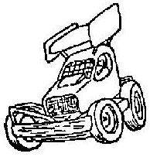

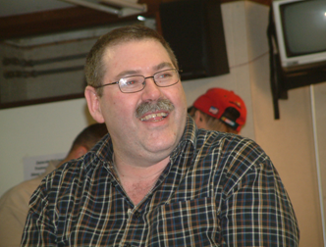
Sunday March 5th

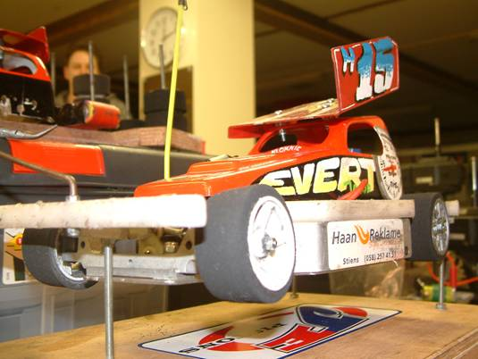
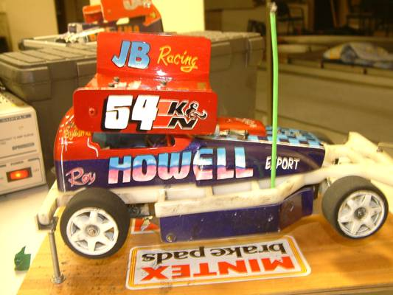
What a weekend !, as I had not planned to go over for this meeting as we had already been over to Holland in January for the European Championship meeting, and I had checked the holiday board at work when the date for this meeting was announced and found out that there was no chance for me to get some time off so that I could go to this meeting, and as I have to work Saturdays and this meeting was over a weekend I thought there was no way that we were going to be able to go , then out of curiosity I decided on the Friday afternoon to see on the internet how much it would have cost me to have gone over to Europe by the Euro-tunnel, this is when I found out that it would only cost £45 for a return ticket, this then got me thinking so I checked the entrée form for the meeting and found out that all of Saturday was practice, so there was no need to be there early, so it was back to the internet to see if the cost was by the number of people or by the car, and to see what times were available to cross, more important was the time coming back, as we had to have enough time to travel back to Calais from Lobith, and before you could know it I was booked on the 17.06 train to cross from Folkestone to Calais, and the return journey was booked for 10.03 pm on Sunday evening as the 10.30 train was fully booked, and the next train was in the early hours of Sunday night / Monday morning which made it too dear to book this one as the price increased by £100. Then I saw Ben Harding at the Friday night racing session at the Rugby club, and as he was thinking about going as well I told him about the deal you could get with Euro-tunnel, and by Saturday morning both Ben and Karl Spencer were booked to go to the meeting as well, and lucky for us Adri Middelkoop the promoter at the Lobith club was very accommodating with us arriving at the last minuet, as we had not booked in to race at the meeting. So after a frantic Saturday morning after work, filling the car up with fuel, changing some money into Euros and loading up the car with everything that I needed to take with me, both me and my son Nicholas were on our way to Lobith by 1.20pm, and by coincidence as I was heading down the M1 Ben and Karl Spencer caught up with me so we decided to travel in convoy as it made the journey more interesting, and what was even more good news for us, there were no hold ups on the way down to Folkestone and we arrived early and were offered an earlier train at 16.30, good news again as this had saved us 35 minuets, once we were in Europe and on our way the miles were flying by, quite literally! Gent soon disappeared behind us as did Antwerp and by 20.30 we were arriving at Breda where Ben and Karl were stopping for the night, and as we were making good time I thought I would follow them and have a quick look at Breda, so after a short detour for me I was soon back on my way to Utrecht then on towards Arnhem and finally on to the club at Lobith arriving just after 22.00 hours, the distance of this journey from home to Lobith was some 440 miles after accounting for the detour around Breda.
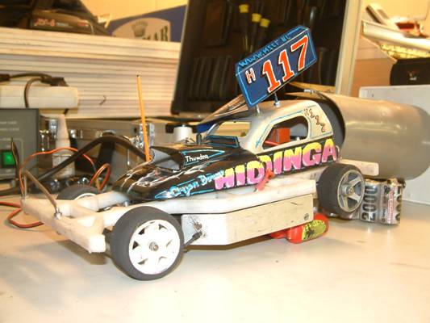
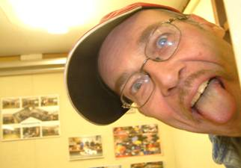
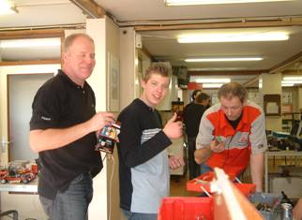
After recieving a great welcome from the Lobith club members and a refreshing mug of coffee it was time to unload the car and settle down for the rest of the evening, and as there were one or two still practicing I decided to have a little practice myself, and boy was there a lot of grip as it was very warm in the hall with the heating on, you could get away with two oranges on the front and still need slightly less grip, hope it would be colder for the actual meeting tomorrow, eventually the evening turned into more of a social natter with some great banter, and after I had lasted out to 2.00am tiredness eventually caught up with me and some much needed sleep was in order as breakfast was arranged for 07.30am.
I was woken up at 7.00am by the sound of someone arriving outside, and as the heating was not on it was very cold so a little snooze was out of the question and Adri was soon turfing us out of our beds for breakfast, then we were soon joined by the rest of the Fryslan club members who had travelled down during the morning, and after a chat and coffee my phone was ringing with Ben and Karl asking for directions on how to find the club.
Once the breakfast things were cleared away, the business of charging up our cars and practice could begin, and after my first venture onto the track the good news was the grip had gone down as the room was cooler than the night before, and watching the others it looked like we were on the pace, even Nicholas was going well (not a good sign) as things normally go wrong!
Once Ben and Karl had arrived and Adri had what crystals they were using he got busy sorting out the heats, the format for the meeting was going to be five rounds with the best three to count, the top twelve would automatically qualify for the semi-finals, and the top three from each of the semi-finals would contest the Dutch open final, and unlike the European event where there is a separate race for the juniors to decide the champion, in this the highest finishing junior from all of the racing would be crowned the Junior Dutch open champion, in all we had a slightly disappointing turn out of twenty five racers although twenty seven were booked in to race, this gave us five heats in each round, and as usual you would stay in the same heat all through qualifying.
Round 1.
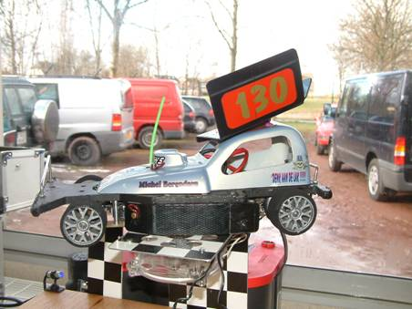
The first of the heats was won by Niek Middelkoop with 89 laps with Michel Berendsen in close attendance with 87, and just behind Michel was Nicholas Cooper complete with a broken chassi, and just one lap behind Nicholas was Pieter v Helden with 84 laps in fourth place. Heat two was won by another of the Middelkoop clan, this time out it was Koen Middelkoop taking the honours with 89 laps, from Evert Jacob Klok in second place with 87 and Arjen B Hiddinga finished with 85 laps in third place, Jelle Biljsma had a poor race and could only muster 64 laps. Heat three was won by Mark Cooper with 88 laps he was pursued by Hidde de Jong in second place with 82 laps and further back was Johan Beimers with 74. Heat four was agreat heat to be in as there were only four cars as Marco Duijster was a non starter, so it was no surprise that Karl Spencer won the heat with an impressive 96 laps, he was chased by the improving Bart Mulder (with yet another version of his race car) with 90 laps, and just behind Bart came both Adri Middelkoop and Tjepke De Vries with 88 laps apiece. Heat five was won by Ben Harding with 89 from Niels Derksen with 82 and Joop Bijlsma with 82.

Round 2.
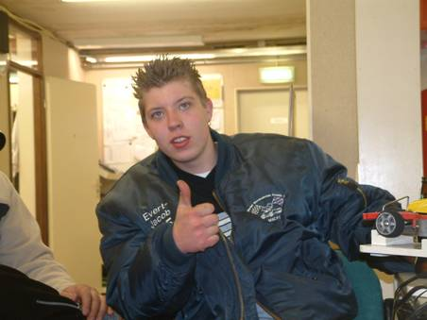
Once again Niek Middelkoop was the winner of the first heat, his winning lap score was one down on round one as he crossed the finish line with 88 laps, behind him it was a close race between Nicholas Cooper and Michel Berendsen for second place, at the finish it was Michel with 83 and Nicholas with 82 complete with his new chassi, they were followed by Pieter Helden with 80. Heat two was a very good race, and the winner Koen Middelkoop did not have things all his own way, he won the race with 89 laps and Evert Jacob Klok was just behind him with 88 and Jelle Biljsma made a big improvement on his first round score with an 86 in third place, and Arjen B Hiddinga did not fare so well this time with 80 laps. Heat three went to Mark Cooper with 88 laps although Hidde De Jong pushed him all the way to the chequered flag, and was just behind Mark at the finish with 87 laps and Johan Beimers finished in third place with 76. Heat four with only four cars was going to produce some high laps, and the best of the four racers was Karl Spencer with a high 98, another racer going well in this race was Tjepke De Vries in second place with 95, Bart Mulder improved his first race score by one lap with 91 and Adri Middelkoop did exactly the same with his lap score of 89. Heat five saw Ben Harding improving on his previous lap score by 5 laps as he won this race with 94 from Maikel Rutten with 90 in second place, and Niels Derksen was third with his 80 lap total.

Round 3.
Two rounds gone three to go, so most should be on top form by now with their optimum set up chosen, would the lap scores from this round reflect this I wonder, in heat one it was Mr consistent Niek Middelkoop collecting his third win with 89 laps, although he was chased right to the very end by Nicholas Cooper who was just behind Niek by a single lap at the finish of the race, then it was Michel Berendsen with 86 laps in third place he was followed by Pieter V Helden with 84. In heat two we had a different winner, he had finished in second place in the first two rounds but Evert Jacob Klok moved up a gear with his best lap score so far of 90 laps to take the win from Arjen B Hiddinga with 86 and Jelle Biljsma in third place with 82. Heat three was also win number three for Mark Cooper with his best lap score so far of 89, although Hidde de Jong had his worst score of 83 laps, it was still good enough to take second place and Johan Beimers was place third again with a lap score of 67. Heat four saw Karl Spencer run into a few problems and could only muster 46 laps! which gave us a new winner of heat four in the form of Tjepke De Vries with 91 laps from Bart Mulder in second place with 89 and Adri Middelkoop posted his worst lap score of the rounds with 84 laps in third place. Heat five had Ben Harding collecting another win with 90 from Maikel Rutten in second place with 87 laps, behind these two came both Niels Derksen and Joop Biljsma in third and fourth places with 76.

Round 4.
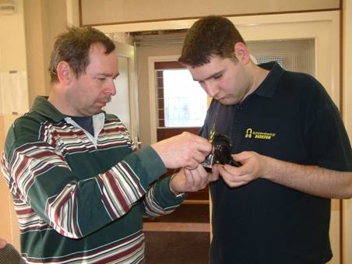
What a surprise was waiting in the result of heat one as Mr reliable Niek Middelkoop had a few problems in this round and could only achieve 25 laps which left the way clear for Nicholas Cooper to record a win with 88 laps, he was followed to the finish line by both Pieter V Helden and Michel Berendsen in second and third places with 80 laps and Hans Rutten had 61 to his credit in fourth place. Heat two was normal service resumed for Koen Middelkoop as he recorded his third win with 89 laps from Evert Jacob Klok in second place with 87 and Jelle Bijlsma with 85 then it was Arjen B Hiddinga in fourth place a single lap behind Jelle with 84. Heat three saw Mark Cooper collecting his fourth straight win with his highest lap score of 91, another racer producing his best lap score was Hidde De Jong in second place with 88 and by coincidence Johan Beimers also posted his best score of the rounds so far with 79 laps in third place. Heat four was a scorcher as Karl Spencer was back on form with a new track record of 100 laps as he kept a cool head to take the win as the watching spectators were enjoying the battle between Adri Middelkoop and Tjepke De Vries for second place, the result went to Tjepke as he recorded 92 laps to Adri’s 90, and poor old Bart Mulder had all sorts of problems with his speed board he did make it to the track a few times although his car refused to move each time, and just as he had managed to fix it and was ready to do battle the buzzer for the end of the race went, the computer showed 0 laps had been achieved, scant reward for the effort Bart had made to fix his car. Ben Harding was the winner of race five again, his winning lap score was 93, Maikel Rutten posted his second best lap score of the rounds by finishing in second place with 89 and another racer posting his best lap score of the rounds was Joop Bijlsma in third place with 83 in this heat.

Round 5.
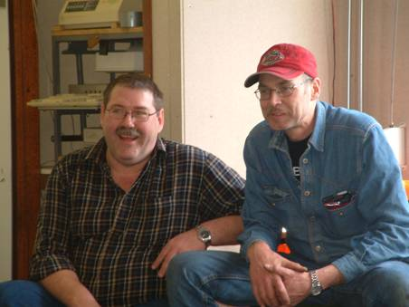
There were no excuses this time as Nicholas Cooper recorded another heat win with his best lap score from the rounds with 90 laps, Niek Middelkoop was second with 87 and Pieter V Helden finished in third place with 84. Heat two had Evert Jacob Klok taking another win in this heat with 85 from Koen Middelkoop in second place with 84 and Jelle Bijlsma was a further lap behind Koen with 83, fourth place went to Arjen B Hiddinga with his lap score of 80. Heat three had Mark Cooper saving the best for last as he won the heat with his highest lap score of 93 laps, another posting his highest lap score was Hidde De Jong with 89 in second place, and Johan Biemers was third in this heat with 77. Heat four was won by Karl Spencer with 96 laps from Bart Mulder in second place with 93 and both Adri Middelkoop and Tjepke De Vries closed their accounts with 91 laps, in Adri’s case this was his highest lap score from the rounds of qualifying. We had a real race in the last of the qualifying heats, as Ben Harding collected another win but it was only just as the computer showed it was by just 1.4 seconds as both he and Maikel Rutten recorded 94 laps in the first and second places, and a little way behind these two in third place was Joop Bijlsma with 81 and Niels Derksen closed his account with 78 laps.
We had a short break as the two semi-finals was worked out, with the best three scores to count from the five rounds, but things were going to get a lot tougher from here on in as there was only one of the heat’s that had a full six cars, in fact heat four was scheduled to be a five car heat but prior to the meeting Marco Duijster ran into a few problems with his radio gear and had had to withdraw from the meeting making it a four car heat. So who would be in with who, in the semi-finals, it all depended on the finishing positions, the only thing for certain was that Karl Spencer would be the top qualifier after the rounds of qualifying.
Here is the line up of two semi-finals along with the best three lap scores added together,

Semi-one
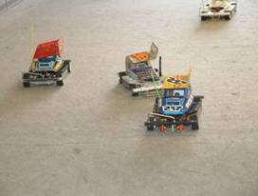
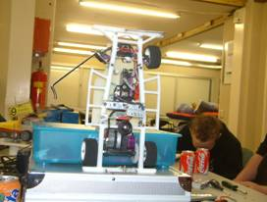
Karl Spencer 294
Bart Mulder 274
Mark Cooper 273
Koen Middelkoop 267
Niek Middelkoop 266
Hidde De Jong 264

Seni-two
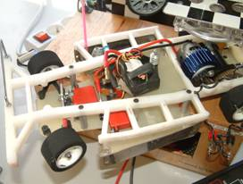
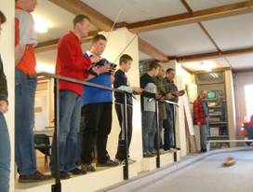
Ben Harding 281
Tjepke De Vries 278
Maikel Rutten 273
Adri Middelkoop 270
Nicholas Cooper 266
Evert Jacob Klok 265

Looking at the list of the two semi-finals things had worked out nicely for the British contingent, we had two racers in each semi-final with Nicholas Cooper qualifying by right for his first big meeting semi-final, the aim now was to finish in the top three to qualify for the final, in the first semi Karl Spencer was on cruise control to take the win with 94 laps, behind him things were a lot more interesting as there were some personal battles going on, and it was right at the finish of the race that Mark Cooper claimed the second place with a split time from Hidde De Jong after both racers had finished on 91 laps, and just outside of the top three was Niek Middelkoop with 89 laps which was one ahead of his brother Koen Middelkoop who came home in fifth place with 88, and Bart Mulder gained some valuable experience in last place with 87. The second semi was a cracker of a race, the result went right to the wire as both Ben Harding and Maikel Rutter were neck and neck throughout the race, at the finish they were separated by a split time with the win going to Ben Harding after both had finished the race with 91 laps, and another racer who had managed to get into the top three on the last few laps was Evert Jacob Klok, it was by a split time after he and Adri Middelkoop had finished with 89 laps each, behind these two in fifth place was Tjepke De Vries with 88 and young Nicholas Cooper could not recover from a bad start and came home in last place with 84 although he was disappointed the experience he gained will be valuable for the future.

The Dutch Open Final.
We had a strong looking line up for the final, with three British racers against three Dutch, two from the Fryslan 1 club and one from the home club Lobith, again I can only tell you from my experience from the final, with the three Brits starting from the front rows they were away and gone at the start, it was even between all three for about half of the race, then my car started to slow with a hot motor and Karl Spencer was gradually pulling away from Ben Harding, as we entered the final part of the race Maikel Rutter had caught Mark Cooper up and was vying for third place, and experience counted for everything as Maikel could not find a way past Mark, although the watching crowd was willing him on very vocally which was a big help to me (Mark) as it told me where Maikel was in relation to me, so the result of the 2006 Dutch Open final was Karl Spencer in first place with 95 laps and in doing so he retained his title for the third consecutive year, second place went to Ben Harding with 93 and Mark Cooper survived in third place with 91 laps on a split time from Maikel Rutten after he had also finished with 91 laps in fourth place, and the fifth and sixth places were also separated by a split time after Hidde De Jong and Evert Jacob Klok had finished the race with 90 laps, fifth place went to Evert.

Name | F/Tyre  Inside | F/Tyre  Outside | R/Tyre  Inside | R/Tyre  Outside | Gear  Ratio | Speed  Board | Charger | Car  Type | Chassi | Cells | Club | Grade | Qualify  Place | Final  Result
Karl  Spencer | Pink | Yellow | Pink | Pink | 12/50 | Mardave | Apex | Elite | Anderton | 3700 | Rugby | S/S | 1 | 1
Evert Jacob Klok | SE | Orange | UFRA  36 | UFRA  35 | 12/52 | Tamiya | TLP | J.B.  Racing | J.B.  Racing | 3300 | M.S.C.F.1 | S/S | 6 | 5
Hidde De Jong | UFRA  40 | UFRA  45 | UFRA  36 | UFRA  36 | 12/50 | Mardave | Schum | Bandit  Pro | Bandit | 1700 | M.S.C.F.1 | Red | 5 | 6
Maikel  Rutten | UFRA  52 | UFRA  52 | UFRA  38 | UFRA  38 | 12/52 | Tamiya | Power  Peak 3 | Mr.  Tanning | J.B. | 1700 | M.B.C.  Lobith | Red | 4 | 4
Ben  Harding | Jap  Med | 812 | Pink | Pink | 12/50 | Mardave  Mk 1 | Apex | Skint | Anderton | TJ  2000 | Rugby | Silver | 2 | 2
Mark  Cooper | UFRA  40 | UFRA  52 | Pink | Pink | 13/50 | 2 speed | Pro  Trak | Lecatt  2 | Anderton | IB  3800 | Stoney  Stanton | Red | 3 | 3

Grade awards were presented to Bart Mulder as the highest finishing Blue grade racer, Nicholas Cooper took home the Yellow grade award and Koen Middelkoop was the highest finishing Junior, and I think Yannick Moorman was the best of the White grade racers. As soon as the trophy presentation was over we had to be on our way back down to the Euro-tunnel as we were booked in for the 10.00pm crossing, so it was a quick goodbye and we were on our way at 4.30 pm, and all in all we made good time although I missed a turn just past Gent, so we had to take a detour down to Lille and come back up to Calais, this cost us about an extra 35 miles, and some time, although we arrived at Calais at 9.20 pm, if it had not been for this we might have made an earlier train, but the main thing was we were in time for our scheduled train, once we were back in the UK, we made good time back up to the Midlands, and I arrived back home at 12.15 pm. Over the course of the weekend I had clocked up 930 miles between 1.20pm on the Saturday afternoon and Sunday evening when I arrived back home. Would I do it again you bet I would!
This race report was written by Mark Cooper.
