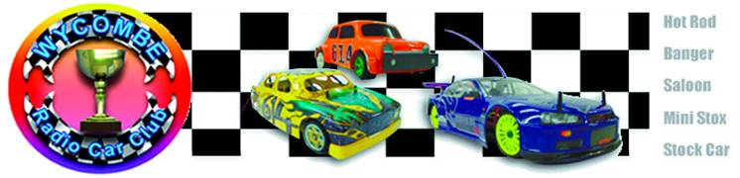

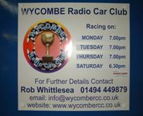
We start the dawn of a new era at the “ New ” club in High Wycombe, although the venue is the same as before this is as old as it gets, because as the headline reads – like a Phoenix- I though this was a very appropriate phrase to use as there has been very big changes, we now have a very thoughtful committee in charge of the club that is very committed in maintaining the very high standards that they have set themselves, there has been some big changes to the venue itself, noticeably the old kitchen has been ripped out and a new oval has been constructed along with a new tea bar, on the benches that are provided for pitting there has been a lot of modernisation in the form of a middle barrier with a shelf which gives you more pit space along with new power points ( no need for extension cables ) but for me the biggest change was the atmosphere in the room, generally there were a lot more happy smiling faces with a relaxed atmosphere in the room, Wycombe Radio Car Club was officially formed in April 2005 when they received the keys to the building, and I hope that this quote can be said for a long time to come, WRCC has been born and it became us, the members of WRCC, our own club for the very first time, with open doors for everyone to come and enjoy our excellent facilities.
In charge of the proceedings for today’s meeting we say a big hello to Jim Harrington, he is the new club secretary, although he steps into the role of race director for today’s proceedings, if there should be any problems there are plenty of additional committee members on hand, and not forgetting the BRCA officials.
The meeting today has attracted thirty-two competitors in the Stockcar class and we have twenty-three for the Bangers, so after a drivers briefing from the new club chairman Jason Bartropp, we were ready to christen their new oval for the first ever Wycombe Radio Car Club Stockcar National Meeting. On booking in it was nice to receive a program to go with today’s historic meeting, it was full of useful information.
All was proceeding well until we arrived at heat five of the first round, and the top competitors were out to do battle, unfortunately we found out that the lap counting equipment could not keep up as the cars were completing a lap under the delay time of 2.50 seconds, a meeting was called between all of the officials and reluctantly we had to switch tracks to the larger ¾ Oval, which meant the first round would have to be re-started, this was an unfortunate thing to happen, but was an unforeseeable thing, and credit must go to everyone that was there for doing as much as they could to help and especially for not moaning about it! So after a second bout of practice and adjustment to the track size we were ready to start once again,
Round 1, Stockcars
The first to achieve a heat win was Richard Harding with a benchmark 68 laps, he was pursued by Allan Inness with 66 in second place, a further two laps back in third place was Daniel Fryett with 64 followed by Wycombe racer Robert Hewitt with 62 and Nicholas Cooper just one lap behind Robert with 61. In heat two we find a new name on the list of race winners, well done to Gerry Fordham with his 64 laps, in second place we had Ian Rolph with 62 followed by Wycombe club chairman Jason Bartropp with 59. Heat three was a close affair as both James Blower and Alan Harding finished the heat with 68 laps, James was adjudged to be the winner by 0.70 of a second, and these two were chased by Bryan Lee in third place with 63. Continuing his good run of results was heat four winner Matthew Bennett with 72 laps the highest lap score of the round so far, behind him it was a great battle between Peter Ayriss, Roy Calver, and Jamies Burkett, throw in Jason Reed and Mark Steel and all of these racers were right in contention to the end of the race, however it was Roy Calver that took second place with 70 laps from Peter Ayriss who also finished with 70 laps as did Jamies Burkett in fourth place, less than three seconds separated them, and for good measure Jason Reed was just one lap further back with 69 with Mark Steel just one lap behind Jason at the finish of the heat. Heat five was another high lap scoring race, with Ian Johnson posting 77 laps in first place from Ben Harding with 76, the Hathern National winner Phil Chadbourne was in third place with 74 chased by Mark Cooper with 73 laps and Karl Spencer just a lap behind Mark with 72, and in sixth place and just one lap behind Karl was Anthony Wyper with 71 laps (a lap score that would have been good enough to win any of the first three races).
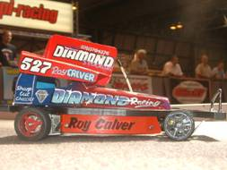
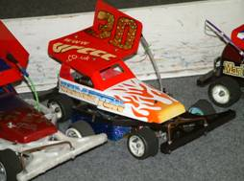
Round 2, Stockcars
Phil Chadbourn gets his name amongst the winners with a winning 72 laps in heat one of round two, he was chased by Matthew Bennett with 69 laps and Allan Inness with 67. In heat two Jason Bartropp was a worthy winner with 70 laps from Mark Cooper with 69, third place was taken by Mark Steel with 64 laps with young Nicholas Cooper registering an excellent fourth place with 62. Karl Spencer makes amends after his poor start to the meeting by wining heat three with 71 laps from James Blower in second place with 70, third place was filled by Jason Reed with 67 laps with Robert Hewitt in fourth on 64 laps. Heat three saw Ian Johnson collect his second win with 72 from Roy Calver with 71, Ian Rolph was in close attendance with 69 laps in third place, Alan Harding squeezed home in fourth place with 65 laps from both Jamies Burkett and Darren Grace with 64 laps each. Heat five saw Ben Harding post the FTQ lap score of 78 with his brother Richard Harding in second place with 74 laps, both Peter Ayriss and Anthony Wyper finished the heat with 70 laps and in that order.

Round 3, Stockcars
Heat one winner Karl Spencer collects win number two with 73 laps from both Allan Inness and Peter Ayriss in second and third places respectively on 69 laps, in fourth place and not far behind was Ian Rolph with 67. Heat two winner Phil Chadbourn was another racer collecting his second win of the days racing with 71 laps from Jason Reed with 67 and Jason Bartropp in third place with 66 laps. Heat three was an excellent result for heat winner James Blower as he beat the previously unbeaten Ian Johnson, both racers had finished the race with 65 laps but James was ahead by a narrow margin of 0.19 of a second, third, fourth and fifth places were separated by just two laps as Matthew Bennett posted 64 laps in third followed by Steve Brown with 63 and Gerry Fordham in fifth place with 62. Heat four was a very frustrating race for me, as all attempts to overhaul the race leader were blocked one way or another, at the finish it was Richard Harding that collected another race win with 72 laps from me (Mark Cooper) in second place with 71, and Jamies Burkett came home in third place with 68 laps. The last heat of this round was won by Ben Harding with 71 laps from team member Alan Harding with 66 and Mark Steel with 62 laps in third place on a split time from Robert Hewitt.

Round 4, Stockcars
After being close to a heat win all day it was not until round four heat one that Mark Cooper finally posted a heat win with 72 laps from Daniel Fryett with 68, behind him came a train of three racers all finishing on 67 laps, in the order of finishing the heat they were Allan Inness, Alan Harding and Darren Grace, and just behind these three with 66 lap apiece were Gerry Fordham and Jason Reed. Ian Johnson made amends for his laps in round three by winning heat two with 75 laps and making it three wins from four heats of racing, in second place with 71 was Peter Ayriss followed by Alan Crossland and Robert Hewitt with 64 laps each. Heat three was decided by a split time after both James Blower and Phil Chadbourn had finished the race with 71 laps, the result going to James by 1.44 seconds, third place was filled by Ian Rolph with 69 he was chased by Mark Steel with 67 laps in fourth place. In heat four we have a different heat winner once again, and the man with the biggest smile was Roy Calver as he had won the heat with 67 laps from Karl Spencer who had also finished with 67 laps a mere 0.64 of a second behind Roy, third place was taken by Bryan Lee with 64. And the final heat of the Stockcars was taken by Ben Harding with 72 laps from Matthew Bennett with 68 and Anthony Wyper with 66.

Bangers, Round 1
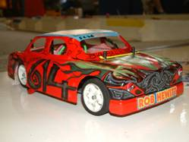
Making a good start to his day’s racing was Keith “Roscoe” Schooling with 52 laps good enough to take heat one, in second place was the current national banger junior champion Nicholas Cooper with 49 laps on a split time from James Harrington, the fourth place finisher was Paul Brooks with 41 laps to his credit. Heat two produced so good racing, the result could have gone to any of the top three racers, at the finish Ian “Zzzz” Rolph got the win by 0.37 of a second from Dan Martin after both racers crossed the line with 59 laps and Robert “big bad bobby” Hewitt was just one lap behind in third place with 58 followed by young Kayleigh Cooper in fourth place with 31. The current British Open Champion Anthony Wyper secured the win with 63 laps in heat three from Mark Cooper in second place with 61 laps followed by Chris Flynn with 53, and in fourth place we find a very young Charlotte Yarwood with a great result and a respectable 32 laps. Heat four was won by Mark “make a donation” Steel with 59 laps from Jamies Burkett in second place with 56 and Richard Branch with 53 in third place, and fourth place was a disappointing result for the current national champion Alastair Needham with 38.

Bangers, Round 2
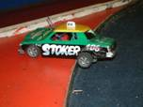
Piloting a rocket shed on rails was Jason “geezer” Bartropp with a flying 66 laps in heat one of round two, he was chased by Allan Inness in second place with 60 and Mark “make a donation” Steele with 58, and continuing his good form was Nicholas “car wrecker” Cooper in fourth place with 53. Heat two saw a good race once again between a few of the racers, at the finish of the heat the win went to Chris Flynn with 57 laps from Dan Martin with 56 and James Harrington with 55 laps in third place, and Wycombe’s own Roy Calver secured fourth place with 54. And it looks like Anthony Wyper has shook off his run of bad luck with another win in heat three with 59 laps from Ian “Zzzz” Rolph in second place with 57, Jamies Burkett took third place with 52 from Keith “Roscoe” Schooling on 49 laps in fourth place. We had another good race again in heat four, are these really Bangers that we are racing? the win went to Mark Cooper with 62 from Robert “big bad bob” Hewitt in second place just one lap behind Mark and Alastair Needham was a further lap behind Rob in third place with 60 laps.

Bangers, Round 3
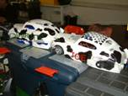
Success once again in the first heat of a new round for Jason “geezer” Bartropp, although not as fast as his previous win a solid lap score of 59 was good enough for the win, coming home in second place was Mark Cooper with 57 followed by Chris Flynn with 53, and young Nicholas Cooper collects some more valuable national points with a fourth place with 41 laps. We had a low lap scoring heat as the racers fought amongst themselves a low 48 was good enough to secure the win for Mark “make a donation” Steel, second and third were separated by a split time after Dan Martin and Robert “big bad bob” Hewitt had finished on 46 laps and in that order. We had a good win for Mike Richardson in heat three with 62 laps over the current British open champion Anthony Wyper in second spot with 60 laps to his credit, and a long way back in third place was Graham Coles with 32. At last! Alastair Needham secures a heat victory with a winning lap score of 60 from Ian “Zzzz” Rolph in second place with 56 and Allan Inness in third place with 53.

Bangers, Round 4
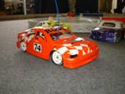
We had a minor sensation in heat one of round four, to make the final as the favourite Jason “geezer” Bartropp needed a good lap score to make amends for his low lap score in the first round after he had barrel rolled out of the track midway through the race, and he was on course to do what was needed until he made the mistake of overtaking Nicholas “car wrecker” Cooper down the outside of the straight, what came next caused a minor sensation as Nicholas thought all of his Christmases had come at once as it was Banger heaven as he went on the attack and with more success than he bargained for both cars left the track, the favourite was out and would not be in the final! This left the way clear for Mike Richardson to collect a win with 63 from both Ian “Zzzz” Rolph and Jamies Burkett in second and third place with 61 followed by a fortunate fourth place for young Kayleigh Cooper with 40 laps. Heat two proved to be the survival of the fittest as most of the racers went on the attack in true Banger fashion, the eventual victor was Mark Cooper with 50 laps from Paul “Brooksy” Brooks with 39 and Peter Urry in third place with 30. Anthony Wyper secured another win in heat three with 60 laps from Allan Inness in second place on 55, Keith “Roscoe” Schooling posted another good lap score in third place with 53 from Mark “make a donation” Steele on 51 laps in fourth place. The last of the banger heats produced a good result for Wycombe’s own Rob “big bad bob” Hewitt in first place with an outstanding 64 laps from Alastair Needham in second place with 63, Chris Flynn finished with 59 laps in third place followed by James Harrington with 55.

All of the heats of racing was now finished, and now it was time to find out who would be racing in what, as the usual format of qualifying means it would be the top seven qualifiers through to the Stockcar final followed by the next eight into a consolation race, with the winner of that through to join the seven already in the final, in the Banger class it would only be the top ten straight through to the final, although there would be a best of the rest race for the non qualifiers with no national points on offer but there would be a trophy for the winner, the first race to take to the track would be the Stockcar consolation race as the winner has to re-charge the cells and get ready for the final, so the racers that had qualified for this were :-
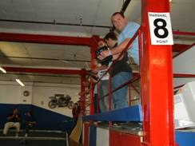
Stockcar Consolation

1. James Blower 209
2. Matthew Bennett 209
3. Roy Calver 208
4. Anthony Wyper 207
5. Ian Rolph 205
6. Jason Reed 203
7. Allan Inness 203
8. Jamies Burkett 202

This was another consolation race that went right to the wire with two racers right in contention, as it finished both Anthony Wyper and Matthew Bennett had crossed the finish line with 72 laps each, the result went to Matthew by less than a second, so it would be Matthew that progresses through into the final, third place went to Ian Rolph with 70 followed by James Blower with 68 laps in fourth place, fifth place was taken by Allan Inness with 67 closely followed by Jamies Burkett in sixth position on 66, and a further lap back was Roy Calver in seventh place on 65 which leaves us with the 64 laps of Jason Reed in eighth place.
The next race to take to the track was the best of the rest in the Banger class, the brave ten to take to the track were Nicholas “car wrecker” Cooper and his sister Kayleigh Cooper, we also had Keith “Roscoe” Schooling and Dan Martin, the flying Jason “geezer” Bartropp along with Jim Harrington and James Harrington, we also had Paul “brooksy” Brooks and Peter Urry, and completing the line up was Richard Branch, just before the start of the race I decided to spice it up a little bit by putting a bounty on the car of Jason Bartropp, so a £1 was taped onto the roof of the car and whoever could dispose of Jason’s car over the barrier would receive the pound otherwise it would go to Jason, needless to say Jason did not get very far as his adversary from the heats done him once again, this time it was midway along the straight when Nicholas Cooper disposed of him to claim the pound, at the end of the race it was Keith “Roscoe” Schooling that took the win along with the winners trophy with 56 laps in first place, the rostrum was completed by Dan Martin in second place with 54 and Nicholas “car wrecker” Cooper with 50 laps in third place.
The Stockcar Final
Here is the list of qualifiers for the final along with their best three lap score’s added together to make their qualifying total,
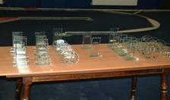
1. Ben Harding 226
2. Ian Johnson 224
3. Phil Chadbourne 217
4. Karl Spencer 216
5. Mark Cooper 216
6. Richard Harding 214
7. Peter Ayriss 211
8. Matthew Bennett Consolation Winner

So near and yet so far, that was the story for me as I had lead the race right through until the finish line was in sight, when the one mistake allowed Karl Spencer through for a well deserved win with 74 laps from me (Mark Cooper) in second place also with 74 laps, third place went to Phil Chadbourne with 73 laps from fellow Hathern racer Ian Johnson in fourth place on the same lap of 73 at the finish as Phil just 0.77 behind, fifth place was taken by the consolation winner Matthew Bennett with 72 laps from Richard Harding with 71, Peter Ayriss was seventh with 70 laps and the ultra reliable Ben Harding suffered with a broken wire on his car to finish in eighth place with 36 laps, and credit must be given to him as he chose to race when he repaired his car and returned to the track a true gentleman.

The tec chart from the finalists.

Name | Front  Inside | Front  Outside | Rear  Inside | Rear  Outside | Gear  Ratio | Speedo | Charger | Car  Type | Chassis | Cells | Club | Grade | Qualif | Final
Matthew  Bennett | Jap | 812 | Jap | Pink | 13/51 | Mardave | Duratrax | Lecatt 2 | Lecatt | 3300 | Rugby | Red | 8 | 5
Ian  Johnson | Gold | 909 | Pink | Pink | 12/51 | Mardave | Apex | Bandit  Pro | Mardave | 2000 | Hathern | S/S | 2 | 4
Peter  Ayriss | SE | Super  40 | SE | Pink | 13/48 | Associ-  ted | Pro  Trak | Carl  Baker | Baker | Orion  2600 | Urmston | Red | 7 | 7
Ben  Harding | Jap  Med | 812 | Pink | Pink | 12/50 | Mardave  Mk1 | Apex | Skint | Anderton | 3300 | Rugby | Silver | 1 | 8
Rich  Harding | Jap  Med | 812 | Pink | Pink | 12/50 | Mardave | Apex | Skint | Anderton | 2000 | Rugby | Red | 6 | 6
Karl  Spencer | Jap | 812 | Pink | Pink | 12/50 | Mardave | Apex | Elite | Anderton | 3300 | Rugby | S/S | 4 | 1
Phil  Chadbourne | Pink | 909 | SE | Pink | 12/51 | Mardave | LRP | Bandit  Pro | Mardave | 2000 | Hathern | S/S | 3 | 3
Mark  Cooper | Jap  40 | 812 | Pink | Pink | 12/50 | Mardave  2 speed | Pro  Trak | Lecatt 2 | Anderton | Orion  2600 | Stoney  Stanton | S/S | 5 | 2

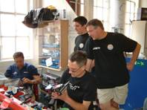
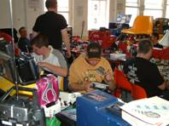
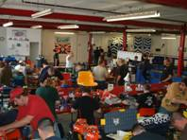

The Banger Final
Hear are the ten qualifiers for the Banger final along with their qualifying total,
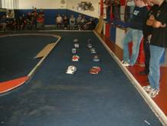
1. Anthony Wyper 183
2. Alastair Needham 183
3. Robert Hewitt 183
4. Mark Cooper 180
5. Ian Rolph 177
6. Mike Richardson 171
7. Jamies Burkett 169
8. Chris Flynn 169
9. Mark Steele 168
10. Allan Inness 168

On a big track with plenty of room it could only be a fast final, with a lot at stake as well (national points wise) and a quality line up of drivers too, and this was only too evident when you look at the scores, the first two both finished with 65 laps, but the winner was Anthony Wyper from Alastair Needham by 2.37 seconds, third and fourth places were also separated by a split time after Mark Cooper and Ian Rolph had finished on 62 laps, third place went to Ian by 3.12 seconds, in fifth place was Chris Flynn with 59, just behind him in sixth place was Mike Richardson with 58 followed by Jamies Burkett with 56 laps, in eighth place it was Robert Hewitt with 32 laps and Allan Inness with 24 ended up with ninth position in the final reckoning, which leaves us with Mark Steele in last place with 4 laps to his credit.

The last event of the day’s proceedings was the Banger Demolition Derby for all comers, and to make things a little bit more interesting it was decided to hold this on the small oval as there are no laps to be counted by the transponders, the survivor and last car moving after nearly twenty five minuets was Ian Rolph, he also receives the extra national point for achieving this.

There were a lot of awards to be presented as there were two classes of racing; we will start with the Stockcar awards,
Best White – Kayleigh Cooper
Best Yellow – Daniel Fryett
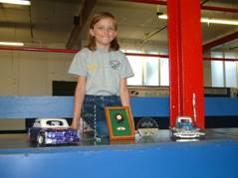
Best Blue – Ian Rolph
Top Lady – Angela Yarwood
Top Junior – Nicholas Cooper
Concourse – Ian Johnson

The Banger awards,
Best White – Kayleigh Cooper
Best Yellow – James Harrington
Best Blue – Nicholas Cooper
Top Junior – James Harrington
WRCC best of the rest – Keith “Roscoe” Schooling
Concourse – Richard Branch
D/D Winner – Ian Rolph

We would like to give a big thank you to you the racers for supporting our event, also a big pat on the back for the BRCA officials who give up their own time to help run these meetings, and the support from our sponsors deserves a very big mention too so hear they are – Roy Calver (Diamond Racing) for the generous sponsorship of today’s concourse trophies, Ian Johnson (Bandit Racing) for his trophy donation and for the spares support along with Alan Crossland and his spares shop, some individual members that have supported us in everything that we do – Brian Seymour, Jill Hewitt and Mandy Bartropp, and Jim Harrington (race control on the day and for all the hard work on the entrée and booking in for today’s meeting) and finally a big thank you to Gerry’s catering, a lonely job out in the car park but an essential one and most appreciated

Meeting race report prepared by Mark Cooper.

