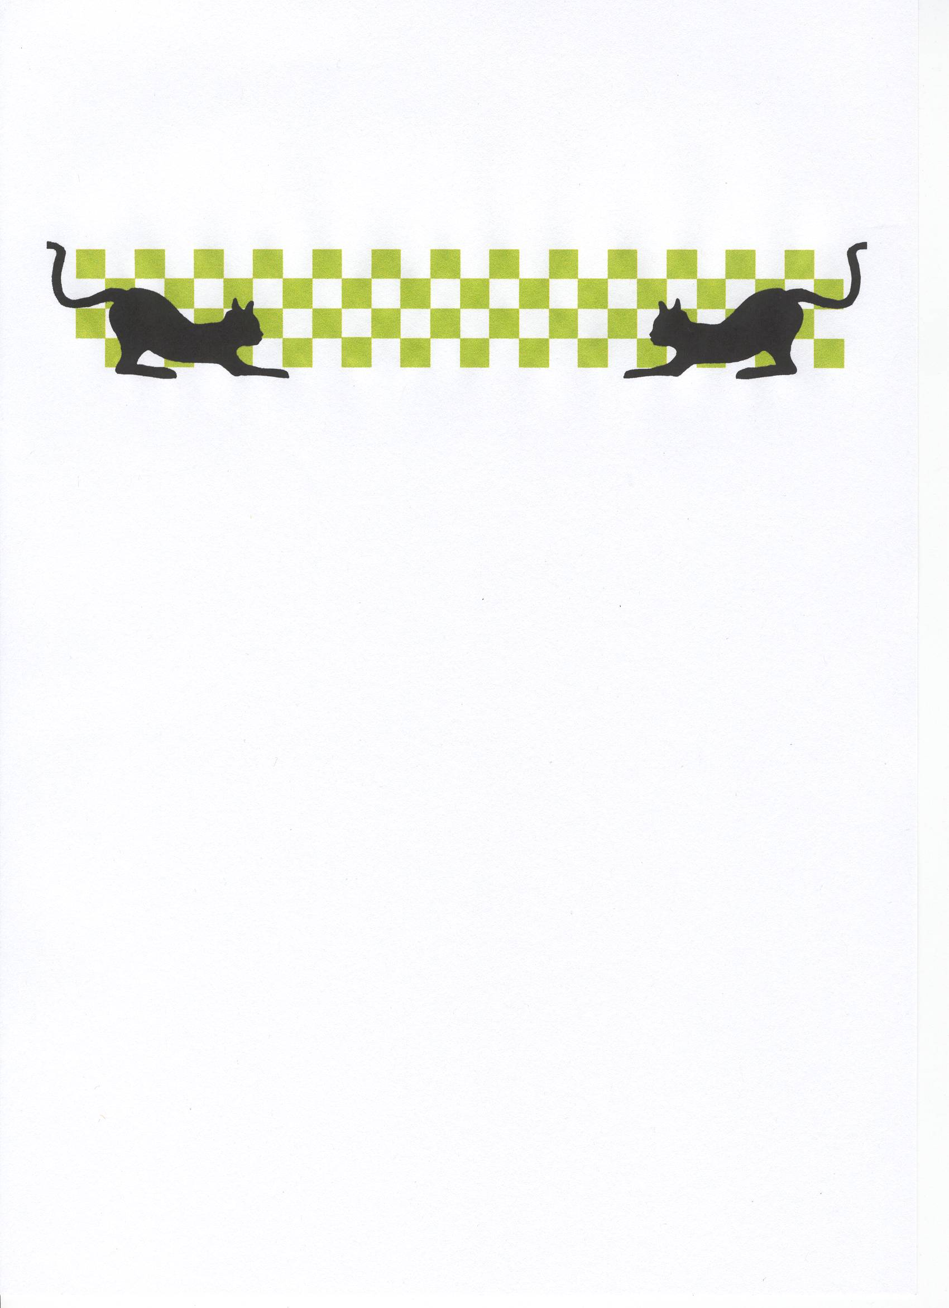

After a National series that started back in February at the Hathern club for the Stockcars and the March club was the venue for the first Banger National which was on the 8th of March, today’s meeting is the last round of this years national series for both formulas, it will be round eight for the Stockcars although the title has already been decided there is still plenty to play for lower down the order, and in the Bangers the title will be decided today with four racers in contention for the title of National champion.
Today’s entrée of thirty seven for the Stockcars is the third highest number of the year, and the Bangers entrée has been consistent all year and today’s entrée of twenty-three is the second highest of the year, although this round might be the most entertaining of them all as the racing will be on a figure of eight.
There is not a lot to report on the activities of the Stoney Stanton Club from the past twelve months other than the purchase of another ten transponders along with a rack to charge them on, although I feel that there is a transitional period going on within the Stoney club, unfortunately the club spares shop has now been sold to Mr Cayzer although Smudge has continued his good work with the club web-site, and Andy Cattell has been concentrating his racing efforts on the 1/5th scale although he says he is still committed to the Stoney club, and the clubs race nights still attracts a good attendance, there has been a slight decline in racing numbers due to the exodus to the 1/5th scale, this was especially noticed at the Urmston National earlier in the year as the entrée was markedly down on previous years, lets hope that this is just a short term decline and new club members will appear on the National scene soon, this section remains as the cheapest form of radio controlled racing and caters for the young and old alike, and the racing is very competitive at the highest level, but there is still a large element of fun for not a large outlay of money.

Stockcars Round 1.
Heat one winner and the new Junior National Champion was Tom Forrest with 86 laps, he was chased to the finish line by Dave Gwilliam with 85 laps and third place went to Gerry Fordham with 78. Heat two was an easy win for Ryan Cattell with 87 laps from Angela Yarwood with 81 in second position. Heat three was a very competitive race between three racers, at the finish it was Mark Cooper (racing a Pinky race car!) taking the win with 85 laps, just behind him Shane Moorcroft took second place with 83 from Pete Ayriss with 82. Heat four saw Matthew Bennett equal the 87 laps of Ryan Cattell by winning this heat with the same lap score, behind him in second place was Ian Rolph with 83 followed by Allan Inness with 78 and Scott Williamson with 77. Heat five was won by Ben Harding with 86 laps from Ian Johnson in close attention with 85 and third place went to Alan Harding with 81 laps. Heat six went to the club promoter Andy Cattell with 82 laps from Jason Reed in second place with 79 and Darren Grace just one lap further behind in third place with 78.

Stockcars Round 2.
The heat is really on as Ben Harding sets a new FTQ of 90 laps by winning heat one of round two, Ian Johnson came home in second place with 86 laps and Shayne Moorcroft took third place with 79. Heat two winner Ryan Cattell finished with 86, behind him came Ian Rolph and Angela Yarwood with 82 laps, Ian had the better split time and was placed second, another racer with a lap score in the eighty lap bracket was Tom Forrest he was just two laps behind Ian and Angela with 80. Heat three went to James Blower with 82, followed by an excellent result for young Nicholas Cooper in second place along with a personal best lap score around the Stoney oval of 80 laps and Jason Reed was a further lap behind with 79 in third place. Heat four went to Andy Cattell with a winning lap score of 84 from Mark Steel with 83 and Roy Calver with a strong 82 laps. Heat five was a very busy race with a lot of racers dicing for a heat win, Dave Gwilliam managed to break free towards the later stages of the heat to take the win with 81 laps from Alan Harding and Peter Ayriss in that order in second and third places with 79. Heat six was a high lap scoring heat, along with the heat win Matthew Bennett also equalled the 90 laps set earlier by Ben Harding, behind him things were close between Mark Cooper, Anthony Wyper and Jamie Burkett, the three racers were separated by one lap at the finish of the race, both Anthony Wyper and Jamie Burkett had 83 to their credit and Mark Cooper was just one lap behind these two with 82 in fourth place.

Stockcars Round 3.
Ian Rolph from the March club secures a heat win in the first heat of round three, his winning lap score was 80 laps, Mark Steel who also hails from the March club finished in second place with 76 and Lauren Cattell came home in third place with 73 laps. Just when you think you have seen everything that can happen something happens that surprises you, and heat two was one of those magical happenings, throughout the years we have had some very close races with two and sometimes three racers all finishing on the same lap, so what were the odds of four racers all finishing a race on the same lap, this is exactly what happened in heat two, and for good measure the laps were very high and worthy of a heat win for each racer, but there had to be a winner on a split time, so in order of the split times, with the first four all recording 84 laps they were James Blower with the win, second place went to Jamie Burkett and third went to Mark Cooper followed by Angela Yarwood in fourth place, and incredibly young Nicholas Cooper upped his previous best laps score with 82 laps in fifth place. Heat three produced another race that saw the first two finish on the same lap, they were Matthew Bennett and Tom Forrest across the finish line in that order with 86 laps each, and some way behind in third place was Alan Crossland with 72. Heat four was won by Shane Moorcroft with 85, and I believe this was his first national heat win, Ian Johnson finished in second place with 83 laps followed by Peter Ayriss with 79. Heat five was win number three for Andy Cattell with 80 lap good enough to secure the win, second place went to Ryan Cattell with 79 and third place was taken by Alan Harding with 76. Heat six winner Ben Harding posted another high lap score of 88 in securing the win from Roy Calver in second place with 83 and Rugby racer Dave Gwilliam was third with 80 laps.

Stockcars Round 4.
The last of the qualifying rounds for the stockcars threw up a real surprise in heat one as Mark Steel joined the top lap scores of the day with a mighty 90 laps, some seven laps more than his previous highest lap score, second place was filled by Matthew Bennett with 82 and Shane Moorcroft was just behind in third place with 81 as was Dave Gwilliam in fourth place on 80. Heat two saw a racer finally recording a heat win after a few near misses, this honour went to Urmston club racer Angela Yarwood with a winning 80 laps on a split time from Jamie Burkett in second place and Ian Rolph was just one lap behind these two with 79 laps in third place. Heat three winner Roy Calver was another racer collecting his first heat win of the days racing, his winning lap score was 86 laps with long distance traveller Dean Ritchie in second place with 75 laps, Dean hails from the Leven club based in Scotland. Heat four was another race that was decided by a split time after Tom Forrest and James Blower had finished the race on 83 laps, the winner adjudged to be James, these two were chased by Mark Cooper with 81 laps to his credit. Heat five was an easy heat win for Ian Johnson with 85, but behind him there was a good battle for the minor places, second place went to Alan Harding with 74 followed by both Peter Ayriss and Brandon Snell with 69 laps and in that order then we had Rosco Schooling a further lap behind in fifth place. The final stockcar qualifying heat was won with 81 laps by Ryan Cattell, second place was filled by Andy Cattell with 76 laps from young Nicholas Cooper in third place with 74.

Bangers Round 1.
There was a lot of anticipation in the air at the spectacle that was about to begin, yes we have raced on a figure of eight track before but that is usually during the demolition derby and anything goes in that, but this was history in the making as this would be the first national Banger point scoring heat around a figure of eight track, and boy was it good I should know as it was me Mark Cooper that went into the record books as the first heat winner with 55 laps or should that be circuits, the reigning National Points champion Alastair Needham crossed the finish line in second place with 49 laps followed by the current British Open champion Anthony Wyper with 48 and Stoney Stanton racer Tom Forrest with 44. Heat two saw the cars flying all over the place as the racers struggled to get on terms with the demands of racing around a figure of eight, at the end of the race it was Mark Steel that took the win with 48 laps from Allan Inness who was just one lap behind Mark with 47, third place went to Rosco Schooling with 40, and Neil Ritchie from the Leven club in Scotland took fourth place with 36. Amazing how close the lap scores were from heat three, after a titanic five minuets of frantic racing it was Sandy Bissett from Scotland that took the win with 48 laps, just behind him was Ian Rolph with 47 and a further lap back on 46 in third place was Darren Grace, then we had both Dave Gwilliam and Dean Ritchie finishing the race with 45 laps and Alan Stewart had 44 to his credit in sixth place.

Bangers Round 2.
Heat one of round two was won by Dave “shaky” Gwilliam with 48 laps from Allan Inness in hot pursuit of Dave with 46 and a further two laps behind Allan was Mark Steele in third place, and Jamie Burkett finished in fourth place with 41 laps. Heat two threw up another great race, the win was decided by a split time after both Mark Cooper and Tom Forrest had finished the race on 50 laps the win went to Mark, third place finisher Ian Rolph was just one lap behind these two followed by Dean “Deano” Ritchie with 42 laps. Heat three saw Alastair Needham find his way around the figure of eight track as he won the heat with a very high lap score of 53, Urmston racer Darren Grace finished in second position with 47 and Allan Stewart was a further two laps behind in third place, fourth place finisher Rosco Schooling collected his second lap score of 40, the difference being that of third place in round one and fourth this time.

Bangers Round 3.
We had another racer post a race win with 53 laps, this time it was the reigning British Open champion Anthony Wyper with the win in heat one of round three and surprisingly it was his first win of the heats, second place went to Allen Stewart with 45 followed by Darren Grace with 44 and Chris Flynn was a further lap behind in fourth place with 43. Heat two was won by Alastair Needham with another respectable score of 52, behind him things were a lot closer between a few of the racers in this heat all fighting over the minor places, at the end of the five minuets it was Mark Steel that secured second place with 46 from Dave “Shaky” Gwilliam by a split time after Dave had also finished with 46, then we had another two racers finishing on the same lap they were Dean Ritchie and Sandy Bissett with 44 laps each and a further four laps behind these two was Neil Ritchie with 40. Heat three winner Mark Cooper set a new highest lap score with his winning 57 laps, he was chased by Ian Rolph with 55 in second place, then we had a gap in laps back to Allan Inness with 43 and Nicholas Cooper in fourth place with 40.

Bangers Round 4.
Heat one was a easy win for Anthony Wyper with 55 laps, trailing in his wake was Neil Ritchie with 33 and a further lap back was Mark Steel with 32. Heat two was heat win number one for Tom Forrest with 49 laps, second and third places were separated by a split time after Dave “Shaky” Gwilliam and Alan Stewart had crossed the finish line on 45, second place going to Dave, and Rosco Schooling collected another fourth place with 38. Darren Grace secured a heat win with 54 laps in heat three it was also his first win of the qualifying rounds, and he also took some National points off Alastair Needham in the process as Alastair could only manage 51 laps this time out although it was enough to secure second place, then we had Paul Brooks get a mention with his 41 laps in third place followed by Chris Flynn with 39.

The Stockcar Consolation Race.
Although Mark Steele had posted one of the highest lap scores in qualifying it was still not enough to qualify straight through for the final, his best three lap scores added together gave him a total of 249 and put him on pole for the consolation as the highest qualifier, also finishing the rounds of qualifying with the same total as Mark was Shayne Moorcroft and James Blower, grid positions are decided by a racers highest lap score so Shayne would go onto the front row of the grid with a 85 counting as his best compared to James best of 84, once again the fourth and fifth qualifiers were on the same qualifying totals, they were Jamie Burkett and Angela Yarwood with 247, Jamie would start from fourth place on the grid as his highest lap score was 84 the same as Angela, so the tie break moves on to the next highest lap score and Jamie’s was 83 compared to Angela’s 82, no surprise then that the sixth and seventh place qualifiers were also tied on the same qualifying total of 246, they were Dave Gwilliam and Andy Cattell, so looking at the tie break scores it would be Dave starting as the sixth place qualifier with his highest lap score of 85 against the 84 of Andy’s, and the final place on offer was filled by Ian Rolph with his qualifying total of 245.
We were treated to an excellent race, one that could have gone to any of the racers at one stage it really was that close, but things started to change once the unlucky Andy Cattell had dropped out of the race after completing 58 laps, the latter stages proved to be crucial as two racers pulled clear of the chasing pack and by the end it was James Blower that took the win from Dave Gwilliam by a single lap, James finished with 81 laps to Dave’s 80, which promotes James onto the final, third and fourth places went to Jamie Burkett and Ian Rolph, they were separated by a split time after both racers finished the race with 77 laps each, Mark Steele secured fifth place with 74 from Angela Yarwood with 73 in sixth place and Shayne Moorcroft in seventh place with 71, and the unlucky Andy Cattell was classified as the eighth place finisher with his 58.

We are now at a crucial stage of the national series of both formula’s, we already know the 2005 National points champion for the Stockcars (Ben Harding) along with the new Junior Champion for both the Stockcars (Tom Forrest) and the Bangers (Nicholas Cooper) there is still a lot of final places to be decided in the Stockcar top ten, and we have a series decider for the Banger’s with four racers still in with a chance of the title going into the last final of the year, so let’s take a look at the ten qualifiers for the Banger final,

1. Mark Cooper 162
2. Anthony Wyper 156
3. Alastair Needham 152
4. Ian Rolph 151
5. Darren Grace 147
6. Tom Forrest 143
7. Dave Gwilliam 139
8. Mark Steel 138
9. Allan Inness 136
10.Allan Stewart 136

All I will say about this final is, what a shame it was spoilt by racers that were not one of the four!
With a full ten car final on a figure of eight it was sure to be a busy race, and we were not disappointed, the race itself was a rather clean one although Allan Inness would dispute that as his car left the track after just six laps, the winner though won the final with a creditable 51 lap, well done to Anthony Wyper finishing a single lap behind him in second place was Allan Stewart and the third place finisher was a further lap behind Allan, so completing the top three was Ian Rolph with 49 laps, Mark Steel finished in fourth place with 46 followed by Alastair Needham with 44 in fifth position, also finishing on 44 laps in sixth place was Tom Forrest and a further lap down on these two in seventh place was Dave Gwilliam with 43, the top qualifier for the final Mark Cooper finished in eighth place with 41 followed by Darren Grace in ninth place with 37, and Allan Inness was placed in tenth with his lap score of 6. So the points can almost be worked out, there is just one more point on offer for the winner of the D/D, and at this stage the title is tied between two racers.

The Stockcar Final.
The list of the finalists for the final along with their best three lap scores added together to give us their qualifying total,

1. Ben Harding 264
2. Matthew Bennett 263
3. Ian Johnson 256
4. Tom Forrest 255
5. Ryan Cattell 254
6. Roy Calver 251
7. Mark Cooper 251
8. James Blower Consolation Winner

We were treated to another fast race, and the quality of the racing is quite staggering when you consider there are eight cars competing on a tight and bumpy oval, also we should not forget that this is a full contact formula, you would wonder about this when you see the standard of racing, at the finish it was Ben Harding who was saving the best for last as he not only won the final but he also set a new track record of 92 laps as well! second place went to Ian Johnson with 87 and in third place with 86 was Matthew Bennett, just one lap behind Matthew in fourth position was Tom Forrest followed by a great result for Roy Calver in fifth place with 84, the outgoing junior champion Ryan Cattell was next to finish with 81 laps in sixth place, and a further lap behind was the consolation winner James Blower with 80, which leaves us with an unfortunate Mark Cooper with 53 laps in eighth place, his demise was caused by a broken wire.

The final places in the top ten of the national series for the Stockcars.

1. Ben Harding 497
2. Karl Spencer 487
3. Matthew Bennett 481
4. Ian Johnson 480
5. Dave Gwilliam 463
6. Mark Cooper 462
7. Anthony Wyper 455
8. Peter Ayriss 426
9. Roy Calver 416
10. Tom Forrest 409 (Junior Champion)

And finishing in twelfth position in the series with a total of 402 was our top lady racer of the series Angela Yarwood from the Urmston club.
The final event the manic D/D and quite possibly it could decide the point’s champion for 2005, the scene was set with the removal of the infield, this gave us the chance to build up some speed and create some carnage along with some big hits, would either of the two racers involved in the championship battle survive and claim the remaining national point on offer, well they both lasted quite some time but the eventual winner was Jim Burkett, so for the second time we have a championship that is shared between two racers this had happened before in 2002 when Gary McMullen and Martin Cooper finished equal with 292 national points each, so congratulations are in order for both Ian Rolph and Alastair Needham at the top of the points chart with a grand total of 384 point each, the round up of the top ten in the series for 2005 looks like this,

1. Alastair Needham 384
1. Ian Rolph 384
3. Anthony Wyper 379
4. Mark Cooper 375
5. Mark Steele 360
6. Allan Inness 346
7. Rosco Schooling 337
8. Chris Flynn 328
9. Nicholas Cooper 291 (Junior Champion)
10. Brandon Snell 276
11. Charlotte Yarwood 274 (Best Lady Driver)

Race report prepared by Mark Cooper.

