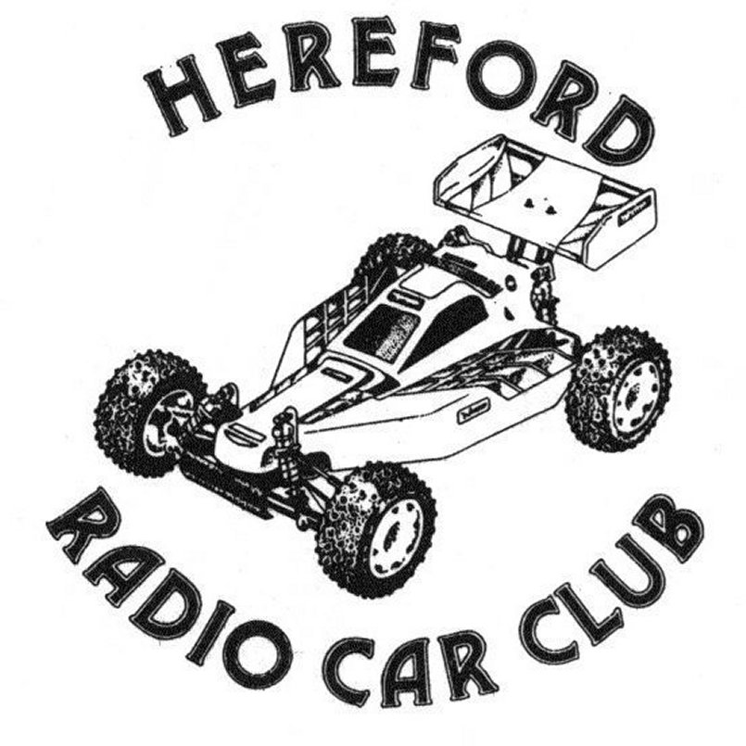

Presents
Round 7 for the Stockcars & Round 4 for the Bangers
Sunday September 4th 2005
At the Bridge Street Sport’s Centre, Leominster.

I can hear you all asking, why is the club called the Hereford Radio Car Club when they are based in Leominster, for the answer you have to go back to February 1987 when the club was formed by David Rogers and David Rose, they placed a few adverts in the local papers for their first meeting at the first venue for the club at the T.A. Centre in Hereford, to everyone’s surprise more than 70 people turned up on the night, this created a problem for the club as the venue turned out to be too small for such large numbers, so a new venue was sought and found at the Shire Hall which was also in Hereford, one of the original founders of the club David Rose left the club in 1990. Once again the club was forced to find a new venue, this was to be at the Tupsley Youth Centre in Hereford with Chris Bottle taking on the role of Chairman, during this time James Anderson brought a second hand AMB system which helped improve the lap counting and general running of the meetings, the club also asked James to take on the Chairman’s role. In 1994 the youth centre was vandalised and the club sought another venue, a temporary venue was found at Bartestree (just outside of Hereford) until a more suitable one was found at Hampton Dene Primary School, eventually the club moved on to Wellington, about 4 miles north of Hereford, the chairman at this time was Mike Williams, at the beginning of 1993 the club moved to it’s present venue at the Bridge Street Sport’s Centre in Leominster, at the AGM meeting in 2004 Mike Williams stood down as the chairman and Chris Bottle took over the reigns once again, it was also in 2004 when the club held their first BRCA national meeting for the Saloon/Mini/Hot Rod class, and the decision was made to hold a Stockcar/Banger National in 2005 which brings us right up to date, so looking back at the history of the club this explains why they have retained the Hereford name in their club.

How to find the club.
As the name might suggest a look at the map to find Hereford would give you a good idea, when in-fact the club is based in Leominster, a small town some fifteen miles north of Hereford, for me the journey was up the A46 towards Stratford at Alcester A46 and got onto the A422 and headed towards Worcester, at Worcester I got onto the A44 which took me onto Leominster. From other parts of the country North or South get onto the M5 and leave the motorway at J7 ( Worcester south ) and join the A44 to Leominster, once you arrive at the large roundabout turn right proceed on to the next roundabout and turn left, continue until you have gone over a level crossing, just after this you come to mini roundabout go to the right and the venue is approximately 300 meters ahead then on your left, the journey for me from home just outside of Coventry was 78 miles.

The meeting today has attracted 28 Stockcars and 20 Bangers, this might seem a low number but as the club does not normally run the Stockcar and Banger class I think this is a reasonable turnout, and as there were a few new Stockcars purchased on the day I am sure this number will climb if there is to be a national meeting at the Hereford club in 2006.

Round 1.
Bangers
As if to break with tradition the meeting started with the Bangers and heat one was won by Anthony Wyper with 65 laps on a split time from Chris Bottle in second place also on 65, third place went to Keith Rosco Schooling with 44. Setting the standard with 71 laps as the heat two winner was Ian Rolph he was chased by Mark Cooper with 68 and Robert L Jones in third place with 65 and young Tom Bottle posted a respectable 43 laps in fourth position. Heat three saw the defending national champion Alastair Needham secure a heat win with 68 laps from Mark Steel with 62, third and fourth place was decided by a split time after Kyle Bouston and Andrew Wigzell had finished with 61 laps apiece, the result going to Andrew by 0.630 of a second.
Stockcars
The first heat of the Stockcars was won by Anthony Wyper with 78 laps ( 14 more than he achieved with his Banger ) Jason Reed was placed second with 72 and Mr Diamond, Roy Calver was third with 63. Heat two was won by Ben Harding with 79 laps from Ian Rolph with 77, and third place in this heat was taken by Allan Inness with 64. Heat three saw the laps increase again, this time it was a winning 80 laps by Mark Cooper from Ian Johnson in second place with 79, things were a lot closer behind these two with third place going to Angela Yarwood with 76 followed by Peter Ayriss with 74 and Dave Gwilliam with 73. Although the laps were down heat four saw a good race, at the finish the win was taken by Darren Grace with 76 laps from Michael Fryett in second place with 75, then we had both Mark Steel and Daniel Fryett on 73 laps and in that order, and not far behind these two was Chris Flynn with 70. In heat five Matthew Bennett secured a win with 80 laps from Thomas Forrest in second place with 75 and Robert L Jones in third place with 65, and out in his first heat with his new car and taking fourth place was Keith Rosco Schooling with 58.

Round 2.
Bangers
The first heat of the second round was won by Daniel Fryett with 62 laps he was chased by Mark Cooper with 59 and Robert L Jones in third place with 56, behind Robert with 49 laps each was Mark Steel and Chris Flynn and young Charlotte Yarwood posted a respectable 43 laps in sixth place. Kyle Bouston raced to an easy win in heat two with 61 laps some 26 laps ahead of Nicholas Cooper in second place with 35, behind Nicholas in close attendance was Brandon Snell with 34 and Derek Grumpy Cayzer with 33. Heat three was a high lap scoring affair as Anthony Wyper took the win with 70 laps from Alastair Needham with 69 in third place came Ian Rolph with 67 followed by Andrew Wigzell with 64, two more racers breaking into the 60 lap bracket in this heat were Allan Inness with 62 and Keith Rosco Schooling with 61.
Stockcars
In heat one Mark Cooper collected his second win with 79 laps, Scott Williamson claimed a good second place with 76 laps from Ian Rolph on 72 and Allan Inness with 71. Heat two saw a close race with the lead changing hands several times during the race, at the finish both Roy Calver and Daniel Fryett finished on 74 laps, the result going to Daniel by 4.120 seconds, and in third place was Alan Crossland with 71. Heat three was dominated by Ben Harding as he set a new FTQ lap score of 84 laps, second place behind him went to Michael Fryett with 75 and young Nicholas Cooper was worthy of his third place with 68 laps chased by Brandon Snell with 64. Ian Johnson fell just short of the FTQ in heat four as his winning lap score was 83, behind him came Dave Gwilliam with 78 and Thomas Forrest with 76, in fourth place with 74 laps was Jason Reed followed by Robert L Jones with 73. Heat five saw Matthew Bennett regain some form with a heat win with 79 laps over Anthony Wyper with 78 laps in second spot, Derek Cayzer got a good result with 72 in third place with a split time decision over Peter Ayriss after Peter had also recorded 72 laps

Round 3.
Bangers
Ian Rolph collects a second win in heat one of round three with 69 laps, the reigning British Open Champion came home in second place with 63 and a distant Keith Rosco Schooling took third place with 40. This had to be the race of the day by far! as the lap scores will testify, just remember that these are four cell Bangers when you see the laps! the winner but only just was Mark Steel with 73 laps just 1.200 seconds behind him was Alastair Needham also finishing with 73 laps, and just behind these two with 72 laps was Mark Cooper in third place, and Kyle Bouston recorded 60 laps in fourth. Heat three saw a win for Chris Bottle with 69 from Robert L Jones in second place with 64 and the persistent Alan Inness was just one lap behind Robert with his 63 and Daniel Fryett was not far behind Alan in fourth with 61 laps.
Stockcars
Michael Fryett collects his first win in the Stockcars with a winning lap score of 78 in heat one, things were very close behind him as Jason Reed and Angela Yarwood both finished with 71 laps in second and third places just 0.720 of a second separated them at the finish, and just behind them in fourth place with 70 laps was David Forrest. Heat two saw Ben Harding take the FTQ score with an amazing 86 laps, which is also the new track record for the Hereford Oval for the Stockcars, I say this because the track used for the Saloons/Hot Rods is larger, in second place with his best lap score so far was Matthew Bennett with 82, both Peter Ayriss and Scott Williamson finished the heat on 79 laps separated by 0.620 of a second, then we had a 75 lap score by Chris Flynn in fifth place. Another racer to collect a first heat win was Roy Calver in heat three, his winning lap score was 77 laps, two racers getting in each others way were Mark Cooper and Ian Rolph both finished the race just one lap behind Roy on 76 laps, Mark finished ahead of Ian by 1.530 seconds. Heat four was win number two for Ian Johnson with 80 laps, and as we have seen before in earlier races the minor places were keenly contested as Daniel Fryett took second place by 2.590 seconds from Mark Steel after both racers had finished the race with 71 laps, and just behind these two was Allan Inness with 70. The final heat of the round, heat five was won by Dave Gwilliam with 79 laps from Alan Crossland with 75 and Thomas Forrest just one lap behind Alan with 74 and Anthony Wyper was a further lap back in fourth place with 73.

Round 4.
Bangers
What a race more like a banger heat should be! And a racer that was not complaining was Allan Inness as he collected his first win with 64 laps in heat one, Chris Bottle came home in second place although he only completed 4/5 fifths of the race distance as Nicholas Cooper deposited his car over the barrier, and Kyle Bouston had enough laps to his credit to claim third place with 62, Mark Cooper had come off worst in an earlier skirmish and had also gone over the barrier after completing just 3/5 fifths of the race distance but still took fourth place with 55 laps, and the attacking Nicholas Cooper was place fifth with 46 laps. Heat two saw Mark Steel claim the scalp of Alastair Needham once again, Marks winning lap score was a healthy 73 and Alastair was a mere two laps behind Mark with 71, third place went to Daniel Fryett with 58. Ian Rolph was the winner of heat three with 68 laps from Anthony Wyper with 59, just one lap behind Anthony came Keith Rosco Schooling with 58 and Robert L Jones was a further lap behind with 57.
Stockcars
Another name is added to the list of heat winners as Jason Reed secures a win with 76 laps from Allan Inness in second place with 74 followed by Chris Flynn in third place with 67. Ian Johnson collected his third win in the heats with 79 laps from young Thomas Forrest with 76, he was followed by his father in third place with 67 laps, behind him Brandon Snell and Keith Schooling were having a good race, at the finish Brandon was just ahead of Keith by one lap the lap scores were 65 to Brandon and 64 to Keith which was his best lap score of the days racing with his new car.

Another racer collecting his third win was Mark Cooper in heat three, his lap score of 82 was also his best so far, finishing in second place was Anthony Wyper with 81 followed by Michael Fryett with 80, fourth and fifth places were separated by just two laps after Scott Williamson finished the race with 79 and Ian Rolph had 77 to his credit. Heat four was won by Ben Harding with 83 laps, finishing in second place was Angela Yarwood with 78 and Dave Gwilliam was just one lap behind Angela with 77, fourth and fifth positions were decided by a split time after Mark Steel and Roy Calver had finished on 73 laps, Mark was ahead by 1.830 seconds. The heat five winner finished just as he had started the heats with a race win, his winning lap score was 77 by Darren Grace, it was very close behind him as Peter Ayriss and Alan Crossland recorded 76 laps apiece in second and third positions, they were followed by young Nicholas Cooper in fourth place with 69.

The Stockcar Consolation
The race that features the best of the rest, but the big prize on offer to all eight of the competitors is the one remaining place in today’s final that is waiting for the winner of this race, not to mention the extra national points that can be gained for a higher finish in the final list of competitors, the luck eight that will race for this are, Dave Gwilliam a member of the Rugby Club and Team Skint race member, Dave Gwilliam is also responsible for some of the smart looking body-shells that are on some of the car’s. Ian Rolph hails from the club in the Cambridgeshire area that is called March, Peter Ayriss comes from the Manchester club run by Alan Crossland and is to be found at Urmston, Peter is also a big track specialist, Thomas Forrest a junior member and most likely winner of the junior points title this year, Thomas races at both Stoney Stanton and Rugby and races a car that is supplied by Lecatt Racing (Andy Cattell) Angela Yarwood is the country’s top lady racer and her home club is Urmston, Roy Calver hails from the Wycombe Race Car Club, Roy also produces the Diamond type of race car, Jason Reed is an up and coming racer from the Hathern club, and the final competitor is the Urmston Club promoter himself Alan Crossland.
We had a fascinating race as some of the more fancied racers seemed to struggle, and the eventual winner looked like he was doing his best to throw away the lead at one stage of the proceedings as it was the win was by a split time after both Peter Ayriss and Angela Yarwood had both recorded 72 laps, the result going to Peter by 1.910 seconds, third place was taken by Thomas Forrest with 70 he was followed by Dave Gwilliam with 68 and Alan Crossland on 67, sixth and seventh were separated by a split time after both racers had recorded 61 laps, in sixth place it was Jason Reed and seventh went to Ian Rolph just 0.810 behind, and the unlucky Roy Calver had to retire from the race when it looked like the win was going to be his with a blown motor.
The Stockcar Final
The top qualifier for the final and the only racer that had won all of his races so far was Ben Harding, lining up along side of him on the front row was Ian Johnson, next on the grid would be Matthew Bennett with Mark Cooper next to him on the second row, moving onto the third row of the grid on the inside position we have Anthony Wyper with Michael Fryett along side of him, and the back row of the grid has Scott Williamson on the inside and the consolation winner Peter Ayriss on the outside of the back row.
Well done to Ben Harding in collecting another national win, he also goes in the record books as the first Hereford national winner with 83 laps, a close second place was taken by Matthew Bennett just one lap behind Ben with 82, and the final rostrum place was filled by Ian Johnson with 78 laps, Anthony Wyper posted a good result in fourth place with 77, Mark Cooper came home in fifth place suffering from grip roll and on a split time from Michael Fryett after both racers had recorded 76 laps, Mark was ahead by 2.760 seconds, seventh place went to Scott Williamson with 74 laps and the consolation winner Peter Ayriss came home in last place with 68 laps.
The Banger Final
A mouth watering prospect for the Banger final on the super fast Hereford oval, a full grid of ten cars! The line up for the first Banger final in order of qualification looked like this,
1. Alastair Needham 213
2. Mark Steel 208
3. Ian Rolph 208
4. Mark Cooper 199
5. Anthony Wyper 198
6. Chris Bottle 196
7. Allan Inness 189
8. Robert. L. Jones 186
9. Kyle Bouston 184
10. Daniel Fryett 181

With so many fast cars amongst the line up it was going to be a fast final, and this proved to be the case as most of the racers were going for the laps and not the cars! The winner of the first Hereford Banger final was the defending National Champion, Alastair Needham with 69 laps, behind him in second place was Ian Rolph with 67 and the current British Open Champion Anthony Wyper was third with 66, the current leader of this years championship Mark Cooper came home in fourth place with 64 laps, fifth and sixth places were separated by a split time after Chris Bottle and Daniel Fryett had both finished on 62 laps Chris was ahead by quite a margin as he had already posted this many laps before the full race distance, this time is 5 x 60 = 300
His time was 271.800 compared to that of Daniels 300.670, seventh place was taken by Mark Steel with 61 laps and Kyle Bouston was eighth with 54, ninth place went to Allan Inness with 34 in a time of just 222.270 and Robert. L. Jones was tenth with just 22 laps in a time of 133.280.

The Banger Demolition Derby
This event is open to all of the Bangers that have took part in the meeting, and all twenty of them took to the track in this one to slug it out in an anything goes event to see who could last the longest and be declared the winner, as the last car moving within the track, there were one or two early casualties that were put over the barrier and were declared out as no cars are allowed to be returned to the track, the biggest cheer was reserved for the head on with another car that resulted in Ian Rolph’s car flying over the barrier and out of the event, after quite some time we were down to the last two or three cars limping around the track and eventually Andrew Wigzell was declared to be the rightful winner.

After this D/D all of the usual awards were presented to all of the luck recipients in both the Stockcars and the Bangers for both the Finals and also the grade award trophies, and the general consensus of the days proceedings was well done to the Hereford Club on a good days racing.

Here is a technical chart of the Stockcar finalists car set up, although it does not tell you things like tyre diameters and widths i.e. stagger, also some racers use toe-in on their front axles and some race with an in line wheel arrangement, so remember a tec chart tells you what type but not how if you know what I am on about,

Name | Front  Tyre in | Front  Tyre out | Rear  Tyre in | Rear  Tyre out | Gear  Ratio | Speedo  Type | Charger | Car  Type | Chassis | Cells | Home  Club | Grade | Qualif | Final
Peter  Ayriss | SE | 812 | SE | Pink | 12/48 | Assoc | Pro  Trak | Ayriss 2 | Anderton | 2400 | Urmston | Red | 8 | 8
Anthony  Wyper | SE | Super  40 | Pink | Pink | 12/51 | Mardave | Apex | Pinky | Anderton | 3300 | Urmston | S/S | 5 | 4
Scott  Williamson | SE | Super  40 | Pink | SE | 12/50 | Mardave | Apex | Taz  I Bend | Anderton | 3300 | Urmston | Blue | 7 | 7
Ben  Harding | Jap  Med | 812 | Pink | Pink | 12/50 | Mardave  MK.1 | Apex | Skint | Anderton | 3300 | Rugby | Silver | 1 | 1
Matthew  Bennett | Jap | Jap | Pink | Pink | 12/51 | Mardave  2 speed | Duratrax | Lecatt 2 | Lecatt | 3300 | Rugby | Red | 3 | 2
Mark  Cooper | Jap  40 | 812 | Pink | Pink | 12/50 | Mardave  2 speed | Pro  Trak | Lecatt 2 | Anderton | 2600 | Stoney  Stanton | Red | 4 | 4
Ian  Johnson | Gold | 812 | Pink | Pink | 12/51 | Mardave | Apex | Bandit  Pro | Mardave | 2000 | Hathern | S/S | 2 | 3
Michael  Fryett | SE | Super  40 | Pink | Pink | 12/50 | Mardave | Apex | Pinky | Anderton | 3300 | March | Red | 6 | 6

