Roundup of the 2005 Stockcar National Series

The number of racers attending national meetings was down by a considerable margin compared to the previous year, although the quality of the racers at the meetings remains as high as ever, there was a total of ninety-one racers that took part in the series with eight racers appearing at all of the rounds up four from the previous year, the series was contested over eight rounds with the best five counting towards the championship the same as last years championship although there were only seven rounds last year. One thing a racer tries to achieve is a perfect point total of one-hundred, thirty points for three heat wins, one point for the FTQ and sixty nine for the final win, there were two racers that achieved this feat they were Ben Harding (three times) and Mark Cooper, so hear are the rest of the meeting details from 2005,

Hathern.
The highest attendance for a national meeting of fifty-three appeared for this one, in total there was thirty-six heat’s which produced sixteen different winners, only Ian Johnson and Ben Harding were unbeaten in the heats, the FTQ was set with ninety-one laps by Ian Johnson, one lap down on the previous year, the winner of the consolation race was Ryan Cattell with eighty-six laps and the final was won by Phil Chadbourne with eighty-nine laps, the top national points scores from this meeting was ninety-eight by Ben Harding and Phil Chadbourne.

Rugby.
Forty-seven racers were out to do battle for this round, the good news was that the numbers were slightly up on the previous years attendance of forty-four, in total there was twenty-eight heats which gave us thirteen different heat winners, as the previous round two racers remained unbeaten in the heats they were Karl Spencer and Ian Bingham, amazingly Ian Johnson collected another FTQ with ninety laps in round one, although Karl Spencer equalled this in round four, but his split time was slower, the consolation was won by Roy Calver with eighty-three laps and the final went to Karl Spencer his winning lap score was eighty-eight laps on a split time from Dave Gwilliam. The most national point from this meeting went to Karl Spencer with ninety-nine.

March.
Just one down on the attendance of 2004, which was thirty-three, I hope the numbers improve next year from this years thirty-two, we had a total of sixteen heats with a high total of nine different racers winning a heat, there was only one racer that remained unbeaten by an opponent in the heats, well done Phil Chadbourne, the extra point for the FTQ went to Karl Spencer in round four with eighty-eight laps. Qualifying for the final as the consolation winner was Dave Gwilliam with a winning eighty-four laps, and the final was won by Ben Harding with eighty-seven, three meetings raced and so far we have had three different final winners, the best of the national points scores was ninety-nine by Ben Harding although Karl Spencer is currently holding the top position after the three rounds.

Urmston.
We had a real surprise as the usual high attendance at this meeting plummeted from a high fifty racers in 2004 down to a disappointing thirty-two, the racers were split into twenty-four races over the four rounds, and we had twelve different race winners from these with Matthew Bennett and Mike Tomkinson collecting four heat wins each, in round four Ben Harding claimed the FTQ with ninety laps. In the consolation race it was Clive Buckler that progressed to the final as the winner with eighty-two laps and the final was won by Ben Harding with eighty-nine laps which made it two finals on the trot, and more importantly he achieved the perfect one-hundred points which moved him up to the top of the national points chart.

Leven.
Due to its location this is usually one of our poorest meetings for attendance, the real surprise here was an improvement of five racers from that of twenty-two in 2004 up to twenty-seven this year, it would be good to break into the thirty numbers of racers next year, in the heat’s only Mark Cooper remained unbeaten, we had a total of eleven different heat winners in the twenty heats, the FTQ went to Mark Cooper with seventy-two laps from a full heat of cars, although Stewart Smith recorded a seventy-three in round four and sportingly he declined the FTQ as the heat started with just three cars and was quickly down to just two, the consolation was won by Peter Ayriss with sixty-two laps, the final was won by Mark Cooper with sixty-nine laps, in the national series we now have four different final winners from the five completed rounds, on the points front it was a maximum for Mark Cooper the second racer to do so this year, one more than last years series which had Matthew Bennett as the only racer to achieve the maximum point score, and in the race for the championship it was Karl Spencer moving back up to the top as Ben Harding was not at this meeting.

Wycombe.
How do I explain this one? Same venue as last year but a different club, so take this comparison lightly, at the previous club in 2004 there was thirty-two racers, and would you believe we had the same total at the new club in 2005, the thirty-two were slit into five different heats over the four round which gave us a total of twenty, we had a better than 50% success rate with eleven different racers recording a heat win, and for the first time this year no racer remained unbeaten through the heats although James Blower, Ian Johnson and Ben Harding all won three, the FTQ saw Ben Harding record a high seventy-eight laps, the consolation race was a closely fought affair with less then a second separating the first two, but it was Matthew Bennett that was first across the finish line with seventy-two, and just like the consolation the final also had two racers on the same lap at the finish, but the record books will show Karl Spencer as the final winner with seventy-four laps. In the chase for points it was Karl Spencer at the top of the charts with ninety-eight. As this was the sixth round of the series and the best five were to count at the end of the series the racers that had completed all six rounds could now drop their worst score, so with this in mind Karl Spencer still headed the points chart with 487 (best five scores) and Ben Harding had now completed five rounds in second place with 485.

Hereford.
There is no comparisons to last year as this is a new venue, we had a disappointing turn out of thirty-two racers, there were a total of twenty heats of racing with a healthy number of different heat winners, and would you believe we had the same number as the previous national meeting eleven winners from the twenty heats, the FTQ of eighty-four was posted by Ben Harding in round two, in the consolation race we had two racers finish on the same lap once again, and as there are no prizes for second place the name to be mentioned as the winner was Peter Ayriss, and collecting his third final win of the year was Ben Harding with eighty-three laps, he also collected another maximum points score his second of this year’s series and was the only racer to remain unbeaten in the heats, moving on to the all important national points chart, it is now Ben Harding in the top spot with a total of 492 from his best five rounds with Karl Spencer in second place with 487 with one round remaining.

Stoney Stanton.
We had six less racers than the previous year attend this one, in 2004 there was forty-three and the number for this one was thirty-seven, there was a total of twenty-four heats over the four rounds, with a high total of fourteen different racers recording a race win, and for the second time this year no racer remained unbeaten, although Ryan Cattell, Matthew Bennett, Ben Harding, Andy Cattell and James Blower all recorded three wins each, the consolation race was won by James Blower with eighty-one laps, and the final was won with ninety-two laps a new track record, by Ben Harding and as Karl Spencer was not at this meeting Ben was already crowned as the 2005 National Points Champion.

Over the eight rounds a total of one-hundred and eighty-eight heats were contested, here is the top ten racers with the most heat wins,
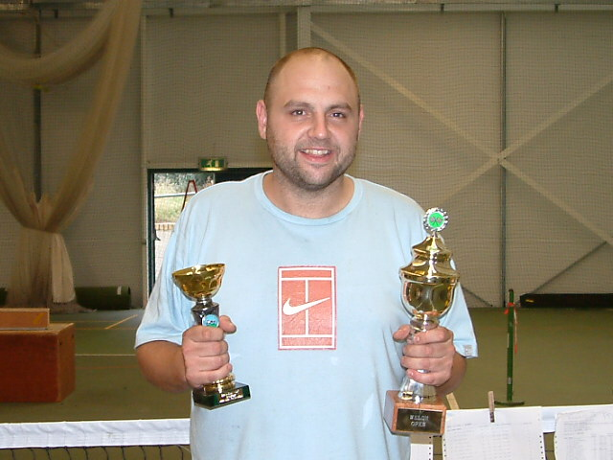
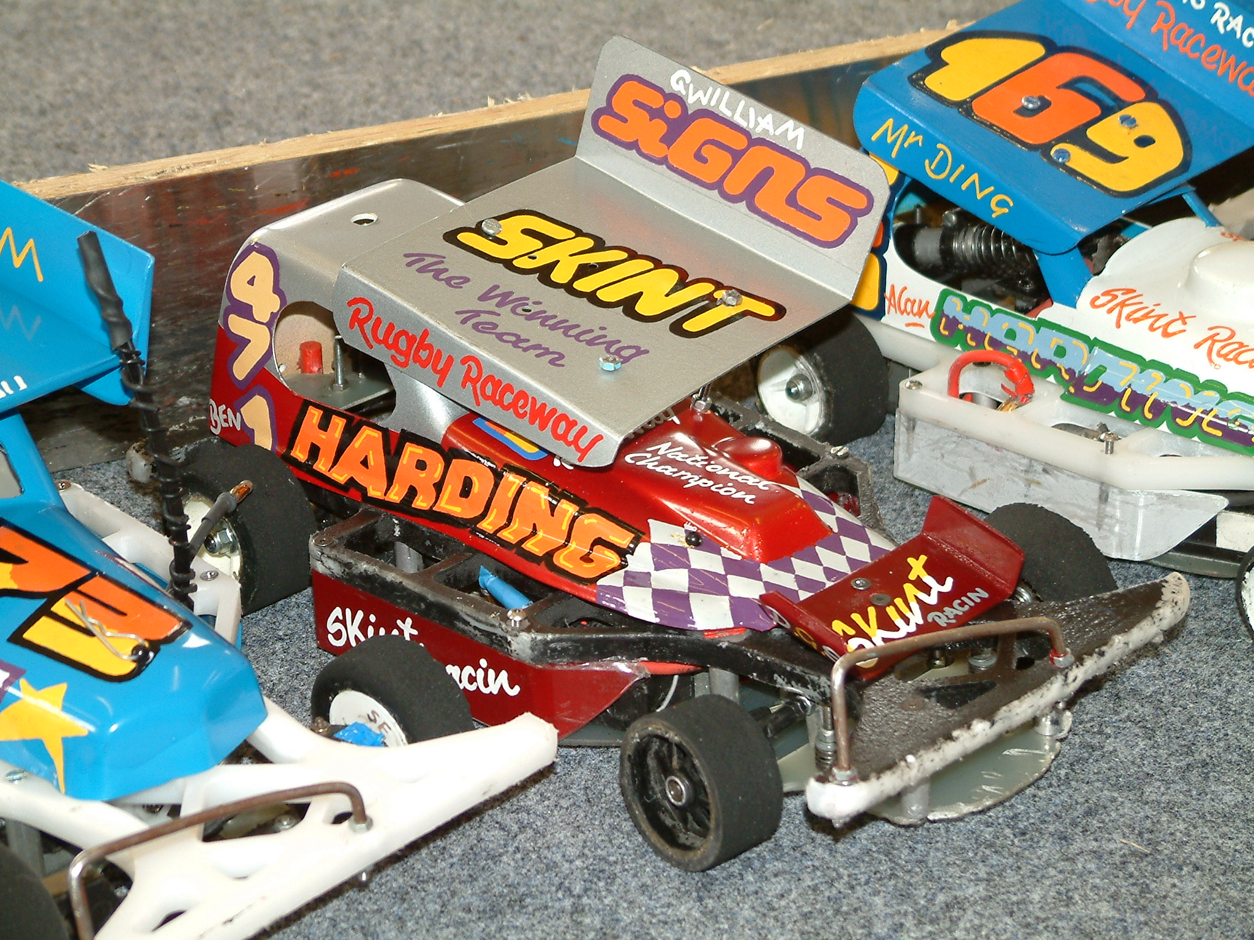
1. Ben Harding 22
2. Matthew Bennett 19
3. Ian Johnson 16
4. Karl Spencer 14
5. Mark Cooper 13
6. Phil Chadbourne 9
7. Stewart Smith 9
8. Dave Gwilliam 8
9. Ryan Cattell 7
10. James Blower 6
10. Anthony Wyper 6

The rest of the heat winners from the series were Clive Buckler, Andrew Cox, Jonathan Goodacre, Jon Cutts, Alex Wood, Chris Flynn, Ade Eaglen, Ian Bingham, Mark Steel, Ian Rolph, Jim Burkett, Mark Foster, Mike Tomkinson, Angela Yarwood, Darren Grace, Kevin Falconer, Allan Inness, Iain Roper, Carl Baker, Alan Bellis, Richard Harding, Gerry Fordham, Jason Bartropp, Roy Calver, Daniel Fryett, Michael Fryett, Jason Reed, Tom Forrest, Andy Cattell and Shayne Moorcroft, a grand total of forty-one different heat winners. Along with Ben Harding as the National points champion, Angela Yarwood was crowned as the Ladies national champion and Thom Forrest was the Junior champion.

