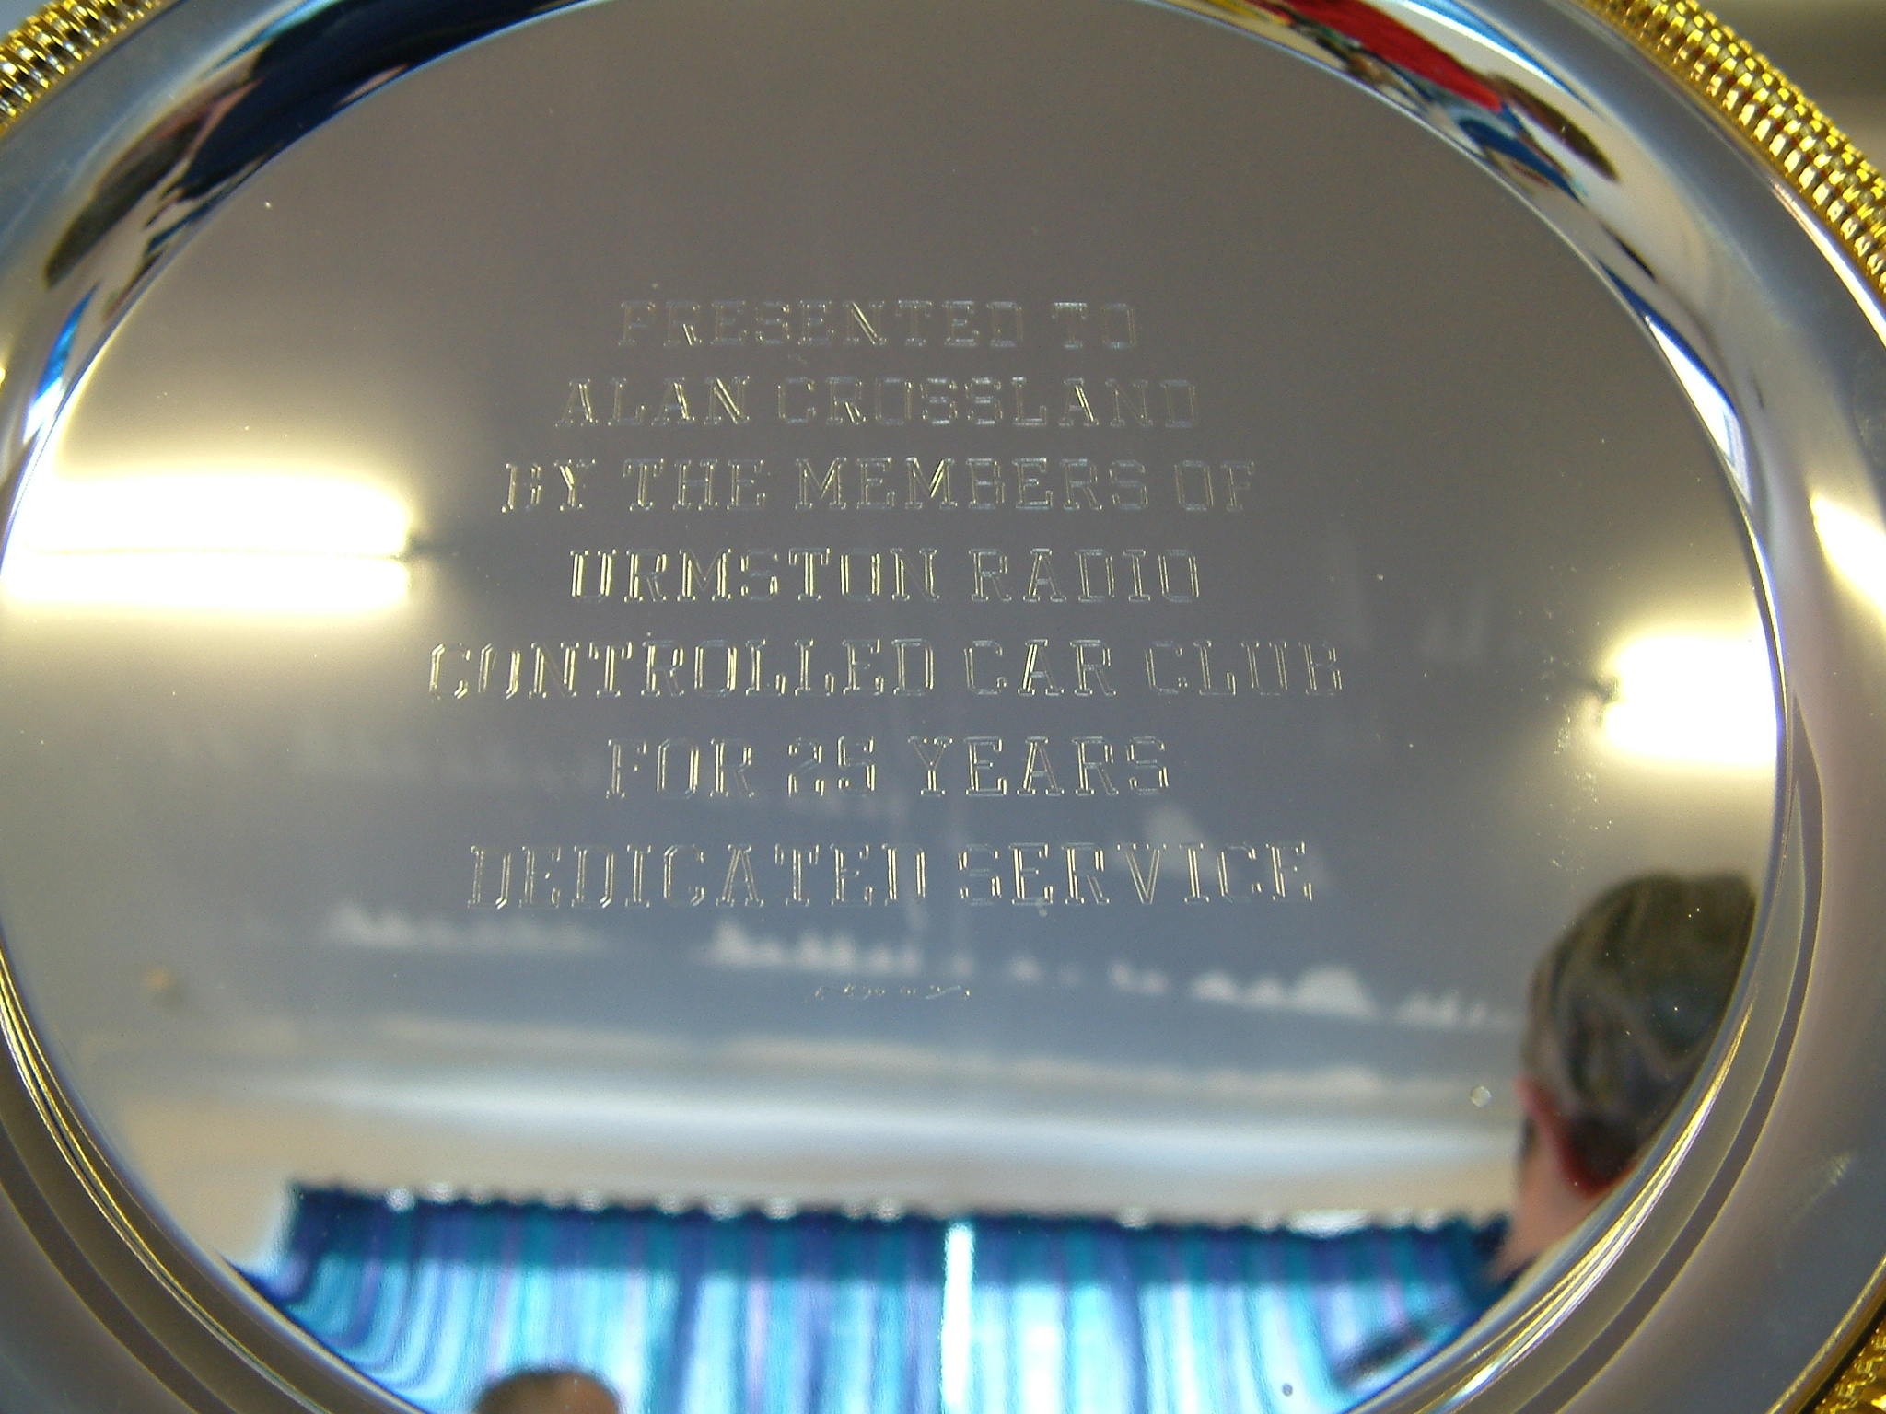
Urmston 25th Anniversary Meeting

Saturday 13th November 2004

Alan Crossland :- Mr Stockcar & Urmston Club Promoter
Reciever of the Section BRCA Award 2004
You have to agree that twenty five years is a long time, especially as the promoter of the same club for all of those years, so taking a trip down memory lane Alan explained to me that his interest in the world of radio control started as far back as 1976 and this was through his then employer who used to sail model yachts, Alan soon purchased one and joined the Bolton R/C sailing club which was during the same year, then to our good fortune Alan saw a new type of race car in a model shop window during the year of 1979, it was powered by rechargeable nicad batteries and Alan purchased one for a bit of fun to go along side of his sailing hobby, then showing it off to the other members of the sailing club one of them said to Alan they have just started a club near to me at Sale for those, so Alan went along and joined this new club, but he immediately realised there was a better and more comfortable place to race, yes you’ve guessed it, Alan’s own church room in Urmston where he was the organist and also a committee member, and soon the first meeting in the new hall was booked for the 10th of November 1979, a track was formed with some tape and wood and plastic saucers along with some cones borrowed from work, a total of 24 drivers came along from the club at Sale for the first meeting promoted by Alan and the Urmston Radio Controlled Car Club has been based there ever since, although the club ran a second venue midweek during the early 90’s at a scout hut in Heaton Chapel, Stockport, the club also ran buggies when they became available and ran them at various local scout huts during the summer months, the club also ran them indoors and constructed a fly-over bridge for them ( photos can be seen in the various scrap books that are on display at the club ) the club stopped racing buggies in 1999 and now the club concentrates on running the Stockcars, Saloonstocks and Bangers. Here are some of the landmarks in the clubs history that make the Urmston club what it is today, as you know the first meeting was held on November 10th back in 1979, but let me remind you that this was on a wooden floor surface with silicon on the tyres to obtain some degree of grip, in 1980 the first Stockcars were raced followed by the construction of an oval track in 1981, the first stockcar national meeting was held during 1986, it was in 1988 that the record for the highest club attendance was achieved with a total of 63 cars made up of 48 buggies, 10 ministocks and 5 race cars, in 1989 Friday night racing was introduced for the ministock class, also in this year at the clubs tenth anniversary they were visited by the Mayor of Trafford, in 1991 a new solid centre for the oval track was made, then some significant changes came in 1995 the first was the purchase of an AMB automatic lap counting system (good by to the manual clickers) and the club changed over to carpet racing which was soon to be enforced at national level, and also in this year a LED message sign was purchased and the first Urmston club newsletter was produced, the latest newsletter is issue number 32 then in 2000 extra transponders were purchased and in 2002 the new class of bangers were introduced, and then and almost recently in 2003 the club purchased a frequency monitor and a new permanently fitted carpet.
Alan has officiated at all of the 1,779 meetings that has been held to date at the club in the church hall over the 25 years, and more outstanding is the number of members that have passed through in that time an amazing 1,266 and to help celebrate this all of the current Urmston club members are to receive a special Urmston Anniversary T-shirt.
Looking back over some of Alan’s personal highlights from the last 25 years after some probing questions from me, Alan tells me that his biggest highlight was the visit by the mayor of Trafford who came to the club on the tenth anniversary meeting to present the trophy’s, Alan also bristles with pride when he recalls the names of the F1 drivers who have come along to the club to present trophy’s some of the famous names mentioned were Dave Berresford, Frankie Wainman(snr), Stuart Smith, Willie Harrison and Ray Tyldsley when he was world champion! When I asked Alan if there was anything that he could change over the last 25 years the reply that came back was, no there is nothing that I would change. As most of us racers follow the real cars, I asked Alan who his all-time favourite driver was and Alan quoted Ron Rogers from the late 60’s and the 70’s when I attended meetings almost every week. As most of you are aware Alan devotes most of his time to his club but I just had to ask him, have you ever won anything with your stockcar and the proud reply was, won the stockcar final at the week long Model Makers festival at Pontins holiday camp at Brean Sands in 1993, I also used to get in some national finals, but too busy selling spares these days to concentrate on the car. I asked Alan which in his opinion was the 1/12th type of car that had the biggest influence on our section and the surprising reply was the old Lectricar, and the reason for this was that it had a big influence on our section in the early days as it was an engineers luxury-but was eventually considered too heavy, and gave way to the lighter Mardave type of car and also the Schumacher car. When I asked Alan about how the club has kept going all these years he proudly states that the club has never had to advertise and states that the racing has kept going by the fact that I started stocking spares in 1983, along with the royalties received from a book on old Urmston which Alan had written, and new drivers had found the club by word of mouth and more recently they had found the clubs web-site, and I think the clubs canteen helps attract a lot of people also and this is currently run by Jean, Carol and other helpers from time to time and Alan also quotes that all profits are promptly returned to the club through the spares, at this point I would like to say that most of us are still racing thanks to Alan’s dedication to the stockcars in stocking all the bits that we need, and if a supplier disappeared Alan would source out an alternative so that we could continue racing, and I personally think that the stockcars would have disappeared without Alan’s dedication and dogged determination to put his hand in his own pocket many times and purchase the quantity of spares that were quoted by the suppliers, we also had a lot of help from Alan in the early day’s of the automatic lap counting systems when Alan used to bring the Urmston club’s system along for use at the nationals until the section purchased their own system. When asked about the future of our racing Alan was sure that the future looked good for the foreseeable future. Alan has received many accolades to help celebrate the first 25 years, but the most pleasing of them came at the BRCA AGM when Alan received an award from our section chairman for services rendered, then during the afternoon AGM Alan was presented with the award for our section from the main BRCA committee, and no one deserved these awards more than Alan, so once again thank you from us all.

The Stockcar Anniversary Meeting 13th November 2004
We had a big turn out for this meeting some 53 racers had made the effort to attend, along with some that had travelled a fare distance, and Alan has decided to be a little bit different with the format of the meeting, we have four minuet heats, and as usual for a club meeting we stay in the same heat of racing, then the top eight racers will go straight into the final along with the top two from a nine car consolation race to make up a ten car final.
Round one.
In round one heat one Ian Bingham made the perfect start to his days racing with 68 laps in first place from Margaret Dunbar with 65 and Mike Tomkinson on 64, also finishing with 60+ scores were Carl Baker with 63, Terry Crowley on 62 and Colin Eardley with 61. Heat two was won with 66 laps by Alan Bellis, Alan is the man in form as he is the new Urmston club champion a title he won on Saturday 30th October, he was chased by both Peter Ayriss and Richard Harding with 64 laps and then we had both Phil Chadbourne and Gary Osbourne with 62 laps. Heat three saw two racers finishing with 62 laps they were Dave Hastings and Stewart Smith and Debbie Jackson was not far away from the 60 lap mark with 59. Heat four went to Mark Foster with 61 followed by Darren Grace with 60. Heat five saw the laps clime up to the 66 laps of Gareth Jones in first place followed by Clive Buckler on 65 and Allan Inness finished the race with 60. Heat six was won once again with 66 laps this time it was by Ben Harding, finishing in second place we had Angela Yarwood with 64 followed by Matthew Bennett on 63 and Anthony Wyper on 61 laps at the finish. Heat seven saw both Gary McMullen and Shane Moorcroft finish with 64 laps they were chased by Andy Cox with 62 and Mark Cooper with 60 laps.
Round two.
In heat one both Ian Bingham and Colin Eardley recorded 67 laps with Carl Baker just one lap behind on 66, then we had Mike Tomkinson with 64 followed by Terry Crowley with 61. Heat two saw Alan Bellis claim a heat win with 69 from Pete Ayriss on 67 and Gary Osbourne with 66, also breaking into the 60+ laps bracket we had Phil Chadbourne with 65 and Richard Harding with 61. Heat three was a scrappy affair with Duncan Bullock the only racer to record a score in the 60 laps bracket, his lap score was 61. Heat four saw both Martin Cooper and Darren Grace finish with 62. Heat five was won by Clive Buckler with a creditable 66 laps from Allan Inness on 60 laps in second the spot. Heat six was won by Matthew Bennett with 65 laps from Ben Harding on 63 followed by both Angela Yarwood and Anthony Wyper with 62 laps apiece. Heat seven saw both Mark Cooper and Gary McMullen record 66 laps they were chased by Andy Cox with 64 and Dennis Yarwood with 60.
Round three.
Once again we had two racers sharing a heat win in race one of round three, they were Colin Eardley and Carl Baker with 65 laps with Ian Bingham just one lap behind these two, also in the 60 lap bracket were Mike Tomkinson with 61 and Terry Crowley with 60. Heat two was a very close race between a number of racers, at the finish Gary Osbourne and Peter Ayriss had 65 laps followed by both Phil Chadbourne and Alan Bellis with 64 and also in close attendance was Richard Harding with 63. Heat three was won by Stewart Smith with 65 laps from Tom Forrest with his best lap score of the days racing a healthy 61. Heat four was won by the only racer to break into the 60 laps bracket in this race, and it was achieved by Martin Cooper with 60. Heat five went to Clive Buckler with 62 followed by Gareth Jones with 61. Heat six was a good race between Ben Harding and Matthew Bennett, at the finish Matthew was first with 66 closely followed by Ben with 65 then it was Angela Yarwood with 62. The last heat of the rounds was won by Mark Cooper with 67 from Andy Cox on 64 and a subdued Gary McMullen with 61.

As this was a club meeting all three rounds would count towards the qualifying total, with the top eight racers straight into the final, and they will be joined by the top two racers from the nine car consolation race, the racers through to the consolation race were, Gary Osbourne – 193, Clive Buckler – 193, Phil Chadbourne – 191, Gary McMullen – 191, Andrew Cox – 190, Mike Tomkinson – 189, Richard Harding – 188, Angela Yarwood – 188 and Terry Crowley – 183.
This was a very interesting race, and at the finish two racers had broke clear from the chasing pack with the win going to Gary McMullen with 65 followed by Clive Buckler with 64, and it will be these two who go into the final, behind them things were extremely close with the next five racers all finishing with 61 laps in order of crossing the finish line they were Andrew Cox, Mike Tomkinson, Angela Yarwood, Richard Harding and Phil Chadbourne less than three seconds separated all five racers! they were followed by Gary Osbourne who was just one lap behind with 60 and finally Terry Crowley crossed the finish line with 56.

The Final.
We know Gary McMullen and Clive Buckler are in the final as they finished as 1 and 2 in the consolation race, the racers that had already qualified for the final were Alan Bellis – 199, Ian Bingham – 199, Peter Ayriss – 196, Carl Baker – 194, Matthew Bennett – 194, Ben Harding – 194, Colin Eardley – 193 and Mark Cooper – 193.
This was to be an historic event as there are few stockcar finals that have more than eight cars, although the first world final was a ten car race but the track was much larger than the Urmston club track so it will be interesting to see how the racers cope with the traffic, and the answer was very well if you ask the winner Matthew Bennett who recorded an astonishing 68 laps in winning the final, second place went to Gary McMullen some four laps behind Matthew with 64, in third place we had Clive Buckler with 63 laps also finishing with 63 laps were Peter Ayriss and Ben Harding followed by the next three racers all on 61 laps they were Colin Eardley, Ian Bingham and Carl Baker in that order at the finish, Mark Cooper had 59 to his credit with the unlucky Alan Bellis retiring from the race after just 3 laps.

During the break between the consolation race and the final there were two grand national races due to the number of racers that wanted to enter, the first one which had eight cars was won by Darren Grace, and the second one featured nine cars and was won by Duncan Bullock, the grand national trophy was presented to Darren Grace as he had the highest lap score from the two races, the grade award trophy’s went to Tom Forrest as the best junior, the blue award was won by Angela Yarwood and the best yellow went to Ian Yarwood (jnr).

During the anniversary week a total of 115 cars have raced at the club, this was made up from the 28 cars that had raced at the Wednesday night meeting, then on Friday night a total of 35 were in attendance followed by the 53 from the Anniversary meeting on the Saturday.

Reported by M. Cooper.

