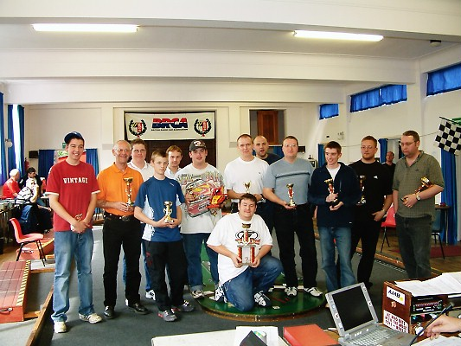

Round four of the stockcar national series finds us at the country’s number one club, Urmston Radio Controlled Car Club, promoted by Alan Crossland, this is the one national meeting above all others where you want to make the final due to the usual high standard of racers that are in attendance at this meeting, they have come from north of the boarder in Scotland and from the strong midlands base of clubs, as well as from the south and from the clubs based in the east of the country, we have current reigning champions and past champions amongst the strong entrée of some fifty racers, this is two more than we had at Alan’s previous two National meetings.
All the usual refinements are in place for this meeting, we have an on site spares shop providing everything that you could wish to purchase for you’re race car, and the ladies in the kitchen were doing us proud with they’re fantastic range of goodies that were on offer to tempt us. Plenty of notices boards around the hall displaying plenty of information about the club and also news from the national meetings as well.
As Stuart Preston was away on holiday the legality of the cars will be checked throughout the day by Mike Tomkinson.
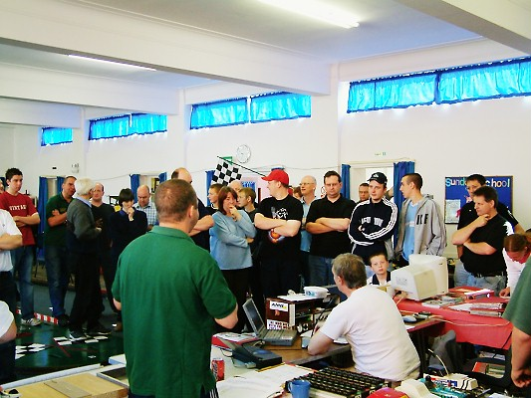
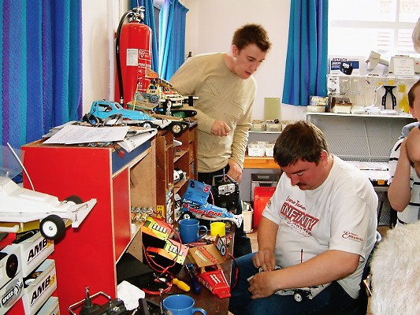

Alan had the meeting underway on time at two minuets to ten, after the usual driver briefing.

Round 1.
Heat 1 went to local racer David Smith with 82 laps followed by Dave Gwilliam on 80 and Steve McMullen with 79 followed by Irene Lancaster with 74. Heat 2 saw Phil Smith set the FTD score so far with a winning score of 83 he was chased by Angela Yarwood with 78 and then we had local racer Carl Baker on 77 and Clive Buckler with 76 followed by Derek Cayzer with 75. Heat 3 saw another home favourite take the spoils of victory, this time out it was Mike Tomkinson with 83 laps, he claimed the scalp of the current World Champion Gary McMullen in the process as well after Gary had finished with 82 laps in second place, then it was Matthew Bennett on 81 in third spot and then we had a gap back to Pete Clarke with 76 in fourth place.

Round 1 continued.
Heat 4 was won with 84 laps by Karl Spencer followed by Stewart Smith with 81 these two were some way out in front of the rest in this heat as Paul Riddell was some way back in third place with 73. Heat 5 was taken by another local racer this time it was Gary Osbourne securing the win with 80 laps, he had Roy Calver and Tom Forrest in close attendance with 79 laps each followed by Duncan Bullock with 75. Heat 6 went to Ben Harding with a new FTD of 88 laps followed by Gareth Jones with 85 and Anthony Wyper on 82. Heat 7 was won by Jon Cutts with 82 from Mark Cooper on 81 followed by Rugby’s yellow grade racer Dave Forrest on 68 as was Darren Grace in fourth place.

Round 2.
Heat one saw a great result for Biddulph Moore racer Steven Farmer after his poor showing in round one, he won the heat with 85 laps followed by Andrew Cox with 82 and Mike Tomkinson also broke the 80 lap mark with his score of 80 followed by the promising youngster Owen Ramsden with 78. Heat 2 was a good result for Carl Baker, he comes from the Urmston club so a heat win in his home national can not get any better his winning score was 81, he was chased by Matthew Bennett on 80 and then it was a struggling Andy Cattell back in third place with 75. Heat 3 went to the reigning National Points champion Ben Harding with 87 laps this time, just one short of his own FTD score, finishing in second place we had Stewart Smith on 85 and just one lap behind Stewart was David Smith followed by Diamond racer Roy Calver on 79. Heat 4 went to veteran racer Clive Buckler with 86 laps as did Phil Smith in second place they were chased by Dave Gwilliam with 79 laps and Duncan Bullock with 77. Heat 5 was won with 81 laps by Gary McMullen from young Tom Forrest with 76, Tom racing a Lecatt 2 type of race car from the Andy Cattell stable of cars, third place went to Allan Inness from the Hathern club on 73 followed by young Nicholas Cooper with 70. Heat 6 and Urmston racer Gareth Jones claims the win with 82 from Karl Spencer on 81 then came Mark Cooper with 74 after a quick pit stop to replace a track rod that had popped off. Heat 7 was won by Joe Brown, Joe is also a member at the Urmston club, he won with the winning race score of 80 laps he was closely followed by a train of three racers who had all finished with 79 laps, the finishing order was Jon Cutts in second, Gary Osbourne in third and Ryan Cattell was fourth then we had Paul Riddell finishing in sixth place with 76 laps.
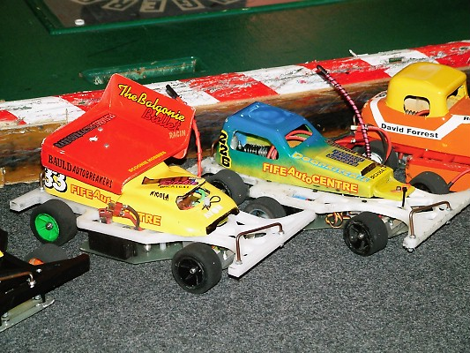
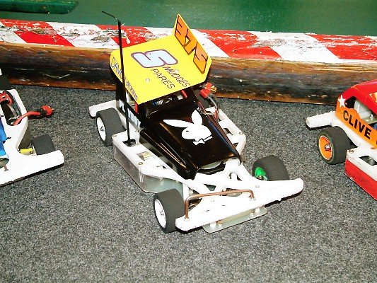
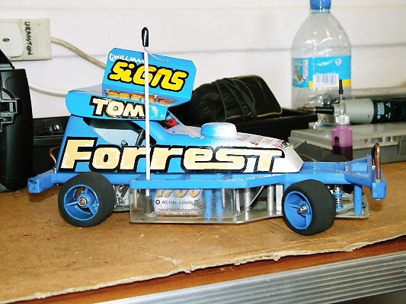

Round 3.
The honour of the first race winner in round three went to Stewart Smith with 80 laps followed by Andrew Cox with 79 and Angela Yarwood with 77 then it was Owen Ramsden 76 and Irene Lancaster also finished with 76. Heat 2 was won by Super Star racer Karl Spencer with 83 laps followed by Matthew Bennett on 81 and Roy Calver with 80 then it was Steve McMullen with 74. Heat 3 was won by Phil Smith with 84 laps chased by Steven Farmer with 80 and Ryan Cattell on 75 and a good result for Damon Smudge Atkins in fourth place with 73. Heat 4 was win number one for Mark Cooper with 84 laps to his credit followed by Dave Gwilliam on 81 and Karl Baker with 77. Heat 5 went to Sir Clive Buckler with 85 laps from David Smith and Jon Cutts in that order on 83 laps and Mike Tomkinson also broke into the 80 laps with just that amount, in fourth place. Heat 6 was taken by Ben Harding with 83 from the 80 lap score by Anthony Wyper finishing in second place, the third finisher was Pete Clarke with 78 followed by Derek Cayzer on 77. Heat 7 went to Urmston racer Gareth Jones with 83 he was chased by both Gary McMullen and Gary Osbourne on 82 laps then we had young Tom Forrest with 78 laps in fourth place.
Round 4.
Out in front in heat one was Andrew Cox with a winning score of 81 followed by Carl Baker with 79 and Pete Clarke on 76. Heat 2 was win number two for Mark Cooper with 81 from Clive Buckler with 80 and Tom Forrest finished the race with 79 and Dave Gwilliam was not far behind on 77. Heat 3 was won by Gareth Jones with 82 laps chased by Jon Cutts with 77 and Damon Atkins with 73. Heat 4 was won in fine style by Ben Harding with 88 laps which also took the FTD score bettering his first round 88 by virtue of a better split time, he was followed by Gary McMullen with 84 as was David Smith in third place, Roy Calver also recorded a race score in the 80’s with his score of 82 as did Gary Osbourne in fifth place with 81. Heat 5 was win number one for Ryan Cattell with 79 laps from Steven Farmer on 76 and Alan Greig on 73. Heat 6 was another high scoring race at the finish the win went to Matthew Bennett with 86 from Anthony Wyper who also finished with 86, third place went to Stewart Smith with 84 laps, as did Mike Tomkinson in fourth place. Heat 7 went to Phil Smith with 83 laps from Paul Riddell with 81 and Steve McMullen on 77.

Consolation.
At this stage of the proceedings all of the racers best three lap scores from the four rounds are added together, the top seven racers are then seeded straight through into today’s final, then the next eight racers contest the consolation race with the winning racer going through to join the previous seven racers that have qualified for the final, which then gives us our eight for the final.
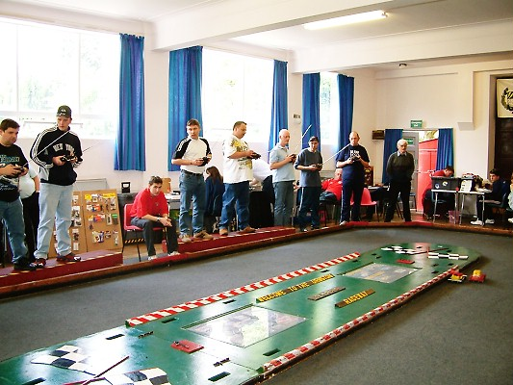
The eight that are going to be in the consolation race are,
Name Best three lap scores
1. Matthew Bennett 248
2. Karl Spencer 248
3. Gary McMullen 248
4. Mike Tomkinson 247
5. Mark Cooper 246
6. Jon Cutts 244
7. Gary Osbourne 243
8. Andrew Cox 242

We had a very fast and furious race with very few mistakes from the racers, though there were some deliberate spoiling tactics going on, but at the finish the top qualifier from the consolation had earned his right for a place in the final with a winning lap score of 82 laps, second place went to Mark Cooper with 81 then it was Mike Tomkinson on 80 as was Gary McMullen in fourth place, finishing in fifth place with 77 laps was Andrew tactic Cox, also finishing with 77 laps was Karl Spencer in sixth place, Gary Osbourne was seventh on 76 which leaves Jon Cutts in eighth place with 62.
Between the consolation and the final there was a junior grand national race, these racers are the future of our sport and I wish more of our promoters would take the time to organise races like these where the younger members can race with others of their own ability, and confidence is a wonderful thing if you can win at least one race. The racers taking part were Aron Eaglen, Scott Williamson, Ryan Cattell, Nicholas Cooper, Richard Gaffney, Chris Flynn, Daniel McMullen and Owen Ramsden, unfortunately Dean Ritchie did not take part.
At the finish experience prevailed as Ryan Cattell was a clear winner with 74, he was followed by Chris Flynn in second place with 65 laps and Nicholas Cooper with 64 laps completed the top three, young Daniel McMullen was just one lap behind Nicholas with 63.
The Final.
There were some top names in this line up of racers, but the top qualifier for the final and also taker of the extra point for the FTD score was :- Ben Harding
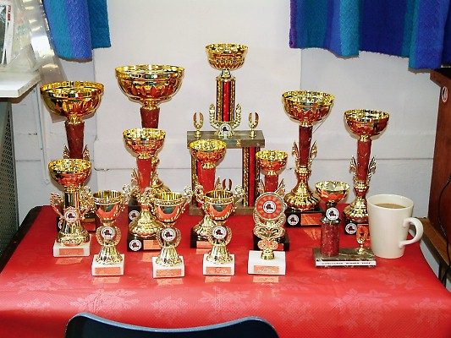
Name Best three lap scores
1. Ben Harding 263
2. Phil Smith 253
3. Clive Buckler 251
4. David Smith 251
5. Stewart Smith 250
6. Gareth Jones 250
7. Anthony Wyper 248
8. Matthew Bennett Consolation Winner

What a quality final between these racers, with three or four racer in with a chance of winning the race right up to the end, and when you consider the FTD score was 88 laps from the heats of racing, where there is not so much pressure to do so well and make no mistakes as in a high pressure final, at the finish we had a home winner and a deserved one at that in David Smith finishing with 88 laps, he was hard pressed all the way to the finish by Ben Harding and Phil Smith who both finished on 87 laps, separated by the computer on split times in that order fourth place went to Anthony Wyper on 85 laps also finishing with 85 laps in fifth place was Clive Buckler, consolation winner Matthew Bennett was the sixth best finisher with 82 laps, coming home in seventh place was Stewart Smith with 78, and the unlucky Gareth Jones had just 2 laps to his credit, as he had to retire right near the start of the race and was reduced to a spectator himself, but still collects a trophy for eight place in the final.
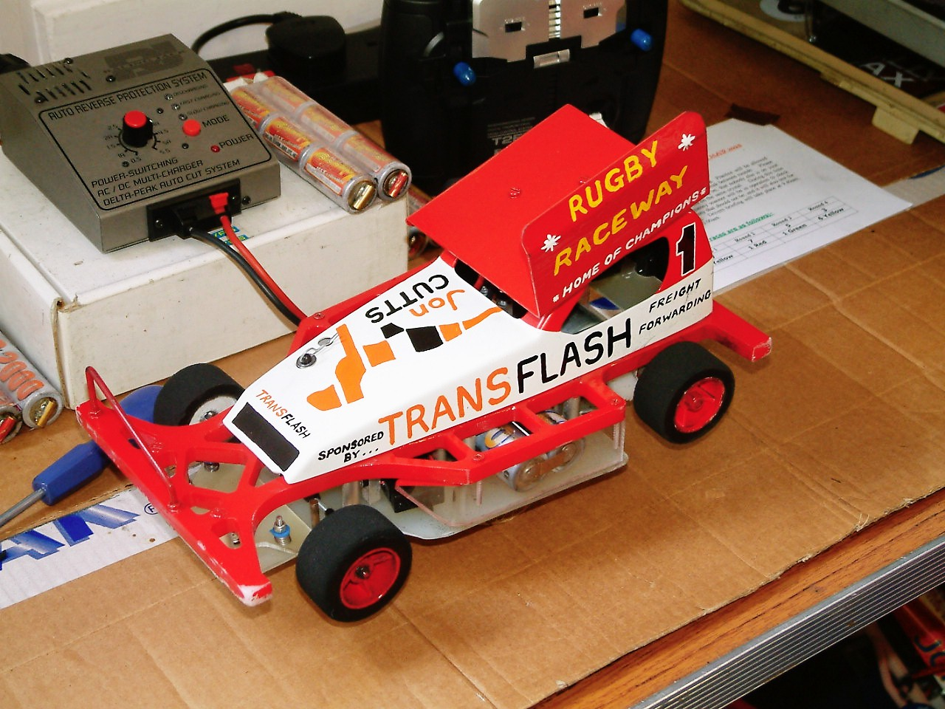
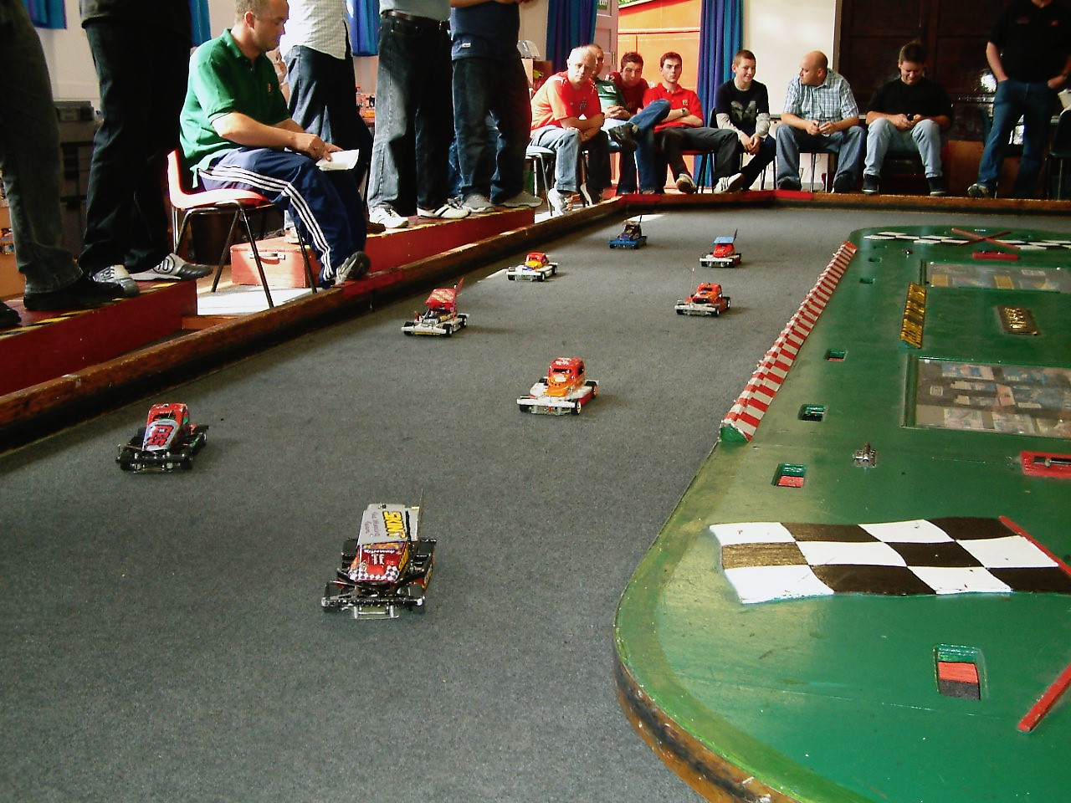
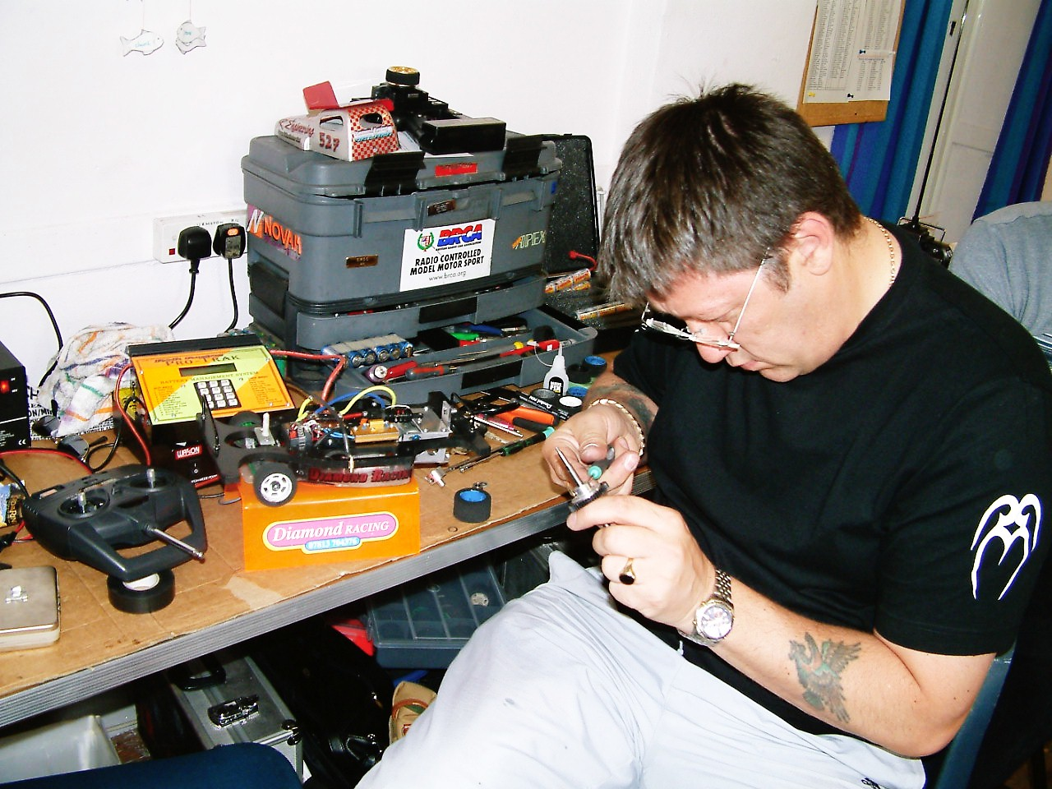

Tec chart of the finalist’s

Name | F/Tyre  In | F/Tyre  Out | R/Tyre  In | R/Tyre  Out | G/Ratio | Speedo  Type | Charger | Car  Type | Chassi | Cells | Club | Grade | Qualif | Final
Ben Harding | Jap Med | 812 | Pink | Pink | 12/50 | Mardave | Apex | Skint | And | Corally  2000 | Rugby | Silver | 1 | 2
Stewart Smith | SE | 812 | Pink | Pink | 12/50 | Mardave | Apex | Self  Build | Own | Corally  1700 | Urm | S/S | 6 | 7
Phil Smith | 05 | SE | Pink | Pink | 12/50 | Mardave | Apex | Bingo | Bingo | 2000 | Rugby | S/S | 2 | 3
David Smith | Pink | 812 | Pink | Pink | 12/50 | Mardave | Pro  Trak | Pinky | And | Corally  1700 | Urm | S/S | 4 | 1
Gareth Jones | SE | 812 | Pink | Pink | 12/51 | Mardave | Apex | Self  Build | And | 2000 | Urm | Red | 5 | 8
Clive Buckler | 05 | 812 | Pink | Pink | 12/50 | Mardave | Quasar | Kiwi | And | 2000 | Rugby | Red | 3 | 5
Anthony Wyper | Jap  Med | 812 | Pink | Pink | 12/50 | Mardave | Apex | Skint | And | 2000 | Urm | Blue | 7 | 4
Matthew Bennett | SE | 812 | Pink | Pink | 12/50 | Mardave | Apex | Lecatt  2 | Lecatt | 3300 | Rugby | Red | 8 | 6

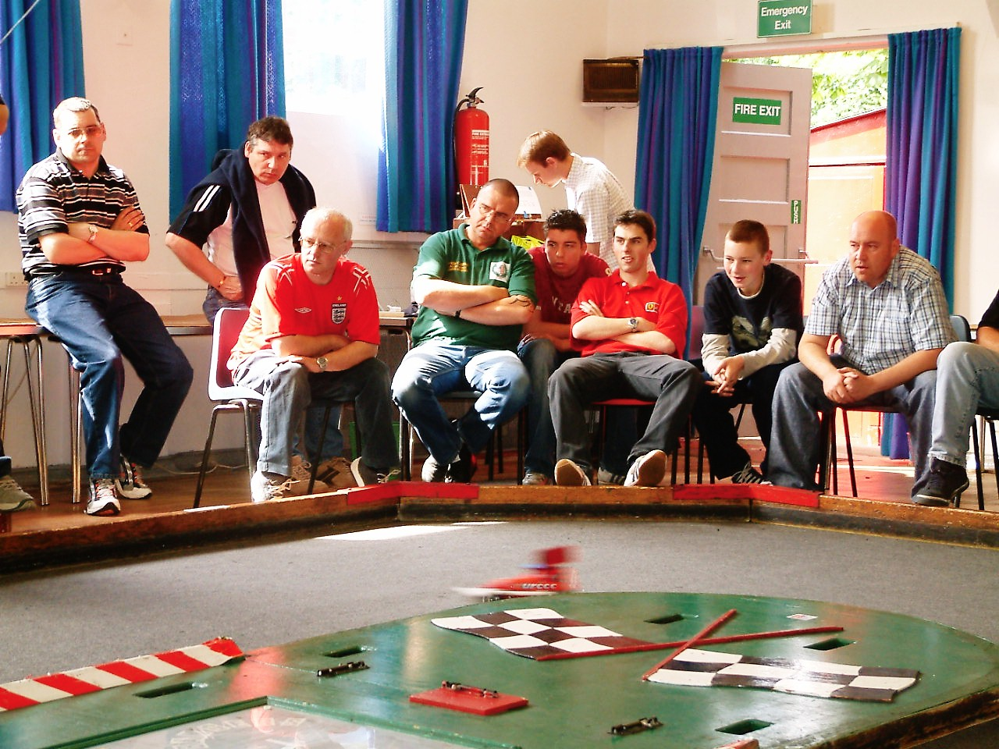
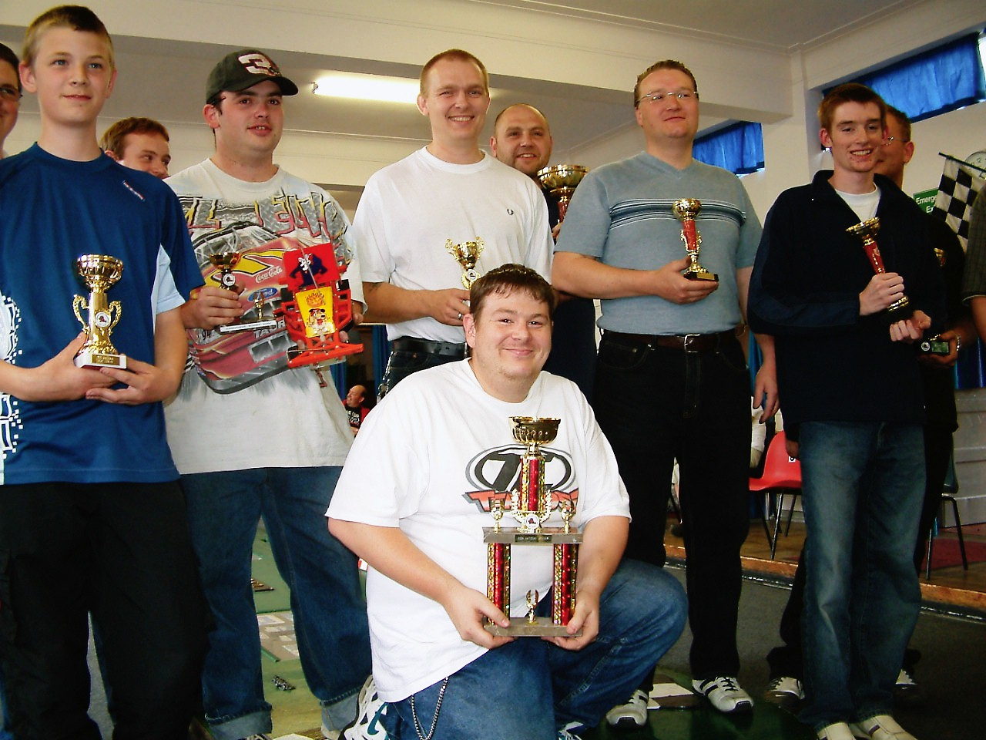

Awards went to best white grade – Chris Flynn, yellow grade – Damon Atkins, blue grade – Gary Osbourne,
Best junior – Tom Forest, concourse – Derek Cayzer, FTQ – Ben Harding 88 laps

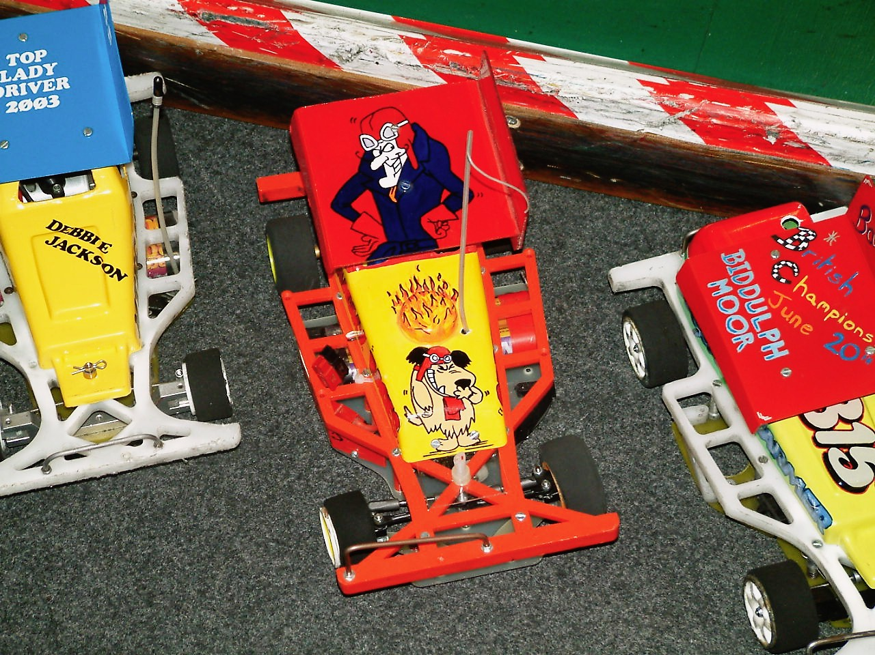
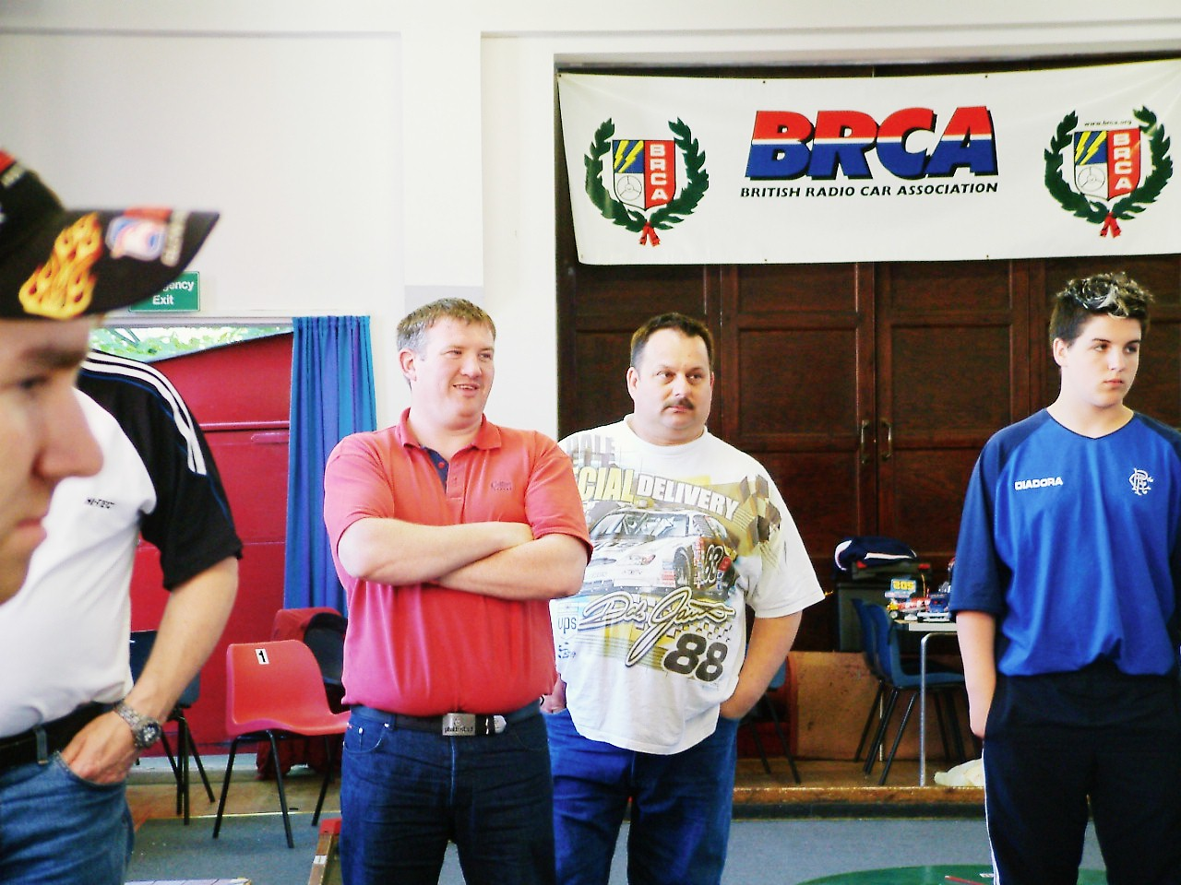

The top ten in the national series after four rounds now looks like this :-
- Ben Harding 389
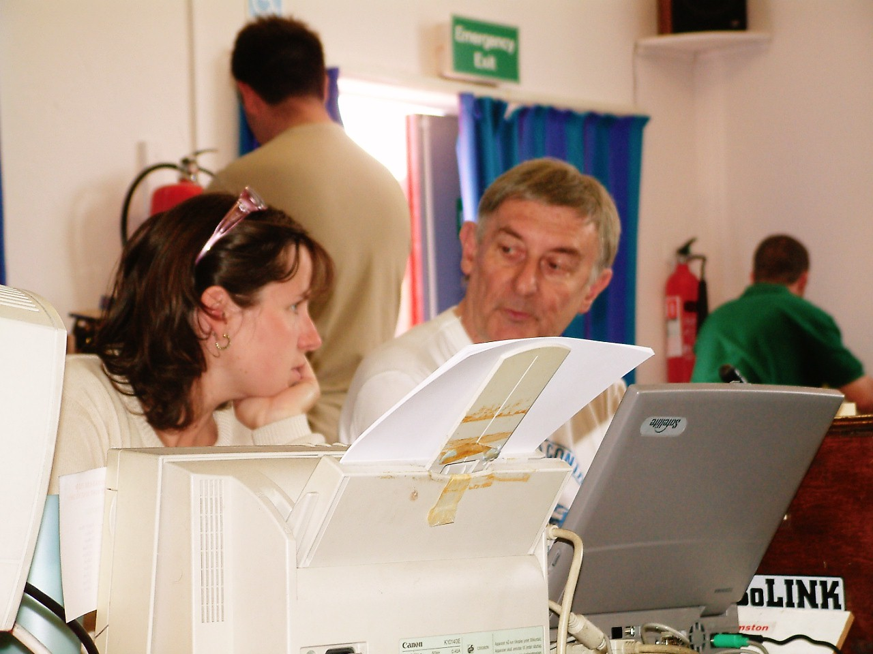
- Karl Spencer 374
- Gareth Jones 373
- Stewart Smith 371
- Mark Cooper 366
- Gary McMullen 365
- Mike Tomkinson 345
- Dave Gwilliam 341
- Andy Cox 318
- David Smith 276

