Stockcars Saloons
……………………………………
Bangers Hot Rods

The BRCA Oval championship chase moves north for round five of the Stockcars and round three for the Bangers, most of the travelling competitors have arrived in Scotland sometime during Friday evening, myself being one of these after a journey of some 380 miles, and some have chosen to fly into Edinburgh on the Saturday morning after racing at a club meeting on the Friday night at Rugby, once again we have a full weekend of racing to look forward to with the Banger national on the Saturday with a meeting for Hot-Rods and Saloons as the support formula, and on Sunday we have the Stockcar national along with the Bangers in D/D races along with the famous ramp on the track which makes thing just a little bit interesting. Numbers for the Bangers are slightly down on last years entrée of thirty three, down to twenty nine the same as the Hathern meeting, in the Stockcars we have a disappointing turn out of just twenty two racers, ten less than last years turn out of thirty three.

We start the report with the Bangers from the meeting on the Saturday, and the big news from the start of the meeting was that the racers that were due to arrive this morning had been delayed at the airport, so a few racers were going to be missing from the early rounds,
Heat one winner was Iain Roper with 57 laps a clear winner from Peter Bissett on 43 and Ivan Black with 34, Mark Cooper finished with 26 followed by Sam Strickland with 20 and Alan Stewart with 13, Andy Cattell, Graham Roger and Scott Roger were all non starters. Heat two went to Alastair Needham with 60 followed by Neil McCluskey with 48 and Nichola Jones on 44 and a low score of just 12 laps for Gary McMullen, Nicholas Cooper finished with 7 laps and James Thompson had 4 to his credit, all of these next racers had been delayed at the Airport Dave Gwilliam, Shane Moorcroft, Ben Harding and Karl Spencer. Heat three was the first full race of cars won by David Smith with 56 laps chased by Sandy Bissett with 51, finishing in third place we have Neil Sutherland with 39 followed by Stuart Preston with 36 and Craig Brown on 31 on a split time from Neil Ritchie who also finished with 31, Kevin Faulkner had 26 laps to his credit followed by Calum Sutherland with 12 and Dean Ritchie with 3.
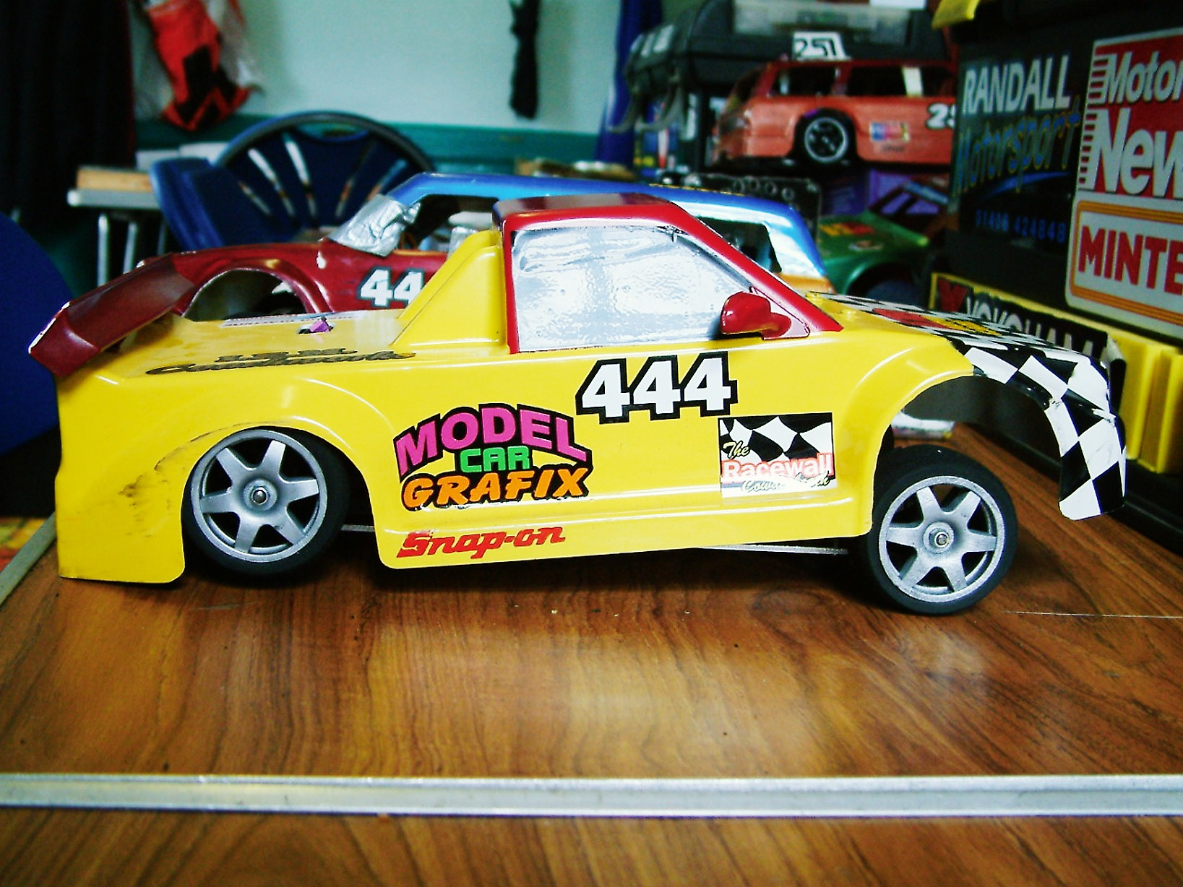
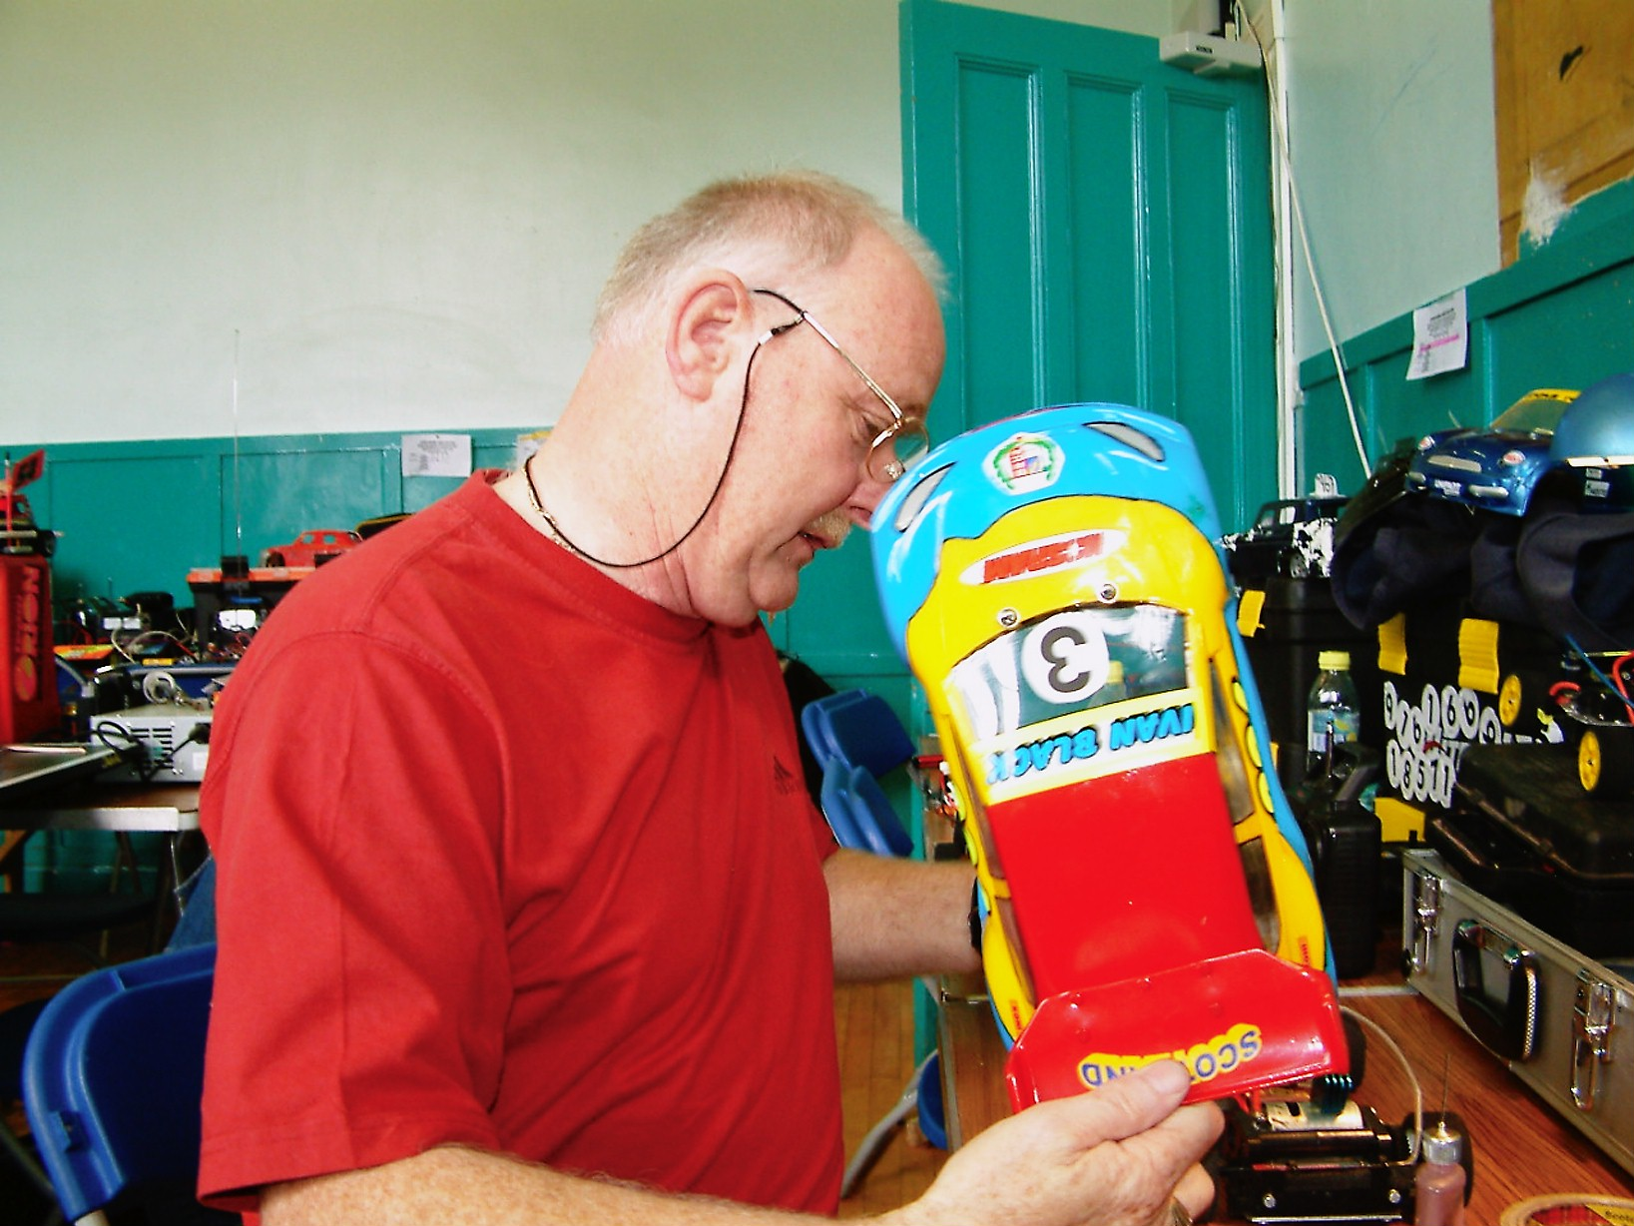
Round two and still we have some racers missing! Race one was won by Gary McMullen with 58 followed by Neil Sutherland with 44, both Craig Brown and Kevin Faulkner finished with 41 laps in that order, next across the line was Andy Cattell with 31 followed by Calum Sutherland on 28 and Nicholas Cooper with 23, Ben Harding, Shane Moorcroft and Dave Gwilliam did not start the race. Heat two was another race that started with a full line up of cars, the winner was David Smith with 57 laps chased by Mark Cooper with 51 and Stuart Preston with 42, then we find Dean Ritchie with 30 and Sam Strickland with 21 followed by Brian McKay on 17 laps and just one behind Brian was Neil Ritchie with 16 followed by James Thompson with 14 and Peter Bissett on 7 and Ivan Black recorded just one lap. Heat three was won with 60 laps by Iain Roper followed by Sandy Bissett with 57 and Nicola Jones with 49, Neil McCluskey finished with 20 followed by Alan Stewart on 16 and Scott Roger with 14 and Alastair Needham finished with just 6 laps, both Graham Roger and Karl Spencer were non starters.

Round three,
And we finally have all the competitors, which should make things interesting, in heat one Sandy Bissett recorded a race win with 49 laps chased by Dave Gwilliam with 46 and Neil Ritchie on 44, Shane Moorcroft was next across the line with 38 followed by Nicholas Cooper with 35 and Dean Ritchie with 24 laps, Andy Cattell recorded just 12 laps which was one in front of James Thompson followed by Scott Roger on 9 and Graham Roger with 3. Heat two was won by David Smith with 57 laps followed by Gary McMullen with 50 and Iain Roper with 46, also finishing on 46 was Ben Harding followed by Mark Cooper with 45 and Stuart Preston with 43, Alan Stewart finished with 39 as did Peter Bissett they were followed by Karl Spencer with 30 laps and Calum Sutherland with 22. Heat three saw Alastair Needham back to winning ways with 57 chased by Neil Sutherland with 55 and Neil McCluskey on 48 laps, also finishing with 48 was Craig Brown followed by Nichola Jones with 43 then we had a big gap back to the 14 laps by Ivan Black followed by Brian McKay with 12 and Kevin Falconer on 10 and Sam Strickland finished with 4 laps.
Round four,
Gary McMullen collects another win with 57 laps chased by Sandy Bissett with 54 and Iain Roper with 51, a rejuvenated Stuart Preston finished with 49 laps followed by James Thompson with 45 as was Neil Sutherland they were followed by Nichola Jones with 38 and Brian McKay with 28, and Andy Cattell completes his meeting with another low score of 5 laps.
Heat two was won by David Smith with 54 laps from Ben Harding with 45 who was just one lap in front of Alastair Needham on 44 followed by both Alan Stewart and Dave Gwilliam on 43, then it was Craig Brown with 41 and Neil Ritchie finished with 37 followed by Nicholas Cooper on 33 and Sam Strickland with 26 followed by Graham Roger with 21. Heat three winner was Mark Cooper with his winning score of 54 laps followed by Ivan Black with 44 and Karl Spencer on 43, Shane Moorcroft finished with 39 followed by Dean Ritchie with 29 and Peter Bissett on 21, Kevin Falconer finished with 17 laps followed by Neil McCluskey with 9 laps, both Scott Roger and Calum Sutherland were non starters.

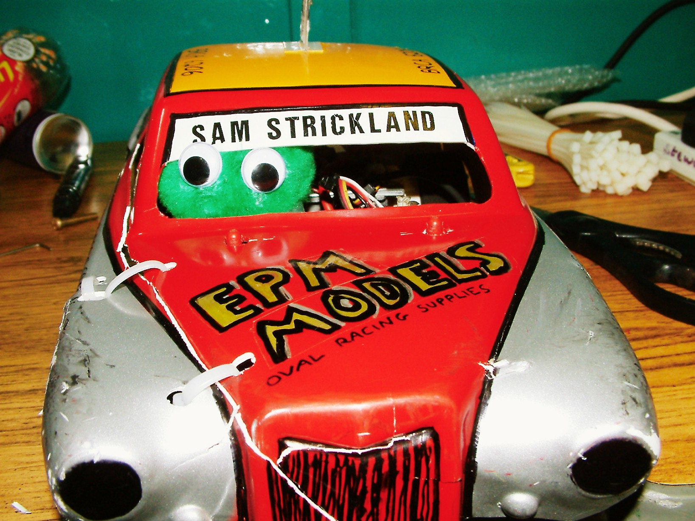

That brings us to the end of the heats of racing, and as is the norm with the Bangers it is the racers best three scores that count and only the top ten qualifiers go through to the final, the ten qualifiers were,
- David Smith
- Iain Roper
- Gary McMullen
- Sandy Bissett
- Alastair Needham
- Mark Cooper
- Neil Sutherland
- Nicola Jones
- Stuart Preston
- Craig Brown

Sometimes these finals resemble a non contact formula when you see the results, and in my opinion this one was more like a hot rod final as there was very little contact in what should be a full contact type of racing!
The winner was David Smith with 60 laps pursued right to the finish by Alastair Needham with 59, third place went to Gary McMullen with 58 followed by Mark Cooper with 57, home racer Iain Roper finished in fifth place with 52 laps on a split time after Sandy Bissett had also finished with 52 laps, seventh place went to Nicola Jones with 45 followed by Stuart Preston on 40 laps in eighth place and ninth place went to Neil Sutherland with 32 and Craig Brown was awarded tenth place as he did not start the final.
The final foray for the Bangers is the D/D event, with one point on offer to the last car on the track that is still on its wheels and is still moving in a forwards or reverse motion, and once again Gary McMullen was declared the winner, I wonder how many D/D events Gary has now won?
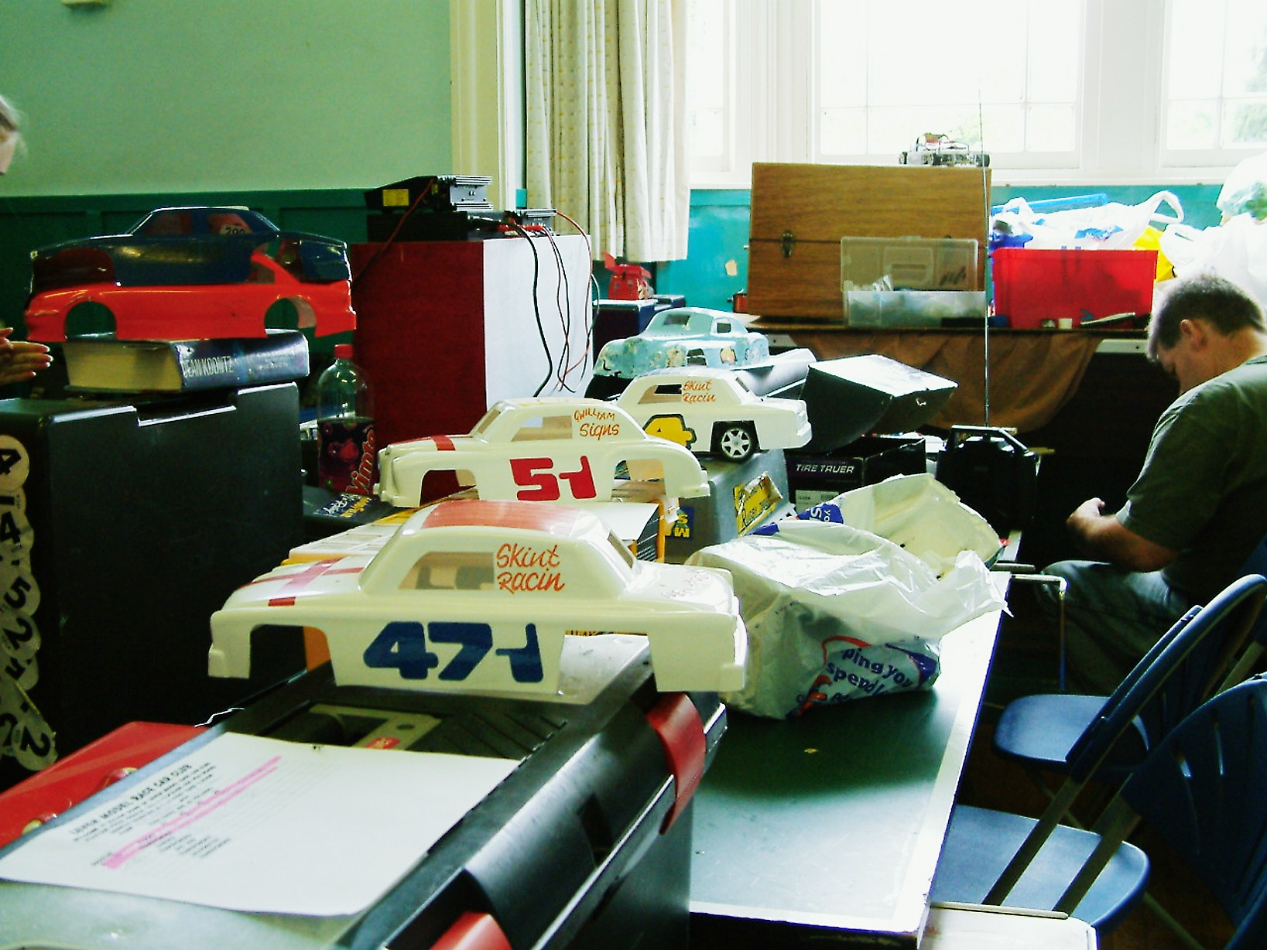
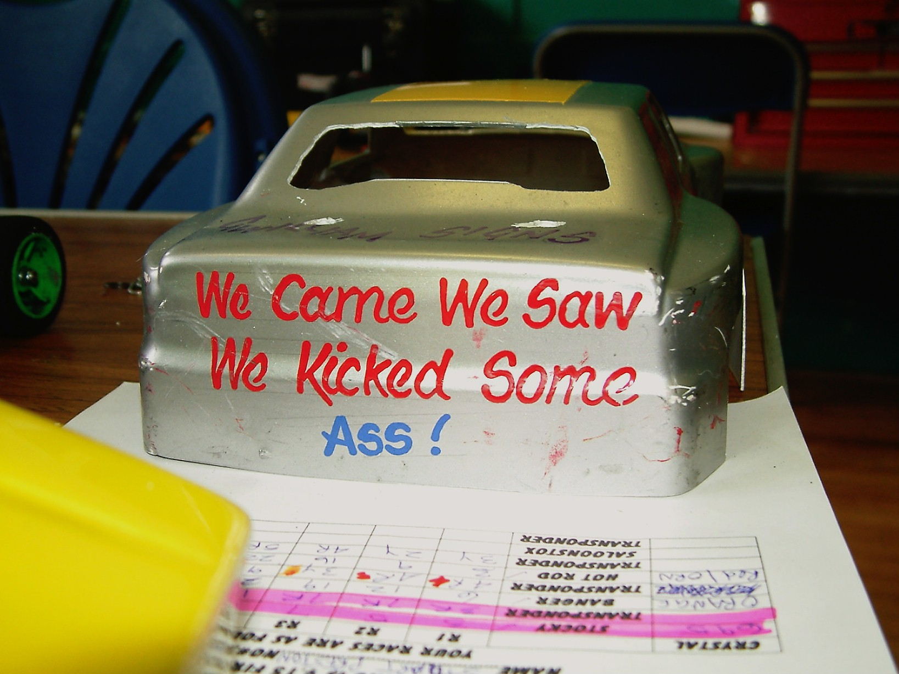
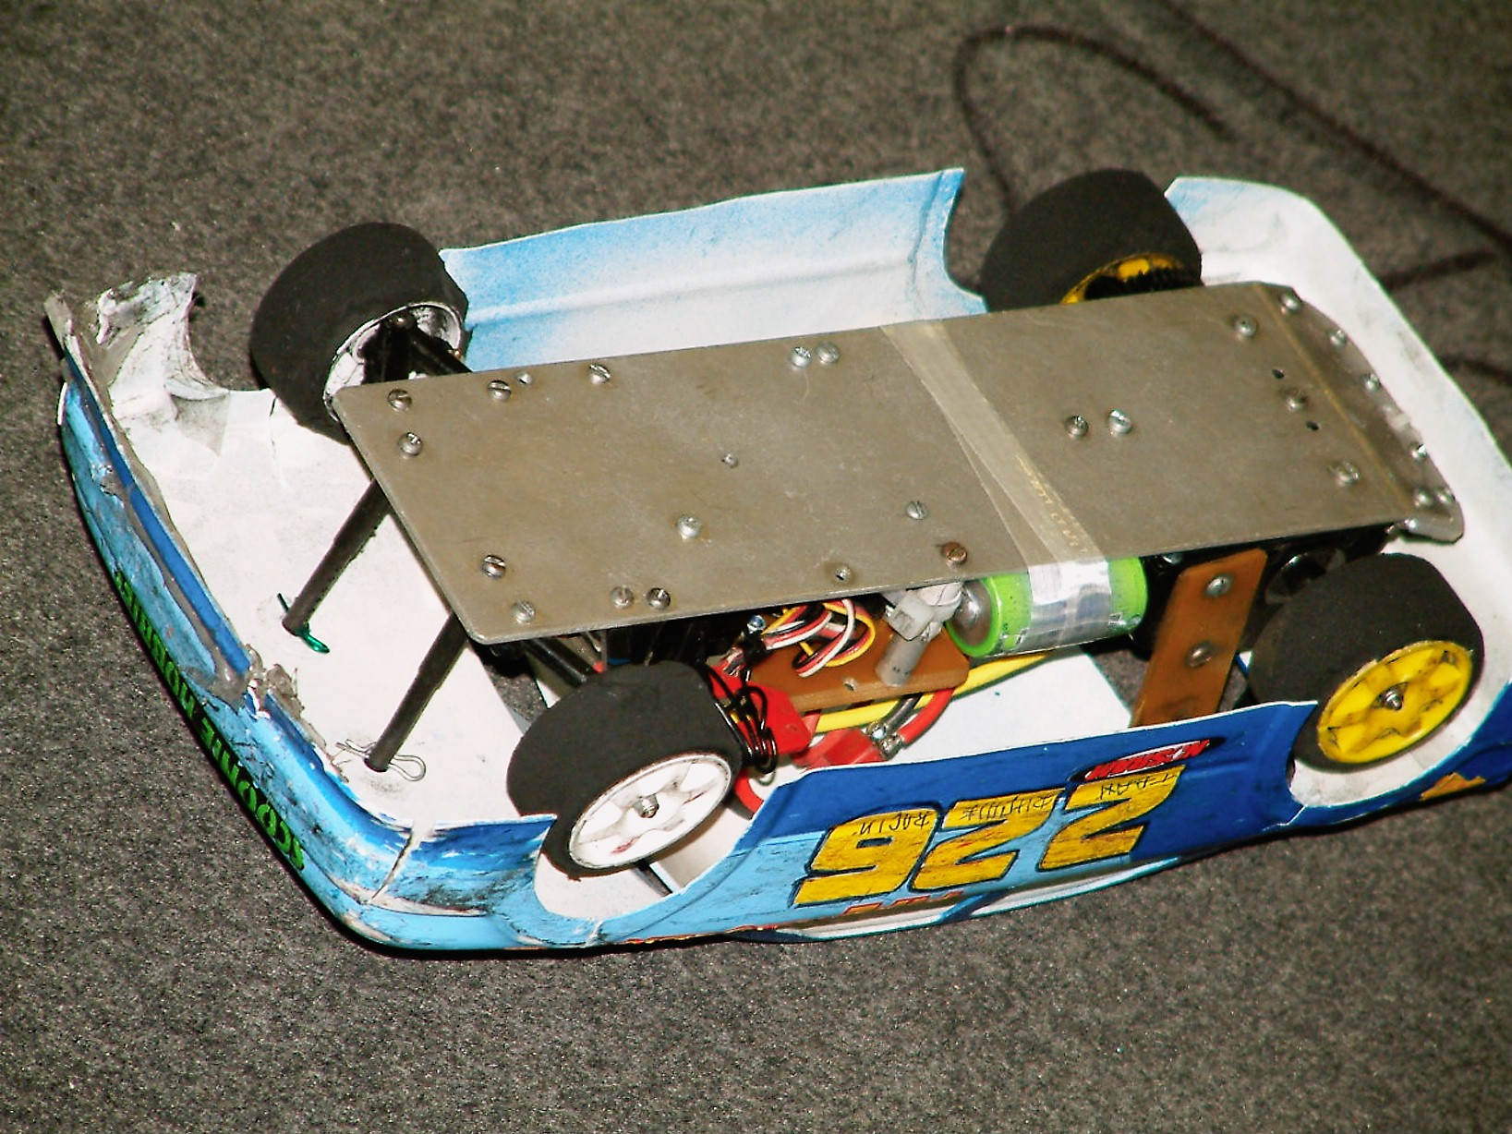

Stockcar National Sunday 4th July
We move on to the events from the stockcar national meeting,
Opening his account in heat one with a winning score of 70 was Mark Cooper he was chased by Andy Cattell in second place with 68 followed by Pete Ayriss on 67 and just one lap behind Pete came Iain Roper with 66, he was followed by Ryan Cattell with his score of 65 and then we had Dave Gwilliam with 63 followed by Scott Roger on 58 and Ivan Black finished the race with a score of 49. Heat two saw Karl Spencer taking the honours from Ben Harding with his 69 laps to Bens 67 they were followed by Andy Cox with 66 laps and Gary McMullen with 64, Paul Riddell came next with 62 closely followed by Shane Moorcroft on 61 and Daniel McMullen finished the heat with 52 laps to his credit. Heat three saw David Smith continuing from where he left off from the Banger national with a win, his winning heat score was 67 laps followed by Craig Brown on 60 and Neil Ritchie with 59, young Nicholas Cooper was next over the line with 47 followed by Stuart Preston on 43, finishing the heat in sixth place was Kevin Faulkner on 37 laps followed by Dean Ritchie with 25.

Round two.
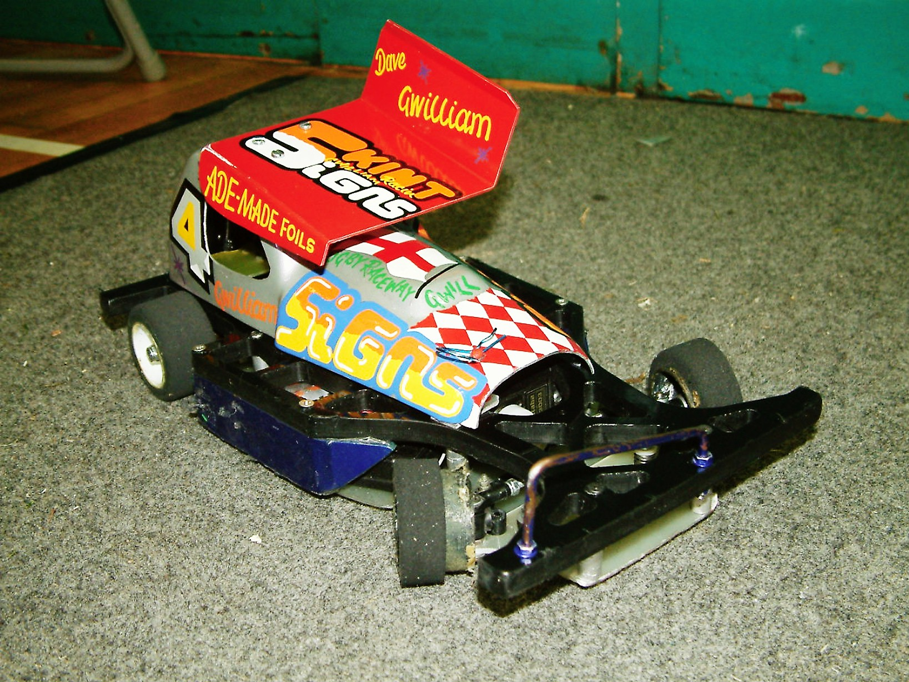
Andy Cattell claims one of his rare race wins in heat one with 69 laps, just in front of Pete Ayriss, who was just one lap behind Andy with his score 68 then it was Paul Riddell with 65 followed by Iain Roper with 63 and Scott Roger finished the race with 59 followed by Andy Cox on 45 laps, Ben Harding was a non starter in this heat. Heat two saw Karl Spencer taking his second race win with a winning lap score of 68 he was chased by Ryan Cattell with 66 and Dave Gwilliam on 62, then just one behind Dave came Stuart Preston with 61, Ivan Black improved from round one to claim fifth place with 59 laps an improvement of some ten laps! the next racer to finish was Neil Ritchie with 54 laps followed by Nicholas Cooper on 35 and Dean Ritchie with 14 laps to his credit. Heat three saw another racer claiming his second race win this time it was Mark Cooper with 67 laps, he was followed by a train of racers all finishing with 64 laps separated by split times in their finishing order it was Craig Brown in second place followed by Gary McMullen and Shane Moorcroft, at the finish there was less than three seconds separating these three racers, fifth place was claimed by Daniel McMullen with 57 he was followed by David Smith with 54 and Kevin Falconer on 19.

Round three.
Heat one winner was Andy Cox from the Urmston club with 67 laps on a split time from Dave Gwilliam his winning margin was just 1.17 seconds, Pete Ayriss was next across the line with 65 followed by Stuart Preston on 63 and Craig Brown with 59, Nicholas Cooper was not far behind these with his lap score of 58, Paul Riddell finished the heat with 41 laps followed by Ryan Cattell having a bad race with just 28 laps to his credit. Heat two was a very good win and a surprise one at that for Shane Moorcroft with 65, he was followed by the previously unbeaten Karl Spencer just one lap behind on 64, the third finisher in this heat was young Daniel McMullen with 59 laps ( finally free of his dads hindrance ) he was followed by Iain Roper on 56 and Neil Ritchie with 55, next to finish was Mark Cooper, another racer who had won his previous two races but was not in contention this time out with his lap score of 52 which was only good enough for sixth place in this heat, Mark was followed by Kevin Faulkner with 51 and Scott Roger on 47. Heat three was won with the FTD race score of 74 laps by Ben Harding he was followed all the way by David Smith with 72 laps and Gary McMullen was just one lap behind David with 71 and just one lap behind Gary came Andy Cattell with 70, finishing the heat in fifth place with 62 laps was Ivan Black followed by Dean Ritchie with 50 laps.

Round four.
Heat one victor was Ben Harding with 69 laps followed by Dave Gwilliam with 66, next to finish was Pete Ayriss on 63 as was Andy Cox and how close it was between the two of them just 0.02 of a second separated them at the finish, they were followed by Ivan Black with 59 and Iain Roper on 57 followed by Dean Ritchie with 54. Heat two was won by David Smith with 69 laps from Paul Riddell on 66 and Shane Moorcroft with 63, then it was Stuart Preston in fourth place with 59 laps followed by Andy Cattell with 58 and young Nicholas Cooper with 56, Scott Roger closed his account with 49 and Daniel McMullen finished with 34. Heat three was an interesting result, the win went to Gary McMullen with 71 laps in a split time of 2.54, second was Karl Spencer who finished with 71 also, but in a split time of 2.75 just 0.21 behind, but when you look at the average lap times they were identical at 4.26 seconds, and just for comparison the average lap time of the FTD score set by Ben Harding was 4.08, Mark Cooper finished the race with 68 laps followed by Ryan Cattell on 67 and Craig Brown with 64 then we had a gap in lap scores back to Neil Ritchie with 25 and Kevin Faulkner on 21.

The end of the heats meant it was time for the consolation race for the eight racers that were unlucky not to have made the final, heading the list of qualifiers was Dave Gwilliam and Ryan Cattell followed by the third place qualifier Andy Cox, fourth on the grid for the consolation was Paul Riddell followed by Shane Moorcroft in fifth place on the grid with Craig Brown lining up next to him as the sixth qualifier, seventh was Iain Roper and the final place was taken by Stuart Preston.

And what a race it turned out to be, the lead changed a number of times during the race and going into the final lap of the race Ryan Cattell thought he had done enough to take the win, but had not realised that Dave Gwilliam was in close attention, and made the mistake of tangling with Andy Cox which let Dave sneak by and take the win by a narrow margin of 1.05 seconds after they had both finished with 68 laps, as it turned out Andy Cox was already trailing by a couple of laps before Ryan’s mistake and he finished in third place with 66, fourth across the finish line was Shane Moorcroft with 65 followed by Paul Riddell with 62 and just one lap behind Paul was Iain Roper with 61 and a further lap behind Iain was Stuart Preston with his lap score of 60 which just leaves the unfortunate Craig Brown who had retired from the race after completing just 5 laps.

The Final
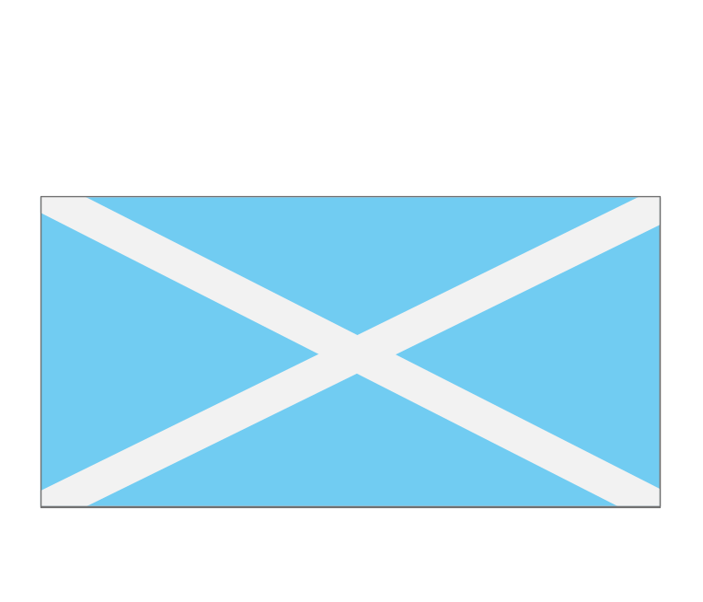
Heading the list of qualifiers for the final and the FTD holder was Ben Harding, second on the grid was David Smith and third place was occupied by Karl Spencer followed by Andy Cattell in fourth place on the grid, starting off the third row of the grid we have Gary McMullen in fifth place with Mark Cooper alongside as the sixth qualifier for the final, and the seventh and last of the automatic qualifiers was Pete Ayriss, and we already know that Dave Gwilliam is the eighth qualifier from the consolation race.
This was a very fast and clean final, with two racers breaking clear of the rest and the result could have gone to either of them, but under immense pressure Ben Harding held his nerve to take the win from David Smith by a narrow margin of just 1.79 seconds after both racers had finished the race with 71 laps, third place went to Karl Spencer with 69 and Mark Cooper was just one lap behind Karl to take fourth place with 68 laps, fifth place went to the consolation winner Dave Gwilliam on 66 laps and this was with a split time after Gary McMullen had also finished with 66 laps but he was 2.27 seconds behind Dave, seventh place went to Andy Cattell with 64 laps and Pete Ayriss had retired from the final when he had achieved 49 laps.

Name | F/Tyre  In | F/Tyre  Out | R/Tyre  In | R/Tyre  Out | Gear  Ratio | Speedo | Charger | Car  Type | Chassi | Cells | Club | Grade | Qualif | Final  Place
Ben  Harding | Jap  Med | 812 | UFRA  Pink | UFRA  Pink | 12/50 | Mardave  MK 1 | Apex | Skint | Anderton | Corally  2000 | Rugby | Silver | 1 | 1
David  Smith | UFRA  Pink | UFRA  Pink | UFRA  Pink | UFRA  Pink | 12/50 | 2 speed | Pro  Trak | Pink | Anderton | Corally  1700 | Urmston | Red | 2 | 2
Karl  Spencer | UFRA  Pink | Yellow | UFRA  Pink | UFRA  Pink | 12/51 | 2 speed | Apex | Elite | Anderton | 2000 | Rugby | Red | 3 | 3
Andy  Cattell | UFRA  Pink | 812 | UFRA  SE | UFRA  Pink | 12/49 | 2 speed | Apex | Lecatt  2 | Lecatt | Corally  1700 | Stoney  Stanton | Red | 4 | 7
Gary  McMullen | Double  Blue | Jap  Med | UFRA  SE | UFRA  Pink | 12/49 | 2 speed | Pro  Trak | Pink | Anderton | Corally  2400 | Urmston | World & Euro | 5 | 6
Mark  Cooper | UFRA  SE | 812 | UFRA  SE | UFRA  Pink | 13/50 | 2 speed | Pro  Trak | Lecatt  2 | Anderton | Protrak  3300 | Stoney  Stanton | Red | 6 | 4
Pete  Ayriss | UFRA  SE | 812 | UFRA  SE | UFRA  Pink | 12/50 | Associ-  ated | Pro  Trak | Pink | Anderton | Corally  2400 | Urmston | Red | 7 | 8
Dave  Gwilliam | Jap  Med | 812 | UFRA  SE | UFRA  SE | 12/50 | Mardave  MK 1 | Apex | Skint | Anderton | Corally  1700 | Rugby | Red | 8 | 5
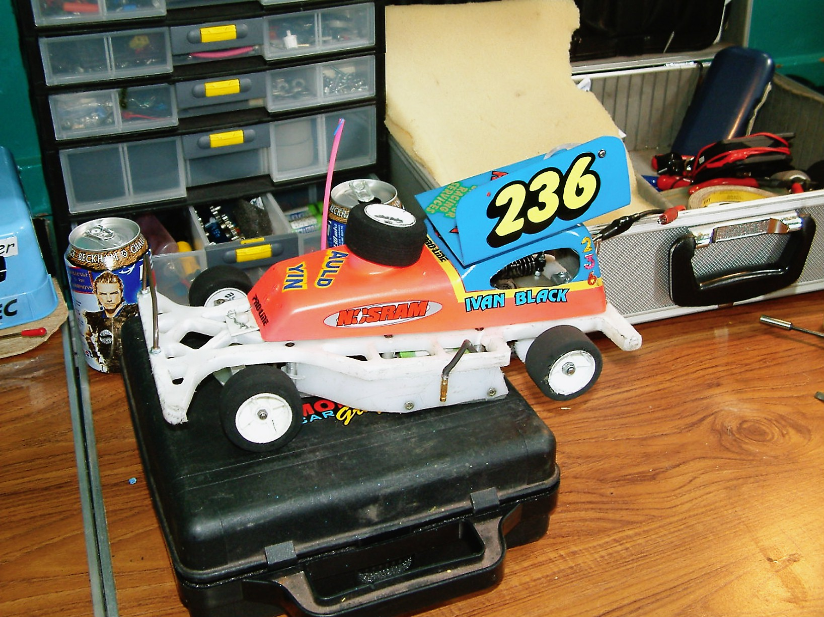
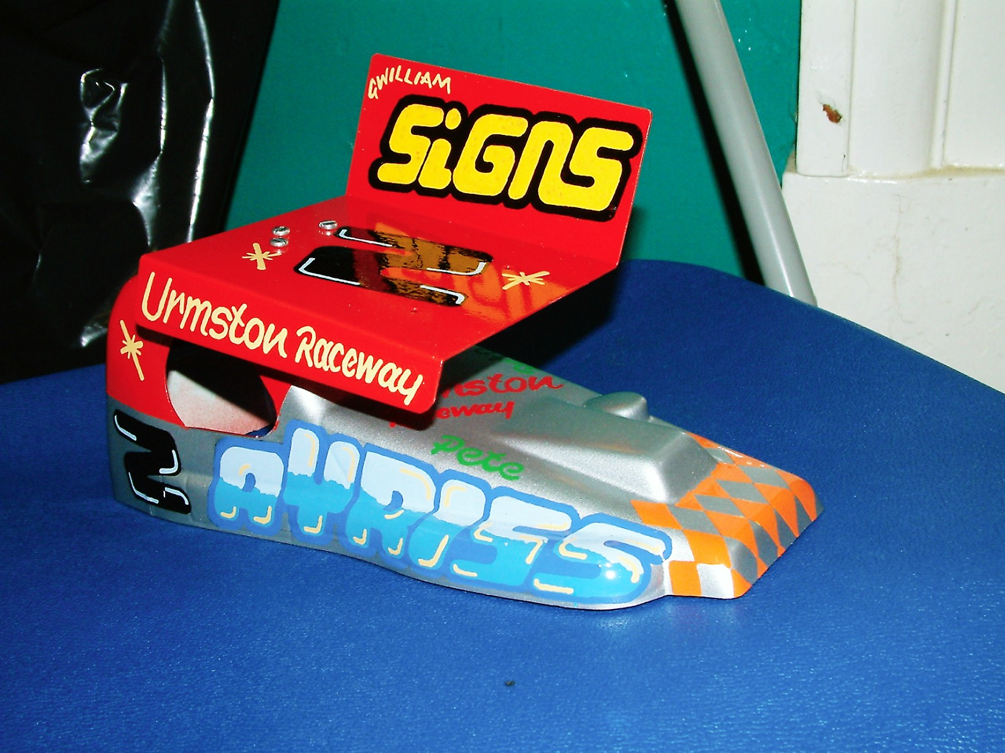

Backtracking to the Saturday there were also Hot-rods and Saloon races during the day, here are the best of the results from them starting with the Hot-Rods, Round 1,
Heat one for the Hot-Rods was won by Alan Stewart with 67 laps from Andy Cattell with 62 followed by Ryan Cattell on 61.
Heat two went to Peter Bissett with 66 from Ivan Black on 62 and Derek Murray in third on 61.
Heat three was won with 67 laps by Neil Ritchie followed by Dean Ritchie on 65 and Craig Brown with 62.
Round 2,
Heat one winner was Derek Kerr with 68 followed by Ivan Black with 64 and James Thompson with 60.
Heat two saw Alan Stewart take the win with 68 from Ryan Cattell on 64 followed by both Dean Ritchie and Peter Bissett with 62 laps.
Heat three was won by the Leven club promoter Neil Ritchie with 65 from the 63 laps by Scott Roger and 61 by Andy Cattell.

Round three,
Heat one winner was Ivan Black with 68 laps, he was chased to the finish line by Neil Ritchie with 66 followed by Peter Bissett with 64.
Heat two was a close race between Dean Ritchie and Ryan Cattell, just 2.55 seconds separated them at the finish after both racers had finished with 64 laps, and third place went to James Thomson with 57.
Heat three saw another close finish this time it was between Derek Kerr and Alan Stewart, both had 69 laps separated by just 1.09 seconds in favour of Derek, third place went to Craig Brown with 64.
Round four,
Heat one was won by a different racer and I believe this was his first win in the Hot-Rod class for Ryan Cattell with a winning score of 64 from Ivan Black on 63 and the 54 of Paul Riddell.
Heat two was a very close race, at the finish Scott Roper won with 68 laps on a split time after Derek Kerr had also recorded 68 but in a slower time by just 1.67 seconds.
Heat three went to Dean Ritchie with 67 laps from Peter Bissett on 65 laps as was Derek Murray but he was behind Peter by 4.03 seconds which is nearly one whole lap.
Hot-Rod Final
The six racers that were to contest the final in order of qualification were Derek Kerr, Alan Stewart, Neil; Ritchie, Dean Ritchie, Peter Bissett and Ivan Black.
This race was for the purist’s, for a cleaner and more sporting race you will have to go a long way to find one to equal this, at the finish the winner was Alan Stewart with 70 laps from Derek Kerr who also finished with 70 laps and was just 1.31 seconds behind, the story of the race was Derek had the faster car but was not getting the run in the final and in trying to pass Alan cleanly kept clipping the corners or he tried to pass the long way round and paid the price for it, there were no complaints at the finish which was great to see, third place went to Neil Ritchie with 69 followed by Ivan Black with 68 laps in fourth, fifth place went to Dean Ritchie with 65 and just one lap behind in sixth place was Peter Bissett with 64.
Saloons
There were just nine saloons, all cars were in one heat, so here are the results for them,
Heat one was won with 59 lap by Neil Ritchie from Neil Sutherland with 58 and Craig Brown on 57 followed by Kevin Falconer with 55 which was the same as Iain Roper, Scott Roger was just one lap further back on 54 followed by Peter Bissett with 48 and Ivan Black with 24, Derek Murray was a non starter. The fasted lap recorded during the race was by Craig Brown in a time of 4.13 seconds.
Heat two was won by Iain Roper with 60 laps from Neil Sutherland on 59 laps, also on 59 laps was Craig Brown followed by Scott Roger with 56 as was Kevin Falconer with Neil Ritchie some three laps behind these two on 53, he was clearly in front of Peter Bissett with 15 and Derek Murray with just 6 laps, Ivan Black was a non starter in this race. The fastest lap went to Neil Sutherland with 4.13 seconds the same as the previous best from the first round.
Heat three saw another different winner this time it was Kevin Falconer leading the way with 65 laps chased by Peter Bissett with 61 and Neil Sutherland on 60, fourth place went to Scott Roger with 59 followed by the 58 of Craig Brown, next to finish was Iain Roper with 53 laps followed by Derek Murray with 36, Neil Ritchie did not record any laps in this race. The fastest recorded lap went to Craig Brown with a time of 4.05 second.
Heat four and it was Kevin Falconer taking his second win in this class of racing with 64 laps from Neil Sutherland on 61 and Neil Ritchie with 60, fourth place went to Craig Brown with 58 laps followed by the 57 of Peter Bissett and the 56 of Scott Roger also on the 56 lap mark was Iain Roper followed by Derek Murray with 30, Ivan Black was a non starter. The fastest lap went to Craig Brown with a lap in 4.02 seconds.
The Saloon Final
We had two racers who did not start the final they were Craig Brown and Ivan Black, so this left seven racers to contest the final, at the finish Kevin Falconer won with 63 laps from Neil Sutherland who was just one lap behind Kevin with 62, third place was taken by Iain Roper with 60 followed by Neil Ritchie in fourth place with 57, fifth place went to Scott Roger with his score of 56 followed by Derek Murray with 53 laps in sixth place which just leaves us with Peter Bissett in seventh with 22 laps. The fastest lap of the final went to Kevin Falconer in a time of 4.07 seconds.

Thank you to all who took part in the weekend of racing, and to all of the winners, but the biggest thank-you goes to all of the Leven club members who helped to make the weekend a success.

Report by Mark Cooper.

