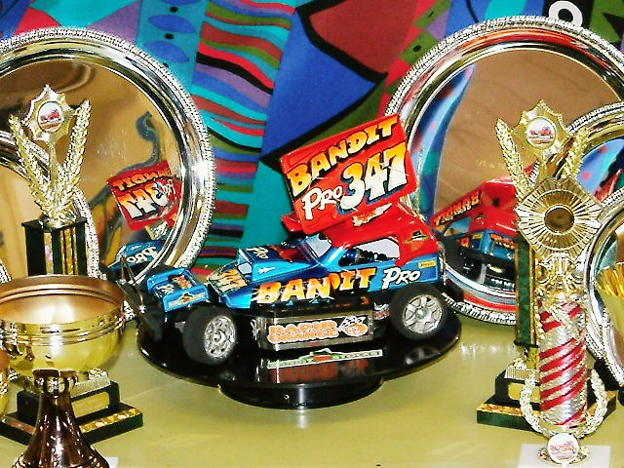

Date: Sunday February 15th Venue: Hathern Community Centre, Pasture Lane
Welcome to the first national meeting of the new season, the national series will be contested over seven different rounds this year (that’s for the stockcars) we have a very good turn out for the meeting today lets hope this continues throughout the year, the meeting in 2004 attracted 41 Stockcars and 16 Bangers, today we have a healthy 48 for the stockcars although 51 had booked in to race, and for the Bangers we have 29, thirteen more than the previous year. The defending national points champions are Ben Harding (stockcars) and Jason Bartropp (bangers) unfortunately Jason will not be with us today as he is currently away on holiday.
There has been a lot of activity on the club scene over the winter months with some new clubs opening their doors for the first time, we have Thames Valley Stock Car Club which opened their doors for their first meeting on the 21st January, this club is based just up the road from the High Wycombe club and is run by Roy Calver, we also have a new club based in Preston, they ran their first meeting on the 9th February, our own Gary McMullen is involved with this new club, then down on the south coast we have a club starting up in Hastings, their first meeting is scheduled for 20th February we wish them all well in their new ventures. As I reported this time last year in the meeting report of the 2003 Hathern national, about another new club called March, we can now welcome them to the national scene, late last year they ran a successful open meeting which was won by Ben Harding and this year they are to hold their first national meeting. Let me wish all the competitors the best of luck for the forthcoming years racing.
Just before the racing commenced a one minuet silence was held in memory of Ian Kiteley who was tragically killed on the 23rd Febuary last year, after competing in the Hathern national.
Results from the Stockcars
Round 1, Stockcars heat 1. The first win of the days racing went to Urmston racer David Smith with 85 laps followed by fellow Urmston racer Gareth Jones on 84 and Jason Reed on 76. Heat 2 saw Hathern club member Paul Culverwell taking the win, again it was with 85 laps as in heat one he was chased by Jody Foster on 84 and then we had Doug Giles finishing in third place with 76 laps with Gary Osbourne in close attendance on 75. Heat 3 and another Hathern racer takes a win this time its Phil Chadbourne with 86 from Stephen Farmer with 85 followed by Mike Tomkinson on 84 and Pete Ayriss with 83. Heat 4 went to another Hathern racer, and once again it is with 86 laps by Steven Farrer, finishing in second place with 83 was Dave Gwilliam followed by Urmston racer Karl Baker on 81. Heat 5 was won by a flying Mark Cooper with the best lap score so far of 89 followed by Alan Bellis and Roy Calver both on 84 and not far behind these two was Jon Cutts with 82. Heat 6 went to Rugby racer Karl Spencer with 86 laps with Andy Cattell some way behind him with 78 laps followed by Aron Eaglen on 76. Heat 7 was won by the current world champion Gary McMullen with 87 followed by Stewart Smith with 86 and Hathern racer Jonathan Goodacre on 81. The last heat of the round was won by Ian Johnson equalling the previous best lap score set by Mark Cooper of 89, he was followed by Ryan Cattell and Derek Cayzer both finishing on 80 laps.

Round 2. Heat 1 went to a very pleased Mike Tomkinson with a winning score of 88 he was chased to the finish line by Jody Foster with 87 and Chris Blount on 80. Heat 2 was an incredible race between five of the racers that were in it, at the finish three racers finished on 85 laps separated by split times the win went to Pete Ayriss by 0.06 he was closely followed by David Smith over the finish line who was then followed by Phil Chadbourne just 0.17 behind David, then we had Alan Bellis just one lap behind these three followed by Andrew Cox with 82. Heat 3 was won with 86 laps by Gareth Jones from the 84 of Mark Cooper and the 83 by Jon Cutts. Heat 4 was won by the flying Stephen Farmer with 90 laps followed by Paul Culverwell on 82. Heat 5 went to surprise winner Gary Osbourne with 81 beating Gary McMullen into the process after Gary had finished with 80 as had the current national points champion Ben Harding in third place. Heat six was won by Steven Farrer with 82 followed by young Aron Eaglen with 80 and Derek Cayzer and Dave Gwilliam both on 78. Heat 7 went to Karl Spencer collecting win number two with 90 chased by Ryan Cattell on 84 and the Urmston promoter himself Alan Crossland with 78. Heat 8 was won in fine style by Stewart Smith with 92 which sets the FTQ so far finishing in second place we had Ian Johnson with 87 followed by last years Hathern national winner Andy Cattell with 85.
Looking at the scores at this stage of the meeting tells me that it is going to be tight on qualification, so to show that here are the top qualifiers at this stage of the meeting:
- Stewart Smith 178 2. Ian Johnson 176 3. Karl Spencer 176 4. Stephen Farmer 172 5. Mark Cooper 173 6. Mike Tomkinson 172 7. Jody Foster 171 8. Phil Chadbourne 171 9. Gareth Jones 170 10. David Smith 170
It’s sure going to be tight as only the top seven racers gain automatic qualification into the final.
Round 3. Heat 1 Gareth Jones secures the win with 89 laps he was chased by Gary Osbourne and Paul Culverwell both on 84 laps. Heat 2 saw Mark Cooper back to winning ways with 91 laps to his credit, he was followed by Phil Chadbourne with 87 and both Pete Ayriss and Carl Baker on 84 laps. Heat 3 and it was Karl Spencer collecting win number three with 85 followed by Stewart Smith on 82 also on 82 laps was Jody Foster in third place. Heat 4 was won by Pete Clarke from the Rugby Club with 78 laps he beat his stable mate Jon Cutts into the process too as Jon finished with 77 followed by Derek Cayzer with 76. Heat 5 and this looked like a man on a mission as Ben Harding finally slipped into top gear winning this heat with 90 laps he was chased by Stephen Farmer on 84 and Steven Farrer with 82. Heat 6 went to another racer finally tasting success this time it was Andy Cattell enjoying the spoils of a race win with 87 laps followed by Roy Calver on 82 and Hathern racer Doug Giles on 80. Heat 7 went the way of the current world champion Gary McMullen with 86 laps closely followed by Mike Tomkinson with 85 and Ryan Cattell with 80. Heat 8 was win number two for Ian Johnson with 88 laps followed by Dave Gwilliam on 82 and both Andrew Cox and Aron Eaglen with 78 laps each.
All change on the current list of qualifiers, after the three rounds the leader board now looks like this:
- Mark Cooper 264. 2. Ian Johnson 264. 3. Karl Spencer 261. 4. Stewart Smith 260. 5. Stephen Farmer 259.
6. Gareth Jones 259. 7. Phil Chadbourne 258. 8. Mike Tomkinson 257. 9. Gary McMullen 253. 10. Jody Foster 253. 11. Pete Ayriss 252. 12. Paul Culverwell 251. 13. Andy Cattell 250. 14. Steven Farrer 250. 15. David Smith 246.
The fourth and final round of qualifying and as you can see from the list it is going to mean heartbreak for some of the racers, who was going to move up and in to the top seven and who was going to move down, or I could be wrong and there could be no change, ok enough of my ramblings on lets see what did happen.
The fourth and final round heat 1 victor was Gareth Jones with 92 which equalled the previous best lap score set by Stewart Smith, he was chased by Gary Osbourne on 86 followed by Carl Baker with 82 and Pete Ayriss on 81. Heat 2 went to Jon Cutts who was claiming his first race win of the day with 85 from Phil Chadbourne with 84 and Pete Clarke on 83. Heat 3 was win number three for Mark Cooper with 88 laps followed by Mike Tomkinson with 84 and Andrew Cox with 82. Heat 4 and another racer records an 92 this time it was the Hathern club promoter himself Ian Johnson, chasing him to the finish line was Stephen Farmer with 89 and Paul Culverwell on 81. Heat 5 was won by Stewart Smith with 86 he was followed by Andy Cattell on 79 and Damon Atkins with 70 laps as was young Daniel McMullen. Heat 6 victor was Ben Harding with 87 from Ryan Cattell on 84 and Alan Bellis with 82. Heat 7 saw another racer collecting his first win, this time out it was Dave Gwilliam with a winning lap score of 87 he was chased to the finish line by David Smith with 84 and Roy Calver with 81. Heat 8. Karl Spencer is the only racer to go unbeaten in the heats after he collects win number four with 89 laps he was followed by Steven Farrer with 86 and by Gary McMullem on 83.

By know you will have a good idea of the racers that have qualified for the consolation or the final, but the big question is who goes into what, and who will force their way into the pecking order at the last chance, we will start with the consolation race first, and just squeezing into the race we had Pete Ayriss with a total of 252 as did Dave Gwilliam, Pete had the lower throwaway score so takes the eighth qualifying place and Dave was the seventh qualifier, which meant that Andy Cattell (last years final winner) along with Gary Osbourne and Paul Culverwell had all missed the cut by just one lap and Jon Cutts and Alan Bellis by two laps. The sixth place on the grid went to
Jody Foster, this caused some argument as he had already gone home due to the late running of the meeting, his total from the three rounds that he had raced in was 253 then we had David Smith on 254 as did Steven Farrer, the order decided by the throwaway score once again, then lining up on the grid in third place we have Gary McMullen with a total of 256 followed Mike Tomkinson with 257 in the number two position, then we find the reigning national points champion Ben Harding with a total of 257, Ben was one of the racers on a late charge in the meeting after he had broken a track rod in round one, Ben also had the same total as Mike but with the better throwaway score and was unlucky to miss the cut for the final as you will see later in this report.
The race itself was a good one, but one racer excelled above all others and at the finish he was six laps clear of the next placed racer, and needing to qualify for the final in order to make a good start to the defence of his national title we find Ben Harding with 86 laps followed by Steven Farrer on 80 followed by Gary McMullen with 79 in third place, then we had three racers finishing with 77 laps their positions decided by split times, so the fourth place went to David Smith followed by David Gwilliam just 0.59 behind, then it was Pete Ayriss coming home in sixth place just 0.43 behind Dave, and taking the final place in the race we had Mike Tomkinson with 69 laps this was due to the fact that Jody Foster had qualified for the consolation but did not take part as he had earlier gone home, so he will be awarded eighth place.
The Stockcar Final
At this stage we already know that Ben has qualified for the final by winning the consolation, the complete line up for the final looks like this :-
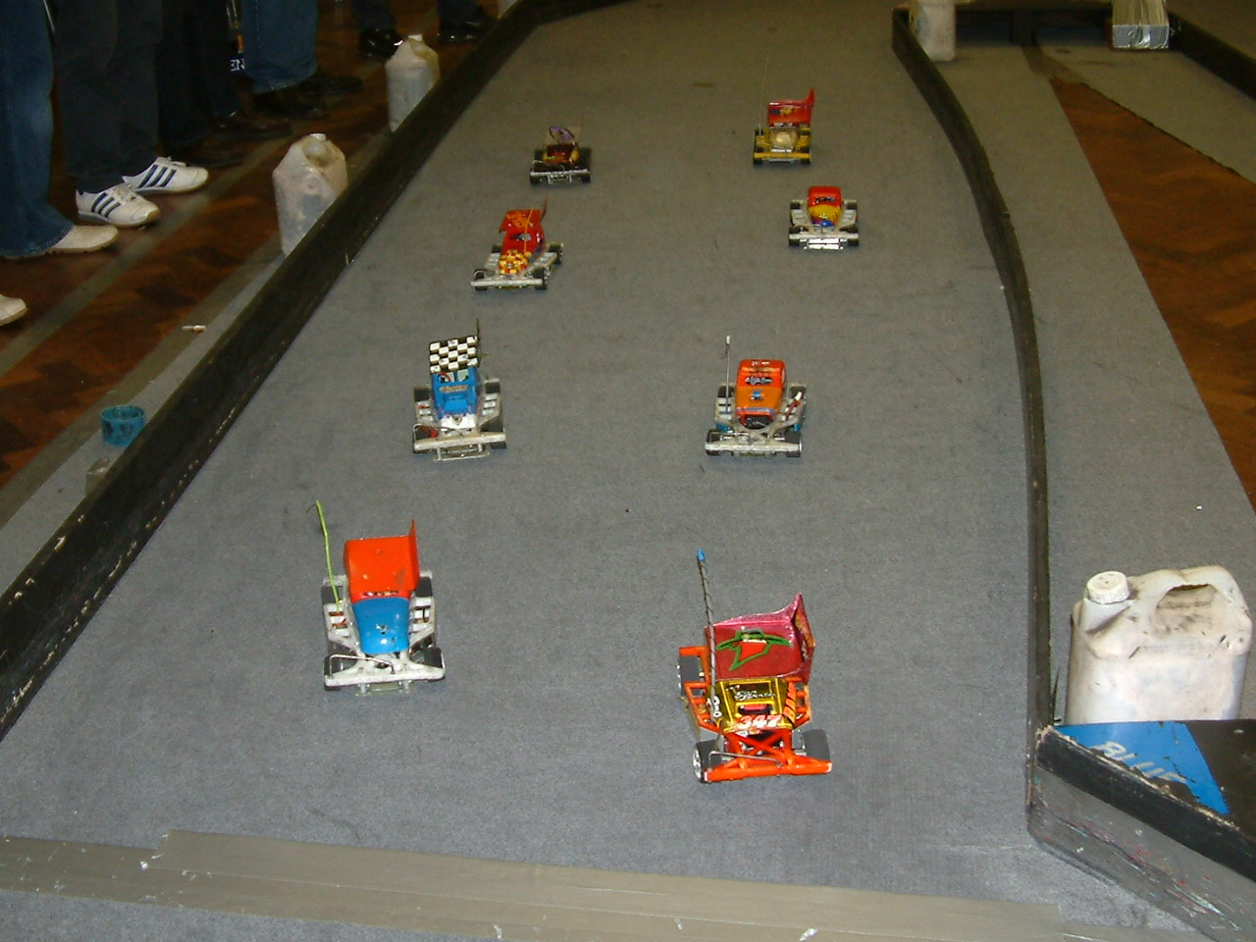
Phil
Ben Chadbourne
Harding 258

Stephen Farmer Stewart Smith
264 265

Karl Spencer
- Gareth Jones
267

Mark Cooper
268
Ian Johnson
269

The final was a very fast race indeed and it was also a very clean race on the smallest of the ovals that we race on, a great testament to all that were in it, at the end the Hathern promoter Ian Johnson took the first final of the year with 86 laps from Mark Cooper who finished on 84 laps in second place and completing the rostrum line up in third place was Gareth Jones with 83 he was chased by Ben Harding with 82 laps in fourth spot, coming home in fifth place we had Karl Spencer with 78 laps to his credit followed by both Stewart Smith and Stephen Farmer with 77 laps each, Stephen taking sixth place by 0.52, and that leaves just Phil Chadbourne in eight place with 73.

The grade awards went to John Freeman who races at the Hathern club he picked up the beat White award, best Yellow went to Shane Moorcroft his local club is Rugby, Urmston racer Alan Bellis picked up the Blue grade award and fellow Urmston racer David Smith won the Red grade award, the top Junior of the day was Ryan Cattell and the concourse was won by yet another excellent paint job from Dave Gwilliam only this time it was his own bodyshell that had won.

Results from the Bangers.
Round one
Race one was won by the Stoney Stanton club champion Damon Smudge Atkins with 65 laps from Urmston lady racer Debbie Jackson on 64 who was chased by Steven Mansell with 53 laps to his credit. Race 2 went to Urmston club racer Gary Shaky Osbourne wwith 61 followed by Mr Mardave himself Lee Bishop on 55 and Gary Mansell just one lap behind Lee with 54. Race 3 David Hot Rod Smith sets the track alight with an outstanding 70 laps (some one tell him this is supposed to be Banger racing- better still we will put a target on the back of his car for the next national) on the way to winning race three he was chased by Alastair Needham with 67 and Mark Cooper on 62. Race 4 was won by yet another Urmston racer this time it was Mike Too Nice Tomkinson with a winning race score of 61 followed by Dave The Body Gwilliam with 58 and Andy The Baron Cattell on 56.
Round two
Race one was a very good race between Alastair Needham and Lee Bishop, both racers finished with 69 laps the winning margin for Alastair over Lee was just 0.50 of a second these two was followed by Derek Grumpy Cayzer with 63 laps to his credit in third place. Race 2 Someone tell him its Bangers! yes its David Smith again with yet another 70 to his name and win number two he was followed by Hathern club racer Alan See you in the Final Inness with 61 laps and Debbie Jackson with another good score of 60. Race 3 went to Mike Too Nice Tomkinson with the winning race score of 57 he was chased by Robert Come on Honey Hewitt with 52 laps and Ian The Bandit Johnson with 44. Race 4 and its nice to see a new name collecting a win this time it was Ian Rolph from the March club posting a score of 68 he was chased by Mark Cooper with 66 and Ben Thumbs Harding with 65.
Round three
The first of the race winners in this round was Mark never say die Cooper with a respectable 64 laps he was chased to the finish line by Gary Shaky Osbourne with 62 and Phil Chadbourne with 57. Race 2 went to Alastair Needham with a winning score of 62 followed by David Rolph with 57 and Debbie Jackson with 54 laps, must mention here that David Hot Rod Smith was “sorted” this time and only got 26 laps! Race 3 went to Mr Mardave, Lee Bishop with 66 he was followed over the finish line by Andy The Baron Cattell with 57 and Gary Mansell on 47. Race 4 and another win was chalked up by Mike Too Nice Tomkinson with a winning lap score of 64 from Ben Thumbs Harding with 59 and the 56 by Ian Rolph.
Round four
Alastair Needham collects his third win with a winning lap score of 68 he was followed by Keith Rolph with 60 and then we had a big gap to the 46 of Gary Smith in third place. Race 2 and just to show that the last round was just an error, we have David Hot Rod Smith also collecting his third win with 67 laps this time, then we had Ben Thumbs Harding with 56 followed by Ian Rolph with 55 and Rob Come on Honey Hewitt on 53. Race 3 was a roundy roundy race as there was not enough cars in it! at the finish Phil Chadbourn took the win with 65 laps chased by Allan See You in the Final Inness with 63 then both Gary Mansell and Andy The Baron Cattell finished with 62 laps in that order, and in this race young Nicholas Cooper had his best lap score of 52 laps finishing in fifth place. Race 4 the last of the heats went to Mr Mardave, Lee Bishop with 69 laps followed by Mark neaver say die Cooper with 62 followed by Damon Smudge Atkins with 59.
The Banger Final
So who were the top ten racers straight through to the final, as there is no consolation race in the Bangers like there is in the stockcars, so here are the qualifiers along with their qualifying totals in order of qualification 1. David Hot Rod Smith 207 2. Lee Bishop 204 3. Alastair Needham 204 4. Mark Neaver say Die Cooper 192 5. Mike Too Nice Tomkinson 182 6. Gary Shaky Osbourne 181 7. Ben Thumbs Harding 180 8. Debbie Jackson 180 9. Ian Rolph 179 10. Andy The Baron Cattell 177 and the unlucky racer that finished in the eleventh qualifying position was Phil Chadbourne with a total of 174 better luck next time eh!

