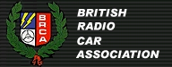
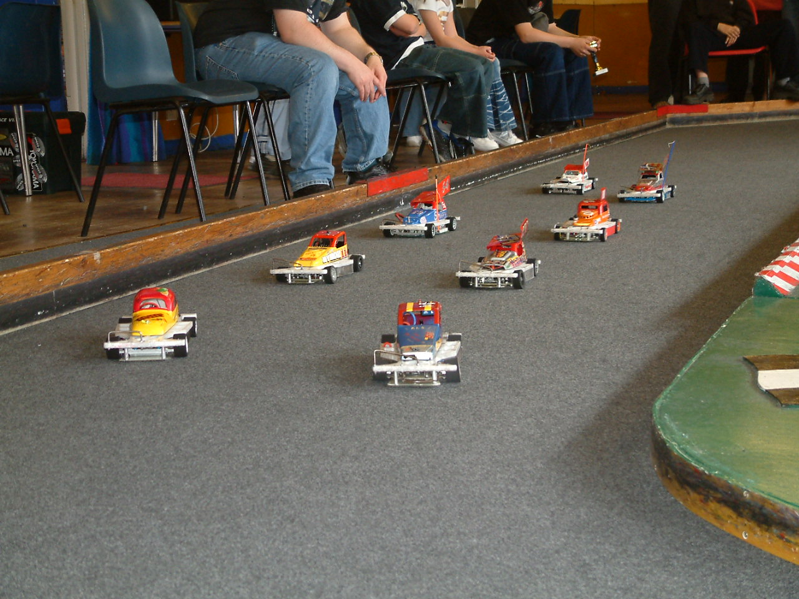

Round four of the 2003 series of national meetings

Once again Alan has been busy making improvements to the Urmston club’s facilities, the big change has been the purchase of a new carpet, which has been laid down in a permanent position, there has also been a lot of activity with the computer programs that Alan uses to run the meetings with, or should I say the programs that the computer uses to run the meetings with, as the qualifiers are automatically sorted round by round, and the computer even takes into account the dropped score from the worst round, no more working out with a calculator to sort out the qualifiers. Alan also has a useful electronic gadget that tells him what frequencies are switched on in the room at any one time, so if someone has radio interference Alan can tell if there are more than one of the same frequencies switched on at the same time.
Amazingly we had the same number of racers as last year’s national meeting – 48, and it was good to see some of the Scottish lads making an appearance south of the boarder, checking out the competition for the next national meeting which is at the Leven club in Scotland! on the 15th June.
Keeping check on the legality of the cars was the official BRCA scrutineer Stuart Preston, along with the regulation scrutineering box, and a flat surface in the form of a piece of Formica board, no arguments about ground clearance then!
The spares shop was doing bisque business as was the kitchen, with full breakfast’s and a variety of other food during the day, getting back to the spares and the availability of them, there is now a very good spares club shop at the Stoney Stanton club run by Damon Atkins, more information can be found on the web site SSORW.CO.UK if you experience connection problems just click the refresh button as I normally have to do, or alternatively contact Damon on damonatkins@ssorw.co.uk for the availability of spares for the stockcars and also the V12’s ( used by the banger class )

Round One.
The first race of the day saw a win with 85 laps from Rugby racer Clive Buckler, closely followed by Andy Cox with 84 then it was Margaret Dunbar on 81 and a very good score of 78 by young Aron Eaglen. Heat 2 was won by another young racer in the form of Rob Teuke with 85 on a split time from Stephen Farmer who also finished on 85, then we had Ryan Cattell on 80 and Mark Cooper along with a loose gear carrier on 73. Heat 3 was won by Karl Spencer with an impressive 89 laps, just one in front of Stewart Smith finishing on 88 then we had David Smith and Peter Ayriss both on 84 laps and then surprisingly we had Jon Cutts finishing some way behind on 80. Heat 4 was a more sedate affair by comparison with Ian Johnson recording a win with 84 laps on a split time as Joe Brown also recorded 84 laps in second spot, then we had Andy Cattell on 80 laps. Heat 5 was won by Urmston racer Gary McMullen with 82 laps just one in front of Phil Chadbourne on 81 then we had a big gap back to Irene Lancaster on 74 and Scottish racer Neil Ritchie on 71. Heat 6 saw the lap score increase dramatically back up to the high 80’s by Ben Harding, taking the win with 89 laps, easily beating Dave Williamson on 77 and Ade Eaglen finishing on 75 laps in third place. Heat 7 was won with a score of 82 by Anthony Wyper chased by Mike Tomkinson on 80 next racer across the line was Urmston youngster Daniel McMullen on 73 laps as was Jane Wyllie.

Round 2.
The first race win of the round went to Clive Buckler with 82 laps chased by Ryan Cattell who was just one lap behind Clive, then we had a big gap back to the lap score’s of 75 by Peter Ayriss and Stephen Farmer. Heat 2 was another win by Karl Spencer with another good race score of 88 laps, chased by Rob Teuke on 85 then we had two 84 lap score’s from Ian Johnson and Mark Cooper. Heat 3 was won by Stewart Smith with 87 laps followed by Andy Cox on 82 and Terry Crowley with 79, then we had another surprisingly low score from Jon Cutts with 75. Heat 4 was win number two for Ben Harding with 85 just one lap in front of Urmston’s David Smith who finished on 84 then it was an 78 by Joe Brown and 77 by Angela Yarwood. Heat 5 victor was the reigning national points champion Gary McMullen with 83 laps just one lap in front of Mike Tomkinson on 82, then we had Andy Cattell getting to grips with his new car on 79 followed by Urmston racer Gary Osbourne on 77. Heat 6 was a first national heat win for Dave Williamson with 77 laps followed by Neil Ritchie from the Leven club in Scotland, on 74 and Irene Lancaster on 70 as was Daniel McMullen. Heat 7 was won by Hathern club racer Phil Chadbourne with 80 laps, followed by Martin Cooper with 76 and Pete Clarke on 72.

Round 3.
Urmston racer Stewart Smith wins the first heat in round three with 86 laps followed by Rob Teuke on 84 and Stephen Farmer on 83 and Pete Ayriss on 77. Heat 3 was won by Ian Johnson with 84 laps just one lap in front of Ryan Cattell finishing in second spot then it was Joe Brown with 80, and big surprise in the score of just 73 by Jon Cutts as Jon is usually amongst the racers vying for a final place, but finding it hard to get the right set up on his car today! Heat 3 was a win for Mark Cooper on 87 laps followed by Andrew Cox with 82 then we had a good result for Rugby racer Laurence Collins finishing in third place with 72 laps, Laurence is currently a yellow grade racer, it just shows that if you get it right then you can get amongst the front runners as this heat proved, as previous heat winner Dave Williamson finished in fourth place on 71 laps beaten by a lower grade racer! Heat 4 was win number three for Karl Spencer with 88 laps from an 85 by Clive Buckler in second place then we had an 81 by Mike Tomkinson. Heat 5 saw a different winner in the form of David Smith with 81 laps chased by young Aron Eaglen in second place with 76, Aron choosing to go for laps instead of his usual mode of racing! then it was Martin Cooper on 75 and Andy Cattell with 74. Heat 6 and an 83 lapper secures a win for Anthony Wyper from Zoe Spencer on 78 and then we had Ben Harding in third place unusually with 71 followed by Neil Ritchie on 70. Heat 7 was win number two for Phil Chadbourne with 86 closely followed by Gary McMullen on 85, then we had both Terry Crowley and Darren Grace with 74 laps.

Round 4.
Karl Spencer completes the set of race wins in heat one, round four with 88 laps followed by Rob Teuke on 85 then we had Stewart Smith with 84 and an 81 by Mike Tomkinson. Heat 2 was win number two for Mark Cooper with a low score of 79 laps in a very scrappy race! the second racer across the line was Anthony Wyper on 76 followed by Dean Ritchie with 70. Stephen Farmer takes heat three with 83 laps, then it was very close for the minor placings behind him, both Neil Ritchie and Martin Cooper finished on 76 laps and Laurence Collins was just one lap behind these two. Heat 4 was win number three for Ben Harding, on a split time after finishing on the same lap score as Joe Brown but in a better split time of just 0.010 of a second, the winning lap score was 86, third person across the line was Phil Chadbourne with 82. Heat 5 and saving the best till last was Angela Yarwood, winning a heat in the very last round with 81, followed by Ian Johnson and Andrew Cox both on 80 laps. Heat 6 victor was David Smith, collecting win number two with a score of 85, just one lap in front of the chasing Gary McMullen on 84 in second place in this heat then both Derek Cayzer and Peter Ayriss finished on 77. Heat 7 and the last race of the heats went to Clive Buckler with a winning score of 83, followed by Margaret Dunbar on 76 and Dave Williamson with 74.

Some facts and figures from the heats of racing, we only had two racers scored the maximum thirty points from the heats, they were Ben Harding and Karl Spencer, only Karl won all four of his races. The FTQ went to Karl Spencer with 89 laps in a time of 5: 01. 090 compared to Ben’s best of 5: 03. 140, which was also on 89 laps. A further six racers won two of their races and were second in another. A total of fourteen different racers won a heat. Incredibly Anthony Wyper won two heats and was second in another but was unfortunate not to make the consolation race. Two blue grade racers won a heat. Amazingly former National Points Champion Jon Cutts did not win a heat all day, also recent National winner’s Martin Cooper and Andy Cattell failed to record a win in the heats along with the current National Junior Champion Ryan Cattell!

Consolation Race.
As previously mentioned there were a lot of racers not qualified for the final or the consolation race that you would have expected to have been there, were they just having a bad day or has the competition got better!
The eight racers to make the consolation race were, in qualifying order -
Name Total
Ian Johnson 252
Stephen Farmer 251
Joe Brown 250
Mark Cooper 250
Phil Chadbourne 249
Andrew Cox 248
Ryan Cattell 244
Mike Tomkinson 244

We had another quality race between those that were allowed to race, some tactics employed by racers that have the ability to win such a race as this one, but chose not to in order to spoil someone else’s race, is something that I do not understand! At the finish the result went to Urmston racer Joe Brown with 86 laps in a time of 5: 01.550 he was pushed all the way by Hathern club racer Phil Chasdbourne, finishing in second place with 86 laps but with a slower split time of 5: 03.310, then it was Ryan Cattell with 85 followed by Ian Johnson on 84 and Stephen Farmer with 83, then came Mike Tomkinson with 82 and Mark Cooper with 81, and finishing last was Andrew Cox on 72.

After the consolation race there was a junior grand national race, these racers are the future of our section and these extra races for the younger members are a good idea, here is an idea for you, as you know the national championship is decided upon the results of a number of finals at all the nationals, well why don’t we decide the junior championship in the same way ? it would give more of the younger racers a chance to compete in a final for want of a better way of putting it, along with racers more on there ability so giving them more confidence, the last euro junior champ was decided in this way and was a success.
The racers lining up for this one were Joe Huxley, Nicholas Cooper, Amy Gilpin, Aron Eaglen, Thomas Collins, and Daniel McMullen. Just six taking up the challenge then, but a close result at the end with the win going to Aron Eaglen with 78 laps closely followed by Daniel McMullen on 77 then we had Nicholas Cooper crossing the line on 68 followed by Thomas Collins with 50, then it was Amy Gilpin with 22 and Joe Huxley with 2 laps.

The Grand Final
The line up of racers for this one were, again in qualifying order –
Name Total
Karl Spencer 265
Stewart Smith 261
Ben Harding 260
Robert Teuke 255
Clive Buckler 253
David Smith 253
Gary McMullen 252
Joe Brown Consolation Winner

What a race, the track record smashed to pieces with two racers bettering the old record! The result went to Ben Harding in a new record of 91 laps in a time of 5: 03.940, second place finisher was Karl Spencer with 90, third place went to Gary McMullen on 87 as was fourth finisher Joe Brown, fifth across the line was Clive Buckler on 86 as was Stewart Smith in a slower split time, just one lap behind these two was David Smith on 85, then in eighth place we had Robert Teuke finishing with 80 laps.

So another successful meeting comes to a finish, and we move on to the next meeting in Scotland at the Leven Club.
The national points chase now looks like this after the four rounds that have been completed –
1. Ian Johnson 377
2. Mark Cooper 368
3. Andy Cox 355
4. Andy Cattell 351
5. Anthony Wyper 345
6. Ryan Cattell 344
7. Joe Brown 332
8. Martin Cooper 329
9. Mike Tomkinson 309
10.Ben Harding 298

