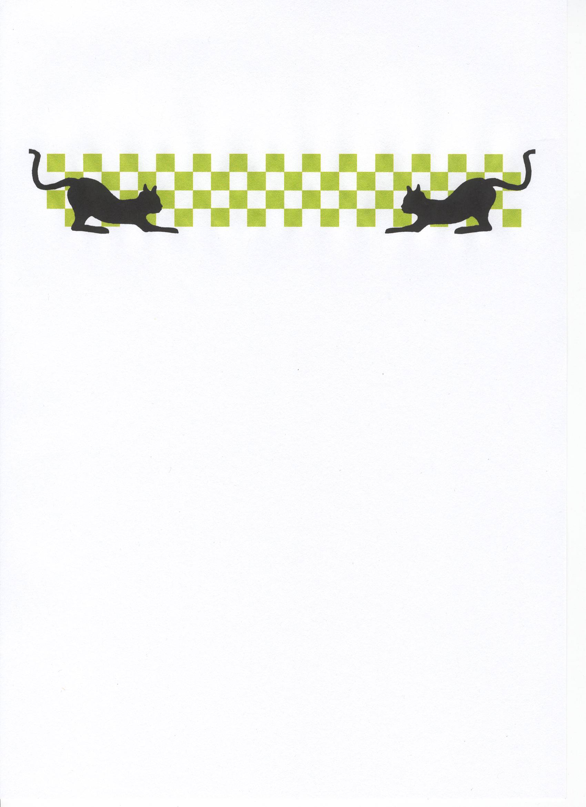
Stoney Stanton National
Lecatt Racing

