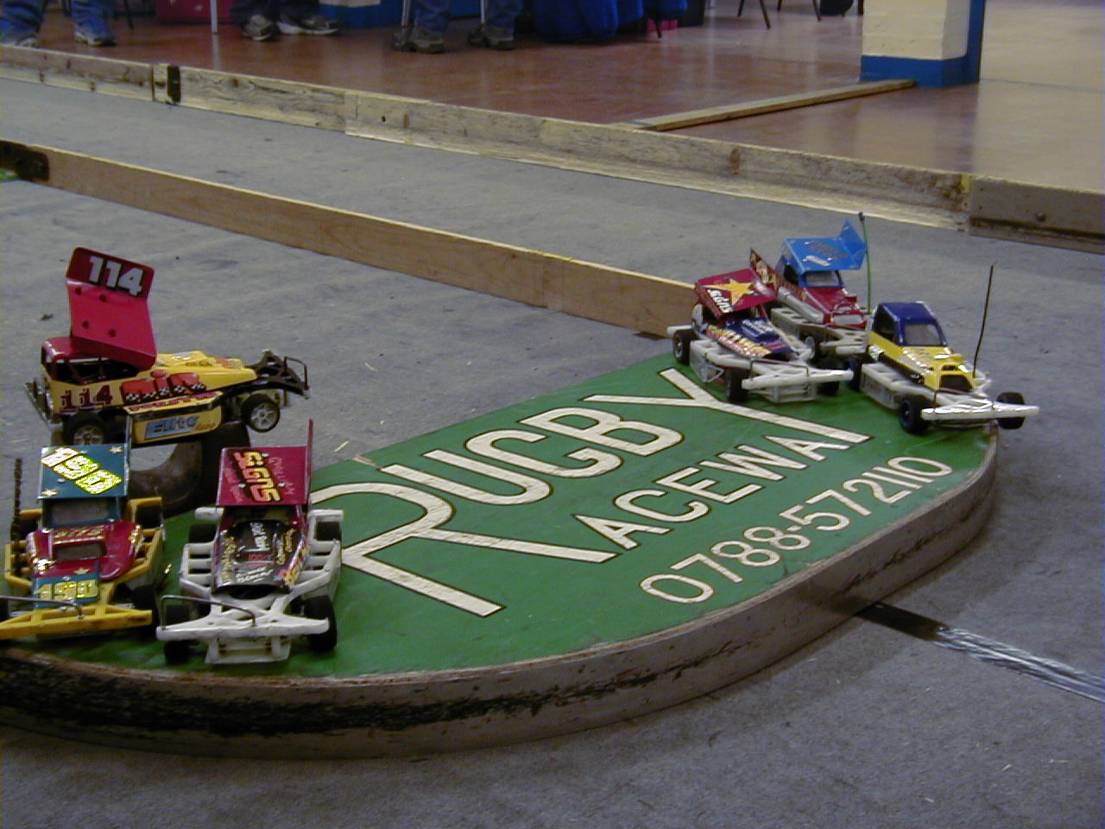

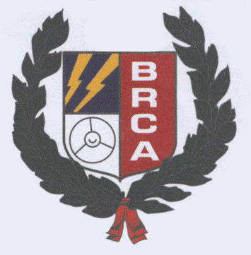

A hectic start to the national series, three national meetings in about eight weeks, after this meeting we have a short break from the nationals, with the next meeting on the calendar, being that of the English Open, originally the meeting was to be run at the Primrose Valley holiday park in Yorkshire, but has now been switched to the Stoney Stanton Raceway, on Sunday May 4th, same date as the original fixture, only Stockcars and Bangers will be racing at this meeting, contact Andy Cattell on 07776411463, with another meeting arranged at a later date for the saloons and hot-rods, at the new club, which is based at March, in Cambridgeshire.
We had another good turn out of forty racers, slightly down on the previous two nationals, I think this was due to there being no support formula, which would attract other participants (usually). But it does mean, the meeting can get finished earlier as there are not so many races to get through. No Gary McMullen racing today ( the defending national points champion) which means, he will have to do all the remaining national meetings, if he is going to defend the title, also this is the last national meeting where you can start in the series, that is if you are going to try for the title, with a further four rounds to go after this one.
Once again we had Stuart Preston – the official BRCA scrutineer keeping check on the cars, along with the “new” scrutineering box! Andy Nash – Chairman of the section, was also paying us a visit today. We also had Mike Tomkinson on hand to oversee the health and safety side to the meeting.
Out in the kitchen we had Jackie, providing bacon sarnies and hot drinks, along with sandwiches and baked potatoes at dinner-time to keep us all fed and content. Thank you much appreciated!
The scrutineering of the cars passed without there being any problems reported on any of the cars that were racing, practice went very smoothly, due I think, to it being a cool day outside making it easier to find the right tyre choice for the cars, I remember that at last years national meeting it was a warm day, and we suffered with a lot of grip going into the bends, which was causing the cars to grip roll, and you had either too much grip or not enough, and getting it just right was a work of art!
With the pre-race information delivered by the Rugby club’s promoter Jon Cutts over, we had a concourse line up of the cars, including a MK.1 Mardave Stockcar in original condition, which sneaked into the line up of cars courtesy of Clive Buckler, the winning car (best paint job) was judged by Mr. Andy Nash. Result at end of the report.
It would have been easy for Jon Cutts, to have divided the forty cars that were in attendance, into five heats, consisting of eight cars in each, but as this is disliked by many racers that travel to the national meetings, due to the Rugby track being very narrow down the straights, which can cause the races to be scrappy, because of the contact between the cars, I think it was sensible to split them into the six heats that we had, which I’m sure made for better racing on the day, well done good decision, a little reminder here from a previous report, was that the Hathern national also had less cars in each heat and worked very well. Please not here that some of the tracks we race on are larger and will accommodate eight cars in a heat more easily
Round 1.
Off to a good start was Hathern club promoter, Ian Johnson with a respectable 81, chased by Mark Cooper on 77 laps then we had Rugby youngster Rob Teuke with 71, and then it was Jason Bartropp finding the racing different on a small track with 68. Heat 2. Was won by Rugby superstar Karl Spencer on 79, chased by the man in form Mr. Andy Cattell on 74, then it was Pete Clarke on 72 and Joe Brown with 71. Heat 3. Rugby supremo Jon Cutts registers a win with 78 laps, followed by Zoe Spencer with 74 and the Diamond racer himself, Roy Calver on 72. Heat 4. A very close race indeed, which was won with 71 laps by Martin Cooper, just holding off Anthony Wyper on 69, then we had a good result for Yellow grade racer Graham Farrell in third on 67, finishing just one lap in front of Derek Cayzer, the minor places were contested by two of our youngest racers in this heat, with Nicholas Cooper finishing on 59 and Thomas Collins just behind Nick with 58. Heat 5. A win for Clive Buckler,( showing better form in the national meeting than his club form, as Clive drops down to a blue roof colour this grading period at his home club which just happens to be Rugby ) on 79 laps, followed by Ryan Cattell with 76, another of the youngsters getting a good result this time was Aron Eaglen picking up third place with 67 followed by Alan Harding on 63. Heat 6. What can you say! Ben Harding makes it look easy, by winning with, wait for it 89 laps, chased by stable mate Dave Gwilliam on 80, then we had two racers finishing with 77’s, they were Mike Tomkinson and Ade Eaglen, followed by Urmston youngster Joe Huxley on 70.

Something new for you here, the top qualifiers as they stand round by round, leading the way from round one was Ben Harding, then in order it was Ian Johson, Dave Gwilliam, Karl Spencer, Clive Buckler, Jon Cutts, then equal at this stage were Mark Cooper, Ade Eaglen and Mike Tomkinson
Round 2.
Diamond team racer, Jason Bartropp secures a race win in heat one with 79 laps, chased home by Andy cattell on 75 and Pete Ayriss with 74, then it was Gary Osbourne on 70. Heat 2. Urmston racer Andy Cox takes the win with 79, from Karl Spencer just one lap behind on 78, another Urmston racer was third with 75 laps by Joe Brown, then we had Pete Clarke suffering with handling trouble due to a loose aerofoil on 72. Heat 3. Was won by another Urmston racer, this time it was Anthony Wyper picking up a first place finish with 77, securing second with 75 was Zoe Spencer, then came Graham Farrell and Roy Calver both on 73’s. Heat 4. Win number two for Martin Cooper, this time with 77 laps from a 76 by Cambridge racer Derek Cayzer, then we had fun racer Alan Woodward on 75, and a out of sorts Ryan Cattell way back on 66. Heat 5. Veteran racer Clive Buckler makes it two wins out of two, with 81 laps chased by Dave Gwilliam on 79, then finishing in this order all with 68’s were Aron Eaglen, Jane Wyllie and Alan Harding. Heat 6. The heat of the round in my opinion! Not because I was in it, but the standard of racing was excellent, the race was won by Ben Harding on 86 then came Mark Cooper (me) on 83 gaining revenge over Ian Johnson (from round one) who finished just one lap behind on 82, fourth finisher was Rugby’s Ade Eaglen with 75, a very high standard indeed!

Two rounds raced, and the top qualifiers so far are Ben Harding, Ian Johnson, Mark Cooper, Clive Buckler, Karl Spencer, Dave Gwilliam, and on equal totals were Andy Cattell and Zoe Spencer. So Mark moves up, we say goodbye to Jon, Ade and Mike for now, they were replaced by Andy and Zoe.
Round 3.
Ryan Cattell finally records a race win with 80 laps in heat one, followed by Andy Cox and Graham Farrell both on 76 laps then it was Roy Calver with 75 then we had a good score by Allan Inness from the Urmston club with 68. Heat 2. Ben Harding makes it three on the trot with another win on 85, which also guarantees him a place in the final! Next racer to finish was Pete Ayriss with 74 laps closely followed by Alan Woodward on 73, then it was Jane Wyllie finishing with 71. Heat 3. Went to Karl Spencer on 85 laps, chased by Jon Cutts with 79 and Ian Johnson with 78, fourth finisher was Joe Brown on 72. Heat 4. A win for Mark Cooper with 84 then in order of crossing the line all on 74 were Alan Harding, Rob Teuke and Joe Huxley, then came father and son racers Ade Eaglen and Aron Eaglen finishing with 72 and 71 respectively. Heat 5. New blue grade racer Clive Buckler secures another win with 84 laps followed by 81’s from Anthony Wyper and Rob Teuke, fourth finisher was Mike Tomkinson with 75. Heat 6. Was a good race between Andy Cattell and Dave Gwilliam, at the finish Dave got the verdict over Andy after they had both finished with 77 laps, then it was Gary Osbourne on 74 followed by Zoe Spencer on 70, then it was a good result for Yellow grade racer Nicholas Cooper with 63 laps.

After three rounds the automatic qualifiers for the final were, Ben Harding, Mark Cooper, Clive Buckler, Karl Spencer, Ian Johnson, Dave Gwilliam, Anthony Wyper, and just outside the automatic qualifying places was Andy Cattell. We lose Zoe this time, and Andy Cattell, and joining the qualifiers for the first time was Anthony Wyper.
Round 4.
Heat one was won by Roy Calver from the High Wycombe club with 75 laps, chased all the way by Andy Cox finishing with 73, then we had two local racers, in third place we had Shane Moorcroft on 72 laps closely followed by Graham Farrell with 70. Heat 2 No surprise here, with Ben Harding collecting his fourth straight win with 86 laps, followed by Ian Johnson on 80 and then it was Joe Brown on 77, also in this heat we had Stoney Stanton White grade racer, Damon Atkins record a respectable 70. Heat 3. Another win then for Karl Spencer, this time he records 88 laps, chased by Mark Cooper with 85 and Jon Cutts on 81 and saving the best to his last heat of racing was Alan Crossland, recording a 75. Heat 4. Was a win for Andy Cattell on 80, just one lap in front of Anthony Wyper in second place, followed by two youngsters in the shape of Aron Eaglen with 76 and Joe Huxley on 74.
Heat 5. Team Skint racer Dave Gwilliam wins a heat with 80 laps, just in front of the 79’s by Clive Buckler and Rob Teuke, a 78 by Gary Osbourne and then we had a 77 by Mike Tomkinson. Last heat of racing then, heat 6. Saw the second win of the day for Ryan Cattell with 75, chased by Zoe Spencer on 73 and Alan Harding on 72, also worth a mention here was the 68 by Alan Inness and the 65 by young Nicholas Cooper.

By now you should have a good idea who has qualified for the final, what always amazes me is how someone pulls out all the stops in the last round of qualifying, and usually sneaks into the final as a result of a good last round score. This time it was Jon Cutts coming up with the score needed for automatic qualification into the final at the expense of Urmston’s Anthony Wyper.
At the top of this report I commented on Jon’s decision to run more heat with less cars in each race, lets compare the qualifiers from last year to this, and see if there is a difference in the qualifying totals when you get to this years qualifiers, the top qualifier for the final in 2002 was Ben Harding with 255 laps, last qualifier into the final was Andy Cattell with 231 laps, first consolation qualifier was myself Mark Cooper on 228 laps, and eighth qualifier for the consolation was Rob Teuke with 217 laps.
Consolation.
The qualifiers for the last chance of qualification into the final, in qualifying order were –
2003 Total 2002 Total
1.Anthony Wyper 237 Mark Cooper 228
2.Andy Cattell 232
3.Robert Teuke 231
4.Ryan Cattell 231
5.Mike Tomkinson 229
6.Andy Cox 228
7.Joe Brown 224
8.Ade Eaglen 224 Rob Teuke 217

Please note that Joe and Ade had the same qualifying totals, as did the unlucky Martin Cooper, missing out under the rule which state that – In the event of a tie at any national meeting, it will be decided upon a drivers previous lap scores, including split times, starting with the highest then the next highest etc. All three racers best scores were 77, then the next best scores were the 75’s by Joe and Ade compared to a 74 by Martin, no need for the split time to come in to play here as Martin had the next lowest score! Only when all four race scores are identical by two racers or more, does the split times come into effect.
Compare the totals shown and you can see a difference in the qualifying totals, last years consolation winner was Paul Jenkinson with 75 laps, and would you believe it! This years winner of the consolation race was Andy Cattell (making a habit of it) with 75 laps also, and he progresses through to the final, runner up was Andy Cox just one lap behind on 74, next across the line was Rob Teuke with 72, fourth place finisher was Joe brown with 71, then it was a 70 by Ryan Cattell across the line in fifth place, then we had a close result for sixth and seventh place after both Ade Eaglen and Anthony Wyper had finished with 63 laps, Anthony crossing the line ahead of Ade, and the unlucky Mike Tomkinson finished on 44 laps, dropping out of the race with a broken crystal!

The Final. Total Total
2003 qualifiers 2002 qualifiers
1.Ben Harding 261 Ben Harding 255
2.Karl Spencer 252 Karl Spencer 247
3.Mark Cooper 252 Clive Buckler 240
4.Clive Buckler 244 Jon Cutts 237
5.Ian Johnson 243 Phil Smith 236
6.Dave Gwilliam 239 Gary McMullen 232
7.Jon Cutts 238 Andy Cattell 231
8. Andy Cattell Consolation winner Paul Jenkinson

So it was Jon Cutts producing the good last round score that was needed to qualify for the final, and push out Anthony Wyper!
Compare the scores from qualifying, from this year and last, and you can visibly see the difference the one or two less cars in a race makes.

The result of the final, and yes I know I keep saying this, but I think it will be a while before we get a better quality race than the one that was contested here, just look how close the result was between all eight racers in the final, but when it mattered he came up with the result, is a phrase that springs to mind here, qualifying in fifth place for the final, but taking the honours with the win was Hatherns own! Ian Johnson with 84 laps from Rugby’s Ben Harding also finishing with 84, last place on the rostrum was taken by Karl Spencer finishing with 83 laps, then it was Mark Cooper finishing in fourth place (for the third time running in finals this year) on 82, fifth place finisher was Clive Buckler on 81 followed by the consolation winner, Andy Cattell on 80 as was Dave Gwilliam coming home in seventh place, and last place was filled by Jon Cutts with 79 laps, just five laps separating first and last place in the final, wow!

Looking more closely at the final, it was interesting to note that there was not a single Pinky (type of car) constructed car in the final, in recent years this type of car has dominated the national scene, mainly in the hands of Gary McMullen, the final today consisted of two Team Skint car’s, one Elite – very like the team skint car type, we had a Kiwi Special, Clive Bucklers own, one Bandit Pro - available to purchase, as is the Eaglen Mardave as raced by Jon Cutts, also there were two Lecatt type car’s in the final, these are also available to purchase from the manufacturer, must mention here to be fair, that the Pinky MWB and long wheel base type of car is also available from the manufacturer.
Also there is the new Diamond car type as well, available in rolling chassis form again from the manufacturer.

Trophy presentation time, and we were fortunate to have Rugby’s Dan Squire along to present the trophies and the grade awards, for those of you that are saying Dan who? Well Dan races a real Brisca formula 1 stockcar, currently he is graded as a Blue grade driver, but did achieve a red last year, also Dan is the only driver using a Buick engine in his Formula 1. The preferred choice is a Chevrolet, and Dan’s car is entirely self built.
The concourse award, as judged by our chairman Mr. Andy Nash, went to Rugby’s Robert Teuke.
Grade awards were, best White was awarded to Stony Stanton based racer Damon Atkins (smudge) the Yellow award went to a Rugby racer in the form of Graham Farrell, best Blue went to Ade Eaglen, another Rugby racer. Rob Teuke also won the best Junior award to go with the concourse award.

The National points chase after the first three round now looks like this,
Name Total
1. Ian Johnson 289
2. Mark Cooper 285
3. Andy Cattell 277
4. Andy Cox 273
5. Anthony Wyper 262
6. Martin Cooper 260
7. Ryan Cattell 258
8. Roy Calver 240
9. Joe Brown 240
10.Jason Bartropp 237

Name . | F/Tyre  Inside | F/Tyre  Outside | R/Tyre  Inside | R/Tyre  Out | G/Ratio | Race  No. | Charger | Car type | Cells | Club | Grade | Qualif | Final
Mark Cooper | SE | Gold | SE | SE | 13/50 | 216 | Apex | Lecatt | Corally  1700 | Stony  Stanton | Red | 3 | 4
Karl Spencer | SE | LM | SE | SE | 12/51 | 51 | Apex | Elite  Racing | Sanyo  2000 | Rugby | S/S | 2 | 3
Ben Harding | Jap M | Jap M | Pink | Pink | 12/50 | 471 | Apex | Team  Skint | Corally  1700 | Rugby | S/S | 1 | 2
Dave Gwilliam | Jap M | Jap M | SE | SE | 12/50 | 41 | Apex | Team  Skint | Corally  1700 | Rugby | Red | 6 | 7
Clive Buckler | 05 | Jap M | Pink | Pink | 12/51 | 100 | Reedy | Kiwi  Special | Corally  1700 | Rugby | Blue | 4 | 5
Jon Cutts | Yellow | Gold | SE | SE | 13/51 | 1 | Racing  Jack | Eaglen  Mardave | Corally  1700 | Rugby | Red | 7 | 8
Ian Johnson | Jap S | TK | SE | Pink | 11/53 | 347 | Schum | Bandit  Pro | Sanyo  2400 | Hathern | S/S | 5 | 1
Andy Cattell | Jap M | Pink | SE | SE | 12/50 | 175 | Apex | Lecatt | Corally  1700 | Stony  Stanton | S/S | Cons  winner | 6

Tech chart, of the finalists
Report by Mark Cooper.

