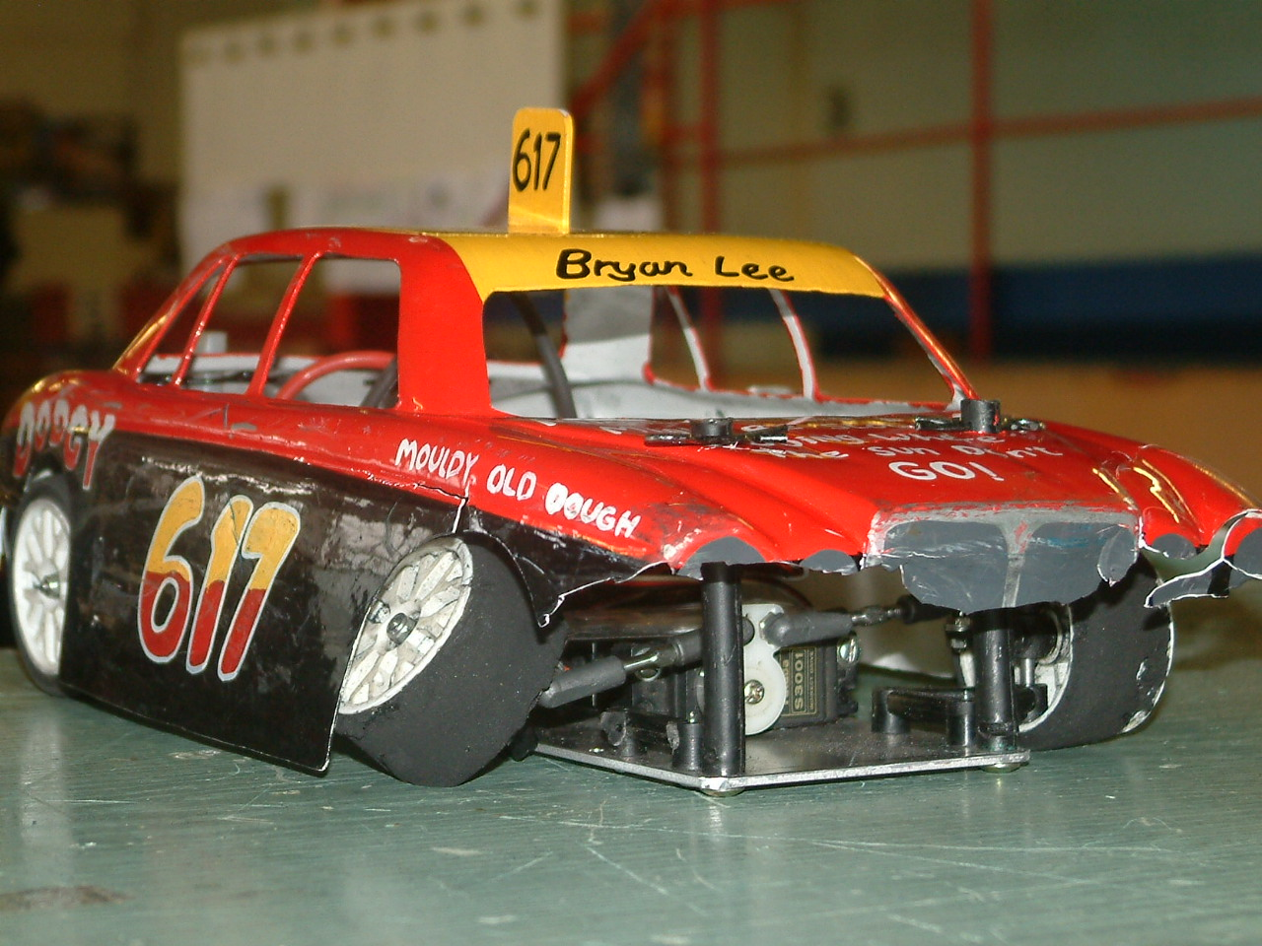

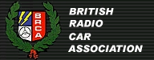

Stockcars Round 6 & Round 4 of the Banger Series

After the British Open meeting yesterday, the burning question for today is – will the track record be broken, with the racers now more familiar with the track it’s a very real possibility that the first 60 lap score by the stockcars will be set today, after so many racers had set 59’s yesterday. We have twenty-six racers for the stockcars today three more than we had for the Open, and there were fifteen for the Bangers, two less than the Open meeting yesterday.
Another burning question for the meeting today is - after Jason Bartropps self destruction in the final yesterday, after he had easily qualified on pole, was would he restrain himself and win the final today.
As this track is a permanent one, it will be interesting to see if the racers that make the final for the stockcars today, that had made the final for the Open yesterday use the same set up or will the conditions be slightly different and cause the racers to use a different set up.
Once again the Frog & Duck café is doing a great job keeping us well fed and watered, the full breakfast was so much nicer today, after the crew had learnt to cook eggs after much protesting from the racers the day before!

Stockcars Round 1
In heat one we had what could be seen as a shock result in the shape of a heat win for Urmstons Peter Ayriss along with a very nice ten national points ( amazing what you can do with a fast car on a large track ) chasing him all the way to the finish was Mark Cooper in second place with 55 laps, also on 55 laps was Jason Bartropp but he was 1.62 seconds behind Mark, then it was Mike Tomkinson on 53 laps in fourth place. Heat 2 was just like he had carried on from yesterdays meeting, chalking up another win was Ryan Cattell with 58 laps from Rob Teuke in second spot on 56 with Joe Brown just one lap behind Rob, then we had Rob Hewitt finishing with 49. Heat 3 went the way of yesterdays final winner Karl Spencer with 58 laps chased by Dave Gwilliam on 57, finishing in third place we had Alastair Needham , who was just one lap behind Dave and in fourth place it was Joe Huxley with 53 laps. Heat 4 was the race of the round without doubt, the win went to Ben Harding on 58 laps, then it was very close behind him, just look at the result, second place went to David Smith with 57 laps in a time of 300.40 third place went to Gary McMullen also on 57 in a time of 300.71 and even the fourth place finisher Mark Stiles was on 57 laps with a time of 303.29, and just one lap behind these three was Roy Calver on 56 laps.

Bangers Round 1
Championship leader Gary McMullen gets of to a good start with a win, along with ten national points in heat one with a winning lap score of 49 chased by Jason Bartropp on 48 in second place, then it was Mike Tomkinson coming home in third with 46 and Roy Calver on 42 laps in fourth. Heat 2 was another close race, at the finish Andy Cattell was just over the finish line first by 1.16 seconds after both he and Alastair Needham had finished on 49 laps, the third place finisher was David Smith with 46 then it was Damon Atkins with 43 and Peter Ayriss with 41 and just one lap further back was Rob Hewitt in sixth place.

Stockcars Round 2.
Ben Harding collects win number two with 57 laps in heat one from his championship rival Karl Spencer finishing with 56 in a split time of 300.80 as Mark Stiles had also finished with 56 laps in a slower split time of 302.41, then we had Mike Tomkinson on 54 and just one lap behind Mike was Anthony Wyper on 53 and then we had a good result for young Nicholas Cooper on 49 laps in sixth place ahead of Stuart Preston on 48. Heat two was the first lap score of 59 by David Smith followed by Mark Cooper on 57 and Joe Brown with 56, the fourth place finisher was Paul Shearwood with 54 chased by \Joe Huxley on 53. Heat three was won by Alastair Needham with a new track record of 60 laps in a split time of 302.76, he was chased by Jason Bartropp in second place with 57 and Rob Teuke on 56, then just the one lap behind Rob was Roy Calver with 55, then rounding off the 50 scores was Andy Cattell with 50 laps. Heat four was a very close race between Gary McMullen and Ryan Cattell, with Gary just edging out Ryan by 3.12 seconds after they had both finished with 58 laps, then it was a 55 by Dave Gwilliam in third spot, and Peter Ayriss with 53 in fourth.

Bangers Round 2.
Things are sure getting real close between the banger boys, the meeting favourite Jason Bartropp wins heat one but only just with 52 laps, he was chased by Andy Cattell and Alastair Needham on 51 with Andy just 3.01 seconds ahead of Alastair at the finish, fourth place went to Gary McMullen on 49 then it was Rob Hewitt finishing on 43. Heat two went the way of David Smith with 50 laps in first place chased by Mike Tomkinson on 49 laps, third place went to Dan Martin on 46 in a split time of 303.68 after Damon Atkins had also finished with 46 but with a slower split time of 306.33 and just one lap behind these two was Debbie Jackson with 45.

Stockcars Round 3.
Heat one was another cracking race, at the finish we had three racers all on 55 laps, heading the train of three was Mike Tomkinson in a split time of 300.36 followed by Dave Gwilliam with a split of 301.35 then it was Andy Cattell with a split of 302.11, just 1.25 seconds between first and third place, fourth place went to Joe Huxley on 51 followed by Stuart Preston with 50. Heat two saw another close finish at the front, this time it was between Roy Calver and Ben Harding with the latter just getting the verdict by 0.66 of a second with a winning score of 59 in 303.18, then we had local racer Mark Stiles on 57 laps in third place followed by Ryan Cattell with 56 and Damon Atkins on 41. Heat three was another race decided by the split time, after both Alastair Needham and Karl Spencer had finished with 58 laps, Karl taking the win by 0.99 of a second, third was Mark Cooper on 56 followed by Peter Ayriss on 54 then it was Debbie Jackson and Nicholas Cooper in that order on 48’s, and can someone tell Nicholas to leave his dads car alone during a race as it’s a long walk home! Heat four and just to keep it nice and even we had another race decided by split times after Gary McMullen and David Smith had finished with 58, the win went to Gary by 0.82 of a second, then we had an improving Paul Riddell in third place on 57 laps followed by Rob Teuke on 55 and Paul Shearwood with 53.

Bangers Round 3.
The mans back in form, Jason Bartropp taking the win with 52 laps from Mike Tomkinson on 48 followed by Roy Calver on 47 laps, then we had Debbie Jackson finishing with 44 in fourth place followed by Ryan Cattell on 33.
Heat two was won by David Smith with 51 laps from the chasing pair of Alastair Needham and Andy Cattell both on 50 laps with Alastair just 1.50 seconds ahead of Andy, fourth went to Dan Martin with 47 followed by Rob Hewitt with 46 and Damon Atkins on 45.

Stockcars Round 4.
Hold the front page, history in the making, an historic heat win for the man with the historic quote of No one told me I’m supposed to be in control of the damn thing, well we will have to add unless I’m winning, yes it’s his first heat win in a national meeting for Stuart Preston in heat one with 54 laps as was Rob Teuke but he was behind Stuart by 2.49 seconds ( fast car big track easy win or was it luck ? ) and just one lap behind in third place was Mike Tomkinson on 53 chased by Karl Spencer on 52. Joking apart congratulations to Stuart on his first heat win & no we can’t use this track for our worlds meeting nice try! Heat two was won by Urmston’s David Smith with 58 laps from the chasing Dave Gwilliam on 55, then we had two racers on 54 laps separated on split times they were Peter Ayriss and Joe Brown on 54 laps with Peter just 1.20 seconds ahead, the fifth finisher was Paul Shearwood on 50 laps. Heat three was one of the best races of the day which provided another blanket finish between three racers, first across the line was Ben Harding with 58 laps in a split time of 300.80 followed by Alastair Needham on 58 laps in 301.92 and also on 58 laps in third place was Mark Stiles in a split time of 302.03, just 1.77 seconds between first and third, then we had Jason Bartropp just one lap behind these three on 57, also cracking the 50 barrier in this heat were Andy Cattell with 54 and Anthony Wyper on 53. Heat four was won by Gary McMullen with 59 laps from Paul Riddell on 57 chased by Ryan Cattell and Mark Cooper both on 56 laps with Mark 1.44 seconds behind Ryan.

Bangers Round 4.
Win number three for Jason Bartropp in round four with a winning race score of 52 from Alastair Needham on 48 and Gary McMullen finishing in third place with 46, fourth place finisher was Steve Anderson on 37. The last heat was won by Dan Martin with 48 laps from David Smith who was also on 48 but 1.41 seconds behind Dan, then it was Mike Tomkinson with 45 and back in fourth place we had Peter Ayriss with 25 laps.

The heats are over and the usual totting up of the scores begins, with there being so many tied scores from the heat’s it’s going to be close on the qualifying for the final and consolation races for the stockcars, and who would be in the top ten qualifiers for the banger final, in order here are the stockcar qualifiers –

Name Final Total Name Consolation Total
1. Alastair Needham 176 8. Roy Calver 170
2. Ben Harding 175 9. Mark Cooper 169
3. Gary McMullen 175 10. Jason Bartropp 169
4. David Smith 175 11. Rob Teuke 167
5. Karl Spencer 172 12. Dave Gwilliam 167
6. Mark Stiles 172 13. Paul Riddell 167
7. Ryan Cattell 172 14. Joe Brown 165
15. Peter Ayriss 165

Banger final qualifiers.

Name Total
1. Jason Bartropp 156
2. Andy Cattell 150
3. Alastair Needham 150
4. David Smith 149
5. Gary McMullen 144
6. Mike Tomkinson 143
7. Dan Martin 141
8. Damon Atkins 134
9. Rob Hewitt 129
10. Steve Anderson 106

Stockcar Consolation
Would home advantage pay off for Roy Calver and Jason Bartropp or the improving Paul Riddell, or would experience prevail and the result go to one of the more experienced band of national racers. The answer was the latter, with a calm and calculated race by Mark Cooper he won the race with 56 laps along with progression into the final, second place went to Dave Gwilliam with 55 laps as did Roy Calver who was just 1.79 seconds behind Dave, coming home in fourth place with 54 laps we had Rob Teuke followed by Paul Riddell on 52, sixth place went to Peter Ayriss on 51 laps along with Joe Brown who was 3.18 seconds behind Peter, and trailing in last place after suffering a break down was Jason Bartropp with 32 laps to his credit.

The Banger Final
Would Jason Bartropp make amends for the final yesterday or would yesterdays winner prevail, or the championship leader win and continue to head the championship or maybe it’s someone else’s turn for a slice of the glory after-all there is a full line up of ten racers in the final!
Wonder what secret he had in his car, because he made it look far too easy with the rest of the field trailing in his wake, a just result after yesterdays disappointment for the winner of today’s final, hailing from the host club High Wycombe a real character and very popular winner with 53 laps for Jason Bartropp, then in second place some 9 laps behind the winner was Mike Tomkinson with 44 followed by Gary McMullen with 43, chasing Gary in fourth place was Steve Anderson on 38 laps, also finishing with 38 laps was Damon Atkins, then we had another substantial gap in laps to the 25 of Rob Hewitt in sixth place followed by Andy Cattell with 18, then it was yesterday’s final winner Alastair Needham with 16 laps in eighth spot, ninth place went to David Smith with 15 followed by Dan Martin in last place with 11 laps.

Tee Stockcar Final
The hot news for the final was that yesterdays final winner Karl Spencer had broken his base plate, would the gaffer tape hold? This is crucial in the chase for the national championship, as Karl is in contention for the title along with Ben Harding.
At the finish it was the defending national champion having one last hurrah! Before he relinquishes his title at the next national meeting, with a win on 58 laps finishing in second place we had David Smith with his best result in a long time with 57 laps followed by Ryan Cattell who also finished with 57 laps and unbelievably he was just 0.09 behind David, fourth and fifth place was decided on split times again after both Mark Cooper and Alastair Needham had finished with 55 laps, the verdict going to Alastair by 2.08 seconds, sixth place and a good result at that for the man with the broken base plate – Karl Spencer finishing with 53 laps followed by Ben Harding who’s luck had changed after his motor screws had come loose, unlucky for Ben but good news for Karl as the championship will now go to the last round at Stoney Stanton, Bens lap score was 43, then it was another unlucky racer in eighth place in the shape of Mark Stiles with just 22 laps after he had broken a track rod on his Diamond car.

The tec chart of the finalists.

Name | F/Tyre  Inside | F/Tyre  Outside | R/Tyre  Inside | F/Tyre  Outside | G/Ratio | Speedo | Car  Type | Chassis | Cells | Club | Grade | Charger | Quali | Final
Alastair  Needham | Double  Blue | 812 | UFRA  SE | UFRA  Pink | 14/49 | Associa | Rapid  Pink | Rapid  Pink | Corally  1700 | Urmston | Red | Schumacher  C20 | 1 | 4
Gary  McMullen | Double  Blue | Lectricar  Hard | UFRA  Pink | UFRA  Pink | 13/51 | Mardave | Rapid  Pink | Rapid  Pink | Corally  1700 | Urmston | Silver | Pro  Track | 3 | 1
Ryan  Cattell | UFRA  Pink | UFRA  812 | UFRA  Pink | UFRA  Pink | 14/50 | Lecatt | Lecatt  Mk2 | Rapid  Pink | Corally  1700 | Stony  Stanton | S/S | Apex | 7 | 3
Ben  Harding | Jap | Jap | UFRA  Pink | UFRA  Pink | 13/50 | Team  Skint | Team  Skint | Anderton | Corally  1700 | Rugby | S/S | Apex | 2 | 7
Karl  Spencer | UFRA  SE | Lectricar  Med | UFRA  Pink | UFRA  Pink | 13/50 | Mardave | Elite  Racing | Anderton | Sanyo  2400 | Rugby | S/S | Apex | 5 | 6
David  Smith | UFRA  812 | Lectricar  Hard | UFRA  SE | UFRA  Pink | 12/50 | Mardave | Rapid  Pink | Rapid  Pink | Corally  1700 | Urmston | Red | Pro  Track | 4 | 2
Mark  Stiles | Jap  Med | Jap  Med | UFRA  Pink | UFRA  Pink | 12/50 | Stiles | Diamond | Diamond | Orion  2000 | High  Wycombe | Yellow | Apex | 6 | 8
Mark  Cooper | UFRA  Pink | Taylor  TK | UFRA  Pink | UFRA  SE | 14/51 | Lecatt | Lecatt | Anderton | Corally  1700 | Stony  Stanton | Red | Apex | 8 | 5

