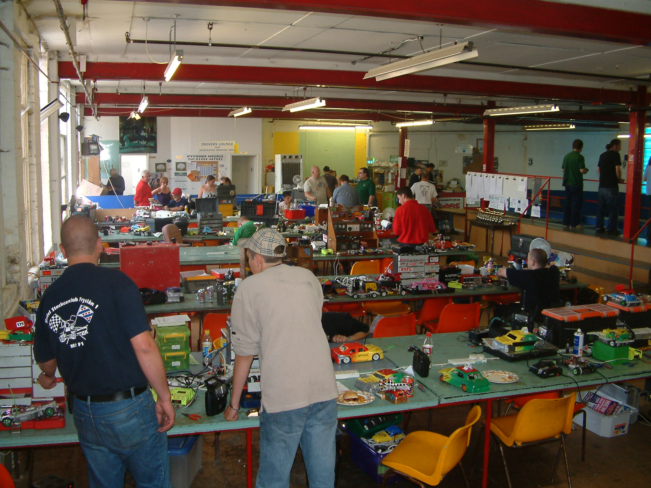
1/12 Stock Car & Banger British Open

Due to not having all the results from last years British Open meeting that was run at the Dunfermline Club in Scotland I will give you the Consolation & Final results at the start of this years report to put the record straight, and do justice to last years Open champion, starting with the result of the consolation race which was won by
Andrew Cox with 72 laps along with progression into the final, then it was Joe Brown with 67 followed by Peter Ayriss on 66 and Martin Nash with 65, fifth finisher was Robert Teuke with 64 then it was Gary Riddell on 63 chased by Derek Kerr on 60 laps, also finishing with 60 was Andy Cattell, then we had Pete Riddell with 22 laps.

Congratulations to the youngest ever winner of the British Open title and a deserving one at that to Ryan Cattell finishing with 74 laps, then we had Gary McMullen in second place on 72 laps as was Karl Spencer in third and also Clive Buckler in fourth spot finished with 72 laps and just one lap behind these racers was Ben Harding in fifth place, sixth across the line was Ross Kerr with 67 then it was the consolation winner Andrew Cox coming home in seventh place with 66 laps followed by David Smith on 65 laps who was followed by Mark Cooper on 63 in last place.
British Open 2003
The High Wycombe Mini-Stox club is one of the older and more established clubs in the country, boasting a permanent venue, along with the Frog & Duck Café, run by Jill Hewitt, Kim Hurst and Maureen Hewitt. Race director is Michella Webster who is also the BRCA secretary for 2003, she is ably assisted by Brian Seymour on the computer along with club committee members Jase Howse, Jason geezer Bartropp and Roy diamond Calver.
Unfortunately the choice of date for the meeting was a bad one as it turned out, with there being a lot of other clashing events happening on the same weekend, the first F1 stockcar semi final being one of them, also there is the problem of work commitments for those who have to work on Saturdays, with all things considered we had a reasonable turn out of twenty-three for the stockcars and seventeen for the bangers.

Heat 1 was won by Karl Spencer from the Rugby club with 57 laps from the chasing David Smith with 56, then it was Ben Harding and Mike Tomkinson on 54 laps in that order followed by Alastair Needham with 53, then we had a 52 by Bryan Lee and Peter Ayriss and last in this heat was Nicholas Cooper on 41. Heat 2 was a battle between the High Wycombe racers, which saw the young pretender Mark Stiles take the honours on 56 laps, also finishing on 56 was Roy Calver followed by Jason Bartropp, Rob Teuke and Mark Cooper all on 55 laps, then we had Andy Cattell just one lap behind these three, Andy was followed by Debbie Jackson on 47, and last place was taken by Martin Cooper with 32. Heat 3 was won by Gary McMullen with 56, then we had three racers cross the line on 55 laps, they were Ryan Cattell, Dave Gwilliam and Clive Buckler in that order, next racer across the line was Urmstons Joe Brown on 43 followed by Derek Cayzer with 29 and an out of sorts Paul Riddell finishing with just 17 laps.

The flying Jason geezer Bartropp wins the firs heat of the bangers with 54 laps, followed by Martin pinky Cooper on 50, then we had both Mike Tomkinson and Gary McMullen on 47 laps, then we had another pair of racers finishing on the same lap score of 40, they were David Smith and Tracy Cooper who were followed by Rob Hewitt on 34 and Andy Cattell with 25 and last in this heat was Roy Calver on 8 laps. Heat 2 was won with 47 laps by Bryan Lee, then we had Debbie Jackson finishing with 39 and just one lap behind Debbie was Dan Martin on 38, next racer to finish was Clive Buckler with 34 followed by Ryan Cattell with 29 laps and Peter Ayriss with 23, then it was Alastair Needham with 18 laps, and bringing up the rear we had Derek Cayzer with 15.

Alastair Needham wins heat 1 with an impressive lap score of 59 which equals the current track record, he was followed by Ryan Cattell on 58 as was Karl Spencer, then it was Joe Brown on 57 chased by Rob Teuke with 56 and Roy Calver not far behind on 54, unfortunately Bryan Lee did not start in this heat. Heat 2 saw Clive Buckler lower the colours of Mark Stiles with a fine win on 54 laps to Marks 53, also finishing with 53 was David Smith and Jason Bartropp, then we had Ben Harding on 48 laps as was Dave Gwilliam, these two were followed by Nicholas Cooper on 36 and in last place we had Martin Cooper on 27 laps. Heat 3 was win number two for Gary McMullen on 56 laps followed by Mark Cooper with 54, then we had Mike Tomkinson just one lap behind Mark on 53, fourth across the line with 50 laps was Peter Ayriss, also finishing on 50 was Andy Cattell, then we had the improving Paul Riddell with 47 chased by Derek Cayzer on 42, and last place in this heat went to Debbie Jackson with 27 laps.

There appears to be no stopping this man! Easily the fastest on the track, collecting win number two was Jason Geezer Bartropp with 52 laps chased by Alastair Needham with 49 laps, third across the line was Martin pinky Cooper with 45 laps as was Bryan Lee, then we had Roy Calver with 37 also on 37 laps was Peter Ayriss they were followed by Ryan Cattell with 30, then it was close for last place between Tracy Cooper and David Smith for last place, with this honour going to Tracy with 8 laps compared to David’s 9. Heat 2 and Gary McMullen records a win with his banger on 47 laps chased by Clive Buckler on 46, then it was Andy the baron Cattell with 43 followed by Dan Martin on 38 laps as was Debbie Jackson, next across the finish line was Rob Hewitt with 29 followed by Mike Tomkinson with 20 and the out of sorts Derek Cayzer finishing in last place with 11 laps.

Yet again the track record is bettered, in round two Alastair set it at 59 laps in a time of 304.47, in heat one Karl Spencer also records 59 but with a better split time of 302.43, in close attendance to Karl were Mark Cooper and Alastair Needham both on 58 and just one lap behind these two was Clive Buckler, Clive was followed by Bryan Lee on 53 as was Andy Cattell with Dave Gwilliam just one lap further behind in last place as Debbie Jackson did not start. Heat two and the record falls once again, this time it’s Ryan Cattell recording 59 laps in a split time of 301.73, second racer across the line was Jason Bartropp on 56 chased by Mike Tomkinson on 55, then we had a big improvement in lap score terms for Martin Cooper with a respectable 54 laps, also finishing on 54 laps were Peter Ayriss and Joe Brown, last place in this heat went to Mark Stiles with 51. Heat 3 was a good round for Ben Harding, posting a 59 score in a split time of 304.79 which is the third best race score of the day so far! finishing in second place we had Gary McMullen with 57 laps then both David Smith and Rob Teuke recorded 53’s they were followed by Roy Calver with an 49 score, then we had Paul Riddell on 37 and Nicholas Cooper with 30, and another bad score for Derek Cayzer in last place with 13 laps.

He did not have it all his own way this time, but still took the win, but only just after both Jason Bartropp and Gary McMullen had finished on 49 laps with Jason in front by virtue of a better split time of 302.87 compared to Gary’s time of 306.23, finishing in third place we had Martin pinky Cooper with 47 followed by Mike Tomkinson on 45 and just one lap behind Mike was Andy Cattell with 44, next finisher was Tracey Cooper with 42 then it was Urmstons David Smith 40 laps, also finishing on 40 laps was Rob Hewitt, then bringing up the rear we had Roy Calver on 25 laps. Heat 2 was another win for Alastair Needham with 50 from a 48 by Clive Buckler, then it was Debbie Jackson with 45 and Peter Ayriss on 34, fifth finisher in this heat was Ryan Cattell with 12 laps followed by Dan Martin with 4, then it was Bryan Lee in last place with 1 lap as Derek Cayzer had thrown the towel in and called it a day!

The last round of heats, and with the lap scores being so close some are relying on a good score this round to guarantee a place in the final, the winner of the first heat was Karl Spencer with 58 laps from Ben Harding on 57, then we had Alastair finishing with 54 and Peter Ayriss just one lap further back on 53, then we had three racers finishing on 52 laps they were Mike Tomkinson, Bryan Lee and David Smith in that order and last in this heat was young Nicholas Cooper with 39 laps. Well would you believe it! after two last place finishes in the earlier heats, Martin Cooper wins one, with 56 laps it was very close behind him with the next three racers all recording 55 laps in order of finishing it was Andy Cattell, Jason Bartropp and Roy Calver, with the next two racers just one lap further behind these three racers they were Mark Cooper and Mark Stiles both finishing with 54 laps, then we had Rob Teuke on 48 and Debbie Jackson bringing up the rear with 39 laps. Heat three winner was Ryan Cattell with 58 laps as was Gary McMullen in second place, next to finish was Joe Brown with 55 laps and just one lap behind Joe was Clive Buckler on 54 followed by Paul Riddell on 45 then it was the unfortunate Dave Gwilliam suffering a break-down in last place with just 3 laps as Derek Cayzer had already called it a day by throwing in the towel!

Bryan Lee is the first racer on the day to beat the previously unbeaten Jason Bartropp, but it was a close run thing after both racers had recorded 51 laps, with Bryan recording a better split time by 3.33 seconds, third place finisher was Alastair Needham on 49 laps as was Martin Cooper in a slower split time, then it was Tracy Cooper with 47 and David Smith on 34, seventh place finisher was Roy Calver with 17 laps as was Peter Ayriss in last place in this heat as Ryan Cattell did not start the race. Gary McMullen wins the final heat with 51 laps chased by Mike Tomkinson on 49 and Andy Cattell with 48, the fourth finisher was Rob Hewitt with 46 chased by DebbieJackson on 43 laps then it was Dan Martin with 28 laps followed by Clive Buckler in last place with 11 laps, as Derek Cayzer had already left for home!

The Qualifiers for the Stockcar Consolation

As I mentioned before it was extremely close between a number of racers on automatic qualification to the final or the consolation race the unlucky racers that had just missed out on the final were –

Joe Brown 166 What a close race it was at the finish, just a whisker between first and
Clive Buckler 166 second place, at the finish it was local racer Mark Stiles first across
Roy Calver 165 the finish line with 57 laps in a time of 303.95 followed by Mike
Rob Teuke 164 Tomkinson who also finished on 57 laps but with a slightly slower
Mark Stiles 163 split time of 304.87 that’s just 0.92 of a second behind Mark, third
Mike Tomkinson 162 place went to Roy Calver with 56 laps followed by Clive Buckler
Andy Cattell 162 with 55 laps as was David Smith but he was 0.7 behind Clive, then David Smith 162 just one lap behind these two it was Rob Teuke in sixth place with
54 laps, following Rob home in seventh place we had Urmston racer Joe Brown with 53 laps followed by Andy Cattell on 50 laps.

The hot favourite for the final has to be local racer Jason Geezer Bartropp, who on his home track easily qualified on pole with a grand total of 157 laps from his best three race scores added together, the rest of the qualifiers along with there qualifying totals were –
Alastair Needham 148
Gary McMullen 147
Martin Cooper 146
Bryan Lee 143
Mike Tomkinson 141
Andy Cattell 135
Tracy Cooper 129
Clive Buckler 128
Debbie Jackson 127

From the start Jason was off like a rocket, with the rest trailing in his wake was it really going to be this easy to win the title, after the first nine laps of the final Gary McMullen was out of the race after his car had left the track and the rules state that his car can-not be put back onto the track, one of the main contenders out looking good for Jason, then the biggest shock of all was about to unfold, with just 12 laps gone Jason made a mistake and got put into the infield, as there was a ramp left in the infield so that a racer could get out and back onto the racing part of the track, Jason backed up into a corner and took a mighty run up to the ramp, his aim was good got it in one unfortunately he was going a bit too fast, because his car took off and landed mid track then barrel rolled all the way out of the track all on it’s own, and just like Gary that meant the race was over for the hot favourite, and boy you should have heard the laughter! after this incident the final soon settled down into a race between the remaining cars left in, at the finish we had a new champion in Alastair Needham with a race winning 50 laps, followed by Martin Cooper with 48 in second place and Mike Tomkinson on 46 laps in third place, Mike was followed by Debbie Jackson with 41 then it was Tracy Cooper on 35 and Andy Cattell with 24, Bryan Lee came home in seventh place with 21 laps followed by Clive Buckler on 18, needless to say Jason finished in ninth place with 12 laps and Gary collected the wooden spoon with his lap score of 9.
So congratulations go to the new BRCA 1/12th Banger Champion for 2003 – Alastair Needham

The qualifiers for the final in order of qualification were –
1. Ryan Cattell 175
2. Karl Spencer 175
3. Alastair Needham 171
4. Gary McMullen 171
5. Ben Harding 170
6. Mark Cooper 167
7. Jason Bartropp 166
8. Consolation Winner Mark Stiles

What a credit to the formula, good clean racing on a extremely fast oval, well done to all who was in the race, at the finish it was Karl Spencer taking the title, along with the track record, once again it’s 59 laps but in a split time of 300.65 compared to Ryan Cattell’s 59 in round three with a split of 301.73, finishing in second place we had Alastair Needham who was also on 59, and the final rostrum place went to Ben Harding with 57 laps although Gary McMullen was also on 57 laps the split time showed that he was behind Ben, next across the finish line was the pole sitter Ryan Cattell with 56 laps, coming home in sixth place was Jason Bartropp with 55 laps followed by Mark Cooper who was on 55 laps as well but with a slower split time once again, and finishing in eighth place was the consolation winner Mark Stiles with 52 laps
Once again it’s congratulations to the new BRCA Stockcar Open Winner 2003 – Karl Spencer

Grade awards went to –
Top Junior Rob Teuke
Best Blue Nicholas Cooper
Best Yellow Bryan Lee
Concourse Stockcar – Ben Harding Banger – Rob Hewitt

Tech chart of the finalists from the British Open Final 2003

Name | F/Tyre  inside | F/Tyre  outside | R/Tyre  inside | R/Tyre  outside | Gear  Ratio | Speedo | Charger | Car /  type | Chassi | Cells | Club | Grade | Qualif | Final
Jason  Bartropp | Ufra  Jap  Med | Ufra  Jap  Med | Ufra  SE | Ufra  SE | 13/51 | Mardave | Protrack | Diamond | Diamond | 3000 | High  Wycombe | Blue | 7 | 6
Gary  McMullen | Double  Blue | Electric  Hard | Ufra  SE | Ufra  Pink | 13/48 | Mardave | Protrack | Rapid  Pink | Rapid  Pink | Corally  1700 | Urmston | Silver | 4 | 4
Alastair  Needham | Double  Blue | 812 | Ufra  SE | Ufra  Pink | 13/49 | Associa | Schumacher | Rapid  Pink | Rapid  Pink | Corally  1700 | Urmston | Red | 3 | 2
Ryan  Cattell | Pink | Ufra  Jap  Med | Ufra  Pink | Ufra  Pink | 14/50 | Lecatt | Apex | Lecatt  Mk2 | Rapid  Pink | Corally  1700 | Stony  Stanton | S/S | 1 | 5
Karl  Spencer | Ufra  SE | Electric  Med | Ufra  Pink | Ufra  Pink | 13/50 | Mardave | Apex | Elite  Racing | Anderton | Sanyo  2400 | Rugby | S/S | 2 | 1
Ben  Harding | Ufra  Jap  Med | Presision  Yellow | Ufra  Pink | Ufra  Pink | 12/50 | Mardave | Apex | Team  Skint | Anderton | Corally  1700 | Rugby | S/S | 5 | 3
Mark  Cooper | Ufra  Pink | Ufra  812 | Ufra  Pink | Ufra  Pink | 14/51 | Lecatt  2 speed | Apex | Lecatt | Anderton | Sanyo  2400 | Stony  Stanton | Red | 6 | 7
Mark  Stiles | Ufra  SE | Ufra  Jap  Med | Ufra  Pink | Ufra  Pink | 13/50 | Stiles | Apex | Diamond | Diamond | 3000 | High  Wycombe | Yellow | 8 | 8

