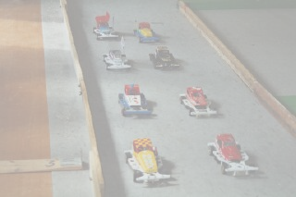

In association with Excel Courier Services C/O Miles Allen
The toughest national meeting of the year, judging by last year’s national, of all the finals this is probably the hardest to qualify for, as is usual with the Urmston national a good turn out of 48 cars were in attendance, although 51 had actually booked in to race. Again we had racers travelling long distances, some from Cornwall and some from Scotland.
There has been a lot of activity going on at the Urmston club since my last visit, the most noticeable being the new track outfield constructed out of thicker and higher wood than the old one, also it is held together by a simple but effective angled iron pieces that slot over the wood but hold it very firmly in place, also there was a new drivers rostrum that is also linked to the outfield helping to keep it in place, also the club has been upgrading the lap counting equipment in various ways, the infield has also been revamped, very impressive I must say.
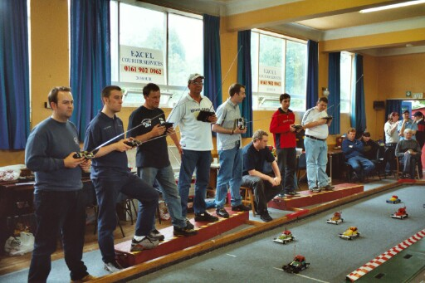
Once again we had Colin Eardley in attendance to do the scrutineering, not an easy job, as there are so many different types of car now being raced, also our safety officer Andy Wallace was in attendance, happy with all the changes that have been made to the track and the drivers rostrum.

Round One.
Race winners were Joe Brown winning his heat on 84, as did Gareth Jones on 79, the best lap score of the round went to Gary McMullen winning his heat and also beating the old track record into the process on 88 laps, some achievement this as we are running the standard 540 Mabuchie motor, as compared to the faster Graupner motor of last year. Ben Harding also won his heat with 85, as did Rugby veteran Clive Buckler on 80, Mark Cooper also recorded a win in his heat with 81, World Champion Phil Smith also got off to a winning start on 85. Other drivers worth a mention in this round were 79’s by Jon Cutts and M.Tomkinson young Ryan Cattell, Urmston racer’s Pete Ayriss and Stewart Smith. A good score of 84 was recorded by Robert Teuke, Dave Hasting on 83 which only gave him fourth place in his heat, Martin Cooper recording 84 which gave him third in his heat, long distance traveller Ross Kerr also went well to record an 80 lapper.

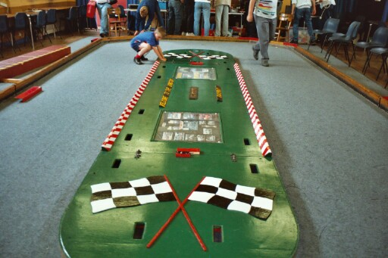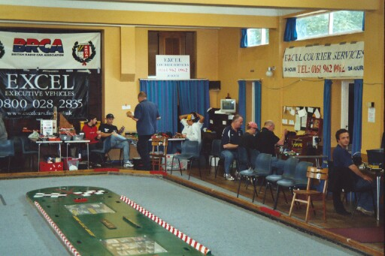

Round Two.

Heading the leader board this round and increasing the track record as well was Ben Harding with an impressive score of 89, Gareth Jones records his second win with an 83 as did Gary McMullen going two laps better on 85, and look at this from the Urmston newcomer Duncan Bullock recording a heat win on 86, also we had Andrew Cox winning a heat with 82 laps.
Clive Buckler just missed equalling the new track record by winning his second heat of the day with 88, as did current World Champion Phil Smith winning on 82.Other good lap scores were 85 by Jon Cutts, another 84 by Joe Brown, both Karl Spencer and David Smith had 84 laps, in Karl’s case this was only good enough for fifth place in his heat! Dave Hastings recording a fine 84 and Andy Cattell recording an 82, Mark Cooper scoring another 81, which gave him second in his heat, Scottish racer Ross Kerr improved his last score by five laps with an 85. The best of the juniors was Robert Teuke with 80 from National Junior Champion Ryan Cattell’s 75 and Arron Eaglen with 72.

Round Three.
Recording his first win and increasing his best score by some 11 laps was Anthony Jewell on 88, matching this was Ben Harding, another first time race winner was Paul Jenkinson with 83, Gary McMullen made it three out of three with another win on 82, Clive Buckler also wins his third heat this time on 81, another having a first heat win and looking like a good bet for the final was Rugby youngster Robert Teuke recording a mighty 86 lapper and last of the heat winners was Dave Hastings with 82. Other good scores this round was a third score of 84 by Joe Brown, David Smith on 80, both Andrew Cox and Stewart Smith get 81, Phil Smith scores 85 which was only good enough for second in his heat, we had Cambridge National winner Martin Cooper scoring 83, and both Liskeard racers, all the way from Cornwall, Martin Nash and Andy Wallace both got 79 laps.

Round Four.
Top score this round was an impressive 86 lapper by Mark Cooper, also we had Jon Cutts recording his first race win of the day with 83, as did current European Champion Karl Spencer winning his heat with an 85, both Ben Harding and Clive Buckler completed their set of race wins, Ben winning with an 84 and Clive with 81, another first time race winner was Andy Cattell on 82 laps, and collecting his third win was Phil Smith with an 84, other good scores were 82 laps by Darren Grace which was for a second place in his heat, young Alan Bellis posted a fine 80 lapper, Gary McMullen finished off with an 83, Ryan Cattell finished with a 74 and surprisingly he did not win a single heat (unlike his dad!) Pete Ayriss had a good heat finishing with an 80, and another good score by Scottish racer Ross Kerr with 82 but once again no heat win.
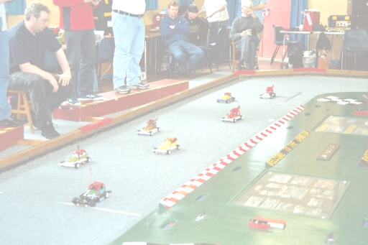
Consolation Race.
With such a high standard of racing qualification into the final or consolation was going to be hard, so with the best three scores to count the eight racers making the consolation were, just making it on count back as eighth qualifier was Andy Cattell with a total of 244 laps the same as the unfortunate Stewart Smith, seventh was Paul Jenkinson on 245, sixth was David Smith also on 245,fourth went to Ross Kerr on 247, third qualifier was Karl Spencer with 248,second was Mark Cooper on 248, and just missing automatic qualification to the final on count back with a total of 249 was Dave Hastings.
At some time or other during the race, every single racer lead the race at some time or other during the five minuets of hectic racing, but after the buzzer to end the race the result looked like this,

1st David Smith 81 split time 0.00310
2nd Mark Cooper 81 0.00480
3rd Paul Jenkinson 80
4th Martin Cooper 79 1.040
5th Karl Spencer 79 2.600
6th Andy Cattell 74 1.540
7th Dave Hastings 74 3.240
8th Ross Kerr 73
So David goes through to the final by the narrowest of margins at the cost of Mark.

Grand Final.
Heading the qualifiers was Ben Harding with a mighty total of 262 which included his new track record of 89, second was Urmston racer Gary McMullen with a total of 255, third qualifier was Phil Smith with 254, comeback kid Joe (pappa) Brown was next qualifier on 252, fifth and making his first final was Robert Teuke on 251, sixth was Clive Buckler with a grand total of 250, seventh was Rugby veteran Jon Cutts with 249, and joining them was consolation winner David Smith.
It has to be said that this race was pure quality, and a real testament to those that were in it, and a real treat for those of us that were watching it! And boy was it fast, the result hung in the balance right to the end with a new track record being set to take the win. If you want quality racing then this is the formula to be racing in, at the end the result was,

1st Ben Harding 90
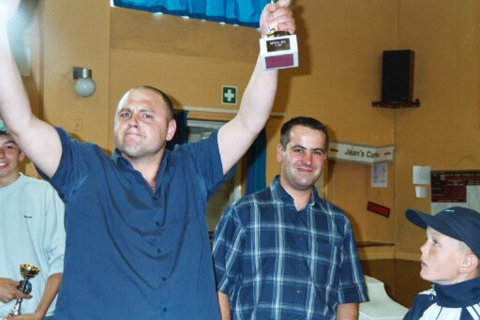
2nd Gary McMullen 89 Final
3rd Clive Buckler 88 Winner
4th Robert Teuke 85 0.880 Ben Harding
5th Jon Cutts 85 1.100
6th Phil Smith 84
7th David Smith 72
8th Joe Brown 33

Between the consolation and final a junior race was run, these are the names to watch out for in the future, as Rob Teuke will testify.
1st Arron Eaglen 74
2nd Joe Huxley 72
3rd Jamie Gundry 67
4th Daniel McMullen 61
5th Nicholas Cooper 60
6th Amy Gilpin 56

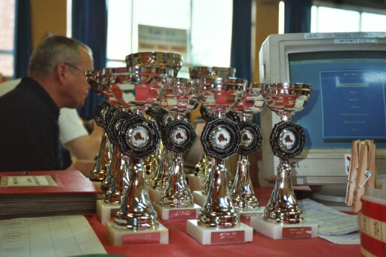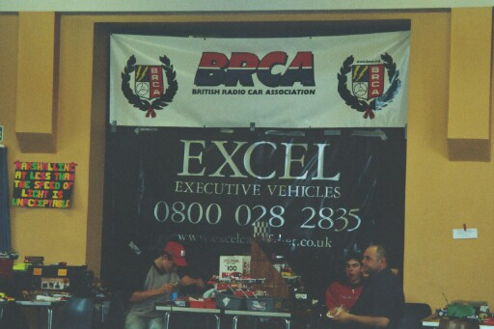
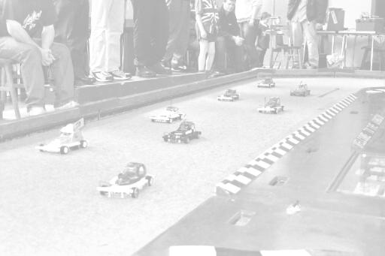  Name . | F/Tyre | F/Tyre | R/Tyre | R/Tyre | G/Ratio | Speedo | Charger | Car type | Chassi | Cells | Club | Grade | Quali | Final
Ben Harding | Jap M | Jap M | Pink | Pink | 12/50 | Mardave | Apex | Spencer  Pinky | Anderton | Corally  1700 | Rug | S/S | 1 | 1
Gary McMullen | 812 | Double  Blue | Pink | GLF | 12/50 | Assoc | Tekin | Pinky  MWB | Anderton | Corally  1700 | Urm | S/S | 2 | 2
Phil Smith | 812 | Jap | Pink | Pink | 13/53 | Mini | Apex | Bingham  Schumacher | Bingham | Corally  3000 | Rug | Gold | 3 | 6
Clive Buckler | 812 | O 2 | Pink | Pink | 13/51 | Mk1  Mardave | Apex | Buckmacher | Buckmacher | 2000 | Rug | S/S | 6 | 3
Robert Teuke | Jap | Jap  Soft | Pink | Pink | 12/50 | Mini | Apex | Teuke  Pinky | Anderton | Corally  1700 | Rug | Blue | 5 | 4
Joe Brown | SE | 812 | SE | Pink | 11/50 | Mini | Apex | Scratch  Built | Anderton | Sanyo  2000 | Urm | Red | 4 | 8
Jon Cutts | SE  Med | Pink | SE | SE | 13/51 | Mini | Racing  Jack | Eaglen | Mardave | Corally  1700 | Rug | Red | 7 | 5
David Smith | EH | Gold | 812 | SE | 12/50 | Assoc | Pro  Track | Mardave | Anderton | Corally  1700 | Urm | Red | 8 | 7

Urmston National June 3rd 2002

