Rugby National 1/12th Stockcars

Round two of the 2002 National Points Championship for the Stock Cars, Thirty-six drivers booked in this year compared to last year’s excellent entry of Forty-seven. Good to see a lot of younger drivers racing, as well as old time racer Joe Brown making an appearance, also there was a variety of different chassis being used Joe’s being one of them, more about that at a later date. Practice went smoothly as did scrutineering, all the cars passing without any major problems. Jackie was keeping the hungry travellers well fed with plenty of bacon butties and cups of tea and coffee appearing from out of the kitchen. Alan was there with plenty of spares for the cars, as Rugby has a reputation as being a bit hard on the cars due to the amount of contact between them, on the tight tricky oval. Jon the promoter not wanting the racing to be easy, as he prefers drivers having to work hard to obtain a win, i.e. a car set up well, to race on the best racing line, and driven well should be able to beat a faster car that is not racing on the best racing line, also a slower car should also be able to avoid more of the pile ups that happen during a race, only one way to see if this is true and that’s by taking a look at the heat’s of racing. Point of interest here, as this is the reigning World Champion Phil Smiths home track and also European Champion Karl Spencer and Urmston Points Champion Ben Harding.

Round One.
Opening his account with 77 laps was Clive Buckler winner of Friday night’s club final, followed by Gary Osbourne on 72. Heat two was won on 86 laps by Ben Harding then came Alan Bellis and Pete Ayriss on 74’s. Heat three and it’s Karl Spencer in front on 78 followed by David Smith with 70. Heat Four was a cracker won by surprise package Andy Cattell on 82 ( dad of Ryan who normally does all the winning ) then came Rugby promoter Jon Cutts on 81 chased hard by current National points Champion Gary McMullen on 80 who was pushed hard all the way by Paul Jenkinson on 79. Heat Five saw World Champion Phil Smith take the win on 82 clearly winning from Martin Cooper and Pete Clarke both on 73 then came Andrew Cox one lap further back. Usual racers in the National series having a bad round were Junior Points Champion Ryan Cattell broken speed board, also Mark Cooper suffering with handling problems due to a loose transponder in his car.

Round Two.
What a scorcher by Ben Harding setting F.T.D. with 87 laps then came Ryan Cattell on 82 pushing race one round one winner Clive Buckler down to third place with 80. Heat two and a win for Pete Ayriss on 71 just in front of Alan Bellis on 70, also going well in third place on 69 was Lawrence Collins, with Liskeard promoter Andy Wallace posting a 68. Heat three and another win for Karl Spencer on 82 from Stuart Smiths 76 then came Robert Teuke and Paul Jenkinson both on 74 chased all the way by Martin Nash finishing on 73. Heat four saw Andy Cattell just finishing ahead of Andrew Cox both on 72 then came Mark Cooper on 70 laps from Pete Clarke’s 68 and look at this National Points Champion Gary McMullen down in fifth place also finishing on 68 !!!!! Heat five saw a surprise winner in Duncan Bullock with 69 then came Cambridge National Winner Martin Cooper on 68 and a good third place on 64 for Alan Greig. Racers having a bad round were Phil Smith and David Smith ( must be the name Smith ) and who would have believed it Andy Cattell two wins out of two can he maintain this form?
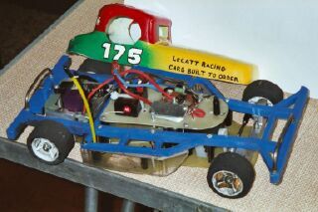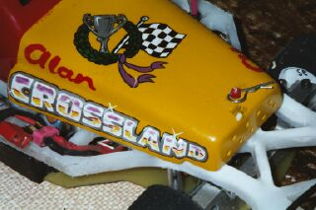
Round three.
Another surprise winner in heat one this time it was Pete Clark racing away to take the win on 77 laps chased all the way by Stuart Smith finishing on 75, then came Robert Teuke on 74 followed by Gary Osbourne on 73 and a 72 by Paul Jenkinson. Heat two was another closely fought race that saw Clive Buckler just beating Karl Spencer who was just in front of Jon Cutts who was just in front of Mark Cooper the scores were 83,82,81,and80 wow! Heat three and Phil Smith back in front after his mishap in round two winning on 76 from Andrew Cox with 69. Heat four saw Ben Harding leading from the front to take the win on 82 from Peter Ayriss on 75 and Martin Cooper finishing on 71. Heat five and it’s Gary McMullen back on top with 75 from Graham Farrell with an excellent 75 from the Rugby yellow grader.
Drivers having a bad round this time included David Smith, Andy Cattell and Robert Teuke, still Andy Cattell has one more round to take maximum points from the heats as you drop you’re worst score.

Round four.
Winning his first race of the day was Mark Cooper taking heat one on 78 from Gary Osbourne on 76. Heat two and another good score by Karl Spencer finishing with 80 then came Andrew Cox on 76 just in front of Jon Cutts finishing on 75 one lap in front of David Smith who was also one in front of Clive Buckler who finished on 73. Heat three was a real close finish between Phil Smith, Ben Harding and Andy Cattell with Phil on 78 and Andy and Ben both on 77. Heat four which was a real scrappy race won by Ryan Cattell on 67 then came Alan Bellis and Pete Ayriss on 61.The last heat of the day was won by Gary McMullen on 77 from Robert Teuke on 69 who was just in front of Paul Jenkinson, Pete Clarke and young Thomas Collins all finishing on 68.

So the nail biting begins as the laps are added together, to decide who goes straight into the final, and the dice of death in the consolation race as only the winner progresses through to the final. Big surprise as Ryan Cattell did not qualify for either the final or consolation race and neither did previous National winner Martin Cooper (another twenty years to the next one?) should read the advice at the top of this report Heading the eight qualifiers in the consolation race, and just missing the final was Mark Cooper, the other seven drivers were, Paul Jenkinson, Gary Osbourne, Andrew Cox, Pete Ayriss, Stuart Smith, Pete Clarke, and Robert Teuke. A good clean race ensued which was lead by Mark Cooper right up to the last thirty seconds where he was overtaken by eventual winner Paul Jenkinson who finished on 75 laps to Mark’s 73, the rest of the drivers not far behind, as last placed Rob Teuke finished on 66 laps.
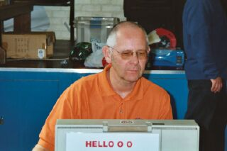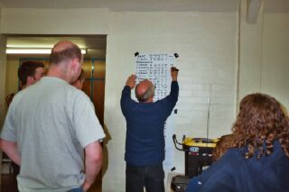
Final
A mouth watering line up of talent made it through to this final, with five drivers in the line up that were also in the World Final race, in qualifying order they were,
Ben Harding Phil Smith
Karl Spencer Gary McMullen
Clive Buckler Andy Cattell
Jon Cutts Paul Jenkinson
And a closer race you would be hard to find, after a very frantic five minuets of racing the win went to Clive Buckler by split time from Ben Harding both finishing on 78, we had another three drivers just one lap behind these two, and finishing third to fifth, separated by split times were Andy Cattell, Karl Spencer and Jon Cutts all on 77, then it was reigning points champ Gary McMullen on 75, seventh was consolation winner Paul Jenkinson on 69 and in last place but suffering a break down on 11 laps was Phil Smith.

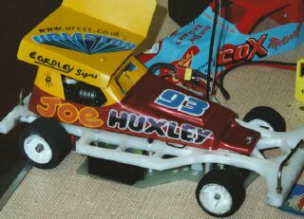
Grade awards went to (as there were no white graders, the white grade award was not handed out) the yellow grade went to Joe Huxley, best blue went to (mr straight on) Pete Ayriss, and best junior was Robert Teuke. There was also a yellow grade race won by up and coming racer Alan Bellis.

After meeting comment, there was twenty heats of racing won by eleven different drivers, but when you look at the winning laps they ranged from Ben Harding’s FTD of 87 all the way down to Ryan Cattell’s winning score of 67, suggesting a slight in-balance in the heat’s, as this difference might suggest, if you average the lap times to about three seconds a lap over five minuets, then the difference works out to almost a whole minuet of racing time. Also Paul Jenkinson had only the one race win in the consolation, which means there were twelve different race winners from twenty-one races discounting the final.

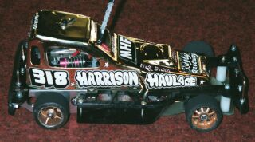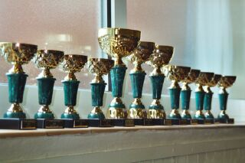

Thank You to C.E.S. for their sponsorship.

Name | F/tyre | F/tyre | R/tyre | R/tyre | Gear ratio | Speedo | Charger | Car type | Cells | Club | Chassis | Qualif | Final Place
Ben Harding | Jap | Jap | SE | SE | 12/50 | Mini | Apex | Pinky  Modified | 2000 | Rug | Anderton | 1 | 2
Karl Spencer | SE | LM | SE | SE | 13/50 | Mini | Apex | Pinky  Modified | 2000 | Rug | Anderton | 2 | 4
Clive Buckler | Hard | 812 | Pink | Pink | 12/50 | Marda  Mk1 | Apex | Buckmacker | 2000 | Rug | Buckler | 3 | 1
Jon Cutts | Pink | SE | SE | SE | 13/51 | Mini | Racing  Jack | Eaglen  Mardave | 2400 | Rug | Mardave | 4 | 5
Phil Smith | Hard | 812 | Pink | Pink | 11/51 | Mini | Apex | Bingham | Corally  3000 | Rug | Bingham | 5 | 8
Gary McMullen | D/  Blue | 812 | Pink | Pink | 12/50 | Associ | Tekin  BC112A | Rapid  Pink | Corally  1700 | Urm | Anderton | 6 | 6
Andy Cattell | Jap | SE | SE | SE | 12/50 | Marda  Lecatt | Apex | Lecatt | Corally  1700 | S/S | Lecatt  Mardave | 7 | 3
Paul  Jenkinson | SE | Jap  Med | Pink | Pink | 12/50 | Associ | PRO  Trak | Rapid  Pink | Schumac  2400 | Urm | Anderton | 8 | 7

Rugby National 14th April 2002

