Liskeard Speedweekend

1/12th Stockcars & 1/12th Unlimited Bangers

The speed weekend is one of the highlights of our racing year, in fact it should read speedweek as those of us that were down here on holiday for the week, were able to race on the club night, as well as an extra meeting on the Friday night as well as the weekend of racing. Once again the meeting’s are taking place in the excellent Menheniot Village Hall, which provides first class facilities, including disabled access. Again Andy Wallace and the club members have worked wonders in attracting sponsorship for the meetings over the weekend, and again they have produced an informative program for all the racers attending the meetings. Credit must go to Andy and his club members for making this one of the best clubs in the country in such a short space of time, long may it continue!


Sponsored by Weldspray Engineering
Twenty-four racers assembled for this championship meeting, racing was to a limited set of rules by the Liskeard club, with the cell capacity set at a maximum of 2400 but six cells could be used.
Round. 1.
Gary McMullen makes a good start in heat one with 75 followed by Mike Tomkinson on 69 and Paul Jenkinson on 68. Race two, was won by David Smith with 69 from Alec Quarman on 63. Race three saw local racer Martin Nash out in front with 68, easily beating Ivan Blacks score of 53 in second place.
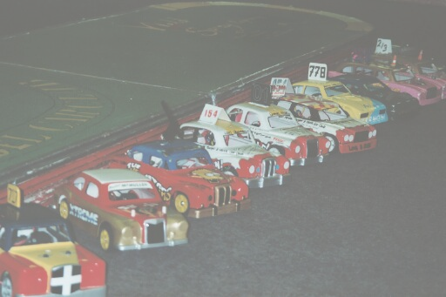
Round. 2.
David Smith takes the win with 71, chased by Paul Jenkinson with 69, then we had two racers on 57, who were Emma Hyde and Jason Dommett. Race two and its Martin Cooper winning with 79 laps from Andy Wallace and Derek Cayzer who both finished with 65. Heat three was a win for Gary Osbourne on 74, next up was Martin Nash with 67 chased by Andy Cattell on 66.
Round. 3.
Martin Cooper went lap crazy winning with 82, from Martin Nash way back on 64. Race two was another easy win, this time it was Alec Quarman on 63, to Caroline Waldock’s score of 44. Race three saw David Smith out in front again, this time he got 81 laps, then it was 74 by Gary McMullen and 69 by Paul Jenkinson.
Round. 4.
Andy Cattell takes a race win with 74, then came Paul Jenkinson on 69 and Emma Hyde with 60.
Race two saw Gary McMullen crossing the line with 71, some way back n second place was Glenn Nash on 57. Race three was a higher scoring affair, won with 82 laps by Martin Cooper, from Gary Osbourne on 80.
No consolation race for the bangers just the top ten racers straight into the final, they were in qualifying order 1. Martin Cooper 2. David Smith 3. Gary McMullen 4. Gary Osourne 5. Paul Jenkinson 6. Martin Nash 7. Andy Cattell 8. Derek Cayzer 9. Emma Hyde 10. Becky Glover.
No real surprise that the title of Ulimited Banger Champion, went to Martin Cooper with a faultless display of racing in the final.

Sponsored by Gilberts Outfitters

Twenty-six racers then, split into five heats of racing over four rounds with the best three to count towards the qualifying score.
Round 1. Heat 1.
Gary McMullen gets off to a good start with a winning score of 97 followed by Gary Osbourn on 89 and Craig Summers on 82. Heat 2. Was won by Mark Cooper with 86 on a split time after Stuart Preston had also finished with 86 then it was David Smith on 84 and Martin Cooper on 80. Heat 3. Ben Harding records 91 laps fro Paul Jenkinson o 85 who was closely followed by Alec Quarman on 84 and Andy Cattell with 82. Heat 4. This one was won with 94 laps by Karl Spencer, then it was home club promoter Andy Wallace with 87 and Pete Ayriss on 84. Heat 5. Home club racer Bryn Finch wins heat five on 87 then came Ryan Cattell on 84 and Ivan (the terrible) Black with 83.
Round 2. Heat 1.
Gary McMullen takes another win, this time on 94 laps then it was Derek Cayzer and Gary Osbourne both on 89. Heat 2. Stuart Preston goes well and records a win with 80 then it was Mark Cooper on 77 and Daniel McMullen on 65. Heat 3. A 90 lapper was recorded by Ben Harding,who was closely followed by Andy Cattell on 88 and Paul Jekinson with 85. Heat 4. It’s Karl Spencer again, this race he got 94 laps to the 90 of Andy Wallace, with Pete Ayriss on 83. Heat 5 Another win for Bryn Finch on 86 chased by Ryan Cattell on 84 and another good score for Ivan Black with 80.
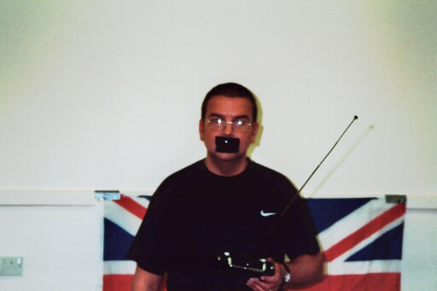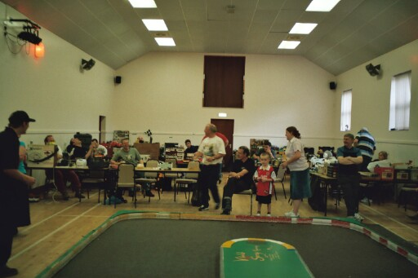
Andy (what did you say) Cattell View of the hall
Round 3. Heat 1.
Gary McMullen records another race win with his stockcar with 86 laps this time then we had Gary Osbourne on 82 and Derek Cayzer on 81. Heat 2. Mark Cooper gains revenge over Stuart Preston winning with 89 laps to Stuarts 84 who was just in front of David Smith also on 84. Heat 3. Ben Hardin records another win with 86 to Andy Cattell’s 83 then it was Alec Quarman on 81 and an 80 by Martin Nash. Heat 4. Another 90 score from Karl Spencer chased by Andy Wallace on 87 and Pete Ayriss with 81. Heat 5.Ryan Cattell just hold off Bryn Finch to take the win with 89 to Bryn’s 88 then we had Ivan Black on 85 and Alan Crossland gets a mention with 83.

Round 4. Heat 1.
Gary McMullen gets another score in the ninety’s winning with 95 to Derek Cayzers 91. Heat 2. Was a very close race with Mark Cooper just getting the win over David Smith after both had finished with 92 laps, trailing in third place was Martin Cooper on 90, then it was Stuart Preston on 85. Heat 3. Was won by Ben Harding with 87 then it was an 85 by Paul Jenkinson and 84 by Andy Cattell. Heat 4. Karl Spencer flies around to record an impressive 97 then we had Andy Wallace on 92, followed by Pete Ayriss with 85 and Alan (pop) Harding on 80. Heat 5. Saw Bryn Finch back to winning ways with 88 then it was close between Ryan Cattell and Alan Crossland after both crossed the line on 85 chased by Ivan Black with 83.

The consolation and the final were both excellent races around this super fast oval with some of the placing’s decided by split times, not your usual line up of racers, due to the good performance by some of the home club racers. Well done to all who took part.

Name | Club | Best 3 | Consolation  Qualifier | Laps | Place | Final  Qualifier | Laps | Place
Gary McMullen | Urms | 286 |  |  |  | 1 | Did not  Race | Not  Placed
Karl Spencer | Rug | 285 |  |  |  | 2 | 95 | 2nd
Andy Wallace | Lisk | 269 |  |  |  | 3 | 79 | 6th
Ben Harding | Rug | 268 |  |  |  | 4 | 95 | 1st
Mark Cooper | Ston | 267 |  |  |  | 5 | 85 | 4th
Gary Osbourne | Urms | 263 |  |  |  | 6 | 84 | 5th
Bryn Finch | Lisk | 263 |  |  |  | 7 | 77 | 7th
Derek Cayzer | Camb | 261 | 1 | 77 | 6th
David Smith | Urms | 260 | 2 | 84 | 3rd
Ryan Cattell | Ston | 258 | 3 | 32 | 8th
Andy Cattell | Ston | 255 | 4 | 88 | 1st | 8 | 88 | 3rd
Stuart Preston | Ston | 255 | 5 | 77 | 7th
Paul Jenkinson | Urms | 255 | 6 | 88 | 2nd
Pete Ayriss | Urms | 253 | 7 | 81 | 5th
Martin Cooper | Camb | 251 | 8 | 83 | 4th

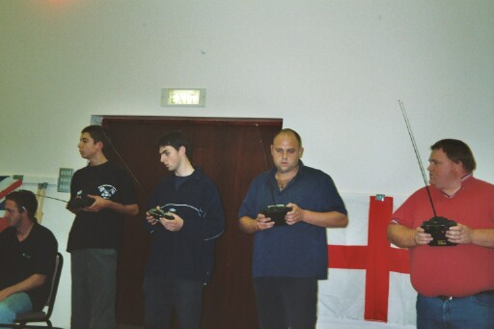
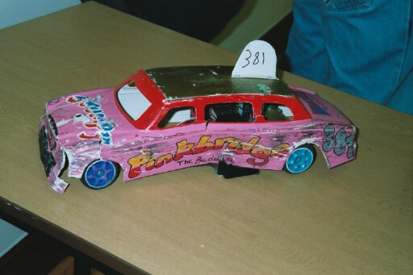

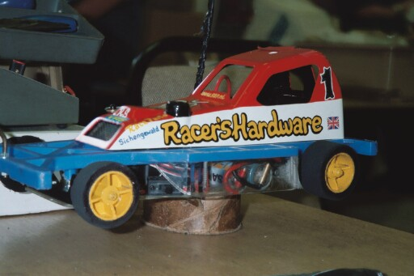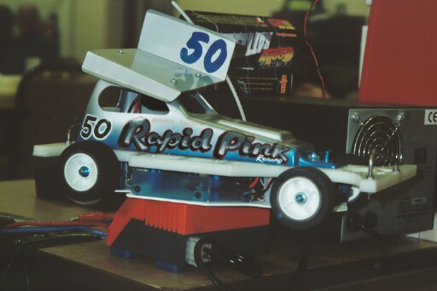

Sponsored by, Roseland Group

For many of the racers this was the main part of the weekend, national points at stake and all to play for. The racers contesting this round in the series were up to thirty-four, compared to the entrée of twenty-six for Saturdays meeting, usual format with the best three scores to count, seven straight into the final, and the next eight contesting a consolation race with the winner progressing into the final.
Round 1. Heat 1.
Just taking the win on a split time was David Smith from Ben Harding both on 94, closely followed by Paul Jenkinson with 93. Heat 2. Gary McMullen goes round on rails, winning with 98 laps chased by Ryan Cattell on 93. Heat 3. Andy Cox claims a race win and ten national points, winning with 92 laps, then it was Gary Osbourne on 87 and Andy Cattell on 86. Heat 4. Club promoter Andy Wallace takes the win on 92 from Mark Cooper on 87 and Alan Crossland with 83. Heat 5. A fine win with 91 for Karl Spencer, then it was Craig Summers on 83 followed by Colin Eardley (racing with four cells and not six like everybody else) on 79. Heat 6. A very close race with the victor being Martin Cooper on a split time from Jon Cutts after both had recorded 90 laps, next up was Martin Nash on 84 and Bryn Finch with 82.

Round 2. Heat 1.
Ben Harding back to winning ways taking the spoils with 97 laps from Ryan Cattell with 92 and Alec Quarman on 85. Heat 2. Gary McMullen claims another race win on 96, then it was a very close race behind him, you could have thrown a blanket, quite literally over the next four racers, just look at how close it was, with the places decided by split times, second went to David Smith, third was Paul Jenkinson followed by Gary Osbourne, all on 88 and just one lap behind these three was Bryn finch on 97. Heat 3. Andrew Cox goes well to record 96 laps, then we had Mike Tomkinson on 88 and Alan Crossland on 85 followed by an 82 by Derek Cayzer. Heat 4. Would you believe it Mark Cooper well beaten by Ivan Black, and Stuart Preston, the scores were 88, 87 and another 87 close racing, with Pete Ayriss just one lap behind these on 86. Heat 5. A 95 by Karl Spencer from a 92 by Andy Cattell and Andy Wallace with 91. Heat 6. Rugby promoter Jon Cutts takes the win with 94, and look at this Colin Eardley claims second on 89 chased by Craig Summers with an 87

Round 3. Heat 1.
Ben Harding secures another ten national, points by winning heat one with 95 laps chased by David Smith on 92 and then it was Jon Cutts with 90. Heat 2. Gary McMullen is out on his own in heat two taking the win with 97 from Andy Wallace on 89 and 88’s by Mike Tomkinson and Ryan Cattell. Heat 3. Urmston racer Andy Cox secures a race win with 88, then it was Rugby racer Pete Clarke on a split time from Pete Ayriss, after both racers finished with 87, then Alan Harding was next with 80. Heat 4. Andy Cattell takes the honours with a score of 87 from Gary Osbourne just one lap behind followed by Mark Cooper on 84. Heat 5. Another win for Karl Spencer, showing his liking for the Liskeard track, on 96 laps, then it was four cell racer Colin Eardley on a split time taking second place with 91 as was Bryn Finch in third. Heat 6. Martin Cooper wins on a split time from Craig Summers, after both had gotb82 laps, they were closely followed by Martin Nash on 80, and a very good score from Urmston junior, Daniel McMullen with 76 laps.

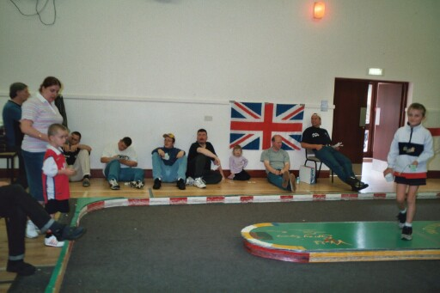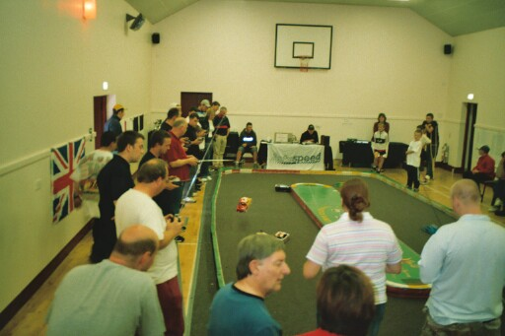

Round 4. Heat 1.
Last round of qualifying saw Pete Ayriss claim a race win in heat one with 85, just in front of Urmston promoter Alan Crossland who had 84, then it was Alan (pop) Harding on 78. Heat 2. Gary McMullen nearly breaks the ton, with another win agonisingly on 99 laps, chased by Mark Cooper with 92 and Jon Cutts on 88. Heat 3. Ryan Cattell chalks up a win with 94 from Andy Cox on 93, then some way back it was Ivan Black with 84. Heat 4. Andy Wallace records another win on 92 laps, then came Andy Cattell and Paul Jenkinson both with 90 chased by Bryn Finch on 89. Heat 5. Clash of the Rugby titans saw Ben Harding victorious with 96, from Karl Spencer on 92, with Martin Cooper and Nick Finch some way back on 81’s. Heat 6. David Smith wins with 95 from Craig Summers on 92, chased by Mike Tomkinson on 91.

Nail biting time again, as the scores are added together, to give us the names of the qualifiers for the consolation and the final. Which were, consolation race first,
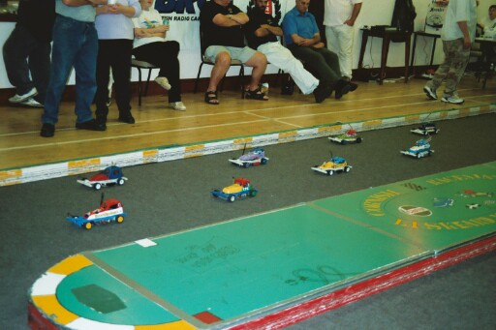
Consolation qualifiers. Total Laps
1. Jon Cutts 274
2. Paul Jenkinson 271
3. Andy Cattell 269
4. Bryn Finch 267
5. Mark Cooper 266
6. Mike Tomkinson 262
7. Craig Summers 262
8. Gary Osbourne 261

Yet again we had a super fast and clean race, worthy of a final, at the end it was Mark Cooper racing a Lecatt type of car for the first time, taking the win with 88 laps, second finisher was Paul Jenkinson on 87 as was Bryn Finch in third place, fourth was Gary Osbourne on 86 then we had Mike Tomkinson on 82 as was Craig Summers in sixth place, seventh was Jon Cutts with 79 and trailing home eighth was Andy Cattell with 63.

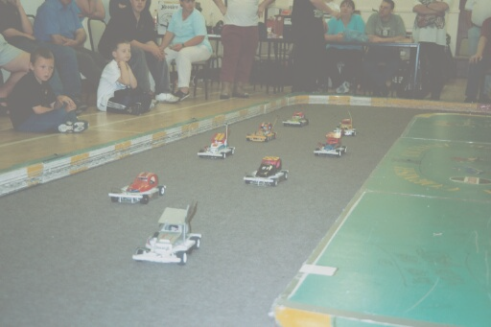
The line up looked like this in grid order,

Gary McMullen 294
Ben Harding 288
Karl Spencer 283
David Smith 281
Andy Cox 281
Ryan Cattell 279
Andy Wallace 275
Mark Cooper

It goes without saying, when you have a quality line up of racers such as this one, that the race is going to be fast and furious, also with such a lot at stake (national points wise) that the racers will also be doing their best to keep the racing as clean as possible, as one mistake around such a fast oval can cost you dear, as all the racers are evenly matched when it comes to a final.

The result and deserved win went to Ben Harding with 95 laps, pushed all the way by Gary McMullen with 94 in second spot, third and final rostrum place went to Karl Spencer on 93, regning junior national champion Ryan Cattell was fourth with 91, finishing fifth we had Andy Cox on 83 as did David Smith in sixth, but with a slower split time, local favourite and Liskeard club champion Andy Wallace finished seventh on 73 and the unlucky Mark Cooper, who suffered a break down, with a broken wire was last on 20 laps.

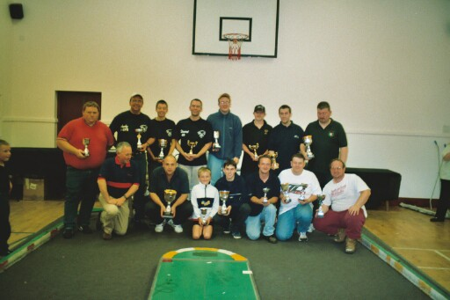
The national points race, with the dropped scores taken into account now looks like this, with just one round remaning.
1. Gary McMullen 494 6. David Smith 455
2. Ben Harding 492 7. Mark Cooper 452
3. Andy Cox 472 8. Jon Cutts 442
4. Ryan Cattell 456 9. Martin Cooper 436
5. Karl Spencer 456 10. Andy Cattell 432

Just twenty cars for this round of the bangers, the ten finalists were,
Gary McMullen, Martin Cooper, David Smith, Martin Nash, Gary Osbourne, Paul Jenkinson,
Andy Cattell, Derek Cayzer, Alex Quarman, and Emma Hyde.
With the win going to Martin Cooper, thus making it two finals wins, in two days with his banger.

Name . | F/Tyre | F/Tyre | R/Tyre | R/Tyre | G/Ratio | Speedo | Charger | Car type | Chassi | Cells | Club | Grade | Qualif | Final
Gary McMullen | D/B | 812 | Pink | Pink | 12/49 | Ass | Tekin | Rapid | And | Corally  1700 | Urm | Silver | 1 | 2
Ben Harding | Jap | Jap | SE | SE | 12/50 | Mini | Apex | Team  Skint | And | Reedy  2000 | Rug | Red | 2 | 1
Karl Spencer | SE | LM | SE | SE | 12/50 | Mini | Apex | Elite | And | Sanyo  2000 | Rug | S/S | 3 | 3
Andy Cox | SE | LH | SE | Pink | 12/51 | Ass | Apex | Rapid | And | Corally  1700 | Urm | S/S | 4 | 5
David Smith | D/B | 812 | Pink | Pink | 12/50 | Ass | Pro  Track | Rapid | And | Corally  1700 | Urm | Red | 5 | 6
Ryan Cattell | 812 | SE | SE | SE | 12/51 | Mini | Apex | Lecatt | And | Orion  2000 | Sto | S/S | 6 | 4
Andy Wallace | D/B | 812 | SE | Pink | 12/49 | Ass | Pro  Track | Rapid | And | Corally  1700 | Lisk | S/S | 7 | 7
Mark Cooper | SE | 812 | SE | SE | 13/50 | Mini | Apex | Lecatt | And | Reedy  2000 | Sto | Re | 8 | 8

Sunday 18th August Sponsored by Dolls House Builder

