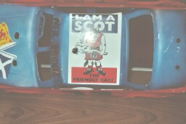

Part one of the weekend of racing at Milton Racehall home of the Leven club, in fact the weekend had actually started on the Friday for the English seasoned travellers, myself included, even though I was not racing until the stockcars on Sunday, after a nightmare journey that saw a slight diversion to Blackpool, I arrived at the B&B just before midnight, I must say thank you to Ian and Peggy Hamilton, the proprietors of the Forth Bay Guest House, who were good enough to stay awake waiting for me to arrive after my long journey north, if you think I had a long journey spare a thought for Andy Wallace and Martin Nash who had once again come up from Cornwall to take part in both meetings.
After a hearty breakfast me and my son Nicholas ventured on to the racehall to witness one of the epic battles that have happened over the years between England and the auld enemy Scotland, lets hope we have a civilised battle on the race track and remain good friends after it, that is until the next challenge is laid down, may-bee we could have a stockcar challenge with amended rules to suite! Well! Would you believe it they are arguing already and they haven’t started racing yet, luckily its only over the scrutineering of the cars or is it just Scottish tactics, before we start I must let you know about the amount of leg pulling that has gone on over a period of time since the date was set, better not, just take a look at some of the excellent body shells, lets just say its one nil to the English lads so far, but remember the Scots have home advantage, so after a few alterations to the English cars the racing can finally get-

under way.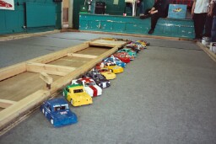 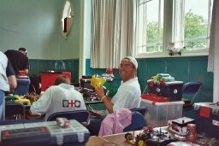
Not quite sure about the tactics of the racing, do you try to annihilate the opposition, or as there are national points at stake, do you go for laps, some thought needed here about the points and how they are scored!!! As the banger boys like to have fun and enjoy the contact element of their racing, which ever way it was, here are the results of the first race, a win for Gary Rabbit Rabbit Osbourne on 48 laps from Peter Baldie Ayriss with 45 then came Steven Diy Duncan on 42, race two was won by Neil Oops Ritchie with 53 laps from Sandy Boo Boo Bisset on 49, race three saw Craig Bomber Brown taking the win on 54 laps from Andy Start Money Wallace on 52 just in front of Andy The Baron Cattell with 51 then came Iain Oval Baws Wann with 46, race four and it’s a win for Ivan Auld Git Black on 53, second was Martin Navigator Nash on 50 as was James Ward in third, then we had Gary Gromit McMullen next on 42 just in front of Stu The Chairman Barbour also with 42.
Round two.
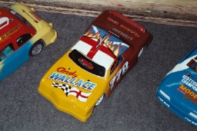
Race one saw David Dave Boy Smith take the win with 58 laps from Gary Gromit McMullen just one lap behind David with 57 followed by Neil Oops Ritchie on 55, race two saw a fine win for Peter Baldie Ayriss on 54 then came Martin Navigator Nash with 51 from Sandra O with 48, race three saw a win for Paul In-clued me Jenkinson with a fine 57, from Iain Oval Baws Wann on 53 chased hard by Andy The Baron Cattell finishing with 50 just in front of Stuart The One and Only Preston on 48, race four saw Ivan Auld Git Black collect his second win with 54 laps from Ryan Hate Mail Cattell on 51 then came James Nice Boy Ward with 48.
Round three.
This time we had a different winner in Andrew Who Me Cox with 47 laps then came Sandra O on 45 followed by Neil Oops Ritchie with 43, race two saw Martin Navigator Nash claim a win on 57 from his travelling buddy Andy Start Money Wallace on 53, then came a Scottish train headed by Ian Oval Baws Wann on 52 followed by Sandy Boo Boo Bisset on 51 as was Ivan Auld Git Black, and not far behind these was Peter Baldie Ayriss with 48, race three saw Gary Gromit McMullen hot –rod his way to win with a storming 61 laps from David Dave Boy Smith on 59 then it was Craig Bomber Brown on 52 from Gary Rabbit Rabbit Osbourne on 49, race four and it’s a win fort Andy The Baron Cattell on 49 from Paul Who Me Jenkinson with 47 then came Ivan O with 46 just in front of James Ward with 44.
Due to the late start to the meeting it was decided to count the three rounds as the qualifying totals for qualification to the finals as there is still a lot of racing to get through!
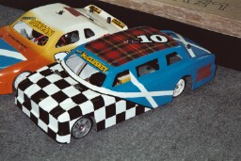
B final (consolation race)
Just the one place to aim for, as the winner progresses to the final and a good race it was too, with Sandy Boo Boo Bissett claiming the place in the final winning with 51 laps from James Second Best Ward on 49, third went to Andy The Baron Cattell on 45, coming home fourth was Iain Oval Baws Wann with 42 then we had Peter Baldie Ayriss on 31 then we had Paul Who Me Jenkinson and Andy Start Money Wallace both finishing on 24 laps.
D final.
A clear winner in the end in the shape of Neil Cluck McCluskey on 46 laps from Peter Kleenx Bissett finishing with 38 then came Stuart the one and only Preston on 31, fourth was Caroline Waldock on 27 the same as Stu the chairman Barbour in fifth closely followed by Dean Deano Ritchie on 25 then we had Steven Mansell on 13 and trailing in last was Greig Skid Marks with 10 laps.
C final.
Who said women cant drive, well to prove different we had Sandra O showing the Boys how it was done winning with 47 laps from Gary Rabbit Rabbit Osbourne on 44 just in front of Ivan O with 43 from Andrew Who Me Cox on 41 chased hard all the way by Joe improving Huxley just one lap down on Andrew with 40 then came Steven Diy Duncan on 37 and trailing in last was Ryan Hate Mail Cattell with 9 laps.
A final.

We witnessed a very good final not exactly in the banger style of racing, as there was national points at stake, at the end the result was-

1st Gary Gromit McMullen 62 laps
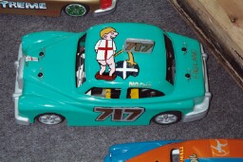
2nd Neil Oops Ritchie 61 split time 302.53
3rd Craig Bomber Brown 61 split time 303.95
4th David Davey Boy Smith 58 split time 302.16
5th Ivan Auld Git Black 58 split time 302.49
6th Martin Navigator Nash 55 laps
7th Sandy Boo Boo Bisset 52 laps

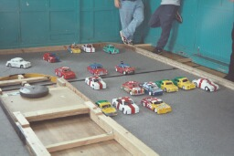
Now the fun can begin, with four ramp races and with the shackles off the proper banger racing commences, there was too much going on to go into detail, but the four winners were
Race one. James Second Best Ward
Race two. Peter Baldie Ayriss
Race three. Gary Rabbit Rabbit Osbourne
Race four. Paul Who Me Jenkinson

Mayhem in grand style as the first demolition derby gets under way, the winner is the last car still moving under their own control after basic-lie anything goes, including head on’s, t-boning, team racing and all sorts of dirty tactics by the drivers, and would you believe it (was he racing a tank out there) after almost twenty minuets the winner was declared to be Gary Gromit McMullen.
After all the cars were charged up, we repeated the process all over again, this time with the ramp on the track to spice things up even further, and yes he was definitely racing a tank because the punishment his car took on the way to yet another win had to be seen to be believed, well done Gromit!

