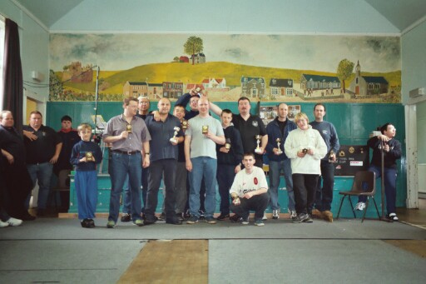

Part two of the weekend of racing at Leven in the Milton Racehall, as the Bangers were centre stage yesterday.
Today sees round five of the Stock Cars in action, joining the travelling band of racers were Karl and Ben as they had travelled up during Saturday arriving sometime during the evening, when most were out enjoying an evening of racing (real cars!) at the Racewall (Cowdenbeath race track) We had twenty nine assemble for this meeting, one down on last years entry. No major changes at the venue to report on. One disappointing aspect about the weekend was the fact that we did not have a single racer from the Edinburgh club racing, why I wonder? When this is a local track racing the same formula as you do at you’re track, and an opportunity to race against other section members other than you’re own club members, it seems strange that some will travel over 600 miles to race and some will not journey 60 miles, I will never understand this! Lets hope we see some Scottish racers venture far south for the Liskeard national meeting in Cornwall.

Race one round one.
Andrew Cox makes a good start to his meeting winning the first race with 70 laps from David Smith who was just behind on 69 as was Gary McMullen also on 69 but 2.11 seconds behind David. Race two saw another Urmston member in front this time it was Peter Ayriss taking the win on 68 laps from Gary Osbourne on 66 and Karl Spencer on 65. Race three and another win by a Urmston club member this time it was Stuart Smith winning with 66, with Andy Cattell in second on 65 just beating Ryan Cattell who finished one lap further back. Breaking the Urmston strangle hold on race wins was Ben Harding taking race four on 70 laps from Ross Kerr in second on 66 from Ivan Black on 65.

Round Two.
This might be his first National heat win have to check that one! For Alan Bellis, winning heat one of round two with 64 laps in second was Neil Ritchie on 62 and then came Joe Huxley with 61. Heat two was won by Andrew Cox on a strong 70 lapper from Peter Ayriss with a 68 who was just in front of Andy Cattell on 67, then it was David Smith on 65. Heat three saw Ben Harding collecting his second race win of the day on 69 laps pressed hard by Ryan Cattell who finished with 67 followed by Gary Osbourne on 62.
Heat four saw Gary McMullen set the F.T.D. score so far of 72 laps in a split time of 301.48, second was Derek Kerr on 70 followed by Mark Cooper on 67 and Paul Jenkinson with 64 then it was a 62 by Craig Brown. Due to an infringement of the rules during his heat Andy Cattell had his score of 67 disallowed.
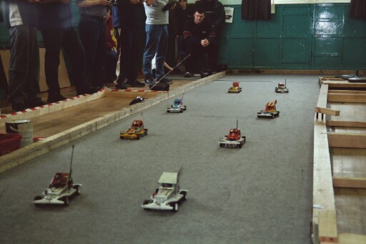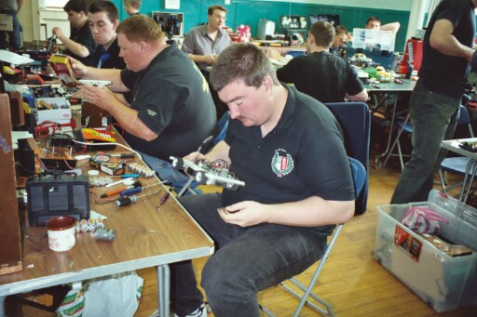
Round Three.
Ben Harding makes it three wins out of three, this time on 71 laps just in front of Gary McMullen on 70 and Andy Cattell on 69, then it was Mark Cooper and David Smith both on 68 with Mark just in front. Heat two was won by Ryan Cattell with 70 from Peter Ayriss on 68 and third came Paul Jenkinson on 63. Heat three saw Gary Osbourne collecting a race win on 65 laps from long distance traveller Martin Nash on 60 closely followed by Gordon Dempsey with 59 and Ivan Black on 58. Heat four, and it’s local racer Derek Kerr coming good with a win on 69 then we had a close battle between Stuart Smith and Andy Wallace both on 66.
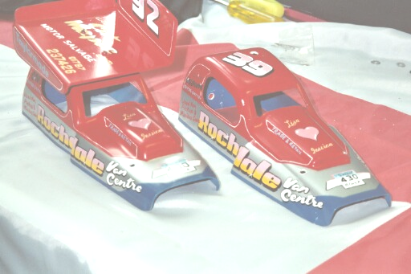
Round Four.
Ryan Cattell gets another win in heat one on 72 laps, but misses out on the F.T.D. time by the narrowest of margins, his split time of 301.99 not good enough to displace Gary’s time of 301.48 second was Gary Osbourne on 69 then came Martin Nash with 66 just in front of Joe Huxley on 65, then we had young Nicholas Cooper getting his best lap score of the heats with 54 laps. Heat two was a real close race, at the end it was Andrew Cox taking the win on 69 laps just in front of Gary McMullen on 68 who was just in front of Paul Jenkinson who finished on 67, who was chased by Alan Bellis who finished with 65. Heat three saw another racer having a go at the F.T.D. time, unfortunately just missing out, this time it was Derek Kerr winning on 72 laps with a split time of 303.59, pushed right to the end by Peter Ayriss who finished with 70, which pushed Ben Harding into third place with 69 laps from Stuart Smith on 67 then we had Steve Mavor getting a good lap score of 64. Heat four was a titanic race between Andy Cattell and Mark Cooper, which saw Mark just in front of Andy by 0.16 after both had finished on 69, next up was Karl Spencer with 65 then came Andy Wallace on 61. This round David Smith did not take part in his allotted race, as he was feeling unwell.

Consolation race.
Another close meeting on the qualifying with some tense faces wondering if they had made it through to the consolation or the final during the adding up of the race scores, this kind of situation no longer surprises me, due to the high standard of drivers attending these meetings, if any-think it is getting harder year by year, and also due, I think to the fact that we race to a fair set of rules that does not allow any racer to have an unfair advantage over anybody else, except for experience, that you cant buy!
The lucky or the unlucky eight qualifiers, depending on how you look at it were
1. Andy Cattell 203 Laps (best three scores)
2. Gary Osbourne 200
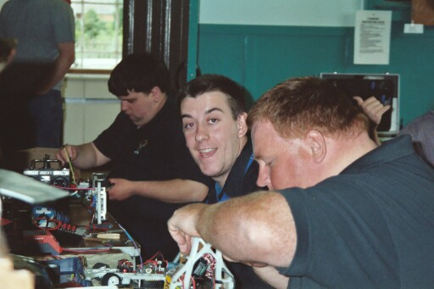
3. Stuart Smith 199
4. Paul Jenkinson 194
5. Alan Bellis 193
6. Joe Huxley 188
7. Martin Nash 186
8. Neil Ritchie 183
Only one qualification place through to the final at stake, winner takes all, and a few grade awards to sort out depending on the outcome of this race, at the end of the race Stuart Smith was the victor on 68 laps just in front of Andy Cattell by one lap, Andy finishing with 67, then would you believe that the next four racers all finished on 64 laps, with the places decided on split times, the finishing order was in third we had Joe Huxley, fourth Gary Osbourne, fifth was Neil Ritchie, and sixth went to Paul Jenkinson then we had another tie for seventh and eighth place between Alan Bellis and Martin Nash after both had finished on 63 laps with Martin finishing seventh by virtue of the better split time.

While we waited for Stuart to get ready for the final a C final and a D final was held the D race was won by Karl Spencer! (European champion having a bad day) with 69 laps, which would have won the consolation race, second place went to Stuart Preston on 60 then came Dean Ritchie on 58 followed by Nicholas Cooper on 44.
We had a good race between the driver in the C race, in this one Ross Kerr managed to race clear of the rest to win the race on 68 laps, the it was a lot closer for the minor placings, with Andy Wallace finishing second on 63 as did Sandy Bissett in third, fourth and just one lap behind on 62 was Steve Mavor, in fifth place was Gordon Dempsey on 59 laps then we had Craig Brown on 58, Peter Bissett seventh with 27 and finally we had Ivan (the terrible) Black on 20, sack the mechanic Ivan!

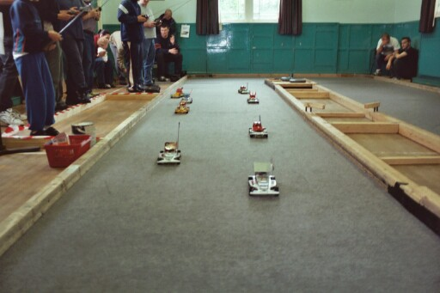
The Final, line up in qualifying order
1. Gary McMullen 211
2. Derek Kerr 211
3. Ben Harding 210
4. Ryan Cattell 209
5. Andrew Cox 209
6. Peter Ayriss 206
7. Mark Cooper 204
8. Stuart Smith Consolation race winner
Before I give you the result of the final, a look back to last years final shows that it was won by a score of 72 laps, so with slower motors this year (supposedly) you would expect the laps to be down this year wouldn’t you! Some chance, take a look at the results and wonder where the improvements have come from, finishing in first place on an incredible 76 laps (compared to last years) was Gary McMullen, finishing second was Derek Kerr with 73, and Ben Harding finished third with 72, fourth and just one lap behind was Andrew Cox on 71 the same as Stuart Smith in fifth place then we had Ryan Cattell on 70 laps as was Mark Cooper in seventh, and finishing in eighth place was Peter Ayriss on 68, all the tied lap scores were separated by split racing times.

The placings in the National Points table now looks like this after five rounds, we start to drop the worst scores after this national so expect things to change!
At the top we have,
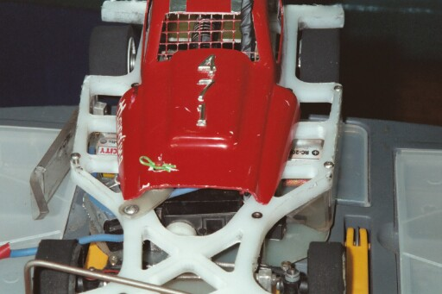
Ben Harding 488 points so far
Gary McMullen 486
Mark Cooper 442
Andrew Cox 441
Karl Spencer 424
Andy Cattell 422
Stewart Smith 417
David Smith 413
Ryan Cattell 413
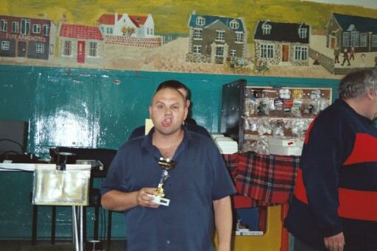
Peter Ayriss 404
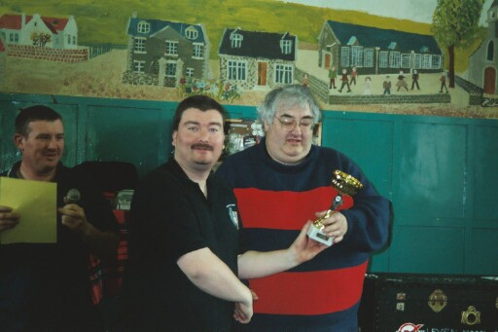
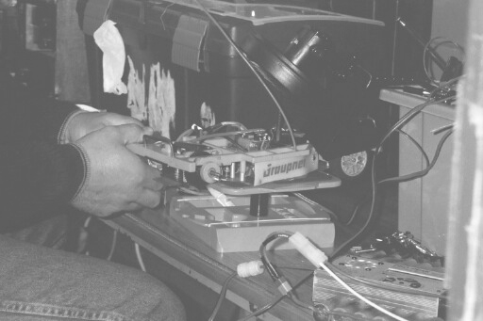  Name . | F/Tyre | F/Tyre | R/Tyre | R/Tyre | G/Ratio | Speedo | Charger | Car type | Chassi | Cells | Club | Grade | Qualif | Final
Gary McMullen | Double  Blue | 812 | SE | Pink | 12/49 | Ass | Tekin | Rapid  Pink | Ander | Corally  1700 | Urm | S/S | 1 | 1
Derek Kerr | Silver | 812 | SE | SE | 12/53 | Ass | Competition  Electronics | Rapid  Pink | Ander | Xtreme  2000 | Dun | S/S | 2 | 2
Ben Harding | Jap | Jap | SE | SE | 12/50 | Mini | Apex | Pinky  Spencer | Ander | Reedy  2000 | Rug | S/S | 3 | 3
Ryan Cattell | Elec  Hard | Jap  Med | SE | SE | 12/50 | Mini | Apex | Lecatt | Lecatt | 2400 | Ston | S/S | 4 | 6
Andrew Cox | Double  Blue | SE | Jap | SE | 12/50 | Ass | Apex | Rapid  Pink | Ander | Corally  1700 | Urm | S/S | 5 | 4
Pete Ayriss | Double  Blue | 812 | SE | SE | 13/51 | Ass | Pro  Track | Rapid  Pink | Ander | Corally  1700 | Urm | Blue | 6 | 8
Mark Cooper | SE | 812 | SE | Pink | 12/50 | Mini | Apex | Rapid  Pink | Ander | Reedy  2000 | Ston | Red | 7 | 7
Stewart Smith | 812 | SE | Pink | Pink | 10/53 | Apex | Apex | Self  Build | Self  Cut | Corally  1700 | Urm | Red | 8 | 5

Leven National June 30th 2002

Key- Urm Urmston
Ston Stoney Stanton
Rug Rugby
Dun Dunfermline

