A better turn out for this one, forty- two racers from far and wide, one better than last years national. Twelve drivers making their first appearance in the series, so far sixty-seven have appeared with twenty-four having raced at all the meetings so far, including long distance travellers Andy Wallace and Martin Nash from Liskeard in Cornwall, hope their meeting on 18th August gets the support it deserves! Once again, Stuart Tennant is trying his hand at 1/12th supported by Jody Foster, both better known in the 1/8th IC stock cars, but are regular Hathern club racers. This track is probably the smallest that we race on in the UK, so it was nice to see that they had given the drivers a chance to race, with a sensible six cars in a heat which worked out well, with forty-two drivers racing, which explains why Ian Johnson (Hathern club promoter) did not race, neither did Simon Farrer who did an excellent job on race control, also we had official B.R.C.A. scrutineer Colin Eardly in attendance to keep check on the cars, with no problems reported the meeting started with a line up of the cars for a concourse / photo opportunity.

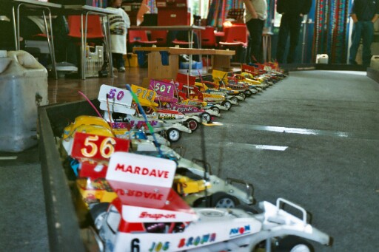

Concourse line up.

Round One.
Heat one saw Ryan Cattell back on form after his miserable national meeting at Rugby winning the first heat with 76 laps from Gary Osbourne in second spot with 72, then came Jim Driver and Joe (pappa) Brown both on 67. Heat two was a real close race eventually won by Rugby racer Pete Clarke on 79 with a tremendous scrap for second place decided by split times between Martin Cooper, Alan Bellis, and Stewart Smith, with Stewart placed second Alan third, and Martin fourth all on 77. Heat three won by home racer Jonathan Goodacre with 82 laps with national points chaser Ben Harding in second on 76. Heat four saw an easy win for David Smith on 79 laps from Martin Nash’s 67. Heat five and a surprise winner in Dennis Watson on 83 from Andrew Cox in second place with 81 from Jon Cutts on 80. Heat six and winning with 85, setting the FTD so far, then came Karl Spencer on 77, then both on the same lap were Steve Farrer and Duncan Bullock with 75. Heat seven saw a return to form for Mark Cooper winning with 84, from Gary McMullen finishing on 82 then came Jody Foster and Andy Cattell both on 81.

Round Two.
And its young Ryan Cattell out in front again on 78 laps, from Gary Osbourne in second with 74, chased hard by Pete Clarke and Joe (pappa) Brown both on 72. Heat two won by championship leader Ben Harding with 83 just beating Jonathan Goodacre into second place by one lap, Jonathan finishing with 82. Heat three and winning on 76 was Martin Cooper, and a good second spot for Liskeard racer Martin Nash on 71, from Alan Crossland and Elouise Bullock both on 68. Heat Four saw Gary McMullen push up the FTD to 86,winning from Jon Cutts on 82. Heat Five and Jody Foster gets his first win with 83 from Pete Ayriss finishing with 80 and Andy Cattell on 78. Heat Six and getting the winning habit was Dennis Watson on 80 laps from Karl Spencer and David Smith both on 78, and worth a mention here in fourth place was Angela Yarwood finishing with 76. Heat Seven and Stuart Tennant snatches FTD back from Gary winning with an impressive 87 lapper, from Mark Cooper in second on 82 who was just in front of Andrew Cox who finished on 81 laps.
Round Three.
Ben Harding raced away for a comfortable win with 81 laps from Alan Bellis who finished with 76 from Darren Grace in third on 73. Heat Two saw a good race between Gary Osbourne and Pete Clarke both finishing on 72, Pete winning on split time, third place went to Liskeard promoter Andy Wallace on 69. Heat three and making it three wins out of three was Dennis Watson,belittle-ing his yellow roof grade, finishing on 80, second was Martin Cooper on 74 laps as was Jon Cutts, and just one lap behind these two was Jason Reed. Heat four and going like an express train was Gary McMullen winning with 84 laps from Jonathan Goodacre on 82. Heat Five and a good win by Andy Cattell on 80 from Rugby consolation winner Paul Jenkinson finishing with 77, and in third place was Rugby yellow grader Graham Farrell on 74. Heat Six saw an excellent race between Mark Cooper and Karl Spencer won by the smallest of split time (0.67) by Mark but both on 80, Mark making a tremendous comeback after being three laps behind Karl at one stage of the race, in third place was David Smith on 77. Heat Seven saw Jody Foster in winning ways again on 85 laps from Stuart Tennant in second finishing on 80 one lap in front of Steve Farrer in third place.
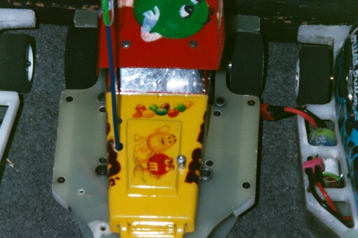
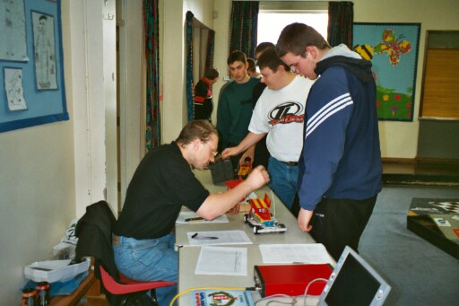

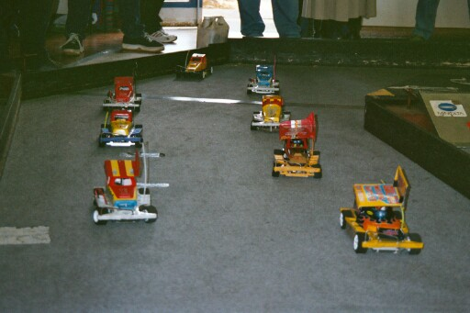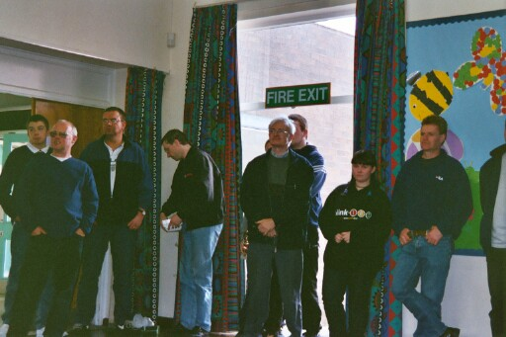

Round Four.
Gary McMullen collecting his third win of the day finishing on 84, from Stewart Smith in second place on 75 just finishing in front of Pete Clarke on 73. Heat Two saw Ryan Cattell upsetting unbeaten man Dennis Watson, scorching round to win on 85 laps also Ben Harding just beating Dennis by split time after both finished on 79, with Alan Bellis just one lap behind these two. Heat Three saw David Smith win his second race of the day with 80 laps from Tim Goodacre on 75 then cane Elouise Bullock and Alan Crossland both finishing with 72.Heat four and it’s win number three for Mark Cooper finishing just one lap in front of Jon Cutts on 84 to Jon’s 83, just surviving in third place was Martin Cooper with 78 from the attentions of both Gary Osbourne and Joe Huxley just one lap behind Martin. Heat Five saw a scrappy race won by Steve Farrer with 71 from Doug Giles on 64. Heat Six and normal service returns with a win by Jonathan Goodacre on 82 from Jody Foster on 79 just beating Andrew Cox who was just one lap behind Jonathan. Heat Seven and last heat of the rounds was won by Karl Spencer on 80 laps, from Pete Ayriss finishing with 78 and Paul Jenkinson on 75.
The heats saw some good racing by the lower graders and younger members, some worth a mention, a high consistent score by Alan Bellis will be rewarded with a higher roof grade soon as is the same I’m sure of Dennis Watson. Both Daniel McMullen and Nicholas Cooper two of our youngest racers went well all day, also it was pleasing to see a few lady racers the highest lap scorer being Angela Yarwood with an 76 lapper in round two and Elouise Bullock with an 72 in round four. And I’m sure that come a new grading period at his home club, that young Joe Huxley will soon be sporting a Red roof.
Consolation.
Once again we had a strong line up of drivers who had missed out on automatic qualification to the final, some of them more used to finals than consolations, just shows how many drivers are now capable of racing at nationals and qualifying for the final, home track advantage no so apparent any more! The unlucky eight were
Dennis Watson
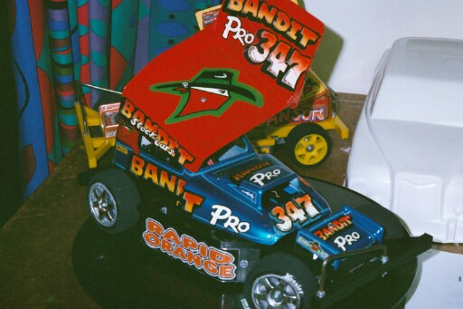
Karl Spencer
Ryan Cattell
Andy Cattell

Pete Ayriss
Steve Farrer
David Smith
Andrew Cox
So no surprise that it was another close race, with Karl Spencer going through to the final winning by one lap from Ryan and Andrew, Karl finishing on 76 to Ryan and Andrew’s 75, finishing fourth was Pete Ayriss on 70 then came Steve Farrer on 68 as was David,
just one lap behind these two was Andy Cattell, and hard luck story here for local racer and yellow grader Dennis Watson who led for most of the race and looked set for the final, when lady luck frowned on him right near the end of the race, when his switch wire unplugged itself from the receiver, with his quality of driving I’m sure it wont be long before we see Dennis in a national final, as it was he only just finished in eighth place just one lap behind Andy with 66 laps.
The Final.
As we know Karl Spencer qualified by winning the consolation race, the other seven qualifiers were,
Gary McMullen Jon Cutts Jonathan Goodacre Jody Foster
Mark Cooper Stuart Tennant Ben Harding
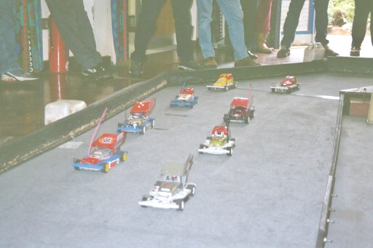
This race had just about everything you could possibly wish for, good clean racing of the highest quality, plenty of tension and drama, and a slice of bad luck for some as well, let me explain, right from the start we had the lead changing places between a few drivers, at about half distance Mark had a problem and pulled his car off the track, a ball joint had come off and a track rod had also moved, a quick fix and he was back into the race losing a few laps into the bargain, so nothing to loose! With about four minuets gone three drivers had broken free from the chasing pack all bunched together, into the last bit of the race and Stuart Tennant was leading by about half a lap when he got rolled by another car, while on his side waiting for a marshall Gary and Ben slipped past, and with only a couple of laps remaining there was not enough time to regain the lead, so the result was another win for Gary McMullen on 80 as was Ben Harding and the unlucky Stuart Tennant, and staging an excellent recovery to finish fourth on 77 was Mark Cooper, also finishing on 77 laps were Jonathan, Jody and Jon in that order, and eighth was Karl Spencer on 74, close or what, we had three drivers on 80 laps and four drivers on 77.

Grade awards went to,
Best White John Freeman Yellow Dennis Watson Blue Pete Ayriss
Concourse Gary Osbourne
The Junior award was given out to Joe Huxley unfortunately as Ryan Cattell did not make the final he was the highest finishing junior, sorry Joe you’re time will come.
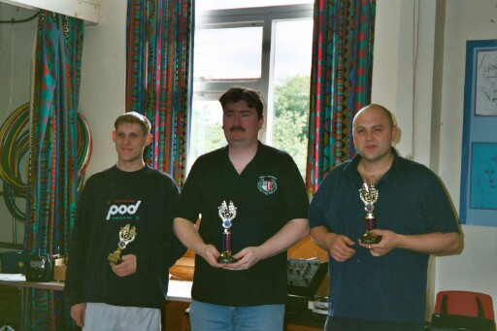
The top ten places in the National points table now looks like this after three rounds.
1. B. Harding 291
2. G. McMullen 290
3. K. Spencer 274
4. A. Cox 267
5. J. Cutts 266
6. M. Cooper 264
7. M. Cooper (pinky) 255
8. R. Cattell 253
9. A. Cattell 250
10. D. Smith 248

Thank you to Mr and Mrs Farrer who did an excellent job in the kitchen all day, also all the Hathern club members who helped set up the track and also pack it up and transport it back to their regular hall, also thank you to Ian Johnson for donating a raffle prize, and Gary McMullen for selling the tickets.

Next national meeting is on June 3rd at the Urmston club in Manchester.

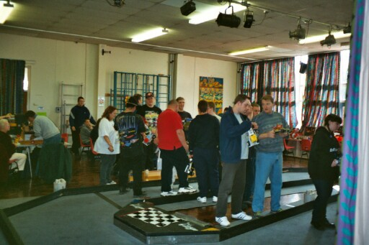

Name | F/tyre | F/tyre | R/tyre | R/tyre | Gear ratio | Speedo | Charger | Car type | Cells | Club | Chassis | Qualif | Final Place | Grade
Stuart Tennant | SE | TK | SE | SE | 12/54 | Mardave | Unknown | Bandit | 2000 | Hathern | Bandit  Mardave | 2 | 3 | Red
Gary McMullen | 812 | SE | SE | SE | 12/50 | Associa | Tekin  BC112A | Rapid  Pink | 1700 | Urmston | Anderton | 1 | 1 | Silver
Mark Cooper | Gold | E/Hard | SE | SE | 12/50 | Mini | Apex | Rapid  Pink  Modified | 2000 | Stony  Stanton | Anderton | 3 | 4 | Red
Jody Foster | TC | TK | SE | PINK | 12/54 | Mardave | Unknown | Bandit | 2400 | Hathern | Bandit  Mardave | 4 | 6 | Red
Jonathan Goodacre | SE | SE | SE | SE | 12/54 | Mardave | Unknown | Bandit | 2400 | Hathern | Goodacre  Racing | 5 | 5 | Red
Jon Cutts | Pink | SE | SE | SE | 13/51 | Mini | Racing  Jack | Eaglen  Mardave | 2400 | Rugby | Mardave | 6 | 7 | Red
Ben Harding | Jap | Jap | SE | SE | 12/51 | Mini | Apex | Pink  Spencer | 1700 | Rugby | Anderton | 7 | 2 | Gold  Coventry  Champion
Ka Karl Spencer | E/Med | SE | SE | SE | 13/50 | Mini | Apex | Pink  Spencer | 2000 | Rugby | Anderton | Consolation  Winner | 8 | Red/Yellow  Chequered  Euro Champion

