

November 17th 2001 …………………. November 18th 2002
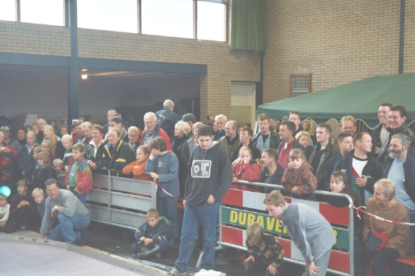
Hopefully as you read through this report you will be able to see the massive strides forward that has been made by our Dutch friends, it is remarkable that they have improved as much as they have, when they have only raced the 1/12 th cars for three years, and then they only race in the winter months, as their main passion is 1/8th i.c. stox. It seems such a long time ago that the first five British racers ventured over to Holland for the first meeting, in 2001 there were fourteen racers from the U.K and it was the first ever meeting for David Cooper, racing one of his lads cars (which was a total surprise to him as he did not know that he was racing) and in 2002 fifteen made the trip. Back in 2000 the first meeting had twenty-two racers, this was up to forty-four in 2002. Also I remember that in the first meeting two Dutch racers were using the same car to race! Also in 2000 all the Dutch cars were of basic Johnson (Bandit) type cars, not so in 2002 as I counted at least three different types of car raced by the Dutch racers, all in all this can only be good for our type of racing, long may it continue, also it was noted that a new car disappeared back to Belgium with a proud new owner.

Once again most of us travelled on a min-bus, piloted by Andy Cattell and Stuart Preston, no comment about the map reading, except that the detour through Amsterdam was very nice! We arrived at our destination just after 9.00pm European time, once unloaded and old friends re acquainted we started to unwind after the long journey, this was not difficult as most of us were sleeping at the Het Graadwe Paard,
(The name of the public house) courtesy of the host Auke Kooistra, so after one or two beers we eventually retired to bed about 3.45am, up again about 7.30 to a sumptuous breakfast provided by Auke, part refreshed and refuelled, we then headed off to the venue of the Euros, and what an impressive job our hosts Fryslan 1 model stockcar club had done, pits laid out, rostrum built to race from, grandstands for the public to watch from, metal barriers to protect the public from the cars, an impressive overhead projector so that we in the pits could watch the results of the racing lap by lap, flashing lights to jazz up the proceedings, and must mention the loan of Oue Bijlsma’s F1 stock car (which was raced in this years World Final at Coventry stadium) on display at the side of the track. Well done to all concerned.

After as much practice as you wanted, we headed back to the pub for refreshments! And something to eat, and an evening of karaoke Dutch style with our host Auke Kooistra (the video is well worth seeing) so after a few star turns (better not mention them by name) some vocal Brits and Dutch, amazing what alcohol can do to loosen you’re inhibitions. With an early start in the morning it was decided to have an early night at about 2.00am (compared to the previous evening)
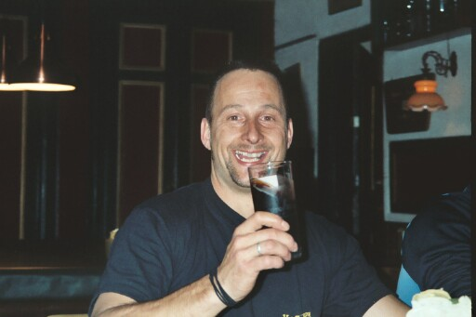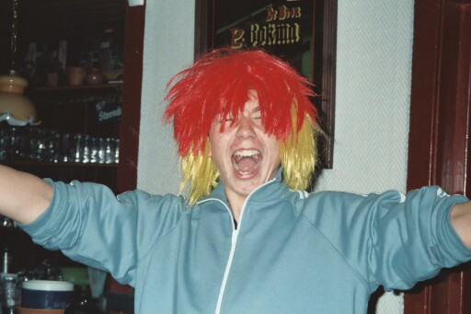
Auke Koostra Ryan (Party Animal) Cattall
Again we were awake early, about 7.00am thanks you guys! Just coffee for breakfast or should I say kick start us, as food would be available at the venue throughout the day, what keeps Auke going we all wondered, did he go to bed? As he was up before all of us! Or was this Dutch tactics, designed to make us Brits as tired as possible before the meeting?
Once at the venue we had time for a last shake down of our cars before the meeting started, all of this little story was pretty similar to the previous year minus the Karaoke on the Saturday evening.
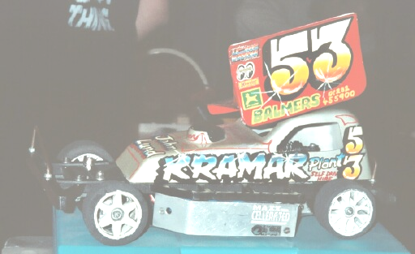
Due to the way there computer prints out the meeting results I can only give you the drivers best lap scores, the bold scores will be 2001’s and the others will be this years 2002.
Heat one 2001.
Kevin de Groot 56, 54,48 David Smith 82, 73, 51 Ronald Jousma 46, 45, 42
Hans Wynia 64 56, 46 Joop Bijlsma 68, 67, 67 Joeke Triemstra 66, 65, 59
Heat one 2002.
Marco Duyster 60, 58, 58 Nicholas Cooper 60, 58, 56 Joeke Triemstra 60, 60, 56
David Smith 76, 76, 74 Adrie Middelkoop 63, 63, 60 Ryan Cattell 75, 72, 70

Heat two 2001.

Jan Beimers 64, 62, 62 Jan Triemstra 65, 64, 63 Gabriel Dijkstra 27, 21, 21

Andy Cattell 74, 74, 70 Koen Middelkoop 61, 53, 43 Wilfred Talsma 58, 55, 53
Heat two 2002.
Gabriel Dijkstra 57, 45,3 Koen Middelkoop 65, 63,63 Peter Kampen 66, 63, 62
Mark Cooper 74, 70, 69 Stuart Preston 65, 64, 63 Klaas Bijlsma 65, 64, 63

Heat three 2001.

Niek Middelcoop 70, 67, 66 Karl Spencer 70, 69, 66 Lauren Cattell 54, 51, 49
Tamme de Groot 45, 45, 44 Ben Harding 74, 71, 70 Klaas Bijlsma 58, 49, 49
Heat three 2002.
Mike Tomkinson 76, 74, 73 Karl Spencer 79, 79, 78 Daniel McMullen 69, 68, 68
Kevin de Groot 71, 69, 68 Joop Bijlsma 72, 70, 67

Heat four 2001.

Jon Cutts 77, 75, 75 Hans v/d Steen 59, 56, 32 Jelle Bijlsma 70, 64, 59
David Cooper 40, 32, 29 Sanders Poels 74, 69, 65 Thijs de Vries 62, 60,57

Heat four 2002.
Gysbert v/d Bij 71, 69, 65 Gary Osborne 72, 70, 67 Ben Harding 81, 79, 79
Niels Hoekstra 68, 67, 62 Auke Kooistra 71, 69, 65

Heat five 2001.

Hidde de Jong 76, 72, 71 Gary Osbourne 73, 73, 71 Evert Jacob Klock 55, 44 36
Ryan Cattell 79, 75, 74 Stuart Preston 74, 69, 69
Heat five 2002
Michel Berendsen 70, 69, 69 Jan Triemstra 73, 72, 72 Damon Atkins 63, 62, 60
Jean Pierre Steegen 72, 69, 69 Jan Beimers 69, 66, 65

Heat six 2001.
Nicholas Cooper 54, 52, 49 Gary McMullen 74, 72, 71 Jeroen Janssen 65, 65, 60 Tjepke Pieter 66, 64, 58 Jouke Stapert 69, 69, 65 Adrie Middelkoop 65, 62, 60
Heat six 2002.
Maikel Rutten 66, 64, 62 Jouke Stapert 78, 76, 74 Gary McMullen 80, 76, 75

Evert Jacob Klok 74, 73, 71 Jane Wyllie 65, 63, 63 Ronald Jousma 57, 49, 29

Heat seven 2001.
Marco Duyster 60, 58, 57 Andy Stanley 68, 66, 7 Mark Cooper 73, 73, 64
Peter Kampen 66, 66, 61 Geoff Needham 52, 48, 48
Heat seven 2002.
Tamme de Groot 60, 59, 36 Rudd Verheyen 62, 61, 59 Tjepke de Vries 71, 70, 65 Andy Cattell 76, 75, 72 Hidde de Jong 75, 74, 74 Hans Wynia 72, 71, 70

Heat eight 2002.

Niek Middelkoop 69, 69, 67 Thijs de Vries 65, 61, 55 Richard Pacey 76, 74, 72
Ger Hoekstra 66, 65, 26 Jelle Bijlsma 75, 74, 71
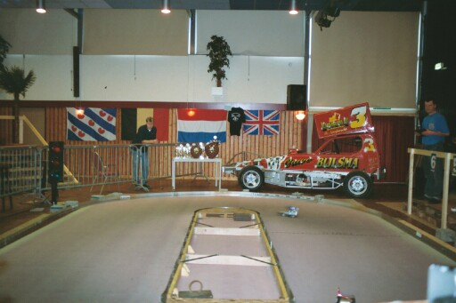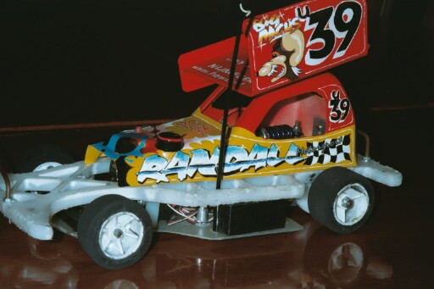
Track layout 2002 Gary Osbourn’s neat car

There it is in black and white for you to see and compare just how much our Dutch friends have improved, looks like we Brits had better pull our socks up, as we might soon be out-numbered in the final, never the less it all makes the racing that much more interesting.
At this point of the meeting the qualifiers are now sorted out into quarterfinals, in qualifying order i.e. 1st into race 1, then second into race two e.t.c. All the way down the top twenty-four qualifiers.
The racers to make it through from the quarters into the semi-finals were, please note that all scores from 2001 are from five minuet races, and due to the improvements in the race scores all the remaining scores from 2002 are all from four minuet races, this is due to the computer crashing after a racer goes past 100 laps as was likely to happen in 2002.

2001 semi final qualifiers. Gary McMullen 98, Karl Spencer 93, Ryan Cattell 93, Ben Harding 91, Andy Cattell 91, Jon Cutts 90, Mark Cooper 90, Niek Middelkoop 88, Hidde de Jong 88, Sanders Poels 88, Gary Osborne 85, Jouke Stapert 82.

2002 qualifiers. Ben Harding 76, Gary McMullen 75, Andy Cattell 75, Karl Spencer 75, Hidde de Jong 73, Jouke Stapert 72, Mark Cooper 72, Jean P Steegen 72, Mike Tomkinson 71, Gary Osbourne 71, Ryan Cattell 70, Richard Pacey 69.

Same format then to determine who goes into which semi final, i.e 1 & 3 qualfier in the first semi and 2 & 4 in the second semi and so on, which would appear to be a fair way to sort out the qualifiers into two even races. It has to be said that there were some hard luck stories from both years, mostly the luck of the draw was responsible for this, some of the quarters and semis saw some of the drivers going out from there quarters and semis with a better lap score, compared to some in the other races, unfortunately it is only the top three drivers from each race that progress forward into the next round regardless of lap scores.
The lucky six racers to make it through into the final from 2001 were, Ben Harding 99, Karl Spencer 98, Gary McMullen 96, Ryan Cattell 96, Jon Cutts 96, Hidde de Jong 89.
2002 qualifiers were Karl Spencer 80, Ben Harding 80, Jouke Stapert 79, Hidde de Jong 77, Gary McMullen 76, Andy Cattell 76.
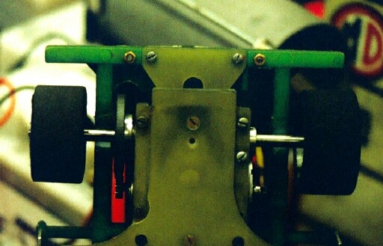
So here goes for the first official winner of the European title from 2001, with five Brits and one Dutch to contest the final, we had a large crowd assemble to watch the proceedings, and it has to be said that they were a bit biased towards local favourite Hidde, after a terrific five minuets of excellent wheel to wheel racing the result went to a well deserved winner in Karl Spencer on 99 laps from Gary McMullen with 97, then it was Ben Harding with 95 then came Ryan Cattell on 92, then we had Jon Cutts on 90 which left the unfortunate Hidde de Jong in sixth place on 79, this was due to a shredded spur gear (see picture) when he was vying for a top three finish, and as Ryan was the top finishing junior he was awarded the Junior European title.
Must say a big thank you to Louw Wobbes who was on hand to present the trophies to the lucky winners, along with a very nice team Wobbes T-shirt.

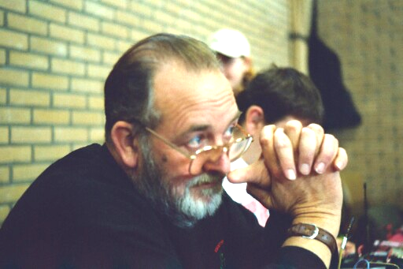
The result from the 2002 final, and must mention that the winner keeps the roof grade for two years this time, and as is the usual in stox finals it was a close run thing with the result going right to the very last laps of the race, at the finish we had a relieved Gary McMullen taking the victory and the title of European Chapion 2002 on 79 laps just in front of Ben Harding who was just one lap behind on 78 as was Hidde De Jong who was one lap behind Ben with 77 finishing fourth we had Andy Cattell that’s right I did say Andy and not Ryan as is the usual, and making a valiant effort to keep his title was Karl Spencer finishing in fifth place with 74 laps, and in sixth place came the reigning Fryslan club champion Jouke Stapert on 73.
This year the trophy presentations was done by World finalist Ouwe Bijlsma, a big thank you, for this and also the loan of you’re actual F1 car to have on display at the side of the track.

A slight change this year from the previous meeting in 2001 was how to decide who was going to be European Junior Champion, before it was the highest finishing junior of the meeting that was declared the Champion, which a few thought unfair, so this time a separate race would decide the title, and the top six juniors of the meeting would contest the race to find the 2002 Champion, so the line up was previous title holder Ryan Cattell, Daniel McMullen (both from the UK) Kevin De Groot, Gysbert V/D Bij, Jelle Bijlsma and Evert Jacob Klok.
Wow what a race, even the watching crowd were getting very vocal, just like a real meeting, and what a result! A first title for the Dutch in the shape of Jelle Bijlsma European Champion 2002 finishing on 75 laps, and in second we had Ryan Cattell finishing with 74, third went to Evert Jacob Klock on 70, fourth was Daniel McMullen with 68 then it was Gysbert V/D Bij on 65 then we had Kevin De Groot on 63.

Must mention that we had no less than five different car types contest the main final, these were,
Gary McMullen Rapid Pink MWB
Ben Harding Pink long wheelbase with front suspension self build
Hidde de Jong Bandit Pro
Andy Cattell Lecatt
Karl Spencer Pink long wheelbase with front suspension self build
Jouke Stapert Stapert self build

At the request of Hidda de Jong, a few of the Brits also took their Four cell Bangers along to put on some demonstration race’s between the heats of racing, also a car was lent to Marco Duyster, the highlight has to be the crowds reaction when the demolition derby started, this is where the cars go on a self destruction mission, with the last one moving declared the winner, well done to all concerned.
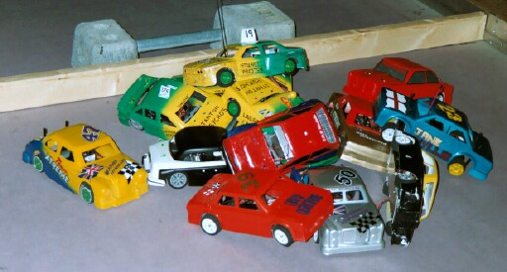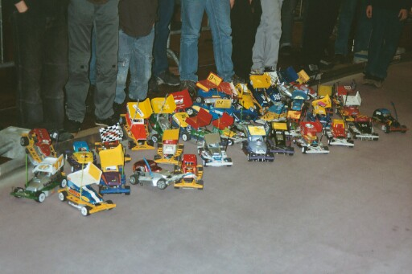
Also we were treated to an indoor firework show, this was done by the younger Dutch lads, this had to be seen, cars parading around the track with fireworks attached to there car’s in near darkness, except for the glare from roving spotlights on the track and the sparks from the fireworks.
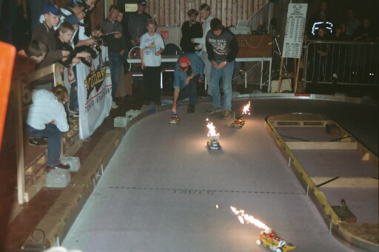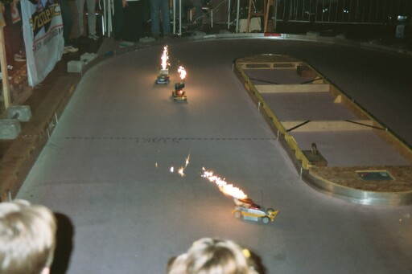
All of us Brits would like to say a big thank you to the Dutch for hosting the European Championship’s, and a very big thank you to Hidde de Jong, Marco Duyster, and also to Auke Kooistra who provided us with such a warm welcome and excellent hospitality, also to Auke again, who also played the role of taxi driver to some of the Brits who had arrived by train!

Report’s by Mark Cooper

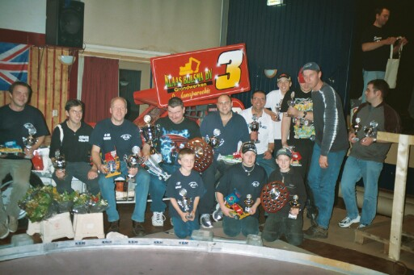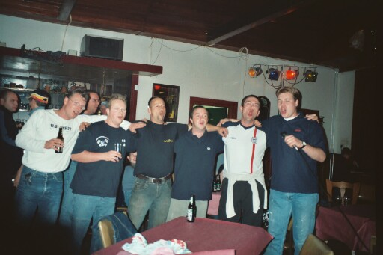
What a racket

