Round six sees us at a new venue for the stockcars, as the Basildon club runs mostly 1/12th scale Bangers. Under the watchful eye of club promoter Alec Quarman and a team of helpful club members, also on site there is a well-stocked canteen offering plenty of nibbles to help keep you going as well as tea and coffee. The hall is sited just off Clay Hill Road (B1464) then turning into Bardfield, the hall is actually a scout hut, with the main hall upstairs. Just in case you don’t know Basildon is in that well known county of Essex famous for other things of course, just up the road from Southend on Sea, and just down the road from London and the M25.
We had a disappointing twenty-three turn up to race, with a further three booked in to race at the meeting, but not appearing on the day, which would have made twenty-six.

Round One.
Off to a flier winning the first race was my good self, Mark Cooper on 77 laps from Ben Harding on 73 who was just one in front of Mike Tomkinson who finished on 72 then came Karl Spencer with 69. Heat two was won by Urmston racer Andrew Cox on 76 laps, second was Martin Nash on 71 then we had a good battle between Andy Cattell and Craig Summers with both finishing on 70, then came Paul Jenkinson on 68. Heat three was a very close race indeed with Derek Cayzer crossing the line first with 77 laps as was David Smith and just one lap behind these two was Ryan Cattell. Heat four was probably won by Gary McMullen, but as he forgot to put the transponder in his car no laps were recorded, so the win went to Joe Huxley with 73 laps second was Pete Ayriss with 71, Ian Kietley finished with 67 then came club promoter Alec Quarman with 64 laps.

Round Two.
Back to winning ways was Ben Harding in heat one on 77 laps, a close second was Paul Jenkinson with 76 then we had Mark Cooper and Andy Cattell both on 74 laps. Heat two was another close race which saw Urmston club racer Mike Tomkinson take the win with 74 laps then it was Andrew Cox and David Smith both on 73 and just one lap further back was Karl Spencer. Heat three and it’s the Junior points champion recording a win with the best score so far of 79 by Ryan Cattell, then we had Liskeard racer Andy Wallace with 76 laps just in front of club mate Martin Nash who finished on 74. Heat four saw a blanket finish between Gary McMullen, Martin Cooper and Derek Cayzer, after all three had finished on 78 laps, the result decided by the computer on the split times, showed that Martin was first followed by Gary then Derek, then we had Craig Summers on 75.

Round Three.
Up goes the best lap score again in heat one, this time its Craig Summers taking the win on 80 from Martin Nash with 78 laps, third was Mark Cooper on 76. Heat two was won by Andrew Cox on 77 laps, Paul Jenkinson finished with 76 then came Andy Wallace on 72, both Peter Ayriss and Alec Quarman finished with 71, and just behind these two was Andy Cattell on 70. Heat three and the best lap score is beaten again, up to 82 laps by Gary McMullen, then we had Martin Cooper on 78, then it was Ben Harding on 76 and Mike Tomkinson on 74. Heat four was won by David Smith with 76 laps from Joe Huxley on 72 and Ryan Cattell on 70.

Round Four.
Another win for Craig Summers on 77 from Mark Cooper on 76 and just one lap further behind was Peter Ayriss with 75, then it was the current European Champion Karl Spencer finishing on 71. Heat two, was won by Andrew Cox on 77 laps,from Ben Harding on 75 followed by Alec Quarman with 73. Heat three saw Martin Cooper put in a good score of 80 laps closely followed by David Smith with 78 and Paul Jenkinson on 74. Heat four and saving the best to his last heat of racing, was Gary McMullen smashing the previous best score in the process, taking the win and new best score to 85 laps from the previous holder Ryan Cattell on 77 then came Mike Tomkinson with 72 who was just in front of Andy Wallace who finished on 71.
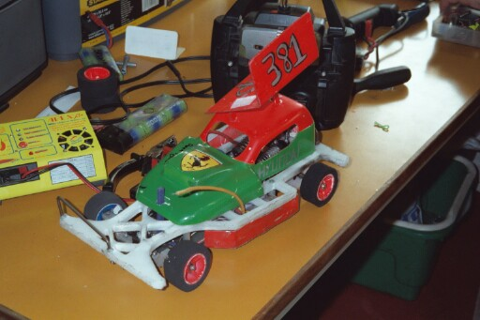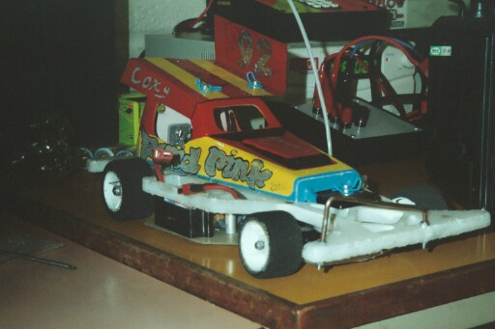

Once again the quality of racing was very good, with a lot of racers posting good scores during their heats of racing, and with the best three lap scores to count from four, and only the top seven straight into the final, then the next eight into a consolation race with only the winner progressing into the final, I’m sure it is going to be close on qualifying straight into the final again!
The unlucky eight, or lucky, which ever way you look at it that had qualified for the consolation race were
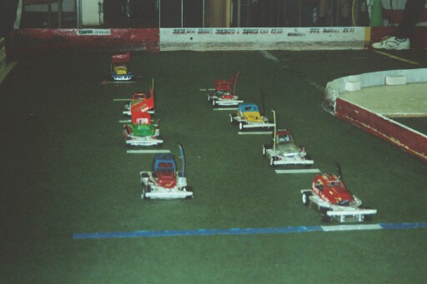

Qualifier Total Laps
- Ben Harding 228
- Paul Jenkinson 226
- Martin Nash 223
- Derek Cayzer 221
- Mike Tomkinson 220
- Andy Wallace 219
- Peter Ayriss 217
- Andy Cattell 214

This is where the report gets a little bit tricky, due to the fact that I have no race scores for the rest of the meeting, thanks you guys, makes my job easier!
From memory then, again it was a very good race with lots of clean racing, the eventual winner and a relieved one at that was championship chaser Ben Harding who progresses into the final.

The qualifiers for the first stockcar national final to be held at the Basildon club were,
In order of qualification,
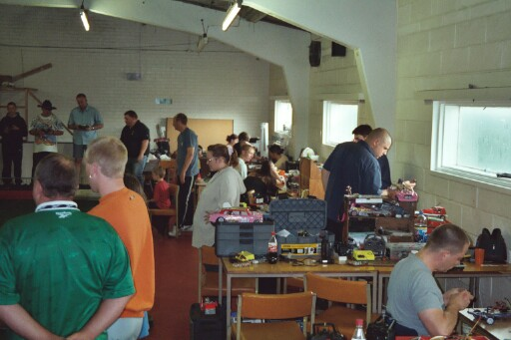
1. Gary Mc Mullen 245
2. Martin Cooper 236
3. Craig Summers 232
4. Ryan Cattell 232
5. David Smith 231
6. Andy Cox 230
7. Mark Cooper 229
8. Ben Harding Consolation winner.

After a bit of detective work, and adding and subtracting from the National points list, the order in which the drivers finished the final were, 1st Gary McMullen who was unlucky to miss his first race of the day, due to the fact that he was sorting something out on an official BRCA level and nobody told him that he was due to race, but he made up for it in the rest of his races dropping just one national point when he was beaten on split time in his first race in round two. 2nd place finisher was Urmston racer Andrew Cox, 3rd went to Ben Harding from the Rugby club, finishing in 4th place was Cambridge club promoter Martin Cooper, 5th was current national junior champion Ryan Cattell who hails from the Stoney Stanton club, another Urmston racer in the shape of David Smith finished in 6th place, 7th finisher was Mark Cooper who is also from the Stoney Staton club, and home club racer Craig Summers finished in 8th place.

The championship race now looks like this after six rounds, this is where we start to drop the lowest round for the racers who have done all six rounds so far, so here are the best racers with the best totals from five rounds of the series
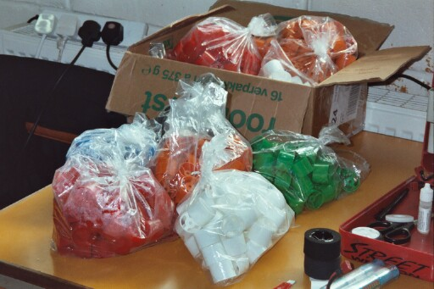
Name Points Club
1. Gary Mc Mullen 493 Urmston
2. Ben Harding 488 Rugby
3. Andrew Cox 461 Urmston
4. Mark Cooper 450 Stoney Stanton
5. Ryan Cattell 438 Stoney Stanton
6. David Smith 438 Urmston
7. Karl Spencer 434 Rugby
8. Martin Cooper 433 Cambridge
9. Andy Cattell 429 Stoney Stanton
10. Stewart Smith 417 Urmston

Name . | F/Tyre | F/Tyre | R/Tyre | R/Tyre | G/Ratio | Speedo | Charger | Car type | Chassi | Cells | Club | Grade | Qualif | Final
Gary  McMullen | Red | Lectr  Hard | SE | Pink | 12/49 | Asso | Tekin | Rapid | And | Corally  1700 | Urmston | Silver | 1 | 1st
Martin  Cooper | Jap  Med | Lectr  Hard | GLF | Pink | 12/51 | Mard | Apex | Rapid | And | Demon  2000 | Cambridge | S/S | 2 | 4th
Craig  Summers | Blue | Pink | SE | SE | 12/50 | Mard | Competiton  Electronics | Rapid | And | Demon  2000 | Basildon | Blue | 3 | 8th
Ryan  Cattell | 812 | 909 | Pink | SE | 13/52 | Mard | Apex | Lecatt | Mard | Sanyo  2400 | Stoney  Stanton | S/S | 4 | 5th
Andy  Cox | 909 | SE | Jap  Med | SE | 12/50 | Asso | Apex | Rapid | And | Corally  1700 | Urmston | Red | 6 | 2nd
Mark  Cooper | Pink | 05 | SE | SE | 13/51 | Mini | Apex | Rapid | And | Reedy  2000 | Stoney  Stanton | Red | 7 | 7th
Ben  Harding | 812 | Jap  Med | Pink | Pink | 12/50 | Mini | Apex | Team  Skint | And | Reedy  2000 | Rugby | S/S | 8 | 3rd
David  Smith | Lectr  Hard | Lectr  Hard | Jap  Soft | 812 | 12/51 | Asso | Pro  Track | Rapid | And | Corally  1700 | Urmston | Red | 5 | 6th

