28th May 2001

Hear we are round four of the national series of 2001.Another good turn out again the best so far fifty-four racers, which brings the total of different drivers to have raced at a national this year to ninety-seven.Urmston looking better than ever thanks to the new carpet and out field,Alan Crossland certainly looking after his club. Jeans café doing good work with the breakfast’s and good hot food all day exellent.Good to see former Urmston racer Joe Brown back racing and Eurocar / Hot rod racing specialist Alistair Needham,also the first outing for former national points champion Stephen Farmer.Car builder Ade Eaglen also out for the first time, Jon Cutts trying a Bandit car and Colin Eardley persevering with four cells and Schumacher specialist Clive Buckler racing a Pinky Mk2 all this should be interesting. No Alan Crossland racing as he prefers to concentrate on running the meeting.

Round one.
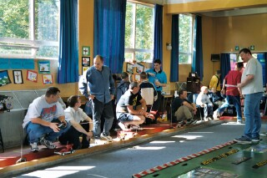
Excellent start for Jon Cutts winning
With 83 laps from Andy Cattell on 79
Just in front of David Smith on 78 then
came Karl Spencer on 77 ( so Jon wins
with his new Bandit car ) heat two won
by Clive Buckler with 80 then came
Ian Yarwood and Anthony Jewell both
On 78.Heat three won on 81 by Gareth
Jones from Phil Chadbourne who also
Finished on 81.Heat four won by Ben
Harding on 83 followed by Paul Jenkinson with 75 and Martin Cooper on 73.Heat five and a good win for Stewart Smith on 76 then came Pete Clarke with 74 also on 74 was Ross Kerr and Andrew Cox placings sorted out by the split times by the computer. Heat six was won by Gary McMullen with 81 and comeback kid Joe Brown just taking second from Robert Teuke both on 76.Heat seven won by Mark Cooper on 80 from Ryan Cattell on 78 then came Alastair Needham on 76.
So a good start for both Gary and Mark one-two in the national points so far, also Jon winning with his Bandit car and just for a nice change! Andy Cattell getting a better score than his son Ryan. The heat winning average for this round was 80.57.

Round two.
Andy Cattell going well in the first heat winning with 82 from Ade Eaglen some way behind on 75 then came Andy Wallace on 71.Heat two saw Anthony Jewell winning with 81 closely followed by Clive Buckler and Phil Chadbourne both on 79 and one lap behind these two was Jon Cutts.Heat three saw David Smith taking the FTD and new track record with a handsome 86 pushed all the way by Karl Spencer who finished on 85 then came Stewart Smith and Gareth Jones on 84 down in fifth place but still recording an 80 lapper was Anthony Wyper.
Heat four saw Mark Cooper continue his winning form taking the win on 81 second came Derek Kerr on 72 as did Angela Yarwood.Heat five and Gary there again winning on 81 from Ian Yarwood with 76 then came Ross Kerr on 73.Heat six saw Ben Harding out in front on 84 then came Paul Jenkinson with 78 and Rugby youngster Robert Teuke getting a looking with 73.Heat seven won by Stephen Farmer on 81 from Pete Clarke with 70.A high scoring round saw the winning average pushed up to 82.28 and a new track record for David Smith.

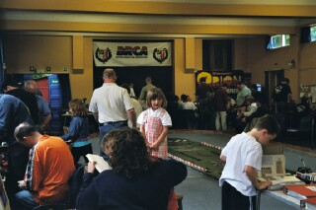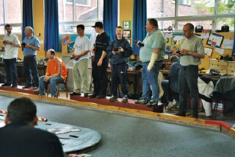

Round Three.
Gareth Jones setting the pace in heat one with 85 with Jon Cutts finishing on 82 and Ade Eaglen third on 77.Heat two and Anthony Jewell in fine form winning with 84 from Ian Yarwood’s 83 then came Darren Grace on 75.Heat three and it’s Stuart Smith out in front again on 82 just beating Phil Chadbourne on 81 then came Ross Kerr with 78 and Andy Cattell on 76.Heat four saw Gary McMullen winning with his third score of 81 then came David Smith on 77 and getting a look-in with his four cells was Colin Eardley finishing with 74 as did Robert Teuke.Heat five and Ryan Cattell on form with a 83 with Martin Cooper next nearest on 74.Heat six Ben Harding finishing on 79 then came Stephen Farmer on 76 and Clive Buckler on 75.Heat seven and it’s Karl Spencer winning on 81 then came Pete Ayriss and Paul Jenkinson both on 77.So a good round for some but Gary making no improvement on his score and no mention of Mark, it looks like a score over an average of 80 was going to be required to make the final.The average winning score this round was 82.14.

Round four.
Anthony Jewell on 81 winning heat one from Stewart Smith on 79 and Mark Cooper struggling back in third on 78.Heat two and it’s Phil Chadbourne in front on 82 from Alastair Needham on 80 then came Darren Grace on 77 and Ade Eaglen on 76.Heat three saw Gareth Jones on 83 next up was Andrew Cox on 75.Heat four saw Ian Yarwood win on 79 closely followed by Clive Buckler on 78 and Paul Jenkinson finishing on 75.Heat five and Andy Cattell back on winning ways finishing on 81 from Stephen Farmer on 79 and just like Mark , Jon Cutts struggling on 78 and a low score from Karl Spencer on 77.Heat six and theres no stopping Ben Harding winning on 83 from Ross Kerr on 76 and Steven Farrer on 75 then came our Cornishman Andy Wallace on 72 handicapped by his broken wrist. The last heat was won by Ryan Cattell on 81 from David Smith on 80 and Colin Eardley there again on 78.
A good last scoring round for some but not for others as the grip increased as the afternoon went on and some drivers myself included found it hard to set up the car so you did not roll on the corners but you could maintain you’re cornering speed as this was the key to getting a good lap score. The winning average this round was 81.42. 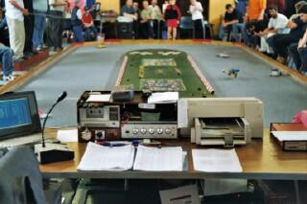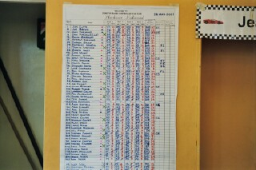
Race control Score sheet
Consolation
Not the usual line up of drivers more like a final line up. Just missing the final and starting on pole with a qualifying score of 243 was Jon Cutts next was Gary McMullen also on 243 third was Ryan Cattell with a score of 242 as was his dad Andy Cattell also on 242 fifth was Ian Yarwood with 240 sixth was Mark Cooper with 239 in seventh was Clive Buckler on 237 and in last spot was Stephen Farmer on 236.What a race all or nothing with no quarter given at the end Jon just across the line first less than a second in front of Mark both on 83 so Jon went through to the final, third was Andy on 81, Stephen next with 80 fifth was Ian Yarwood on 79 as was Ryan seventh came Clive on 77 and after a small repair to his car and racing tactics in last place was Gary on 71.

While we waited for Jon to get ready for the final a Junior grand national race was held with a trophy going to the winner some of these are the stars of the future, in the race we had Ian Yarwood jnr Thomas Yarwood Robert Teuke Thomas Collins Daniel McMullen Nicholas Cooper Glenn Nash and Joe Huxley at the end of five minuets Robert Teuke won on 70 laps.

Final line up.
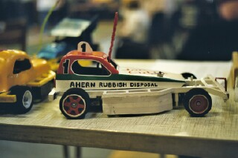

Gareth Jones 252
Ben Harding 250
Anthony Jewell 246
Stewart Smith 245
David Smith 244
Phil Chadbourne 244
Karl Spencer 243
Jon Cutts Consolation winner
Jon Cutts car
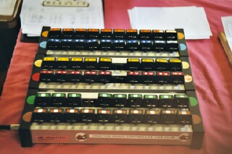
Once again a very closely fought race unfolded after one minuet of fast and furious racing Stuart Smith led the way
On 17 laps,two minuets in and Stuart
Is still leading on 34 laps, the lead changed
After the next split time, and its
David Smith who

Transponders

took over the lead crossing the line at three minuets on 50 laps.we now had three drivers on the same lap with three more just one lap behind. David was still out in front after the four-minuet mark on 67 laps. Agonisingly David was still leading until the last lap when Ben used the bumper on David to allow Karl through to take his first national win and how close a result it was at the end which looked like this;

1. Karl Spencer 84
2. David Smith 84
3. Ben Harding 83
4. Gareth Jones 83
5. Anthony Jewell 82
6. Stewart Smith 81
7. Phil Chadbourne 80
8. Jon Cutts 80

One lap around the Urmston track takes about three seconds, which means the gap from first to last place was about twelve seconds! Very close racing.
Grade awards went to best white Daniel Bullock. Best yellow Aaron Eaglen.Best blue Ian Yarwood.Junior trophy was won by Ryan Cattell
Next meeting Leven plus the Scottish Open Sunday July 1st
