Leven National 1/12th Stock Cars

Round five and we find ourselves in Scotland for the first time and very nice too. Interesting journey north up the M6 nice scenery going past the lake district then into Scotland passing Gretna Green just before the boarder of England / Scotland then across country towards Edinburgh then across the Fourth Bridge and on to Leven with the hall situated at Milton of Balgonie, excellent b&b on the promenade at Leven overlooking the beach and a nice weekend to look forward to.

Unfortunately the heat details got lost in the post between the points compiler and myself, but I can tell you there were some excellent racing during the day and not one single moan from anyone even when some decided to enjoy themselves with the bumper. A modest turn out of thirty drivers and congratulations to long distance traveller Andy Wallace travelling up from Cornwall a journey of nearly 750-800 miles ( must be mad or exceptionally keen! ).
So just for a change hear are the drivers who raced,
David Smith, Ryan Cattell, Sandy Bissett, Paul Jenkinson, Kevin Falconer, Gary McMullen, Ben Harding, Allan Stewart, Dean Ritchie, Peter Bissett, Michael Bethune, Ross Kerr, Craig Brown, Brian Cuthill, Steven Duncan, Neil McClusky, Andy Cattell, Pete Riddell, Neil Ritchie, Martin Nash, Karl Spencer, Paul Riddell, Mark Cooper, Gary Riddell, Andy Wallace, Alistair Needham, Iain Roper, Simon Preston, Derek Kerr, Nicholas Cooper.
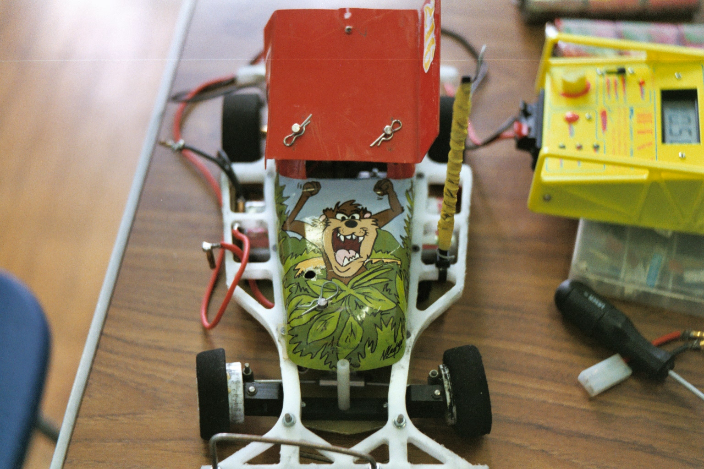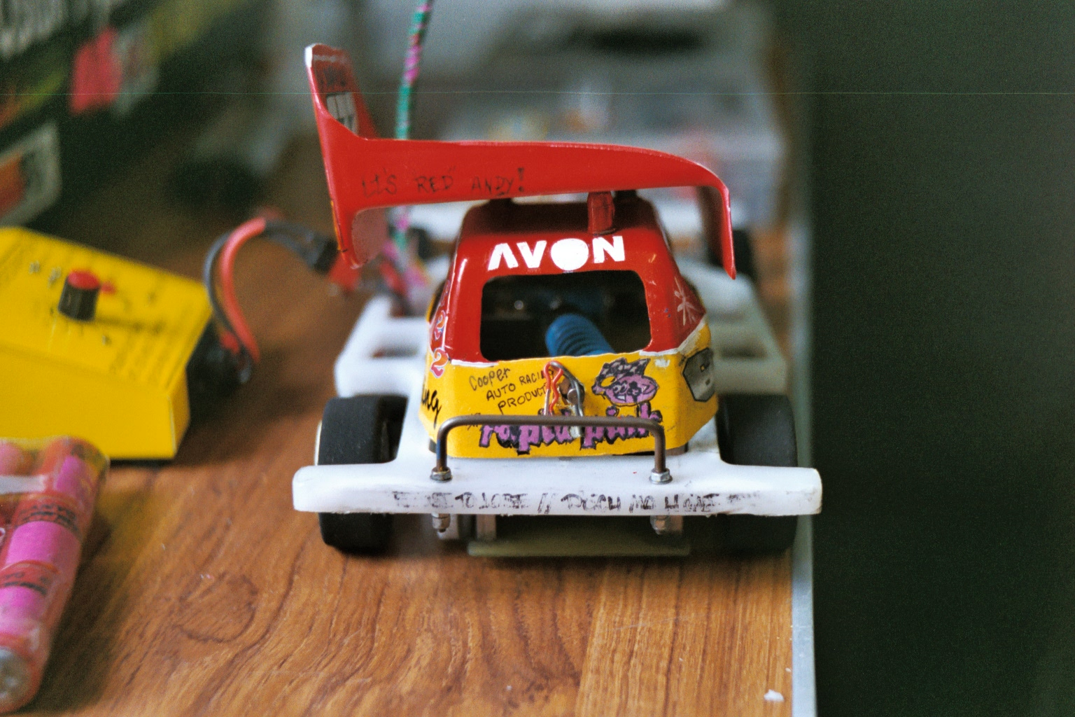
Drivers to qualify for the final were Ben Harding, David Smith, Karl Spencer, Derek Kerr, Andy Cattell, Ryan Cattell, Gary McMullen, and joining them from the consolation was Mark Cooper winning the consolation on split time from Paul Jenkinson.A special mention for Derek as I believe this to be his first national final.
Once again we had a very fast and close race which has been the norm in stox finals of recent years with four or five drivers in with a chance of winning this one, as those in the final all thought someone else had won, with remarks like you must have been in front of me as I saw very little of you during the race, but at the end it was Ben Harding taking the win on 72 laps from Gary McMullen and Ryan Cattell both finishing on 71 next up was Mark Cooper and David Smith on 70 laps then came Karl Spencer on 68, Derek finishing on 66 then came Andy on 59.
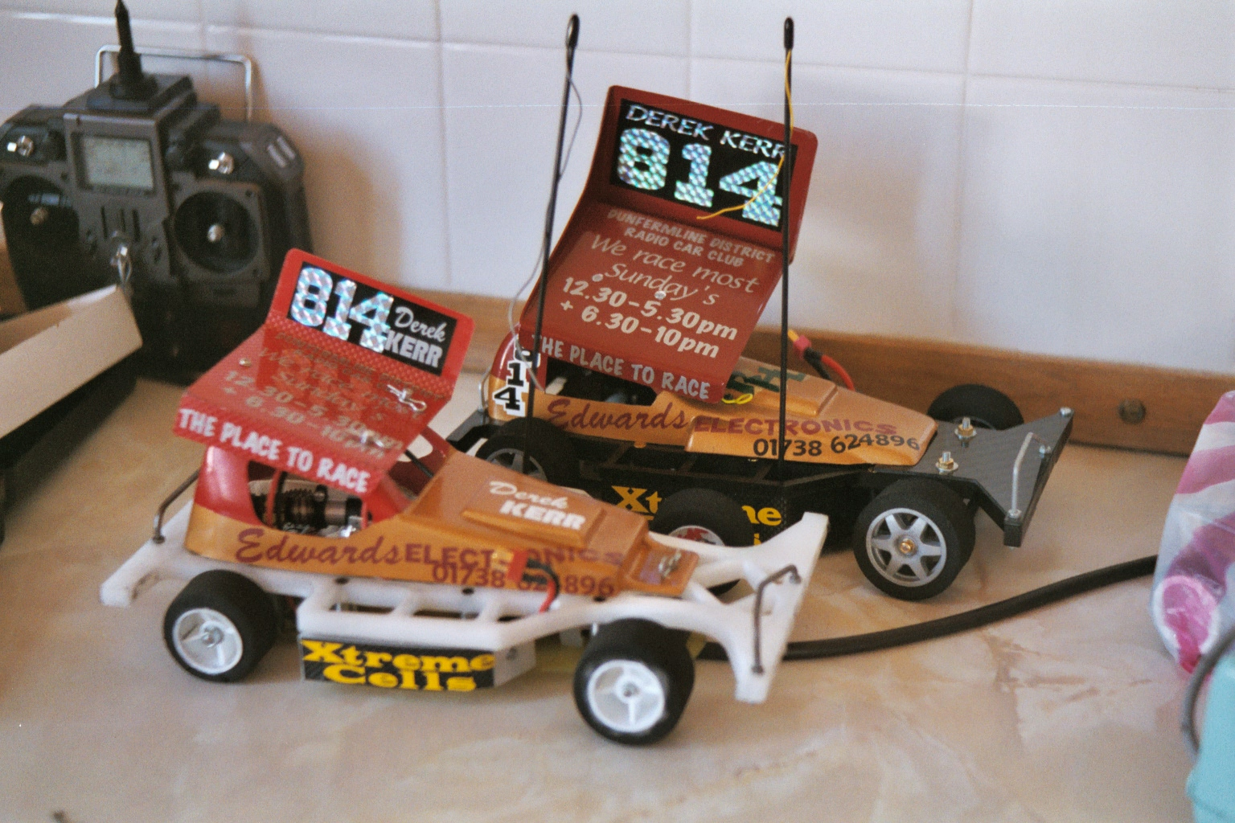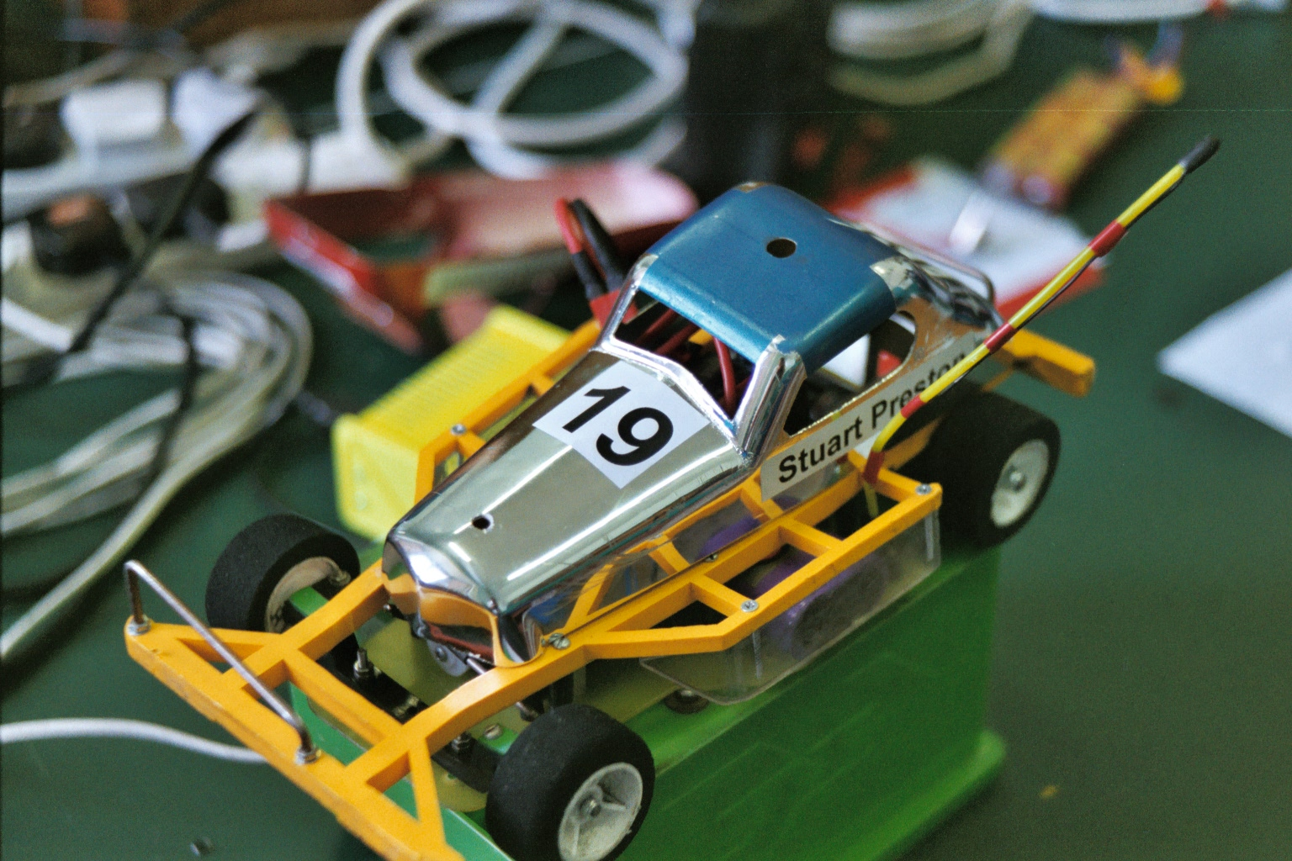
Thanks must go to Scoonie Hobbies for sponsoring the meeting. Michell & Stuart for manning race control ( translator required ) and Fiona in the tuck shop, also the mobile burger van that kept us well fed all day.

Special awards went to Gary Riddell & Peter Bissett in the form of a Booby Prize as they finished join last.

The top ten in the national points table now looks like,
1. Gary Mc Mullen 478 Ben Harding 380
2. Mark Cooper 469 Phil Chadbourne 344
3. David Smith 467 Paul Jenkinson 331
4. Ryan Cattell 457 Martin Cooper 328
5. Andy Cattell 423 Ross Kerr 299

