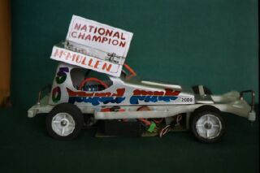
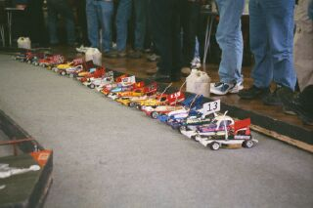

18th March 2001

Excellent turn out for round two of the national series, forty one cars from far and wide with long distance travellers coming from Scotland and Cornwall also Stuart Tennant the current 1/8th stock car champion trying his hand at 1/12th electric stock cars should be interesting because apart from size the only big difference is we have a reverse on our cars and 1/8th do not, Stuart racing a bandit type stock car from Ian Johnson. He should be in good company as Tim Pole & Phil Chadbourn are also 1/8th racers, could Stuart be hoping to be the first ever winner of both world titles as we are holding our first championship this year. After practice the day started with a Concourse which was won by Cambridge racer Stuart Cayzer,for those not in the know a concourse is basically the best looking body shell.

Round One.
And what a start heat one won by Stuart Tennant on 79 laps from Chris Partridge with70 then Andy Wallace on 69 and Gareth Jones 68 early days but looking good for Stuart. Heat two won with 85 laps by Jon Cutts then came Stuart Cayzer on 82 and long distant traveller Doug Giles on 75, heat three won by Gary Mc Mullen with a new track record for a five minuet heat 91 laps closely followed by Mark Cooper on 90 David Smith on 87 and Ben Harding the Coventry champion on 84 all these drivers bettering heat one winning score of 79,heat four won with 80 laps by Andy Cattell and Gary Osbourne Andy winning by .840 of a second third came Peter Riddell on 79,heat five won by 1/8th racer Phil Chadbourn on 85 Pete Clark was next on 83 then came Alan Crossland on 79,heat six won by Hathern racer Steven Farrer with 81 from Ross Kerr and Paul Jenkinson both on 76 heat seven won by ex-national champion Stephen Farmer with 79 from Martin Cooper on 77 then came Andrew Cox on 76 and Jonathan
Goodacre with 75.
A good start to the racing with the old track record broken and heat wins for Stuart &Phil Chadbourn both from the 1/12th Cambridge national winner Roy Calver struggling on a 62 lapper and Andy Cattell beating his son Ryan for a change.
Round two

Heat one saw local track specialist Ian Johnston out in front with 87 laps two in front of Steven Cayzer heat two a close battle between Jon Cutts & Stuart Tennant with Jon just in front by .600 of a second both on 85 laps and third came David Smith on 82 heat three won by Mark Cooper with 85 and a good battle behind between Vincent Brickell,Peter Riddell,Alan Crossland finishing in that order on 77,76,75 respectively heat four won by Gary Mc Mullen from Ryan Cattell on split time both finishing with 89 laps third was Gary Osbourne on 83 Heat five another close one just won by Andy Cattell on 82 then just behind came Pete Clarke & Tim Pole both on 81 heat six saw Ben Harding take the win with 84 Martin Cooper on 82 just in front of Stephen Farmer on 81 heat seven saw Phil Chadbourne win on 81 from Andrew Cox with 78.A good round saw most drivers improve their previous score from round one but the new track record of Gary’s looks safe,and still no mention of Roy Calver previous national winner struggling on the smaller track as set-up is the key keep searching Roy!.
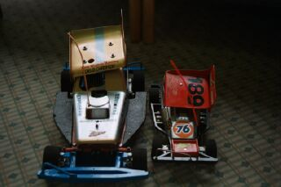
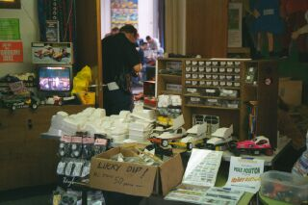
Ian’s spares shop Stuart’s little & large 1/8th-1/12th

Round three.
David Smith off to a good start winning with a 84 from Jon Cutts & Stuart Cayzer both on 81 heat two and Ian Johnston stormed round with an 87 followed by Gareth Jones on 86 with Mark Cooper slipping up this time on 81 heat three went to Vincent Brickell on 83 laps then came Peter Riddell on 80 heat four won by Gary McMullen with a 85 lapper from Ryan Cattell on 79 then came Tim Pole on 77 heat five was won with 81 by Pete Clarke closely followed by Steven Farrer & Paul Jenkinson both finishing on 80 Steven taking second place on the split time heat six won and good to see old cesca racer Jonathan Goodacre winning with a 80 pushed all the way by Martin Cooper on ⁷⁹ then came Andy Cattell on 77 and that man Roy Calver posting his best score to date a 76 heat seven won by Stephen Farmer on 82 just beating Ben Harding into second place on the split time as ben also finished on 82 third was Phil Chadbourn on 81.
Working out the average winning scores tells us that round one heat average winning laps were 82.85 this improved to 84.71 in the second round and the third round the average dropped slightly back to 83.14 working this out tells us that to be in the running to qualify for the final then a 80 or better was going to be required to qualify straight in drivers probably already in so far were Jon Cutts,Gary McMullen,David Smith,Stuart Cayzer,and Mark Cooper a possible five drivers already in the question was who would join them or improve and better these drivers as a lot were just outside of the magic average.
Round four.

Back to winning way’s was Mark Cooper on 82 laps from David Smith on 79 heat two taken by Jon Cutts with 87 from Stuart Cayzer on 83 followed by Phil Chadbourn on 81 heat three taken by Ian Johnston on 87 and Pete Taylor getting a look in with 79 heat four won by Ryan Cattell on 87 from Vincent Brickell on 82 and Steven Farrer on 81 hear five won by Andy Cattell on 79 just in front of Phil Chadbourn on 78 heat six and a surprise here as Gary McMullen was beaten into second by a fine win by Stephen Farmer on 85 laps and Gary on 83 Andrew Cox came third on 82 and the last heat of the day produced a win for Phil Chadbourn on 79 and Martin Cooper second on 76. The average this round improved slightly to 83.71 laps.Out of the fourteen heats of racing there were fourteen different winners,a new track record of 91 laps by Gary.Unusually no one remained unbeaten in the heats but there were six drivers winning three of their races.

The consolation looked like this in qualifying order,

Ben Harding 250 laps
Stephen Farmer 248 ::
Phil Chadbourn 247 ::
Peter Clarke 245 :: Average lap score 81.66 laps to qualify for
Stuart Tennant 245 :: the consolation race
Steven Farrer 242 ::
Vincent Brickell 242 ::
Andy Cattell 241 ::

Unfortunately the consolation had to be re-run as two transponders did not work, In the re-run Phil Chadbourn won the race and progress to the final with the unlucky Stephen Farmer loosing out by 0.44 of a second both finishing on 85 laps, Ben Harding finished with 79 then came Stuart Tennant and Steven Farrer both on 78 sixth was Andy Cattell on 63 then came Vince Brickell with 54 and finding problems with his car in last place was Pete Clarke on 17 laps.

The final in qualifying order lined up like this in grid formation average lap score 85.61 laps.

Gary McMullen 265 laps
Ian Johnson 261 ::
Jon Cutts 257 ::
Mark Cooper 257 ::
Ryan Cattell 255 ::
David Smith 253 ::
Stuart Cayzer 250 ::
Phil Chadbourn Consolation winner

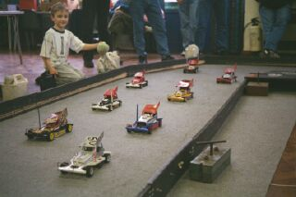
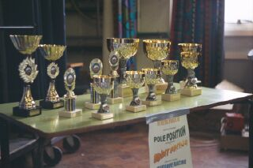
A good battle between Jon and Gary developed, with Gary just beating Jon into second place finishing on 83 laps to Jon’s 82 third was Mark Cooper with 78 laps next was David Smith on 77 Stuart Cayzer finished with 76, sixth was Ryan on 75 Phil came next on 73 and Ian Johnston for the second year running struggling with a problem on his car finished last with 72 laps.

Grade awards went to Barry Weatherhead best white.Yellow went to evergreen racer Malc Davis (mobile chicane) anyone who has raced against malc during his 26 odd years of racing r/c cars of one form or another will know how he acquired this nic-name best blue award went to Gary Osbourne.

A big thank you to the meeting sponsors who were Pole Position final trophies, Bandit Racing grade awards, and Mardave Racing concourse award.

After two rounds of the national series the to ten looks like this
1. Gary McMullen 197 6. Martin Cooper 175
2. Mark Cooper 194 7. Andy Cattell 172
3. David Smith 184 8. Alan Crossland 160
4. Ryan Cattell 181 9. Roy Calver 159
5. Phil Chadbourn 181 10. Tim Pole 159

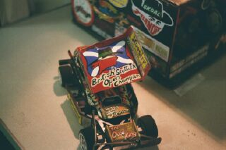
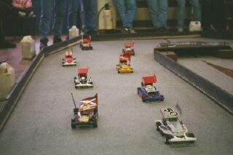
Next round is Rugby 8th April see you there. Report by Mark Cooper.

Ian Johnson’s car Final grid

