

Round seven of the National series, with the title to be decided today as this is the last round of the 2001 series. With two drivers still in with a chance of taking the title and three or four drivers in with a chance of a top three finish. Thirty one drivers in attendance, with some notable long distance travellers i.e. Andy Wallace and Martin Nash making the journey north facing a round trip in excess of 1100 miles, as Andy & Martin raced at both Scottish rounds in 2001 I wonder if we will see the tartan army in Cornwall next year? Amazing how far people will travel for thirty minuets of racing, but as Andy Cattell stated in the Indian restaurant on the Saturday evening, It’s only toy plastic cars, but we race to win! Or is it more of a social event with a good weekend out somewhere different.
After his stay in hospital during the Cornish speed weekend Ryan Cattell, is back with us racing even though he has his foot in plaster and is hobbling about on crutches.
Geoff Needham was amazed there was not more in attendance, as the track at Dunfermline is the closest track in size to the one to be raced on at the worlds this year, and this was a golden opportunity to try out different car set-ups. Geoff mentioned that preparations are well advanced for his dream of the first ever 1/12th stock car world championship event arranged for October, and that entry confirmations will be out soon, and a list of willing helpers is growing, Geoff mentioned that we even have a car park attendant arranged. On the journey north Geoff and myself plus Nicholas stopped en-route at Moffat, a nice little Scottish town, as Geoff explained, he knew of an excellent toffee shop there and a nice cafeteria just up the road, not fancying the local Haggis an excellent Cornish pasty was eaten (with no Andy Wallace in sight him being from Cornwall) followed by a visit to the toffee shop, I was surprised to see that it was a shop dedicated just to toffee and candy sweet’s just like the good old days, well worth a visit!
At the Leven national we had one Scottish driver making the final, I wonder if home advantage would play a part here and we would see more Scottish lads in the final, In fact it has been a bad week for the scots so far, out of the world cup, England the old enemy thrashing Germany, but our hostess Leslie at the Game Keepers cottage was very happy as her team Raith Rovers had won 5-1. Also we had Pete Ayriss racing today in the hope of making a top ten finish in the national series.
So who were going to be the stars of 2001 let’s find out with the report of the racing from Dunfermline.

Round one.
Ian Roper opening his account with a win in heat one finishing on 67 laps just in front of Ross Kerr who was just one lap behind on 66 then came Derek Kerr on 61.Heat two was won by Ben Harding setting a new track record on the way with a score of 75, average lap time was 4.03 seconds, then we had Andrew Cox and Mark Cooper both finishing on 72. Heat three saw reigning national champion Gary McMullen winning on 75 from the in form Karl Spencer who won the final at the Urmston club Saturday morning finishing on 73 and long distant traveller Andy Wallace on 66. Heat four won by Ryan Cattell, showing the stay in hospital had done him no harm on 70, next was Paul Jenkinson with 68 and third in this heat was Campbell McIntosh on 60. Not to be outdone by Ryan dad Andy promptly won heat five with 68 laps chased by Martin Nash who finished with 64 and Pete Ayriss just holding off Stuart Preston on the split time to take third place after both scored 62 laps.
So the track record gets broken in the first round, and both Gary and Ben open their accounts with a win, there for its all to play for in the chase for championship honours.

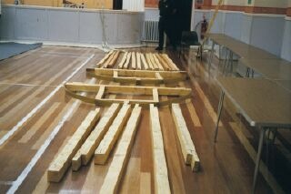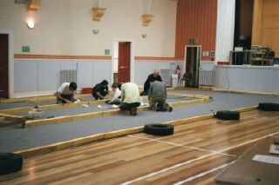
What track? Track crew

Round two.
Derek Kerr going one place better this time winning the first heat on 72 laps from Andy Cattell who finished on 69 in second place. Heat two saw David Smith winning on 69 from Andy Wallace on 66 and Campbell McIntosh with 64. Heat three and the track record is broken again this time Karl Spencer records 76 laps with an average lap time of 3.96 seconds second was Andrew Cox on 73 then came Ryan Cattell back in third on 71. Heat four and Paul Jenkinson also goes one better than the first round to win his heat with 69 laps second was Martin Nash on 64 and third was Ryan Veitch on 58.Also Mark Cooper improved on his first round to win on 73 in heat five from the improving Pete Ayriss who finished on 70 then came Ben Harding on 68 complaining of radio interference in third and Neil Ritchie finishing on 65 laps.
The track record gets re-set in this round, and a lot of drivers improved their first round scores, but both Ben and Gary have a bad round still an open championship race!

Round three.
Gary McMullen gets back to normal service, winning heat one on 75 from Pete Ayriss on 71 then came Mark Cooper doing well to catch up after missing the first three/four laps of the race to finish on 70. Heat two and Paul Jenkinson improves his best score again winning heat two with 72 laps from Derek Kerr finishing on 70, then came the Cornishmen both together on 67 but Martin Nash taking third from Andy Wallace on split times. Heat three and Karl Spencer betters his track record pushing it up to 77 laps and an average lap time of 3.90 seconds, chasing hard in second spot, was Ben Harding, travelling partner of Karl, finishing on 75 but more importantly loosing one valuable national point in the process, advantage to Gary, third was Andrew Cox on 74 pushing Andy Cattell down to fourth on 69.Heat four and a win for Ian Roper on 73 from Sandy Bisset with 66 just in front of Neil Ritchie finishing with 65. Heat five and it’s the junior national champion Ryan Cattell taking the win on 73 laps from David Smith who finished on 71 laps and a good place result for Nicholas Cooper picking up third place and 8 national points.
The track record was re-written this round, Gary scores one more point than Ben in the points chase, and the Scottish lads are starting to pick up some good places in the heats, also Ryan showing his dad how it was done.

Round four.
David Smith sets a fast time just missing the track record by one lap in winning heat one on 76 laps, Ryan Cattell coming home second on 72, then it was Sandy Bisset finishing with 62. Heat two and Ben Harding gets back on track winning with 75 and picking up the ten points for a win, second was Derek Kerr with an impressive 73 the highest lap score by the Scottish boys, then came Ross Kerr on 68 followed by Andy Wallace on 63. Heat three and Gary wins on 75 laps to keep his advantage over Ben, second home was Paul Jenkinson with 69 beating Andrew Cox on split time by 1.75 seconds, and a good score for Stuart Preston with 67. Andy takes the hint and wins heat four with 72 laps, and then it was Gary Riddell on 65 one in front of Ian Roper on 64 then came Pete Riddell one lap further back. Karl Spencer keeps up his winning pace to take heat five on 75, Mark Cooper second with 72 one lap in front of Pete Ayriss finishing on 71 then it was Martin Nash on 68.
After four rounds Gary has increased his advantage over Ben by one point, which equates to one place in the final, also this round we had the best score by one of the Scottish lads with 73 laps.
After twenty heats we had ten different drivers winning, interestingly no one won all their races, but with one drop score from the heats, Gary McMullen and Karl Spencer are both on the maximum score of thirty points from the heats but Karl gets the fastest time of the day with his new track record of 77 which is worth one extra national point.

Consolation.
Last chance saloon as they say! As only the winner goes forward to the final, after the scores have been checked and totalled up the consolation in qualifying order was
Derek Kerr 215
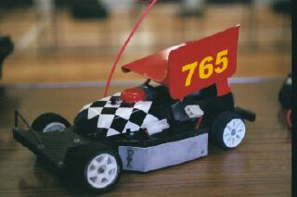
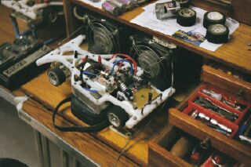
Peter Ayriss 212
Paul Jenkinson 210
Andy Cattell 210
Ian Roper 204
Martin Nash 199
Andy Wallace 199
Stu Preston 194

Interesting line up, we have two Scottish lads one from the Dunfermline club and one from the Leven club, two from the Liskeard club in Cornwall, and four from Urmston club in Manchester. From the off Andy Cattell lead for most of the race but quietly pursuing him and finally overhauling Andy to win the consolation was Paul Jenkinson winning on 73 to Andy’s 71, third was Stuart Preston his final dream in tatters once again! Fifth was Andy Wallace winning the battle of the Cornishmen by one lap Andy finishing on 65 to Martin Nash’s 64 but sandwiched between them on split time but on 64 also was Derek Kerr, Peter Ayriss seventh (with his super pink good advert Pete!) on 62 but on a better split than Ian Roper who also had a 62. So Derek Kerr finishes top Scottish driver (must have been the home advantage)

Final and National Points decider.
The line up looked like an Urmston final with only Mark Cooper spoiling the total domination, but to be fair some of the others also race at Rugby, which is Mark’s home track.
Karl Spencer 228
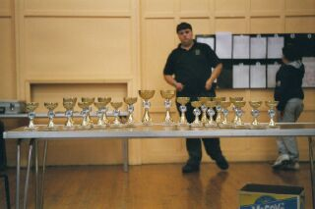
Ben Harding 225
Gary McMullen 225
Andrew Cox 219
Mark Cooper 217
David Smith 216
Ryan Cattell 216
Paul Jenkinson Consolation Winner
It was pleasing that all the drivers left Ben and Gary to decide the championship between themselves, especially as a top three finish in the points was achievable by another three drivers in the race. Ryan was already confirmed Junior National Champion (retaining his title) as I was in the race and suffering with radio interference my only recollection about the final was how clean and fast it was, and the standard of racing was top draw stuff! Must be seen to be believed. The racing is fast and close between any driver making a national final as has been witnessed at all seven finals this year, with just an odd mistake or two sometimes being the difference between winning or finishing outside the top three. At the end of the race it was Karl Spencer taking the win and equalling his own track record in the process! Coming home in second place, which confirmed him as National points champion for the eighth time was Gary McMullen finishing on 75 (must have a chat some time and do a driver profile on Gary, with a mention to Gary’s sponsors if there are any) in second spot just in front of David Smith by 0.84 of a second after they both had finished on 75, Ben Harding fourth with 74, and finishing fifth was myself on 72 (what mite have been!!!!!! Just a private thought there) Consolation winner Paul Jenkinson finishing sixth with 71, seventh was Andrew Cox on 70 as was Ryan Cattell in eighth place.
During the trophy presentation’s someone shouted to Andrew Cox about an earlier comment which was, I thought you said you’re Schumacher (type of car) was flying. Which was received with fits of laughter. And someone made the comment to Ryan about coming home eighth, was the problem due to the fact that you could not put you’re foot down in the final due to the broken ankle then?
So its congratulations to Gary and Ryan both National Champions for 2001/2.

The final places in the top ten National Points table was,
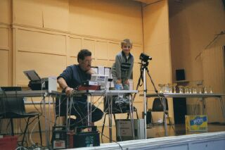
1. Gary McMullen 491 Champion
2. Ben Harding 487
3. Karl Spencer 480
4. Mark Cooper 476
5. David Smith 473
6. Ryan Cattell 462 Junior Champion
7. Andy Cattell 449
8. Paul Jenkinson 424
9. Martin Cooper 412
10. Peter Ayriss 404

A total of 109 different drivers took part in the series, coming from nine different clubs around the country.
After the final a ten-car race was run to try out the world’s format, a pleasant response came back from all who was there, both from those that raced and all who watched the race. The comment from all was that there should not be a problem with the ten car races. Which was accepted by all.

The hot rods were poorly supported with only nine racing, two heats was raced along side each round of stockcar heats, it was decided to run all hot rods in a ten car final the result being,
1. Ross Kerr 69 laps
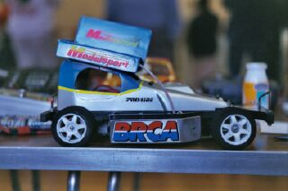
2. Martin Nash 60
3. Andrew Edwards 59
4. Martin Deas 58
5. Ryan Veitch 55
6. Ivan Black 53
7. Paul Martin 49
8. Kevin Blyth 41
9. Richard Hollingsworth 13

We would like to say a big thank you to Dick Springthorpe for manning race control and providing witty comments all day to help keep us all amused. The thankless task of scruteneering performed by Alastair Dees under the watchful eye of Geoff Needham, May and Moira for looking after the transponders as well as the tuck shop, and in the kitchen we had Gordon and Linda Lythgoe keeping us fed and well supplied with tea and coffee. Sponsorship came from Edwards Electronics.
And finally a big thank you to the Dunfermline club and its members for an excellent meeting.

P.S. the final score reads for the stockcars England 8 – Scotland 0.

Dates for the diary next year,

Urmston national June 3rd 2002
Liskeard speed weekend August 17th – 18th 2002

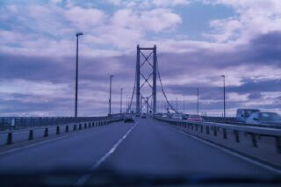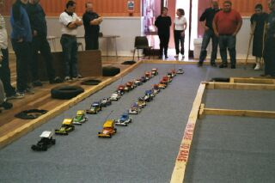

Report by Mark Cooper.

