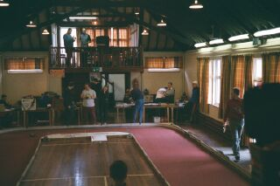
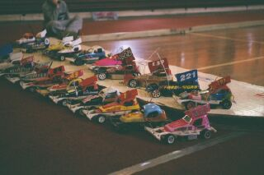
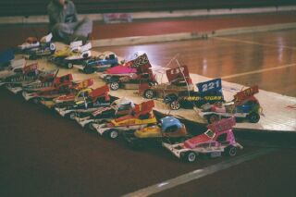

Disappointing turn out for the first national of 2001 especially from the local area ie Ipswich where were you guys.Twenty three drivers arrived one driver not racing with a good excuse was Russell Cooper due to the late arrival of his second baby.The meeting was run excellently by Pinky Cooper with plenty of time for travelling home as the meeting was wrapped up by 4:15pm.So on to the racing

Round one.
Heat one went to Mark Cooper with 65 laps just beating Paul Culverwell by .97 of a second followed by Andy Cattell on 63 heat two was won by Tim Pole on 69 laps closely followed by David Smith just .15 of a second behind then came Alan Crossland on 67 heat three won by the reining national champion Gary McMullen on 67 then came Andrew Cox on 63 heat four was won by Martin Cooper (pinky) with a fine 71 laps which turned out to be the fastest time of the day ie. FTD the came Roy Calver on 65.

Round two.
Heat one was won by Paul Culverwell with 65 laps from Tim Pole on 63 heat two won by Mark Cooper on 65 from Andrew Cox on 63 and Phil Chadbourne on 61 heat three went to Gary McMullen on 69 then Roy Calver 67 and Andy Cattell on 65 heat four won by David Smith with a 68 followed by Ryan Cattell on 65 and Peter Ayriss just failing to break the 60 mark with a 59

Round three.
Ryan Cattell of to a flying start with a win on 65 beating his dad Andy Cattell on 63 heat two won by David Smith on 66 closely followed by Grumpy Cayzer on 65 and Roy Calver on 64 heat three taken by Gary McMullen with a 68 followed by Mark Cooper on 66 heat four won by pinky on 68 then came Alan Crossland with a 66 and Tim Pole on 64 then Phil Chadbourne on 63

Round four.
The make or break round as three from four count towards qualifying so if you have had a break down then this round was going to be crucial and a surprise in heat one won by the evergreen Alan Crossland on 66 by .88 of a second from Phil Chadbourne also on 66 showing that age is no barrier well don Alan! cancel any thoughts on racing retirement. Heat two won by Roy Calver on 67 then came Ryan on 66 beating dad again with Andy Cattell on 65 heat three won by Gary Mc.Mullen (no surprise there!) on 65 followed by Grumpy Cayzer on 62 then came David Smith on 61 the last heat was won by Mark Cooper on 69 just beating pinky who finished on 68 and Tim Pole on 62.

Consolation race time in qualifying order
Ryan Cattell
Andy Cattell
Paul Culverwell
Phil Chadbourne
Grumpy Cayzer
Peter Ayriss
Peter Martin
Weasel Westley

Only the winner of this race goes through to the final and a close one it was with the win and place in the final going to Phil Chadbourne on 60 just overtaking Ryan in the last few seconds who finished on 59 just in front of yes you guessed Andy (dad) on 58

In between the consolation and final a grand national race was run the line up looking like this
Steven Mansell
Stuart Preston
David Chapman
Simon Hogg
Jason Bartropp
Nicholas Cooper
The race won by Steven Mansell on 54 followed by Jason on 53.

Final time in qualifying order

(pinky cooper)

Gary McMullen
David Smith
Mark Cooper
Roy Calver
Alan Crossland
Tim Pole
And the winner of the consolation Phil Chadbourne

What a surprise! An Exellent win for Roy Calver on 69 congratulations on your upgrade to red for the next national second was Mark beating Gary both finishing on 67 mark winning on the split time fourth was pinky fifth came Tim consolation winner Phil was sixth Alan seventh and wooden spoon last place in the final was David .

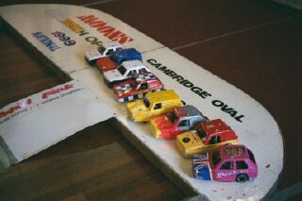
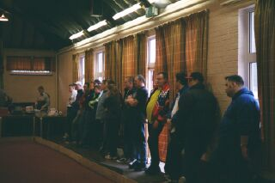
Support formula was the Reliants
There was nine reliants racing producing some fun racing with race wins going to Gary McMullen Pinky Cooper Alan Crossland. Best laps for the reliants was a 60 achieved by Pinky

A “B” final consisted of Steven Mansell Caroline Waldock and Jason Dommett the win taken by Steven on 36 laps. The final for the reliants lined up in qualifying order

Gary McMullen
Pinky
Alan Crossland
Peter Martin
Grumpy Cayzer
Tracy Cooper

A close result produced a win for Gary on 57 laps from pinky on 57 laps but 4.57 seconds behind third was Peter on 50 then Alan on 49 Grumpy with 53 and Tracy on 37.

A special mention to Pinkys mum for running the tuck shop excellent value and very tasty bacon buttys
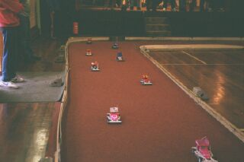
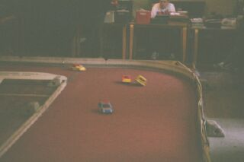
And all the club members who helped set the track up and helped run the meeting.

Report by Mark Cooper.

