


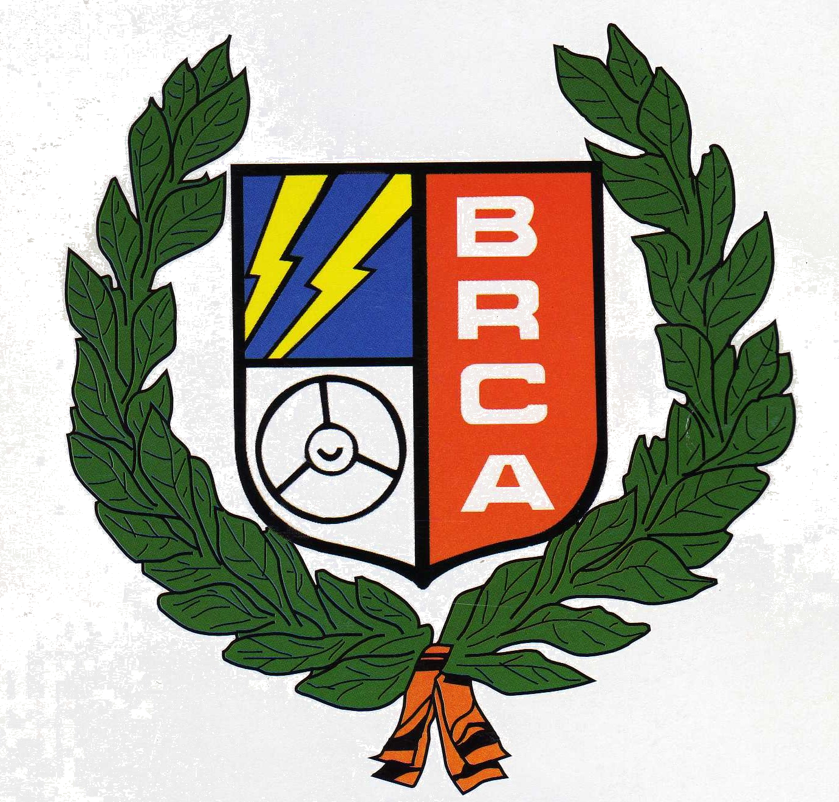
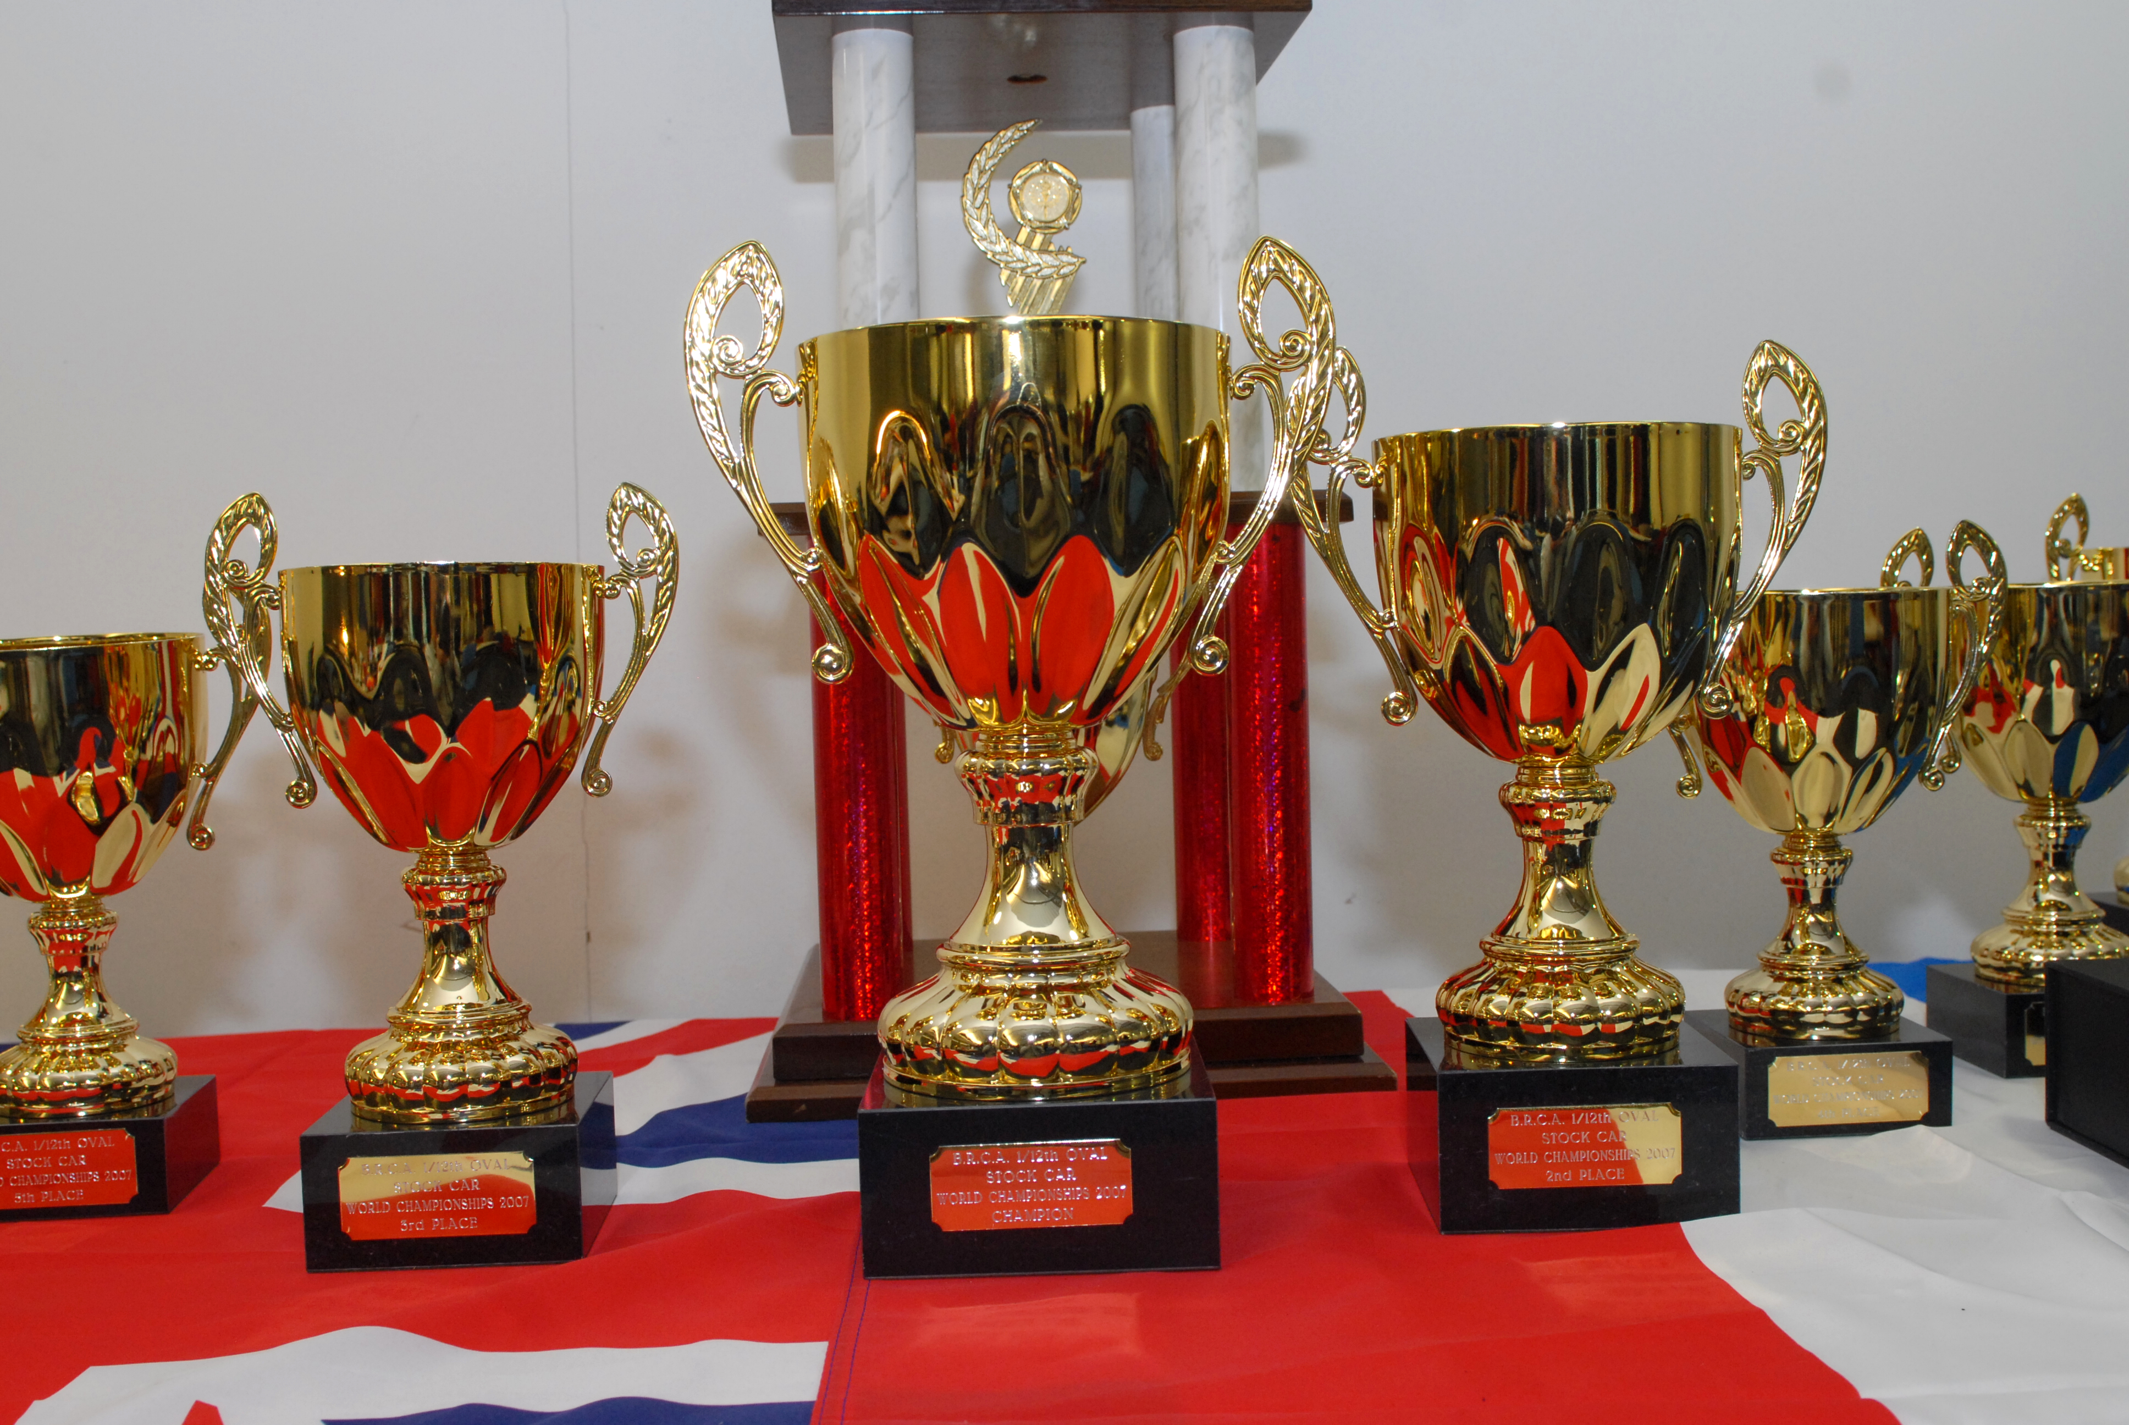
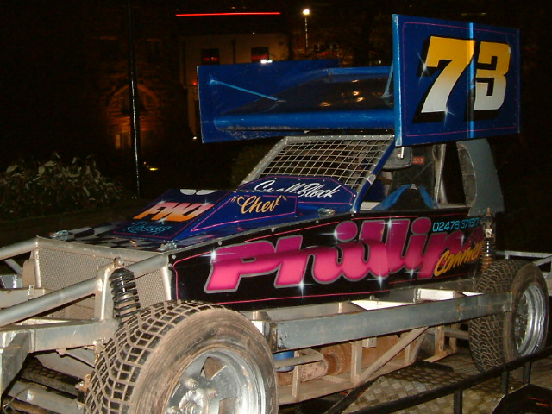


The Championship of the World
Presented by the BRCA for the
1/12th Scale Electric Stockcars
Saturday December 8th Sunday December 9th

In association with Rostec: the new name in 1/12th Oval Racing

The story of this World championship event began at the BRCA AGM in 2006 when we elected a new Worlds organizer, the post was duly filled by Mark Paliser, and he was tasked in finding a suitable venue for the Worlds along with some form of sponsorship from some recognisable names. The announcement of MOTORFEST ’07 At ROCKINGHAM MOTORSPEEDWAY on the 15th – 16th September fitted the bill. Unfortunately as time passed it became apparent that the show organiser was selling space inside the grandstand at Rockingham and thus we were left out in the cold. This left us with a dilemma, and sadly the cancellation announcement came soon after. The members of the committee then searched for a new venue, but with the short notice the original date could not be kept. However a suitable venue for the event was found at the Coventry Transport Museum, and was duly booked with the new date for the Worlds being 8th and 9th December.

With so much to do and so little time to do it all, the committee pulled together, Andy Nash is in charge of the booking in of the racers, sorting out the heats and producing the drivers information packs to be sent out, Allan Inness creating the entry forms with assistance from myself, while I was the liaison with the museum. Lee Bishop is providing the cardboard for covering the tables at the museum and organising the raffle. Brandon Snell would be transporting the track to the museum as we had decided that the Stoney Stanton oval would be used for the worlds along with the “worlds carpet”. This decision meant that we needed to tidy up the Stoney track so that it was suitable for racing in front of the public. A track working party consisting of Brandon Snell, Allan Inness, Ben Harding, Nicholas Cooper and myself, worked to apply a new metal strip to protect the wood and a new coat of paint applied to the whole track, and by the end of the evening the track was almost ready, just a few little things to take care of after the last Stoney club meeting before the big event.

As we would be racing at a transport museum I thought that it would be a good idea if we could have a “real” Brisca F1 car on display inside the museum, so I asked some drivers who lived locally to Coventry about the possible loan of their car. Very kindly Rob Cowley agreed to loan us his car for the weekend, while Hathern racer John Gould was also keen to have his car on display, to which the museum agreed that the cars would take pride of place as you walked into the museum.
The plan of action was to take both cars into the museum on the Thursday evening before the big event, and in true British style the weather was chucking it down, however both car duly arrived at the allotted time and were installed into the museum. I would like to thank Tony Smith “ Brisca F1 racer, number 91” for transporting John’s car to the museum, and to Rob and Chris Cowley for their efforts in getting to the museum in good time and also to Allan Inness who raced to museum on the way home from work to lend us a hand.

This will be the fourth 1/12th Oval World Stockcar Championship, the first (2001) was held at the JJB soccer dome in Manchester racing on a track borrowed from the Dunfermline club in Scotland, the second (2003) was held at the RAF museum at Cosford on a purpose built track ( no track advantage), the third (2005) took place in Milton Keynes on slimmed down track from 2003, and as has been previously mentioned the track from the Stoney Stanton club is the one that we are using for this worlds. The format for the meeting was over the two days, with Saturday having 1 practice session as per your first round, followed by 4 qualifying rounds and on Sunday one practice round followed by two more qualifying rounds, with the best four from the six rounds that will make up the qualifying total. The top 32 from the entrée of 48 will then contest the quarter finals, the top four from each of these will make up the two semi-finals, and the top four from each of these will then contest the world final.

The aim from the qualifying heats was to make sure that you have done enough to finish in the top 32, and with that in mind here are all of the heat winners Matthew Bennett (5) Clive Buckler (4) Maikel Rutten (4) Anthony Wyper (4) Stuart Tennant (3) Ben Harding (3) Alex Wood (3) Karl Spencer (2) Derek Cayzer (2) Miklos Szabados, Mark Cooper, Tom Collins, Jon Cutts, Martin Riley and John Gould. The highest lap score of the rounds was set by Matthew Bennett in round six in the very last heat of qualifying with 94 laps.

After a short break while the quarter finals were worked out, there was time to take a wander around the museum and get away from the building atmosphere of the fierce competition, the time for all of the practice and the trying out of different set ups was over because we were now at the knock out stage of the competition. If you did not finish in the top four then you are eliminated. Just after 2.30 pm the call was made for the first of the quarter finalist’s to get ready, and after the fitting of the transponders and a call to scrutineering to make sure that all of the cars were deemed to be legal as per the rules, the first of the quarter finals took to the track. Here is the result from that race:

Quarter final 1.

1 | Matthew Bennett | 88 | 300.37
2 | Karl Spencer | 83 | 301.08
3 | Carl Baker | 83 | 303.60
4 | Lee Bishop | 81 | 300.07
5 | John Gould | 81 | 302.43
6 | Maikel Rutten | 80 | 300.86
7 | Richard Harding | 59 | 245.13
8 | Alan Greig | 1 | 8.52

Looking at the result the first two were no surprise, however the same could not be applied to the next two as Carl Baker put in a performance of a life time and Lee Bishop just edged out John Gould for the last of the qualifying places, these were at the expense of a hugely disappointed Richard Harding who had somehow forgotten to change his cells, and the flying Lobith club member and Super Star grade racer Maikel Rutten. Maikel later told me he had been suffering with radio interference during this race, this could account for his demise.

Quarter final 2.

1 | Ben Harding | 87 | 302.04
2 | Clive Buckler | 82 | 300.17
3 | Tom Collins | 79 | 300.96
4 | Jamie Burkett | 78 | 300.03
5 | Nicholas Cooper | 78 | 301.73
6 | Paul Riddell | 68 | 302.39
7 | Michel Berendsen | 61 | 300.29
8 | Elliot Oliver | 22 | 88.08

Again no surprises in the first two as the reigning national points champion Ben Harding eases through into the next stage of the competition as had Clive Buckler, behind these two things were not so easy as it was very close between three racers with Tom Collins coming through towards the end to secure third place from Jamie Burkett who finished ahead of the current European junior champion Nicholas Cooper by the small margin of 1.70 seconds, this was very disappointing for Nicholas who looked to be going through to the next round until he had to make a quick pit stop to tighten up his rear wheel nuts.

Quarter final 3.

1 | Stuart Tennent | 93 | 300.56
2 | Anthony Wyper | 92 | 300.95
3 | Andy Day | 86 | 301.22
4 | Stewart Smith | 86 | 301.48
5 | Martin Riley | 84 | 303.05
6 | Niek Middelkoop | 71 | 265.40
7 | Alan Harding | 44 | 167.64
8 | Jon Cutts | 0 | 0

Once again the top two were predictable, and both Stuart Tennent and Anthony Wyper duly oblighed as they took the first and second places, however unknown quantity Andy Day caused a big shock as he claimed third place and Stewart Smith eased through with the final qualifying place in fourth this at the expense of the former national junior points champion Martin Riley and the former world junior champion Niek Middelkoop, and you have to feel sorry for Jon Cutts who never made it to the start line after the radio gear in his car had failed as they took to the track for the start of the race it late turned out to be both the receiver and a servo that had somehow failed.

Quarter final 4.

1 | Alex Wood | 89 | 303.05
2 | Mark Cooper | 85 | 300.41
3 | Miklos Szabados | 85 | 301.58
4 | Derek Cayzer | 85 | 301.71
5 | David Smith | 80 | 301.82
6 | Gerry Fordham | 80 | 302.19
7 | Jamie Collins | 50 | 300.63
8 | Allan Inness | 3 | 25.24

Alex Wood secured a comfortable passage through into the next round and how close was it between the next three, all on the same lap separated by split times! Behind these three came David Smith who looked to be struggling to find the right set up with his new race car that was built by Ben Harding, and once again Allan Inness suffered with a break down this time his demise was caused by a broken speed controller.

Once again there was a small break as the two semi-finals was worked out, the formula for who went where was the qualifiers from the first quarter final would make up the grid for the first semi-final with the qualifiers from the third quarter final, and the second one would be made up of the qualifiers from the second and the fourth quarter finals.
Now down to arguably the best sixteen racers in the world, and the competition was getting tougher, undoubtedly there would be some hard luck story’s to be told, but the truth is only the top four from each semi-final would make up the 2007 World Final line up, to find out who they are here is the results of the semi finals,

Results of Semi 1 & Semi 2
1 | Clive Buckler | 93 | 302.32
2 | Alex Wood | 90 | 301.28
3 | Ben Harding | 88 | 301.83
4 | Derek Cayzer | 85 | 300.66
5 | Jamie Burkett | 85 | 302.65
6 | Mark Cooper | 84 | 300.30
7 | Tom Collins | 83 | 301.25
8 | Miklos Szabados | 61 | 302.86
1 | Matthew Bennett | 93 | 301.41
2 | Stuart Tennant | 92 | 301.88
3 | Stewart Smith | 90 | 300.05
4 | Anthony Wyper | 88 | 302.92
5 | Karl Spencer | 86 | 301.73
6 | Carl Baker | 86 | 302.18
7 | Lee Bishop | 82 | 301.64
8 | Andy Day | 81 | 301.39

Well done to the eight that have fought through to the Final of the 2007 World Championships, and commiserations to those that have fell just short and join the ranks of the also ran’s, but the eight that are left make a mouth watering line up with most of the racers that you would expect to be in a World Final race. We have Matthew Bennett a racer that keeps on getting better and better and has been on form of late, along with Ben Harding the current National Points Champion and European Champion, then there is a former 1/8 IC Stockcar World Champion in Stuart Tennant, , seasoned racer Clive Buckler has won the British Open championship I think a record five times,

Alex Wood is fast becoming a force to be reckoned with and he has recently secured the title of National Junior Points Champion, Anthony Wyper has also been a winner of the British Open and has also won on the national stage and has been the 1/12th Banger champion on a number of occasions, Stewart Smith has the ability to entertain and has done well to qualify for the final and the outsider has to be Derek Cayzer who has performed nothing short of a miracle to get here if past form is anything of a guide.

With a large crowd gathering around the oval and an electrifying atmosphere the time was upon us for the start of the 2007 World Final, the build up was completed with the introduction of the racers as they took to their grid position, and before you knew it the thirty second countdown had begun, once we were underway it became quit clear how fast this race was going to be as Matthew Bennett was setting a fast and furious pace in the lead chased by Ben Harding and Stewart Tennant with the watching crowd appreciating a great race with plenty of oohs and aahs as small mistakes by the racers were being made and the lead of the race constantly changing, before we go to the result. All of the racers must be congratulated on a superb final that was a credit to the whole of the 1/12th oval section and will go down as one of the cleanest and fastest finals ever, great respect to all eight of the finalist’s, so without me rambling on here is the result of the 2007 World Final.

Name | Race No | Club | BRCA No | Grade | Qualifying  Position | Race Time | Average Lap Time | Laps
Stuart Tennant | 189 | Hathern | 3189 | S/Star | 3 | 300.39 | 3.23 | 93
Ben Harding | 471 | Rugby | 6036 | Silver | 7 | 300.66 | 3.23 | 93
Matthew Bennett | 413 | Rugby | 471 | Red | 1 | 301.50 | 3.24 | 93
Anthony Wyper | 30 | Urmston | 3886 | S/Star | 5 | 302.10 | 3.32 | 91
Clive Buckler | 100 | Rugby | 7416 | Red | 2 | 302.67 | 3.36 | 90
Alex Wood | 560 | Hathern | 1610 | Red | 4 | 302.36 | 3.48
Derek Cayzer | 381 | Fordham | 17453 | Red | 8 | 300.57 | 3.71 | 81
Stewart Smith | 56 | Urmston | 3983 | Red | 6 | 85.19 | 3.55 | 24

Here is a chart with each of the finalist’s basic car set up specifications,

Name | F/Tyre  In | F/Tyre  Out | R/Tyre  In | R/Tyre  Out | G/Ratio | Speed  Board | Charger | Car  Type | Chassis | Cells | Home  Club | Grade | Qualifying  position | Final  result
Matthew  Bennett | Jap | 46 shore | Pink | Pink | 12/51 | 2 speed | Duratrax  Ice | Lecatt | Lecatt | EP  4200 | Rugby | Red | 1 | 3
Ben  Harding | Jap  Med | 55  shore | Pink | Pink | 11/50 | 2  speed | Pro  Trak | Skint | Anderton | EP  4200 | Rugby | Silver | 7 | 2
Clive  Buckler | Jap | Org | Pink | Pink | 11/50 | 3  speed | Nosram | Shminka | Anderton | 4200 | Rugby | Red | 2 | 5
Anthony  Wyper | Pink | 44  shore | Pink | Pink | 12/50 | 2  speed | Much  More | Nick Brown pro | Anderton | GP 3700 | Urmston | S/S | 5 | 4
Stewart  Smith | Pink | 52  shore | Pink | Pink | 11/50 | 3  speed | Apex | Self  build | own | 4200 | Urmston | Red | 6 | 8
Stuart  Tennant | Pink | 52  shore | Pink | Pink | 11/50 | 2  speed | Pro  Trak | Modified  Skint | Anderton | Vapex  4300 | Hathern | Red | 3 | 1
Alex  Wood | Gold | 52  shore | SE | Pink | 11/52 | 2  speed | Pro  Trak | Skint | Anderton | Vapex  4300 | Hathern | S/S | 4 | 6
Derek  Cayzer | Red | Org | SE | Pink | 11/51 | 2  speed | Pro  Trak | Skint | Anderton | 1400 | Fordham | Red | 8 | 7

So it’s congratulations to Stuart Tennant becoming the 2007 1/12th scale electric stockcar world champion, a title that he will hold for the next two year’s along with an automatic upgrade of roof colour to Gold.

The meeting report was written and prepared by Mark Cooper with the assistance of Allan Inness.

