

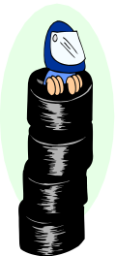
March

This will be the third year that the March club have hosted a National meeting for the Stockcars and Bangers, it will be the final round of the series for both the Stockcars and the Bangers National Points Championship, last year’s meeting attracted thirty-two stockcars and twenty five bangers, the meeting today has an entrée of twenty-two stockcars a very disappointing entrée, and twenty-six bangers an improvement of one on last years entree. The venue is the same as last year at Maple Grove School, at the first ever national meeting the club had the facilities of the school canteen and hot and cold food was available, and as last years meeting the club did not have the canteen available but they had persuaded a burger van to attend, so hot and cold food was available and believe me it was very nice food, provided by a very friendly service. Today’s meeting also see’s the end of the National series for 2006, it looks like Ben Harding is going to retain his stockcar title, however there are still other places in the championship to be decided today, and in the banger section there is a lot to be decided as we go into the final deciding round.
The race directors for the days racing were Mark Steel and Kevin Swan who have taken over the running of the club from Paul Barns, and looking after the Stockcar’s by running the rule over them and checking them to make sure that they conform to the rule book is the BRCA stockcar scrutineer Brandon Snell, and the Banger scrutineer Alastair Needham will be taking care of the Bangers as the official BRCA scrutineer, and as things are going to be busy Allan Inness will be on hand to check the cars over as and when needed.
The March club has its own web site where useful information can be found, the club web site is located at www.marchraceway.co.uk and an additional site for photos can be found at www.marchraceway.piczo.com for avid internet fans links can be found on various web sites, for those that might be interested in visiting the club, here is a map showing where the club can be found in the school that is located on Maple Grove,
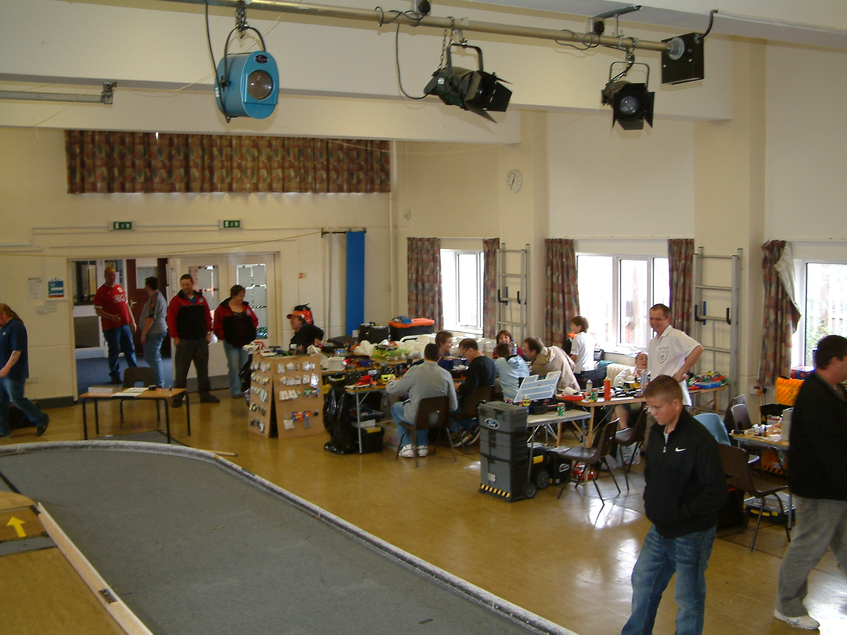
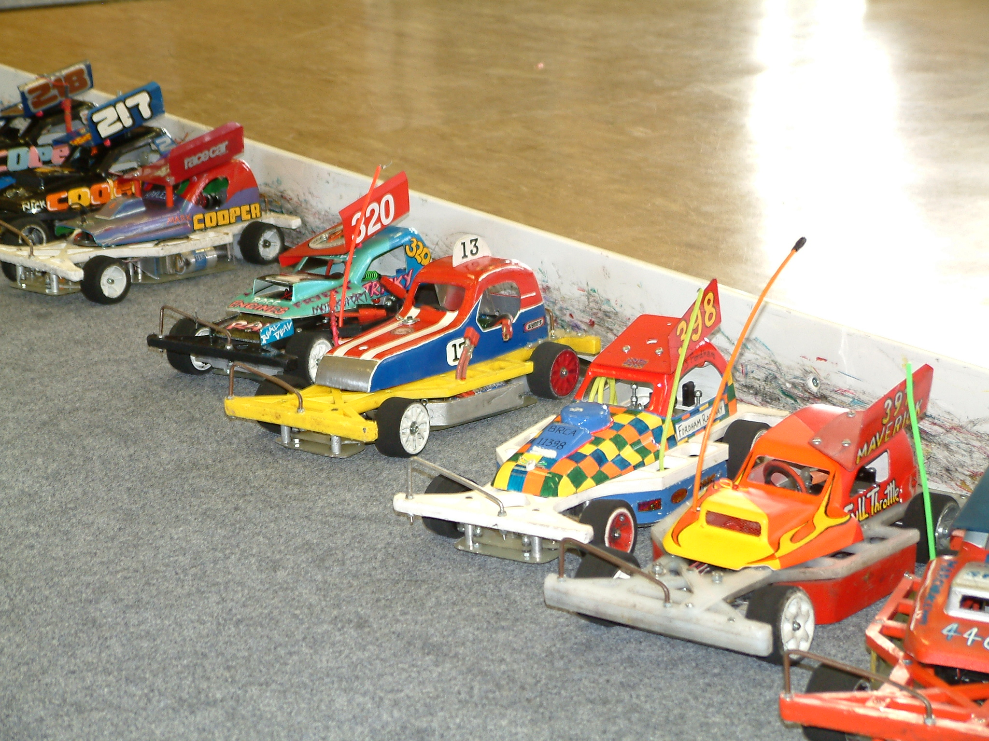
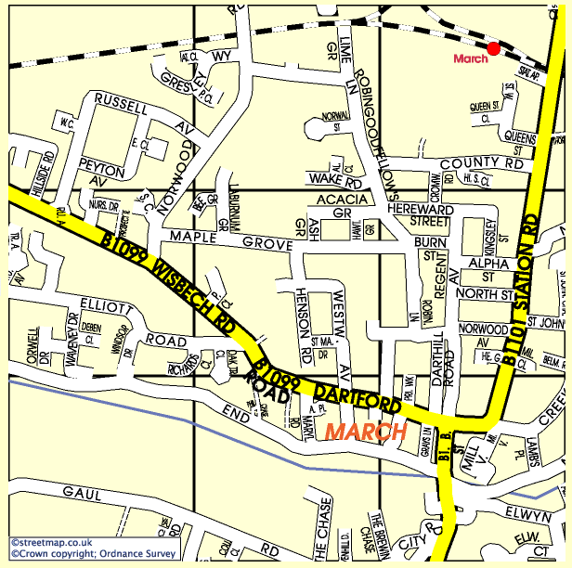

Round One. Stockcars.

Heat one threw up no surprises as Ben Harding took the first win of the heats with 86 laps from Alastair Needham in second place with 85 behind these two came Jim Burkett with 83 and Matthew Bennett was just behind Jim with 82 laps and Dave Gwilliam was also one lap behind Matthew in fifth place with 81, and Miklos Szabados finished in sixth place with 79. Heat two had James Blower showing his liking for the March track as he took heat two with 80 laps, behind him in second and third places came Stewart Smith and Martin Riley with 78 laps each, Stuart was ahead by 0.93 of a second, fourth place went to the frustrated Mark Cooper who was complaining of a lack of speed as he came home with 77 laps he was closely followed by Chris Blower with 76 and the struggling Alan Inness could only muster a poor 69 laps in sixth place.

Heat three saw a very even race as there was only five laps separating all of the seven racers at the finish of the heat, taking the heat win by a split time was Anthony Wyper with 83 laps he was ahead of Sam Grey by 0.85 of a second as Sam also finished the race with 83 laps, behind these two came Carl Baker and Michael Fryett with 82 laps each, the computer showed that Carl was ahead of Michael by 0.98 of a second, finishing in fifth place was Alan Bellis with 81 followed by Derek Cayzer with 80 laps in sixth place and Richard Harding had 78 laps to his credit in seventh place.

Round Two. Stockcars.

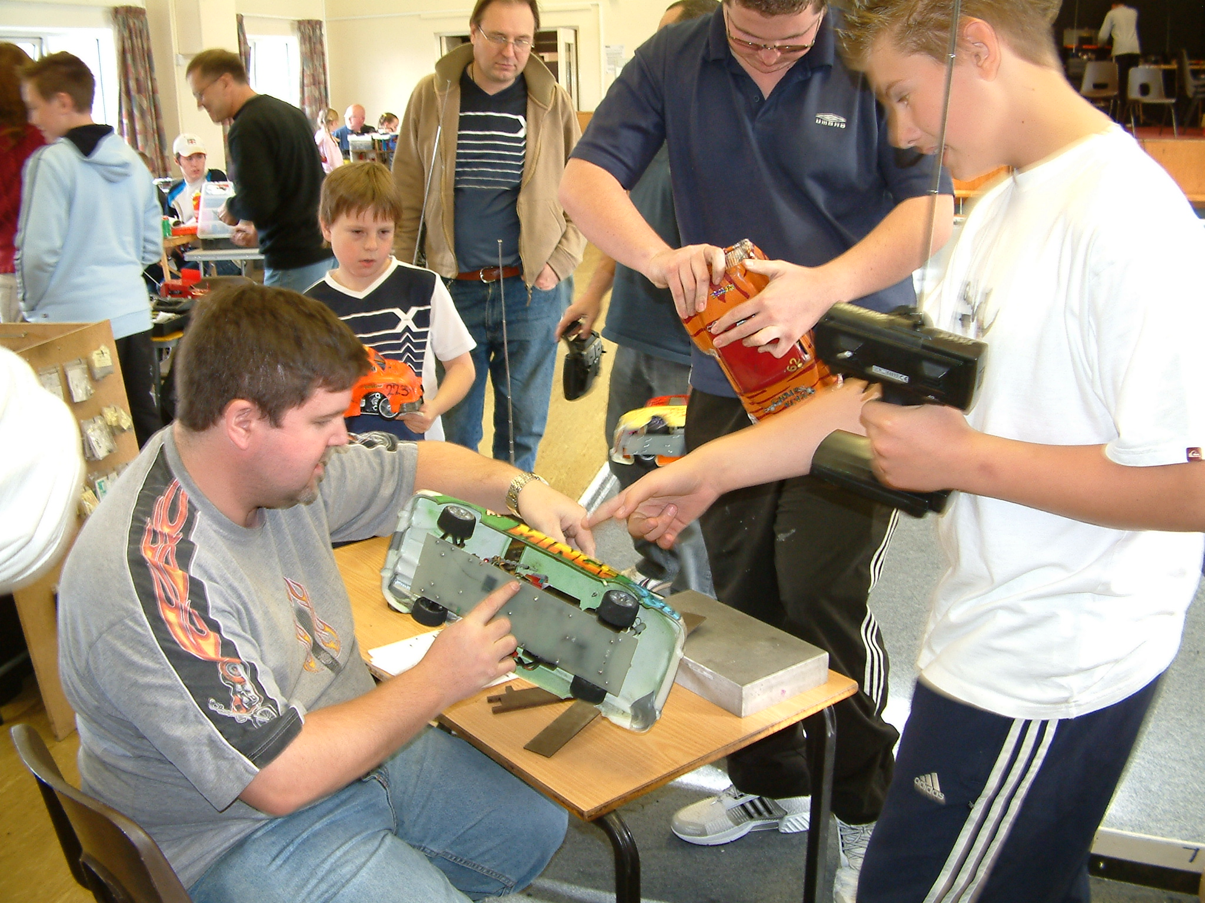
What a result for Anthony Wyper in heat one, not only did he post an impressive 86 laps but he also inflicted a rare defeat on Ben Harding as Ben came home in second place with 85 laps, young Martin Riley from the Urmston club claimed third place with 82 followed by Carl Baker and Alan Bellis both racers finished with 81 laps in fourth and fifth places respectively. Heat two saw the Rugby red top racer Matthew Bennett record a heat win with 84 laps he was chased by Michael Fryett in second place with 82 laps and by Mark Cooper who finished one lap behind Michael in third place on 81 laps, behind these three came Chris Blower with 79 and Stewart Smith also finished with 79 laps a mere 1.67 seconds behind Chris. Heat three was a close race, the win could have gone to any of the top five racers in the heat, however it was Sam Gray that recorded a heat win with a winning lap score of 83, then we had a train of three racers all finishing with 82 laps each in order of crossing the finish line they were Dave Gwilliam, Alastair Needham and Jim Burkett, and for good measure James Blower was a single lap behind these three in fifth place with 81 and that leaves us with young Nicholas Cooper in sixth place with 69 laps.

Round Three. Stockcars.

I know that I have said this before and it still amazes me how a racer can suddenly produce a blistering race that defies what has gone before, previously to this race Ben Harding’s best laps were 86 and 85, so how on earth does he suddenly win heat one of round three with an almighty 91 laps, by comparison Sam Gray was trailing in his wake with 86 laps as was Mark Cooper with 84 in third place, Michael Fryett finished with 83 laps in fourth place and Allan Inness was a few laps behind Michael in fifth place with 74 and Nicholas Cooper was consistent with his lap scores as he finished with 70 laps. Heat two was back to the land of mere mortals as the winning lap score from this heat was 81 laps, although a heat win is a heat win and I am sure that James Blower will accept the ten national points that he collected for achieving this, just behind him by one lap was Alastair Needham in second place he was followed by Richard Harding with 79 laps and Dave Gwilliam was a further lap behind him in fourth place. Heat three saw Anthony Wyper collect his third heat win with 87 laps, behind him in second place was Matthew Bennett with 84 followed by Jim Burkett with 83 and Carl Baker with 82 laps in fourth place, this was with a split time as Martin Riley also recorded 82 laps in fifth place but the computer showed him to be behind Carl by 2.61 seconds.

Round Four. Stockcars.

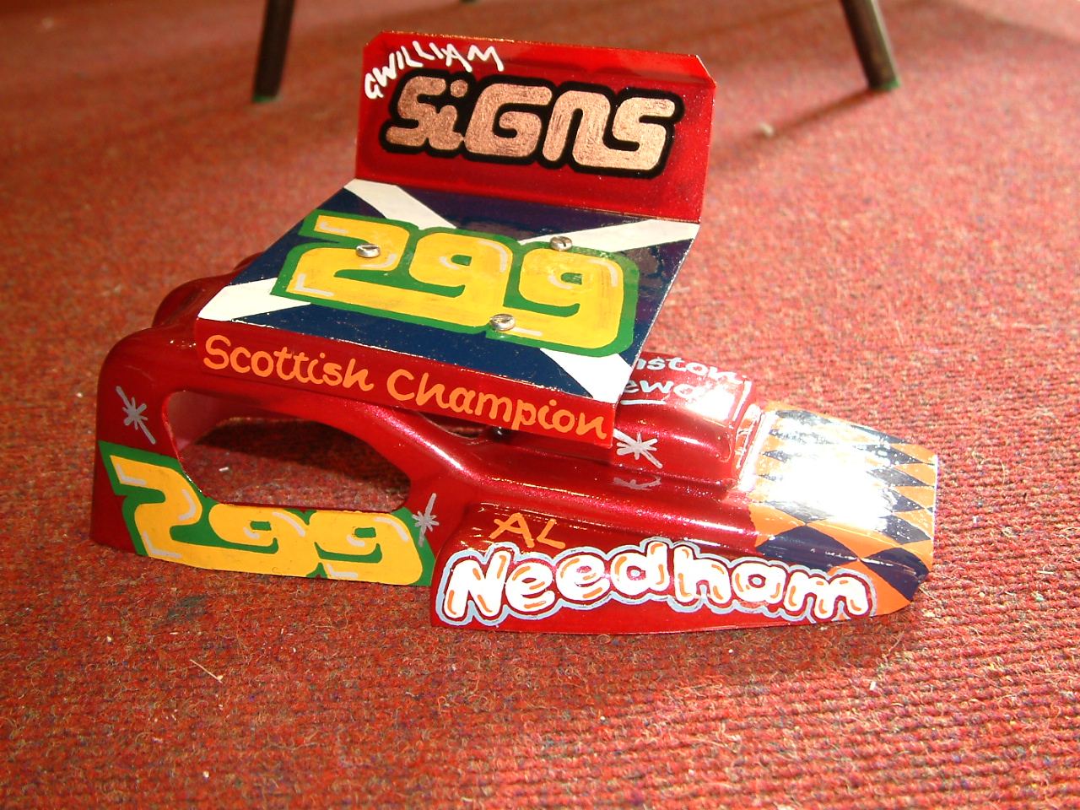
Ben Harding takes a third heat win with 88 laps in heat one of round four, behind him in second place was Jim Burkett with 82 followed by both Carl Baker and Alastair Needham with 81 laps in third and fourth and finishing one lap behind these two was James Blower with his 80 laps. Heat two saw Anthony Wyper remain as the only unbeaten racer as he took his fourth straight heat win with 86 laps, he was pursued by Mark Cooper with 85 laps in second place and by Matthew Bennett with 84 in third place then we had two racers finishing the heat on 82 laps they were Dave Gwilliam and Alan Bellis and another racer posting a lap score in the 80’s was young Martin Riley with his 80 laps in sixth place, although Nicholas Cooper had improved his previous best lap score his 74 laps was only good enough to take seventh place in this heat. The last of the stockcar heats was won by Stewart Smith with 84 laps, he was chased to the finish by two March club racers in the form of Sam Grey with 83 laps and Michael Fryett with 81 laps, Michael was ahead of Gerry Fordham by 1.51 seconds as Gerry also finished the race with 81 laps and just behind Gerry with 80 laps was Chris Blower in fifth place.

Round One. Bangers.

We did not have to wait very long for the first surprise result to happen in the Banger’s, it came in the very first heat as Yellow grade racer Richard Baldock took the first heat win with 68 laps, and what a scalp he claimed in Alastair Needham the reigning national points champion who could only finish in second place to Richard with 66 laps, and then this was on a split time after Jim Burkett and Mark Cooper had also recorded 66 laps each in the third and fourth places, and not far behind in fifth place was Chris Flynn with his 64 laps. Heat two was won by a very happy Derek Cayzer, his winning lap score was 62, chasing him all the way to the chequered flag was Martin Riley who crossed the finish line a single lap behind Derek, we then had a chain of racers that all finished one lap behind the other in order they were Darren Lord (60) followed by Steven Blower (59) and Kevin Swann the March RC club Champion with 58 he was followed by Allan Inness with his lap score of 57. Heat three of the Bangers was won by Mark Steel (who was piloting concord) with an incredible winning lap score of 78, behind him with a decent lap score of his own was Anthony Wyper with 75 which was on a split time from Daniel Fryett who also recorded 75, there was a big gap in lap scores behind these three back to Justin Swann and Callum White who both finished the heat with 59 laps to their credit.

Round Two. Bangers.

Mark Steel recorded his second heat win with 71 laps in heat one, amazingly Alastair Needham is beaten into second place for the second time even with an improved lap score from his first effort, this time he recorded 67 laps behind him came Mark Cooper with 61 and then we had a big gap all the way back to the 49 laps of Andy Hunt in fourth place. Heat two threw up another surprise result as another of the Yellow grade racers took a heat win, this time it was Jacob Gray taking the heat win with 65 laps, just behind him in the second and third positions were Martin Riley and Richard Baldock with 64 laps each, these two were followed by Jake Swann with 60 and Steven Blower with 57 laps in fifth place. Heat three was a good race with another batch of high lap scores being produced, the win went to Anthony Wyper with 72 laps and second place was taken by Jim Burkett with 70 finishing just behind Jim in third place was Derek Cayzer with 69, then we had two March RC club racers in the fourth and fifth places they were Darren Lord with 65 laps and Keith Schooling with 64 and hot on their tail was Allan Inness with 63
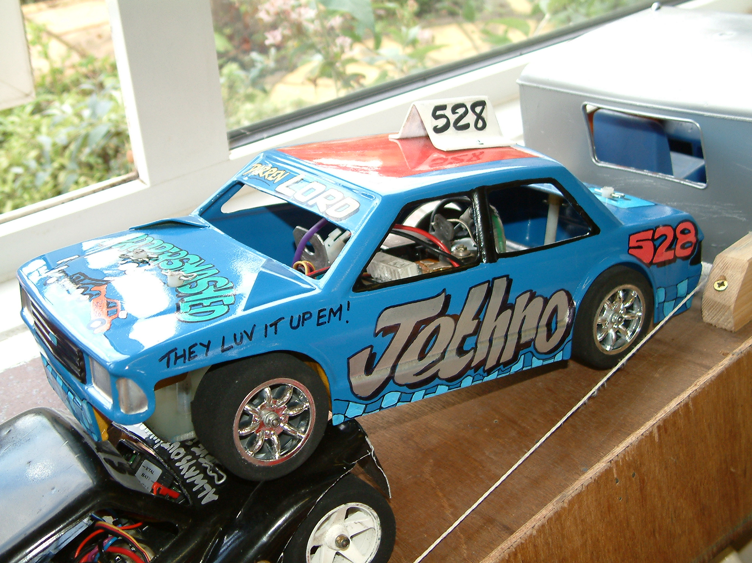
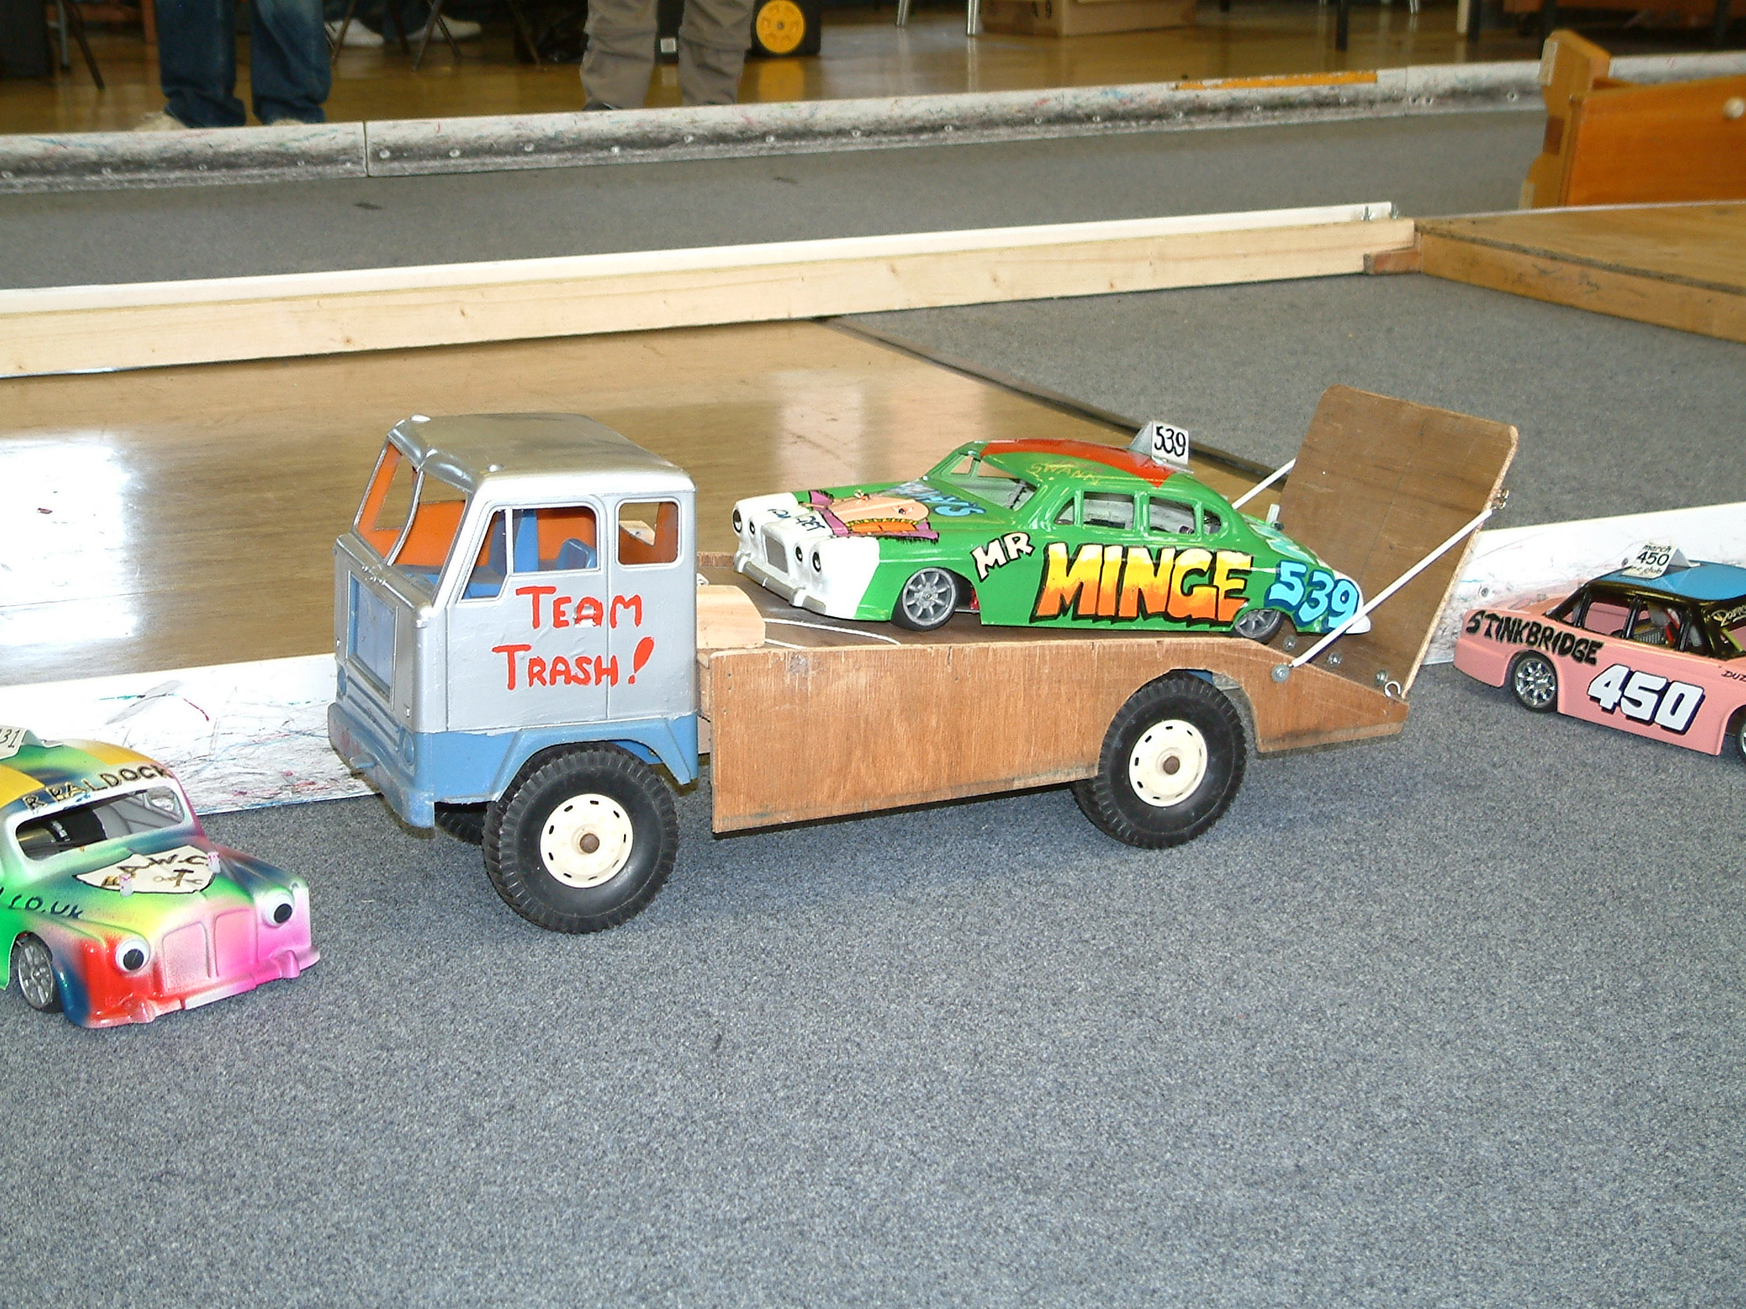
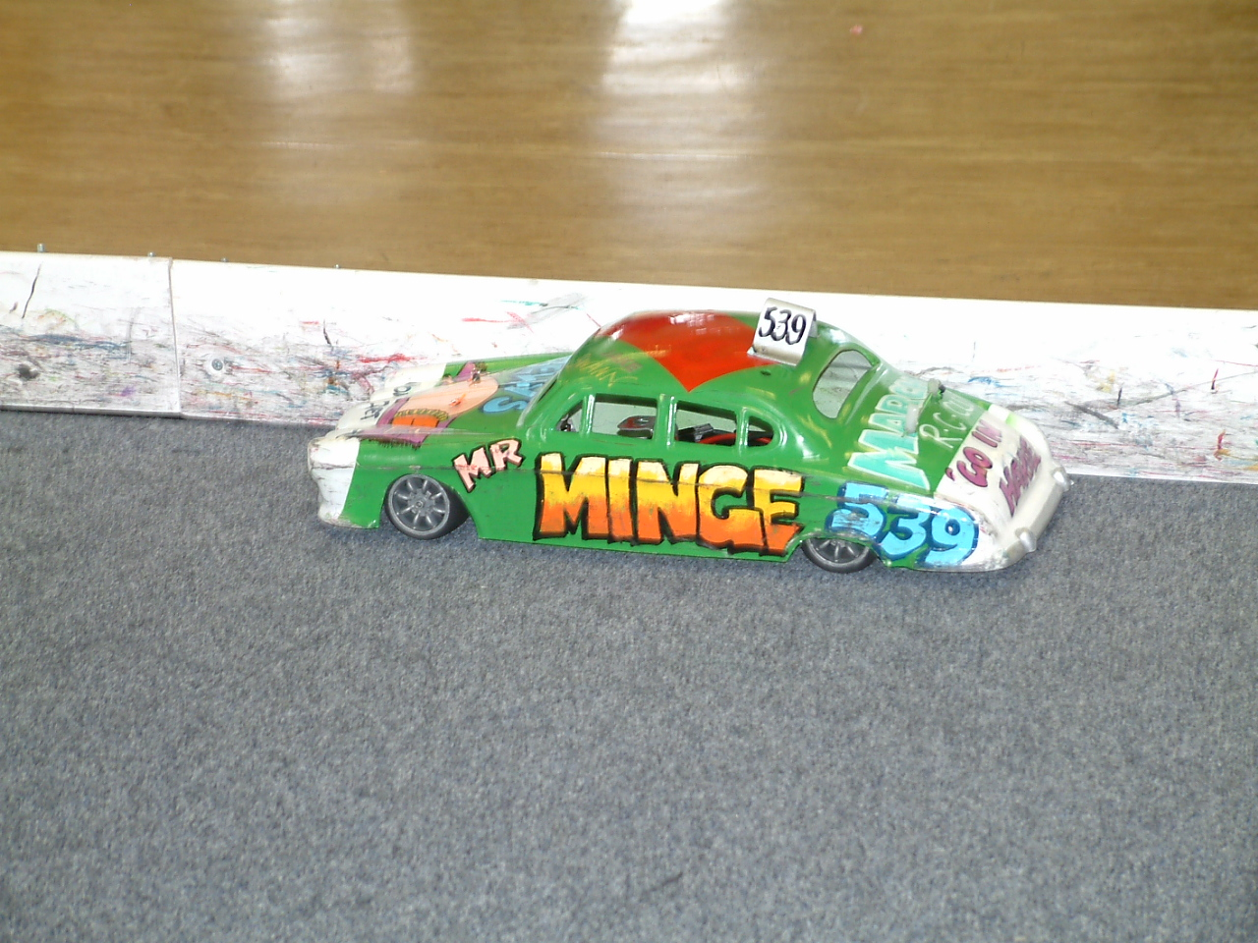
Round Three. Bangers.

If you want to know the definition of happiness then you should be in a race hall when Derek Cayzer collects a heat win and then you will know! His winning lap score from heat one was 68 laps, behind him in the second and third places was Jake Swann with 65 and Darren Lord with 58, behind these three came two of the Yellow grade racers they were Will Baldock with 54 and Kayleigh Cooper with 45 a great result for her as she finished the heat five laps ahead of her elder brother Nicholas. Heat two was won by the reigning national champion Alastair Needham with 71 laps, then we had two racers disputing the second place, at the finish of the race the computer showed that Mark Steel had secured it by 1.39 seconds after he and Martin Riley had both recorded 69 laps, fourth place went to Richard Baldock with 67 followed by Mark Cooper with 64. Heat three was won by Superstar grade racer Anthony Wyper with 75, he was a clear winner over the second placed racer Jacob Gray who recorded 69 laps he was followed by Jim Burkett with 68 and Chris Flynn in fourth place with 66, and right behind him in fifth place was Daniel Fryett with 65.

Round Four. Bangers.

Here we go again, another “Yellow” grade racer defying the odds to register a heat win, with a winning lap score of 66 laps it was Jacob Gray who defeated some of the top names in heat one, behind him came Mark Cooper who could only manage 61 laps in second place with Anthony Wyper a further two laps behind Mark in third place, then we had a train of racers that all registered 48 laps, in the order of crossing the finish line they were Derek Cayzer, Allan Inness and Kayleigh Cooper. Heat two was a good heat win for young Martin Riley with 73 laps he was pushed hard by Daniel Fryett who was only one lap behind Martin at the finish as was Alastair Needham although Alastair was 2.74 seconds behind Daniel, the only other racer in this heat to complete the full race time was Jim Burkett in fourth place with 69 laps, the best of the rest was young Nicholas Cooper with 49 laps in fifth place in a time of four minuets and 0.83 of a second.

Heat three the last of the Banger heats was won by Jake Swann with 69 laps with Chris Flynn right behind him with 68, then we had another of the “Yellow” grade racers taking the third place finish with 63 laps this time it was Steven Blower from the Fordham club, and right behind him and the only other racer to go the distance in this heat was Keith Schooling in fourth place with 62 laps, the best of the rest was Mark Steel with 34 laps which he completed in 177.38 seconds, this compares to a full race distance time of 300.00 + seconds.

For some racers we are now at crunch time, you have those that are involved in the chase for national points, others that have had an exceptional days racing and are about to experience a final or consolation race for the first time, or some that are doing their best to represent their club to the best of their ability, whatever it is I am sure that we are in for some quality racing in the stockcar consolation and then the stockcar final along with the banger final. As the stockcar consolation is the first race lets take a look at the list of qualifiers,

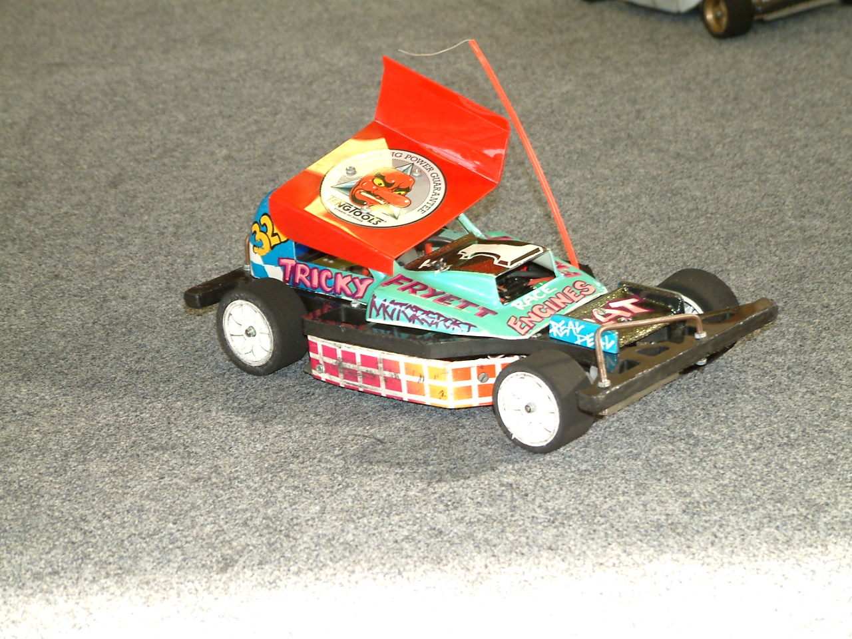
1. Michael Fryett 247
2. Carl Baker 245
3. Dave Gwilliam 245
4. Martin Riley 244
5. Alan Bellis 244
6. James Blower 242
7. Stewart Smith 241
8. Chris Blower 235

Consolation races are never easy to predict who will win, usually the racers that have qualified are very evenly matched, sometimes you have a racer that has had a bad days racing and has suddenly got his set up just right, and you have an odd occasion when everything seems to go your way with lady luck smiling on you, as it turned out this consolation race was a very even one, although the winner did use a lot of his experience of previous races to prevail in this one, and looking at his qualification place you would not have expected that Stewart Smith would come through from the back of the grid to win by a clear two laps the winning lap score was 84 laps, taking second place on a split time was Chris Blower over James Blower by 2.22 seconds after they had both recorded 82 laps, we then had the next four racers all finish the race with the same number of laps, for good measure they were only one lap behind Chris and James with 81, in the order that they finished they were Dave Gwilliam his split time was 300.12, Michael Fryett (300.73), Alan Bellis (301.17) and Carl Baker (302.77) and Martin Riley came home in eight place with 77 laps, so we have Stewart Smith from the Urmston club taking his place in today’s final as the winner of the consolation race.

The Banger Final.
There was certainly heartbreak for some at this meeting as some of the racers quest for national points had come to an abrupt halt, at this stage of the meeting we say goodbye to Mark Cooper and Allan Inness along with Kevin Swann who is the current March club champion, for others there was cause for celebration as they had made the final, so here is a list of the qualifiers along with their current roof grades, home club and qualifying total,
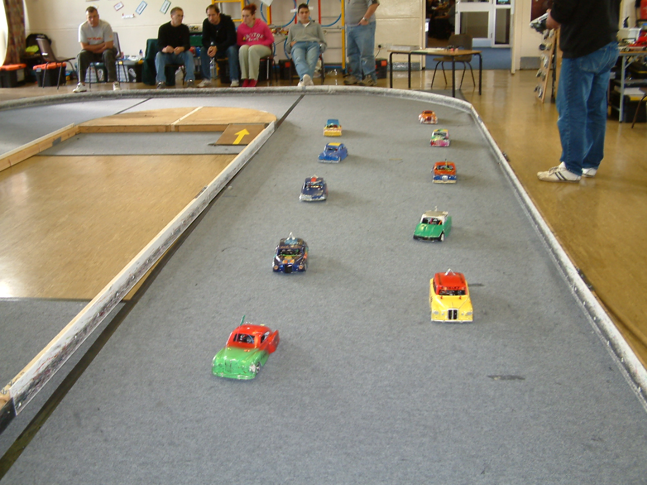
1. Anthony Wyper S/S Urmston 222
2. Mark Steel Red March 218
3 Daniel Fryett Blue March 212
4. Alastair Needham Silver Urmston 210
5. Jim Burkett Red Fordham 207
6. Martin Riley Red Urmston 206
7. Jacob Gray Yellow March 200
8. Richard Baldock Yellow March 199
9. Derek Cayzer Red Fordham 199
10. Chris Flynn Red Urmston 198
The result.
The real surprise of this race was that Alastair Needham the reigning national champion could not raise his game and keep with the two runaway leaders, and after looking back to the qualifying laps scores Mark Steel had the FTQ lap score of 78, although Anthony Wyper had been the more consistent and had out-qualified Mark, all the way through the final Anthony and Mark had swapped places at the front, and even at the end of the race they were both on the same lap, so the result was decided by a split time with Anthony Wyper ahead of Mark Steel by 3.64 seconds, both racers had 74 laps to their credit, behind them in third place with 69 laps was Daniel Fryett followed by Alastair Needham with 66, in fifth place we had Richard Baldock with 64 he was also the last of the finalist’s to go the full race distance, behind Richard came our other Yellow grade racer Jacob Gray his laps score was 58 which he completed in 267.91 this compared to Chris Flynn with 52 laps in seventh place, his race distance time was 298.66 (just short of the full race time) behind him in eight place was Jim Burkett with 37 laps completed, he was followed by Martin Riley with 33 laps and Derek Cayzer who had completed just 4 laps before his car left the track!

The Stockcar Final.
The line up of this race was not complete until the final round of qualifying had been completed, as one or two racers posted a good score in the last round to move up the list of qualifiers, so who had made it let’s take a look,
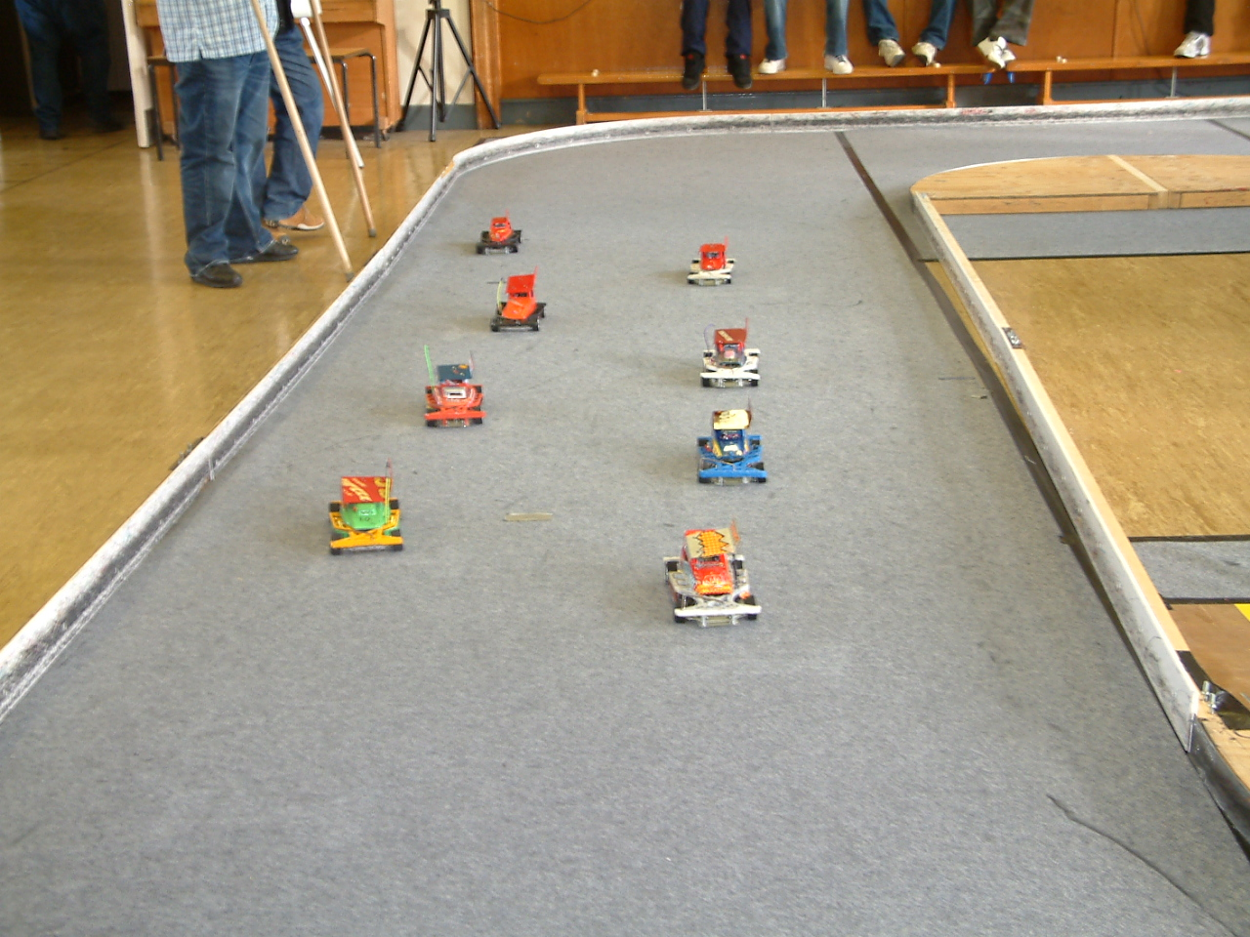
1. Ben Harding 265 Rugby Silver
2. Anthony Wyper 259 Urmston S/S
3. Matthew Bennett 252 Rugby Red
4. Sam Gray 252 March Blue
5. Mark Cooper 250 Stoney Stanton Red
6. Alastair Needham 248 Urmston Red
7. Jim Burkett 248 Fordham Red
8. Stewart Smith --- Urmston Red

Taking a look at the result of the final it was no surprise that Ben Harding had won another national final, looking back at his days racing he had out classed everyone else although Anthony Wyper was just six laps behind him in qualifying but when you analyse this it equates to two laps a race! add to this Ben’s FTQ of 91 laps from round three, this compared to the next best of 87 by Anthony Wyper, what more can you say other than his winning lap score from the final was 89 laps, behind him things were a lot more even between the rest of the racers with just three laps separating them, taking an excellent second place was Alastair Needham with 86 laps, the third and fourth places were separated by a split time after Anthony Wyper and Matthew Bennett had both recorded 85 laps, Anthony was ahead of Matthew by 2.25 seconds, we then had Jim Burkett and Stewart Smith both finishing with the same lap score of 84 the margin between the was 1.85 seconds with Jim adjudged to be ahead of Stewart, than for good measure the seventh and eighth places were also separated by a split time after Sam Gray and Mark Cooper had both finished with 83 laps, seventh place went to Sam by 2.26 seconds.

Name | F/Tyre  In | R/Tyre  Out | R/Tyre  In | R/Tyre  Out | Gear  Ratio | Speed  Board | Charger | Chassis | Car  Type | Cells | Club | Grade | Qualify  place | Final
Anthony  Wyper | St  05 | Orange | Pink | Pink | 12/51 | 2 speed | Apex | Mardave | Bandit  Pro | 3300 | Urmston | S/S | 2 | 3
Jim  Burkett | Jap  Med | 812 | Pink | Pink | 12/50 | 2 speed | Apex | Anderton | Skint | 3600 | Fordham | Red | 7 | 5
Sam  Gray | SE | 52  shore | Pink | Pink | 12/50 | 2 speed | CDC | Lecatt | Lecatt 2 | 3700 | March | Blue | 4 | 7
Matthew  Bennett | Jap | Orange | Pink | Pink | 12/50 | 2 speed | Duratrax | Lecatt | Lecatt 2 | 3600 | Rugby | Red | 3 | 4
Alastair  Needham | SE | 46  shore | Pink | Pink | 12/51 | 2 speed | Pro  Trak | Anderton | Baker | 3600 | Urmston | Red | 6 | 2
Stewart  Smith | Pink | Orange | Pink | Pink | 11/52 | 2 speed | Apex | Smith | Smith | 2600 | Urmston | Red | 8 | 6
Mark  Cooper | SE | 812 | SE | Pink | 12/50 | 2 speed | Pro  Trak | Anderton | Lecatt 2 | 3600 | Stoney  Stanton | Red | 5 | 8
Ben  Harding | Jap  Med | 812 | Pink | Pink | 12/50 | Mardave  Mk 1 | Pro  Trak | Anderton | Skint | 4200 | Rugby | Silver | 1 | 1

We had the usual mayhem in the last event of the days proceedings the banger D/D, the last car moving to win this was adjudged to be Nic Cooper from the March club.

Grade awards from the meeting went to :-
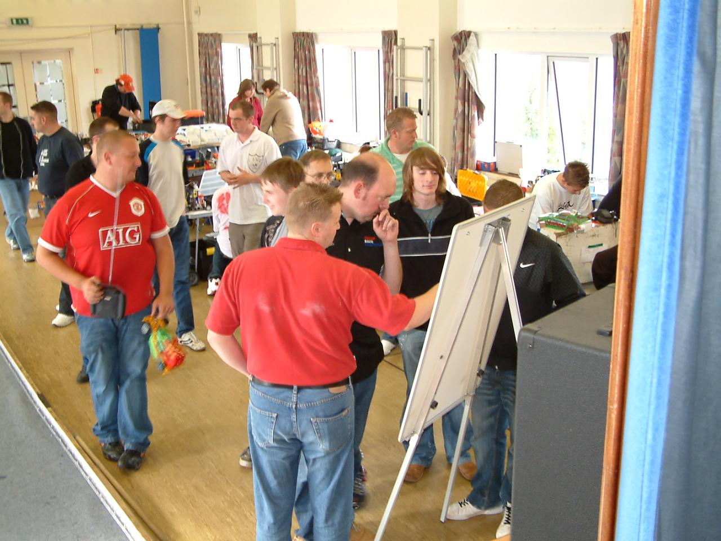
Stockcars,
Best White – Kayleigh Cooper
Best Yellow –
Best Blue – Sam Gray
Best Red – Matthew Bennett
Top Junior – Sam Gray

Bangers,
Best White – Andy Hunt
Best Yellow – Jacob Gray
Best Blue – Daniel Fryett
Best Red – Mark Steel
Top Junior – Jacob Gray

Congratulations go to all of the competitors in this years national championship’s, in the Stockcar class Ben Harding retained his title, he only dropped two national points on his way to the title!
In the Bangers a new champion was crowned as Anthony Wyper did what was needed from the four rounds that he took part in, however this must not detract from his performance, and in his own way he was as impressive as was Ben Harding, the statistics will show that he dropped just eight points, and finished ten points clear of the outgoing champion Alastair Needham.
Looking at the juniors, things looked encouraging as Martin Riley and Chris Blower were tied in the Stockcars, from the rounds that were to count they both had amassed 393 national points and finished in tenth and eleventh places in the final points table.
In the Bangers Martin Riley was a runaway winner, his total point haul was 368 from the four rounds that would count towards the championship, and this total placed him in fourth place overall, and he also won the title of Mardave junior champion earlier in the year at the Hathern banger national meeting.

This race report was written by Mark Cooper.



