Biddulph Moor

Presents
Stock Cars
The 2004 &
British Championship Bangers

Radio Controlled Car Club

Venue :- Biddulph Moor Village Hall, Hot Lane, Biddulph Moor, Stoke – on – Trent, Staffordshire

Biddulph Moor is one of our older and more established tracks, and always excels when it comes to promoting a big meeting, last time the club held this meeting we had the surprise of ‘Laurels’ to adorn the one, two, three on the winners rostrum, what surprises would there be in store for us today I wondered.
There have been a lot of improvements to the hall over the years, which can only benefit the club, but one thing is for sure, and in my opinion this club has the best view from outside the hall of any race car club in the country, and one day I will get a decent photo of it, when it stops raining on one of our visits to this club.
Colin Eardley is the promoter at the Biddulph Moor club, and he will be assisted by Steven Farmer, once again the scrutineering of the cars will be done by Mike Tomkinson the BRCA 1/12 Oval Safety Officer and Stockcar Rep, we also have Alan’s spares shop on site all day for all those things you thought you did not need, and out in the kitchen we have Colin’s mum and dad serving us with the refreshments.
Mystifying was what I thought when asked to draw a raffle ticket, all will be explained came the reply when I asked what it was for, and sure enough all was explained during the drivers briefing, the numbers on the raffle tickets drawn at random were prizes awarded to racers in different heats, some for the winner of the race, or the best blue top finisher, or top junior etc. So you had a chance to win a mystery prize throughout the day’s racing.
Today’s meeting had attracted some thirty-two stockcar’s and twenty-four bangers, we also had both of the defending champions racing today, they are Karl Spencer – Stockcar, and Alastair Needham – Banger.
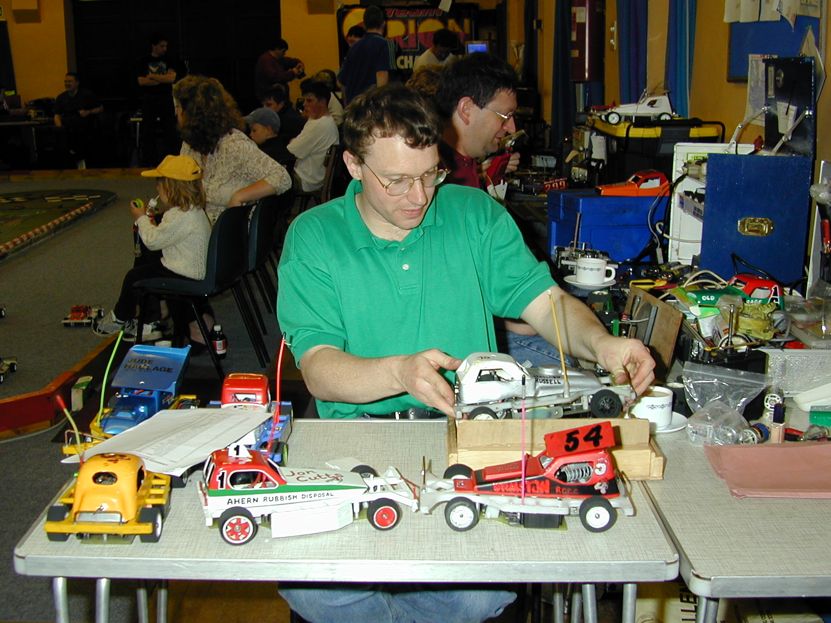
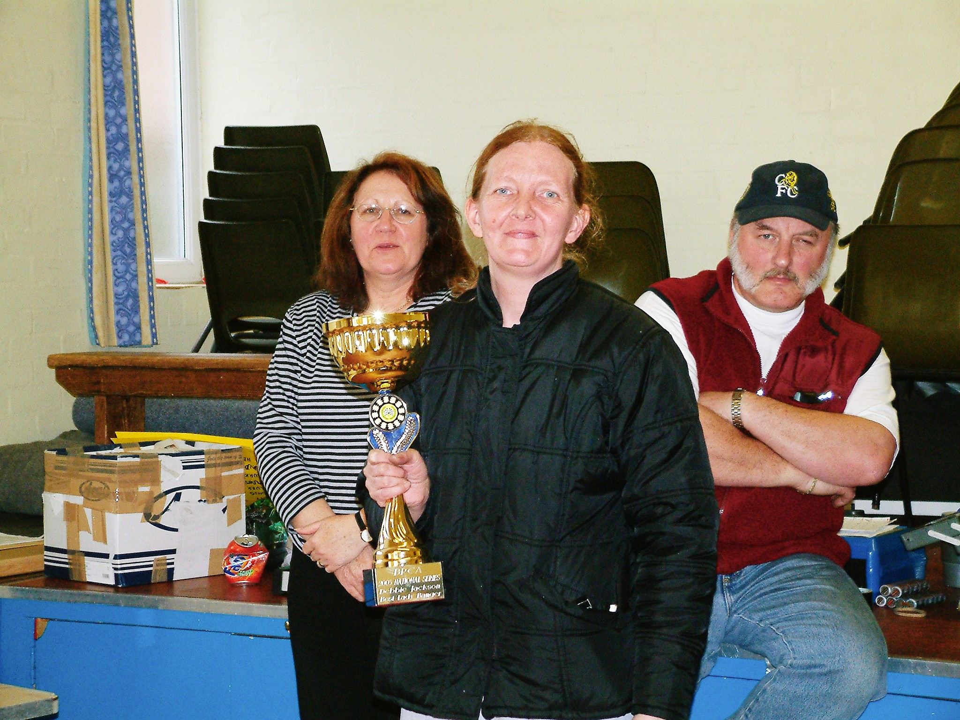

Colin Eardley at work Debbie Jackson Ladies Banger National Champion

There are no national points to race for, so I will report on the racers who have achieved the most laps, along with some of the best achieving racers, leading the way in round one for the stockcars was Anthony Wyper with 84 laps followed by Ben Harding and Mark Cooper with 83, then it was Urmston blue grade racer Gary Osbourne with 81 followed by Andrew Cox and Karl Spencer with 80, then we have Mike Tomkinson with 79 laps and at this stage of qualifying these seven racers would automatically go into the final, I wonder if all seven will be there at the end of qualifying, not far behind these seven racers were Matthew Bennett with his score of 77, Matthew races at the Rugby club and is now showing real progress with his Lecatt 2 race car, two more racers showing signs of real improvement are Urmston blue grader Darren Grace and young Thomas Forrest from the club based in Rugby, but I must mention that he races better with his sponsored Lecatt 2 race car than he does his own on a Friday night at Rugby, and I am sure that it wont be long before he achieves an up-grade to Red, both of these racers have 76 laps to their credit so far, and just behind them we have Jon Cutts, Alan Crossland, Pete Clarke, Karl Baker and Andy Cattell all on the 75 lap mark, Jon Cutts is racing his

new Skint type of race car today as built by the reigning national points champion Ben Harding, also Karl Baker is
showing great form after achieving his red grade at the Urmston club. We have three ladies racing today and so far Debbie Jackson has 73 laps and Angela Yarwood is just one behind with 72, and Jane Wyllie has 68. We also have four juniors racing, one of them has already been mentioned with his race score of 76 for Thomas Forrest, the next best junior was Scott Williamson with 70 followed by Nicholas Cooper with 66 which leaves us with Cattell who suffered with mechanical problems in this round. We also have three white grade racers with us today and the best of the three in this round was Jason Thorne with 53 laps.

Leading the charge in the Banger class was Mike too nice Tomkinson with 68 followed by Clive O.A.P. Buckler and Martin Pinky Cooper with their 66’s and just behind these two came Dave Shaky Gwilliam, Anthony Wyper, Craig roundy McInerney and Alastair wot me Needham all with 65 laps and just one lap behind these racers was Lee Carr with his score of 64, there was only one other racer that broke into the 60 laps and this was Andy the baron Cattell with 60 laps to his credit, the best of the rest were Ben fingers Harding and Andrew goose Edwards with 57 each followed by Mark Cooper with 52 and Steven Anderson with 48 and young Nicholas car wrecker Cooper with 47.
Round two.
Heading the leader board in this round was the reining open champion Karl Spencer equalling the round one best lap score of 84, and just one lap behind was Ben Harding with 83 followed by Gary Osbourne collecting his second lap score of 81, and rounding off the 80 lap scores were Jon Cutts, Anthony Wyper, and Matthew Bennett all on 80 then one lap behind these came Mark Cooper with 79, Cambridge racer Martin Cooper improved his round one score by 8 laps to record an 77 lapper as did Mike Tomkinson and young Thomas Forrest, the best of the ladies in this round was Angela Yarwood with 75, of the juniors Ryan Cattell posted his first decent score with 72 laps, and the top white grade racer in this round was Chris Flynn with his score of 59, from round one to round two only one other racer had made big improvements to his lap score and this was Urmston racer Pete Ayriss, in round one he posted 55 laps and this went up to 73 laps this time out.

In the Bangers Craig roundy McInerney headed the leader board with 71 followed by Martin pinky Cooper with 70 and just one behind Martin was Richard Edwards with his score of 69, the next racer to show on the leader board was Mike too nice Tomkinson with 67, then we had a big gap in lap scores back to Ben thumbs Harding on 60 laps followed by Anthony Wyper with 59 and Dave shaky Gwilliam with 58, a new name to the leader board was Nick the bullet Billett with 57 laps, also on 57 was Clive O.A.P. Buckler, some of the racers to make a big improvement to their first round scores were Debbie Jackson with 46, Jason Thorne on 51, Gary Smith with his 55 and High Wycombe racer Roy Calver with 55.
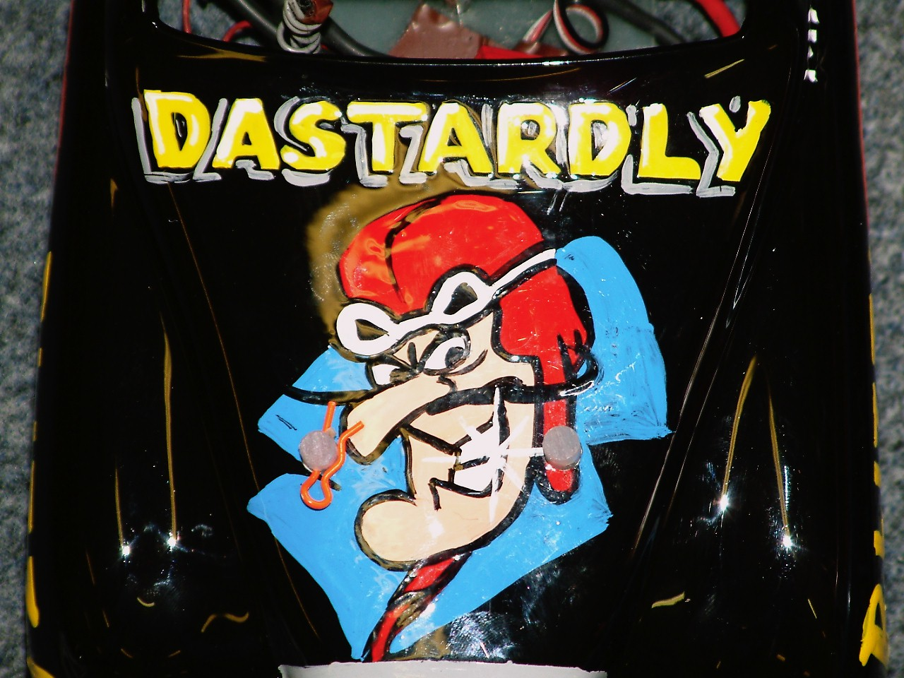
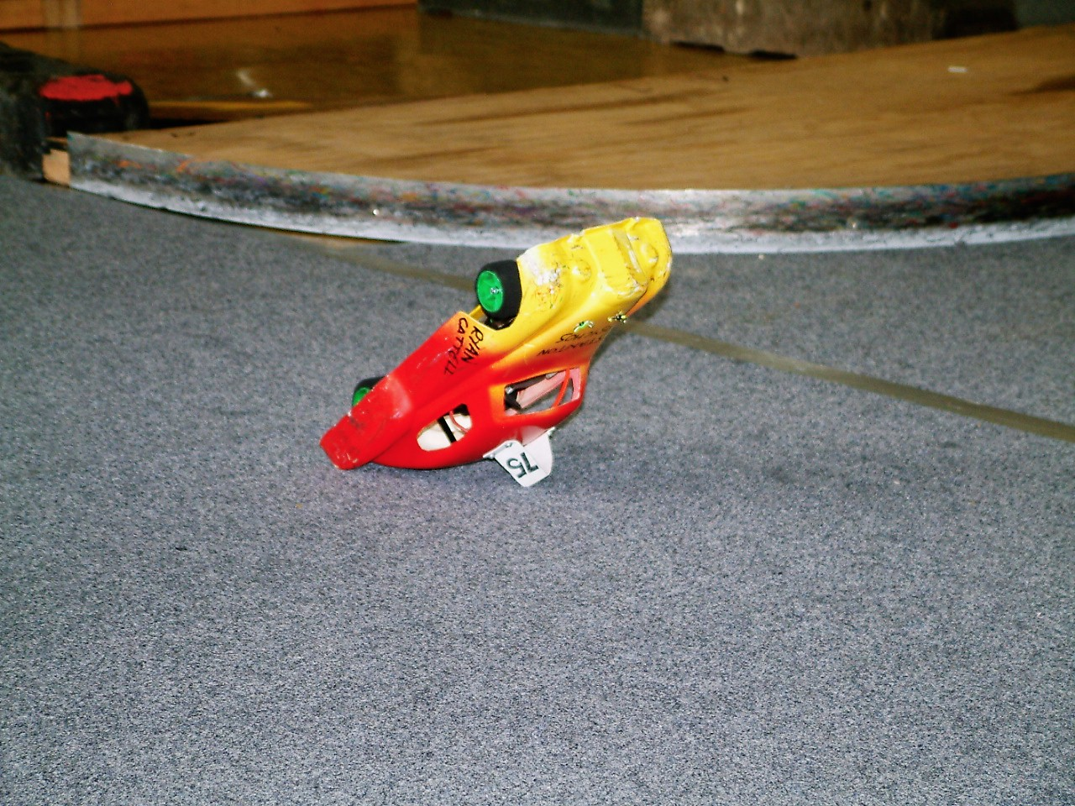

Round three.
Best of the rest in this round was the defending champion Karl Spencer with 83 laps, and just one lap adrift of the leader was Anthony Wyper with his 82 laps, currently Anthony is racing as a Blue grade racer from the Urmston club, but he is another racer adjusting to a change of car type he was racing a Pinky type of car but has recently changed over to a Skint type of race car, and I am sure he will regain his red grade back if he continues in this vain of form, just behind Anthony was the Skint master car builder himself Ben Harding with 81 laps, then it was Andy Cattell adding five laps to his previous best score of 75 he pushed it up to 80 laps, and was the last of the 80 score racers in this round, just missing out on an 80 score were Matthew Bennett and Mark Cooper both with 79 laps followed by the flying Thomas Forrest with 78, and posting his second decent score was Andrew Cox with 77 as did Ryan Cattell with his score of 76 laps, then we find Rugby Blue grader Alan Harding with 76, Alan is another racer with the Skint type of car, the best o0f the rest in this round were young Nicholas Cooper with his best score of 69 laps so far, Pete Clarke is Mr consistency with his third lap score of 75, another racer posting consistent lap scores was Urmstons Karl Baker so far he has 75,74,and 74 to his credit, White grade racers Jason Thorne and Gary Smith post their best scores in this round , they were 60 and 54 respectively, the top yellow grade racer in this round was Dave Forrest with 63, of the top flight racers expected to shine but so far had failed to impress are Clive Buckler former British title holder and also Martin Cooper from the Cambridge club who’s best lap score to date is his 77 from round two. The top lady racer in this round was Debbie Jackson with 70 laps.

Bangers round three.
Heading the leader board was Martin pinky Cooper with 71 followed by Lee Carr with his score of 70, Richard Edwards posts his second decent score with 68 followed by Andrew goose Edwards with 64, three racers recorded 62 laps they were Mark Cooper, Ben thumbs Harding and Roy rocket Calver, and just one lap behind these three was Thomas banz-eye Forrest on 61 and rounding off the 60 lappers was Dave shaky Gwilliam with his score of 60, the defending champion Alastair Needham could only manage an 58 score and is now in real danger of not qualifying for the final and be able to defend his title.
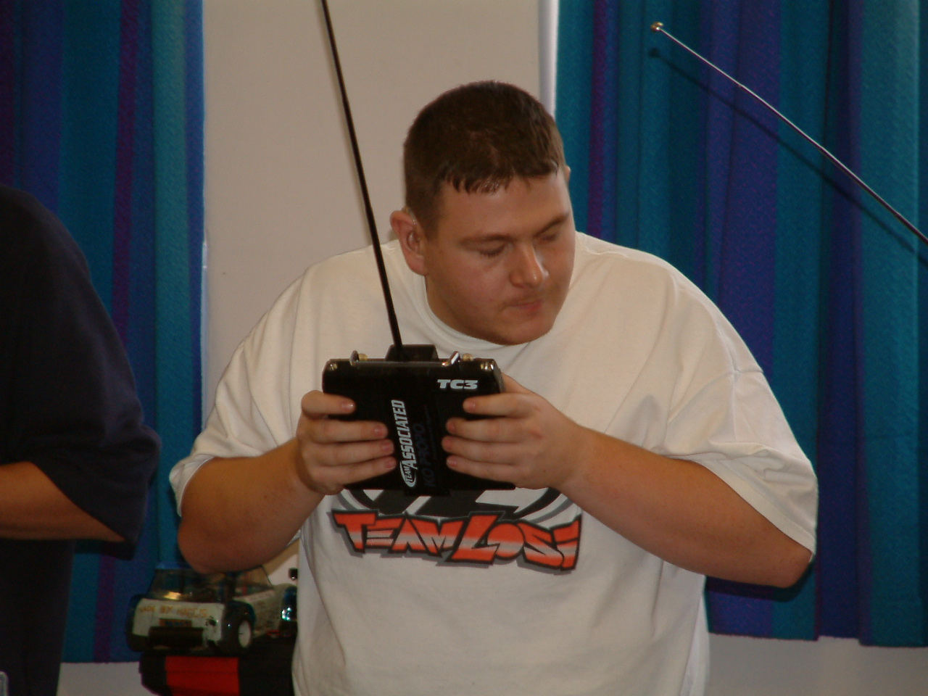
Round Four.
Some of the racer’s were saving their best for the last round of qualifying as
Gary Osbourne and Andrew Cox posted their best personal lap score of 82 also
finishing with 82 laps in this round were Karl Spencer and Ben Harding, then
we had a further three racers with 80 laps they were Anthony Wyper, Ryan
Cattell and Clive Buckler another who was saving his best till last, these three
were followed by Mark Cooper on 79 and Roy Calver with his best lap score
of 77 also finishing with 77 were Jon Cutts, Dave Gwilliam, and Mike
Tomkinson followed by Alan Crossland, Carl Baker, and Thomas Forrest all
on 76 laps, Alan Harding and Matthew Bennett recorded 75 laps, another
saving his best for the last round was Allan Inness with his lap score of 73, there were two other racers posting their best score in this round and they were David Forrest with 68 and Scott Williamson with 72.
Lee Carr headed the leader board in the bangers with his lap score of 69, followed by Craig roundy McInerney with 68 followed by three racers on 65 they were Clive OAP Buckler, Richard Edwards and Roy rocket Calver, then we had two finishing with 63 laps they were Mike too nice Tomkinson and Mark Cooper, Urmston blue grade racer Debbie Jackson recorded her best score of 52 in this round also posting her best score in this round was Tracey Cooper with 42 and another with his best lap score in this round was Steven Anderson with his 57 laps.

Stockcar Consolation.
There will always be some hard luck stories during qualifying, but in the stockcars there is always the chance to put things right by winning the consolation race and progress into the final, the first racer in the line up was Mike Tomkinson from the Urmston club with a total of 233, second on the grid was Rugby club promoter Jon Cutts with 232 followed by young Thomas Forrest with 231 also from the club at Rugby, fourth qualifier was the Stoney Stanton club promoter Andy Cattell with 230, starting from fifth place on the grid was Clive Buckler a former champion and another racer from the Rugby club, sixth on the grid was Ryan Cattell from the Stoney Stanton club with his total of 228 and another previous champion, he previously won the title in Scotland at the Dunfermline club, seventh qualifier was Dave Gwilliam with 227,Dave is another racer from the Rugby club and completing the line up we have Carl Baker from the Urmston club with 225.

We can give you something different here, and that is the positions of the racers at one minuet intervals during the race, so after the first minuet the top three were 1. Thomas Forrest, 2. Carl Baker and 3. Andy Cattell, at the two minuet stage this had changed to 1. Andy Cattell, 2. Mike Tomkinson followed by 3. Carl Baker, at the three minuet mark Carl Baker had taken the lead followed by Ryan Cattell in second place and Andy Cattell in third, at four minuets Carl was still out in front followed by Mike Tomkinson and Ryan Cattell, and at the finish it was well done to Karl Baker with 81 laps and progression into the final, and just one lap behind in second place came Mike Tomkinson with 80 followed by Andy Cattell with 78, both Clive Buckler and Ryan Cattell finished with 77 in that order, sixth place went to Dave Gwilliam on 75 with Thomas Forrest just one lap behind on 74 in seventh place which just leaves us with Jon Cutts who had retired from the race when he had completed just 46 laps.
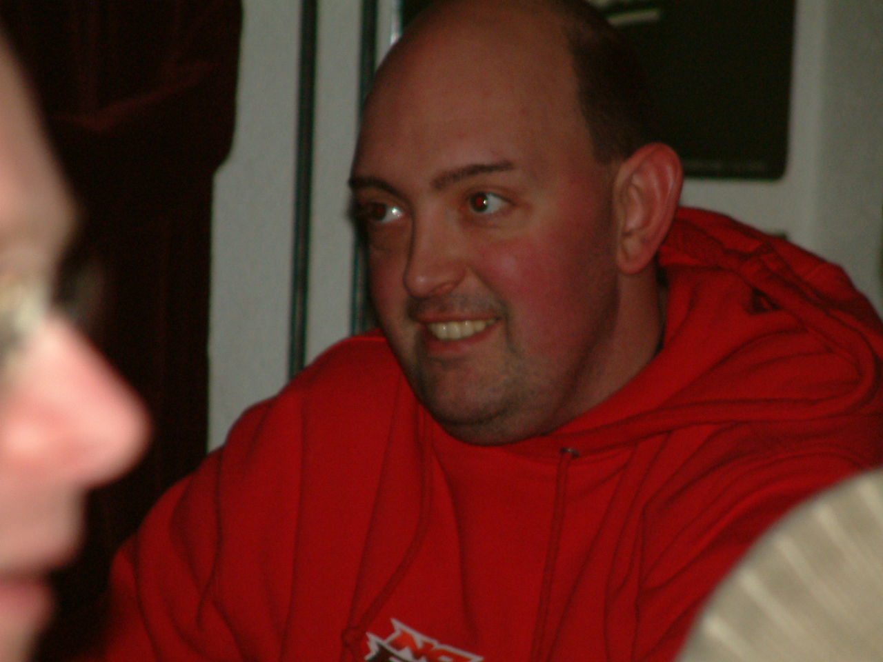
Banger Final.
Unlike the stockcars it is just the top ten qualifiers that make up the final,
and in order of qualification they are 1. Martin pinky Cooper – 207
2. Craig roundy McInerney – 204, 3. Lee Carr – 203, 4. Richard Edwards
- 202, 5. Mike too nice Tomkinson – 198, 6. Clive OAP Buckler – 188,
7. Dave shaky Gwilliam – 183, 8. Roy rocket Calver – 182, 9. Anthony
Wyper – 180 and the last qualifier was Ben thumbs Harding with 179,
which meant there was going to be a new open champion as the defending
champion Alastair Needham had just missed the final by one lap, and just
to show how close it was behind Alastair, Mark Cooper had a total of 177
and Andrew Edwards finished with a total of 176.

After a very hectic five minuets of racing that sometimes resembled a Hot rod race and not a banger one until the Rugby banger boys decided to have some fun, so at the finish the new open champion was Anthony Wyper with his winning race score of 66 laps, second on the rostrum was Craig McInerney with 60 laps after some tactical manoeuvres by the rugby racers! and third place went to Dave shaky Gwilliam with 59 followed by Roy rocket Calver in fourth with 56 and the 54 of Ben thumbs Harding in fifth, coming home in sixth place was Lee Carr with 50, seventh place went to Richard Edwards with his score of 48 followed by Martin pinky Cooper with 35 in eighth place, but with the satisfaction of the loudest cheer when his car left the race track, the ninth place went to Clive OAP Buckler with 24 followed by Mike too nice Tomkinson with his lap score of 23.

Before the stockcar final there was a grand national race which featured Jason Thorne, Scott Williamson, Chris Flynn, Dave Forrest, Nicholas Cooper and Gary Smith, at the finish Chris Flynn was the winner with 70 laps and the proud owner of a new chassis for his car, second place went to Jason Thorn with 67 along with a new motor and Nicholas Cooper was third with 54 laps and for his effort’s he received a new body-shell for his car.

The Open Stockcar Final
We already know that Carl Baker is in the final as the winner of the consolation, the other seven qualifiers are 1. Karl Spencer – 249, 2. Ben Harding – 248, 3. Anthony Wyper – 246, 4. Gary Osbourne – 244, 5. Mark Cooper – 241, 6. Andrew Cox – 239, 7. Matthew Bennett – 236.
Unlike the consolation race the final saw very few changes in positions throughout the race and was lead from start to finish by Ben Harding with a winning score of 84 laps, the runner up was Anthony Wyper another who was in the same position throughout the race, he finished with 81, also finishing with 81 in third place was Mark Cooper again in the place he had occupied throughout the race, another racer who had been in the same position throughout was Karl Spencer in fourth with 79, fifth place went to Gary Osbourn with 76 which was his highest position through the final, sixth place went to Matthew Bennett with 75 laps which was his highest place that he had been throughout the race, seventh place went to Andy Cox with 74, he had been occupying fifth place up to the three minuet mark of the race which leaves just Carl Baker in eight place with 70 laps, which he occupied throughout the who race, but will gain from the experience of his first big final race.

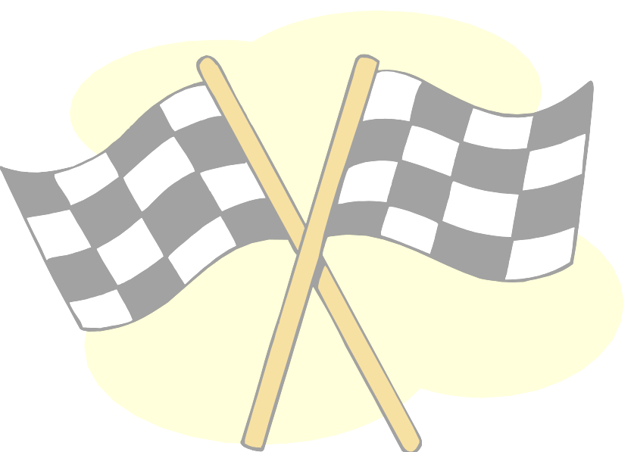  Name . | F/Tyre  In | F/Tyre  out | R/Tyre  In | R/Tyre  out | G  /Ratio | Speedo  Type | Charger | Car  type | Chassi | Cells | Club | Grade | Quali | Final
Karl Spencer | SE | LM | Pink | Pink | 12/51 | Mardave | Apex | Elite | Ander | 3300 | Rug | S/S | 1 | 4
Ben Harding | Jap Med | 812 | Pink | Pink | 12/50 | Mardave | Apex | Skint | Ander | 2000 | Rug | Silver | 2 | 1
Anthony Wyper | Jap Med | 812 | Pink | Pink | 12/50 | Mardave | Apex | Skint | Ander | 1700 | Urm | Blue | 3 | 2
Gary Osborne | Blue | 812 | Pink | SE | 12/50 | Mardave | Apex | Dimon | Dimon | 2000 | Urm | Blue | 4 | 5
Mark Cooper | Pink | Yellow | SE | Pink | 13/50 | 2 Speed | Pro Trak | Lecatt | Ander | 3300 | Ston | Red | 5 | 3
Andrew Cox | Pink | Orange | Pink | Pink | 12/50 | 2 Speed | Apex | Pinky | Ander | 2000 | Urm | Red | 6 | 7
Matthew Bennett | SE | Orange | Pink | Pink | 13/50 | Mardave | Apex | Lecatt | Lecatt | 3300 | Rug | Red | 7 | 6
Carl  Baker | 812 | 812 | SE | Pink | 12/49 | Mardave | CDC | Own | Own | 1900 | Urm | Red | 8 | 8

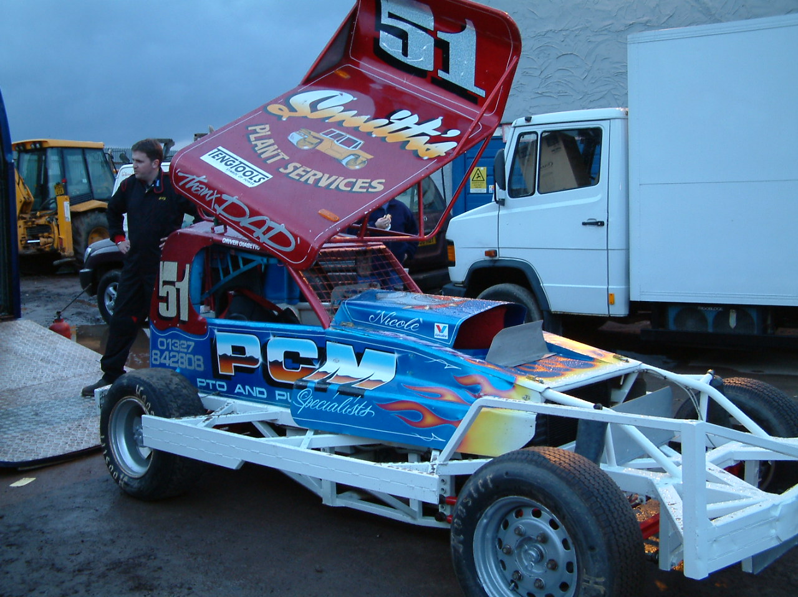
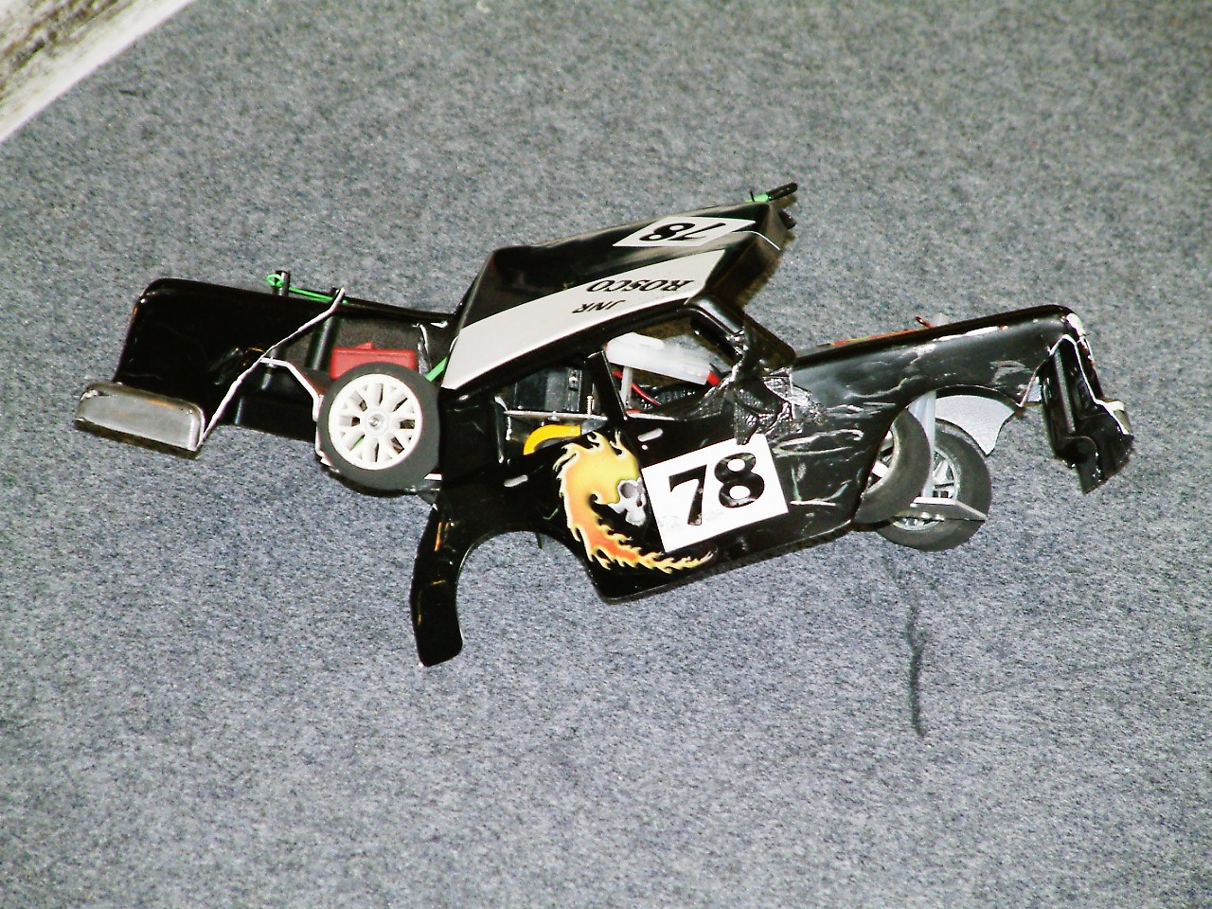
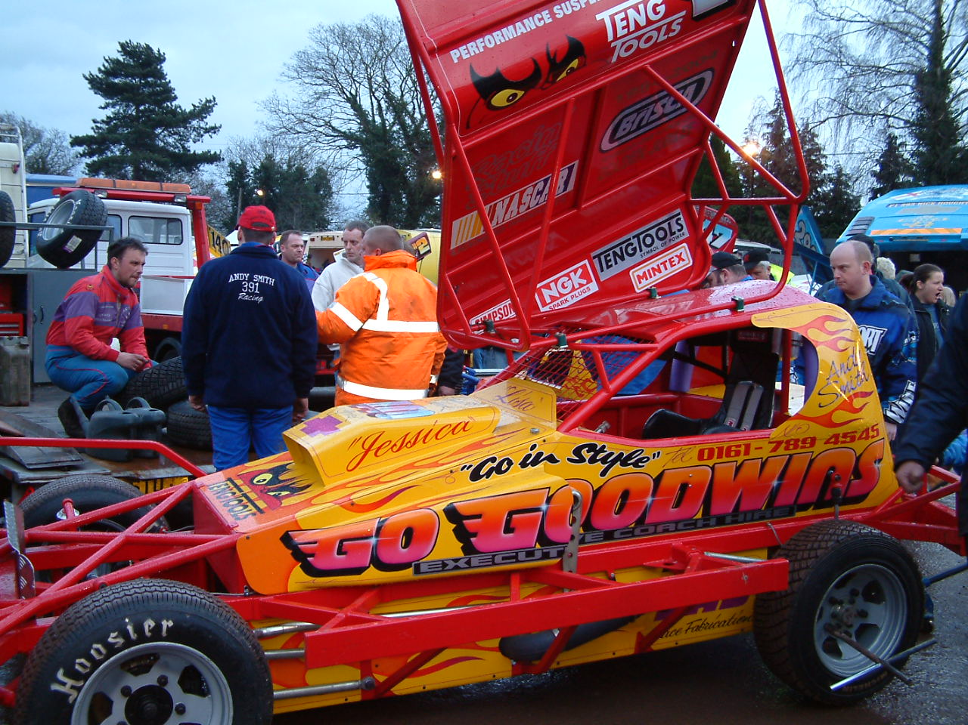

Last but not least, a very big thank you to the Biddulph Moor Club for an excellent meeting, and especially to Colin Eardly and Stephen Farmer who both gave up a days racing to run the meeting to a very high standard.

