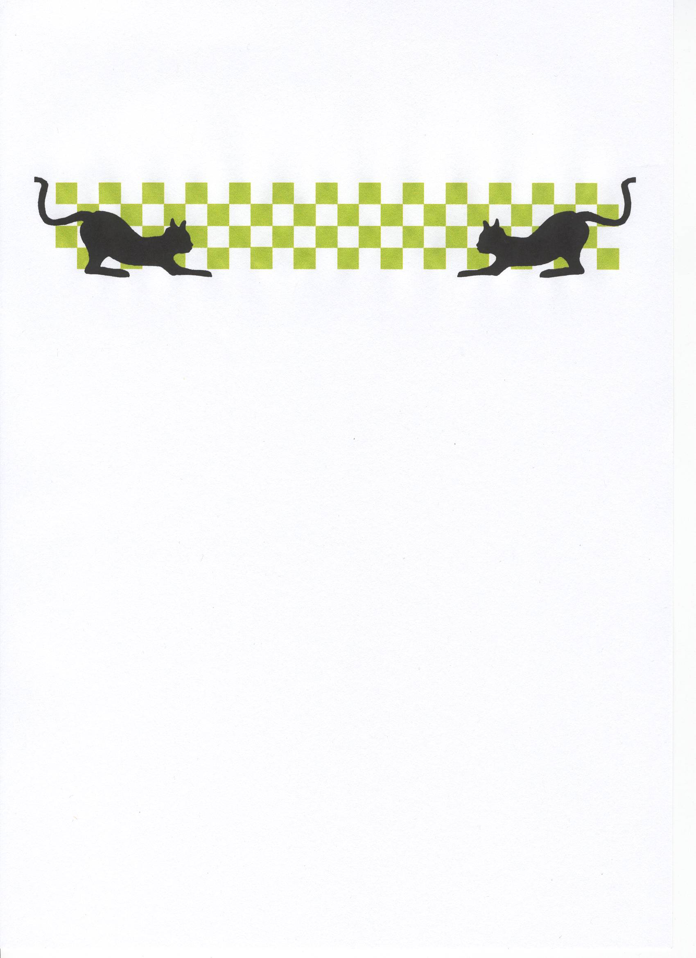
Lecatt Racing

English Open

Venue – Stoney Stanton Oval Raceway Promoter – Andy Cattell
Introduction.
Originally the open was going to be run at Filey in Yorkshire, during a model festival at a holiday park, just as it was run before when Ian Johnson won the title in 2001. Therefore Andy has to be applauded for arranging the meeting at such short notice, and doing an admiral job at that! (along with all the helpers)
Breaking news, there is a new chat forum on the web, if you have a computer or access to one then log on at rcracechatforum.com, lots of interesting news is available through this site! Also Andy Cattell is working on the Lecatt 2, if it goes as well as his first type of stockcar , then look out! It looks like the Diamond type of constructed stockcar re-Roy Calver is going to be the main force down south, i.e. at the High Wycomb Club, venue of this years British Open and the Medway Club, as I have heard that it is selling well. The venue for the world final meeting has now been booked, this meeting will take place at the R.A.F Cosford, museum, just off the M54 between Telford and Wolverhampton. The race organiser for this meeting is Mr. Andy t Nash our section chairman.

Stockcars round 1, race 1.
The first race winner of the day was Joe Brown with 72 laps, closely followed by Stony Stanton racer Rich Pacey with 71 and Martin Cooper on 70 then it was newcomer Mark Stiles racing a Diamond stockcar with 69. Heat 2. Super Star grade racer Karl Spencer wins heat two with 83 laps followed by Mike Tomkinson on 79, then we had Alan Harding on 77 and Stoney racer Stu Preston on 73. Heat 3. Was a titanic race I should know as I was in it! The win went to Ben Harding on 86 laps! Followed by the chasing pack of Rob Teuke on 84 and 82’s by Mark Cooper (me) and Dave Gwilliam, then we had Stony racer Ryan Cattell some way back with 78, must mention that Ryan’s old car Gertie has now been officially retired, and the car that Ryan is now racing is a self built Lecatt car, Ryan is yet to name this one officially, although it has been called a few names that I can’t print, already! Heat 4. First big meeting for Andy Cattells new stockcar, and he takes a win with it on 81 laps followed by Derek Cayzer on 77 as was Andy Cox, just one lap further back was Jason Bartropp on 76, just getting the better of stable mate Roy Calver who finished with 75.

Bangers round 1, race 1.
The first past the post in this formula was Derek Cayzer with 67 laps, then came Gary Mansell on 59 closely followed by Damon Atkins with 58 and Steven Mansell on 57, then we had a big gap to Loz Cattell on 37. Race 2. Was won by Martin Cooper with 72 laps from Jason Geezer Bartropp on 69, then we had Mike Tomkinson on 62 and Roy Calver with 61, then it was Allan Innes with 51 laps.

Stockcars round 2, race 1.
Urmston racer David Smith takes a win with 78 laps chased by Dave Gwilliam on 74 and Mark Cooper with 73. Heat 2. Was won by Ben Harding with a lap score just under the lap record of 88 laps, on 87 chased by Karl Spencer on 85 and Andy Cattell with 80, then came High Wycombe racer’s Jason Bartropp and Mark Stiles with 77 and 76 respectively. Heat 3. Ryan gets it right to record a win with 81 laps from Roy Calver with 80 and Rob Teuke on 78, then we had Stoney Stanton youngster Harley Harrington record a respectable 70!

Heat 4. Was another interesting race, and a close one at that, the win going to Martin Cooper on 79, just in front of Mike Tomkinson who also finished on 79 then it was Andy Cox just one lap behind these two on 78 who was chased by Rich Pacey on 76.

Bangers Round 2, Race 1
A man in form takes a win in the Banger class, all the way from the Urmston club in Manchester, winning with 59 laps was Mike Tomkinson, on a better split time as Damon Atkins also finished with 59 laps, next across the line was Steven Mansell with 54, then we had two 42’s by David Smith and Debbie Jackson. Race 2. Mr. Serious takes another win, yes that’s right, Martin Cooper with 70 laps, then we had both Roy Calver and Jason Bartropp cross the line on 62, then it was the better half (some may argue about that) of the pink duo, oops sorry, I mean Tracy Cooper on 59 followed by Andy Cattell on 45.

Stockcars Round 3. race 1.
Guess I made the right adjustments to the set up of the car, as I won a race, that’s me Mark Cooper with a win on 83 followed by Andy Cox on 80 and Alan Harding with 79, and not much further behind was Derek Cayzer on 76. Heat 2. Saw another win for Ben Harding, again with 87 laps just one in front of Rob Teuke on 86, then it was Mike Tomkinson with a healthy score of 82 followed by Martin Cooper on 80, who was chased by Jason Bartropp with 78. Heat 3. A winning score of 81 for Karl Spencer just one in front of the promising Mark Stiles finishing with 80, then it was Ryan Cattell with 78 then we had a surprise finisher in fourth place in the shape of the car wrecker himself, Nicholas Cooper on 64 laps. Heat 4. Win number two for David Smith on 82, followed by Dave Gwilliam on 80 who was just one lap in front of Roy Calver in third spot, who was one lap up on the fourth place finisher Joe Brown.

Bangers Round 3, Race 1
No surprise, win at all cost, Mr predictable, Martin Cooper out in front again, the score this time was 64, followed by Urmstons David Smith with 61, then we had Mike Tomkinson on 56, and a new face getting a mention here was Stony Stantons Larry Wheatley on 53 followed by Steven Mansell with 48. Race 2. Saw a win for Cambridge racer Derek Cayzer on 69 laps, some way ahead of Damon Atkins finishing with 57 in second place, then we had another big gap to third place finisher Gary Mansell on 48, then it was father and son finishing in fourth and fifth place, with Andy Cattell on 41 and Ryan Cattell on 32.

Stockcars Round 4. race 1.
Saving the best till last was Karl Spencer, winning with 85 laps, next across the line was Dave Gwilliam on 82 who was chased by David Smith with 81, fourth finisher was Mark Stiles with 80. Heat 2. Andy
Cattell makes it win number two for the new car, winning with 81 laps followed by Joe Brown with 78 and then we had Mike Tomkinson on 77, then it was an out of sorts Andy Cox finishing with 72. Heat 3. Win number two for Mark Cooper, this time the winning laps were 78, then we had three racers in close attendance, after all three had crossed the line on 75 laps, the finishing order was, in second place we had Ryan Cattell followed by Rich Pacey in third spot and Martin Cooper in fourth, then we had Roy Calver just one lap behind these three with 74. Heat 4. Must be on rails, as this is his third score of 87 for Ben Harding, next finisher was Rob Teuke on 80 followed by Derek Cayzer on 74, then we had Jason Bartropp on 72 and Alan Harding with 71, and just to prove that it was no fluke the first time, Nicholas Cooper records another 64.

Bangers Round 4, Race 1
We had a new name out in front in the first race of the bangers in the form of Allan Innes with 58, followed by Mike Tomkinson on 55 and Damon (smudge) Atkins with 51, then we had Steven Mansell on 43 and Harley Harrington on 32. Race 2. At last, the pink one is defeated, and the man to do this feat was Jason (geezer) Bartropp with 68 laps to Martin Cooper’s 67, then we had Roy Calver finishing with 66, and some way back in fourth was David Smith with 48 followed by Debbie Jackson on 46.

That’s the heats of racing over, as is the usual with the Bangers, the top ten go straight through to the final, and the stockcars have just the top seven racers through to the final at this stage, with the next eight racers contesting a consolation race with just the winner joining the seven automatic qualifiers for the final.

Stockcar Consolation.
The eight racers to make the consolation race were, in order of qualification – a good start for his new car with front row inside on the grid for Andy Cattell, his qualifying total was 238, second was Ryan Cattell on 237

then it was Mark Stiles with 236, fourth was Andy Cox – 235 then it was Roy Calver – 234, sixth qualifier was Martin Cooper – 234, seventh on the grid went to Jason Bartropp – 231 and eighth qualifier was Alan Harding on 229.
The Ressult
With some new faces lining up in the consolation, predicting a winner was going to be hard, would experience prevail or would a fresh face make it through to the final, one thing that became clear was that whoever won was going to deserve it as the racing was fast and furious, with no hols barred type of gung-ho racing, and nothing to lose from the new faces, showing no sign of nerves, at the finish we had a relieved Andy Cattell taking the win and progression through to the final with 76 laps just one lap in front of Roy Calver in second spot, third went to Mark Stiles on 73 as was Andy Cox in fourth, fifth across the line was Jason Bartropp on 71, then it was Martin Cooper on 70 in sixth place, finishing in seventh place we had Alan Harding with 31 laps, and the unlucky Ryan Cattell finishing or did he get started, with just 2 laps, better ask dad about that one!

The Banger Final.
The racers with enough laps to get into the final were, I say this due to the nature of their racing, remember full contact and no marshals, which creates a variety of race scores! Take note that Stuart Preston only got 14 laps all day and Stoney Stanton star Lewis Wheatley did not fare much better with a grand total of 39 laps! So the line up of racers were -
1st qualifier – Martin Cooper
2 - Jason Bartropp
3 – Roy Calver
4 – Mike Tomkinson
5 – Damon Atkins
6 – Derek Cayzer
7 – David Smith
8 – Steven Mansell
9 – Allen Innes
10 – Debbie Jackson
The winner and new English Champion was pole man Martin Cooper with 65 laps, runner up was Allan Innes with 57 laps just one lap in front of Mike Tomkinson on 56, then it was Steven Mansell with 49 laps in fourth spot, fifth went to Jason Bartropp with 47 laps, sixth across the line was Derek Cayzer on 43, seventh went to Damon Atkins with 41 laps, in eighth place we had Debbie Jackson on 30, ninth place finisher was David Smith with 17 laps, and that just leaves Roy Calver who did not start the race due to damage sustained to his car during the heats of battle!

Stockcar Final.
We had another quality line up of racers through to the English Open final, when you looked more closely it looked more like a Urmston vs Rugby/Stoney Stanton racers challenge! The eight qualifiers were –
Name Total
1. Ben Harding 261
2. Karl Spencer 253
3. Rob Teuke 250
4. Dave Gwilliam 244
5. Mark Cooper 243
6. David Smith 241
7. Mike Tomkinson 240
8. Andy Cattell Consolation Winner

Predictably, the final was an extremely fast and clean race, with not much to choose between all of the racers in the final, at the finish we had Karl Spencer collecting the win and title of English Open champion with 83 laps, second place went to Rob Teuke on 81, then in third we had Mark Cooper with 80 as was Dave Gwilliam in fourth place on a slower split time, fifth place finisher was the consolation winner, taking the first final place finish for the new car, with 79 laps, coming home in sixth place we had Mike Tomkinson on 77 laps, just reward for an excellent meeting by Mike, about time! Then it was David Smith in seventh place, also on 77 laps, and finishing in eighth place was the hot favourite Ben Harding on 43 laps along with a dead set of cells to boot!

Name | F/Tyre  Inside | F/Tyre  Outside | R/Tyre  Inside | R/Tyre  Outside | Pinion | Gear | Car | Cells | Club  Race No. | Radio  Gear | Charger | Qualifying  Position | Final  Place
Mark  Cooper | Jap  Med | Mini  Orange | SE | Pink | 13 | 50 | Lecatt | Corally  1700 | Stony  216 | 40mg | Apex | 5 | 3rd
Dave  Gwilliam | 812 | Jap  Med | SE | SE | 12 | 50 | Team  Skint | 2000 | Rugby  4 | 40mg | Apex | 4 | 4th
Rob  Teuke | Jap  Med | Mini  Orange | Pink | Pink | 12 | 50 | Tucar | Corally  1700 | Rugby  114 | 40mg | Apex | 3 | 2nd
David  Smith | 812 | Pink | Pink | Pink | 12 | 51 | Pink | Sanyo  1700 | Urms  54 | 40mg | Pro  Track | 6 | 7th
Karl  Spencer | SE | Pink | Pink | Pink | 12 | 50 | Elite  Racing | 2000 | Rugby  51 | 27mg | Apex | 2 | 1st
Ben  Harding | Jap  Med | Jap  Med | Pink | Pink | 12 | 50 | Team  Skint | Corally  1700 | Rugby  471 | 40mg | Apex | 1 | 8th
Mike  Tomkinson | SE | Jap  Med | SE | Pink | 12 | 50 | Pink | Sanyo  1700 | Urms  3 | 40mg | Apex | 7 | 6th
Andy  Cattell | Pink | Mini  Orange | SE | SE | 12 | 50 | Lecatt  Mk2 | Corally  1700 | Stony  175 | Ko  40mg | Apex | 8 | 5th

Tec chart of the finalist’s

The last race, or should we say last event of the day was that of the banger demolition derby, open to all comers that want to take part, this is subject to the availability of crystals, the object of this is to eliminate the opposition by any means possible, the last car moving on the track is declared the winner, at the finish and last car moving on the track was adjudged to be Steven Mansell.

Stockcar grade awards went to –
Best White – Harley Harrington
Best Yellow – Stuart Preston
Best Blue – Jason Bartropp
Junior Award – Mark Stiles

Andy would like to mention and say thank you to the following people for their help in making the meeting a success,
Mrs Cattell – Tracey, for putting up with me (needs a medal) and especially for running the kitchen and keeping us fed and watered. To Sandra on race control excellent job, needs more practice with the p.a. system (could use it!) And some big mentions to Smudge – web site master for the Stoney Stanton Club, and to Stuart Preston - scrutineer and general help, and also for all the help from Rich and Harley.

