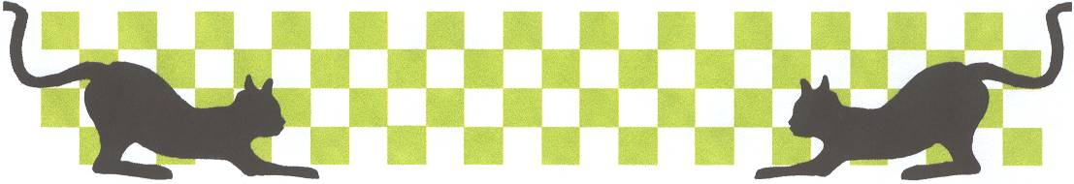
Stoney Stanton National
Lecatt Racing
22nd September 2002

It does not seem all that long ago, that Andy Cattell rescued the former “ Leicester “ racing oval, purchased from some of the former members, myself and a few others went along to retrieve the track and equipment which had been in storage in a lockup at Hinckley, and help set it up at it’s new home at Stoney Stanton and make sure that the track was ready for the first Stoney Stanton Club race night, which was back in March of this year, and here we are at the first national meeting, to be hosted by the club just some six months later! Some of the older members racing today will remember racing on this oval, at the Newfoundland Neighbourhood Centre, and racing with the likes of Bob Jessup, and Simon Kendall.
We have no previous years to mention here, but history is in the making as we have a welcome visitor from the Fryslan 1 club, which is based in Holland, racing in a UK national meeting for the first time, it will be interesting to see how Hidde de Jong copes, we have a good turn out of racers for this new national meeting, forty two racing the stockcars and thirty two racing Bangers.

Round 1. Heat one, Stockcars
Long distance Liskeard club traveller Andy Wallace, gets off to a winning start in race one with 74 laps, just bettering the 74 by Pete Clarke, on a split time, then it was the other Liskeard racer Martin Nash with 70. Heat two. Gary McMullen flies around the track to win with 82, some way in front of Alan Crossland on 71 and Alan Harding with 68. Heat three saw home club racer Ryan Cattell take the win with 80 laps from Ben Harding on 79 and Mark Cooper on 74. Heat four, Hathern super star Ian Johnson wins race four with 80 chased by Stuart Smith and Jon Cutts both on 78 laps. Heat five was taken by Urmston racer Andy Cox on 73, from another Urmston racer in the shape of Mike Tomkinson on 72 followed by Steve McMullen on 66. Heat six. Paul Jenkinson just beats Rugby super star Clive Buckler, by one lap, 79 to Paul and 78 to Clive, and not far back was Rugby youngster Rob Teuke on 76. No mention of Hidda de Jong yet!

Round 2. Heat one.
Rob Teuke races away to win with 79 laps, chased by Paul Jenkinson on 77 and Martin Cooper with 75. Heat two was a close race between Jon Cutts and Andy Cox, the latter just crossing the line first after both had finished with 80 laps, third and fourth were also separated by the computer after both Craig Summers and Alan Crossland recorded 70 laps. Heat three was a win just! For Mark Cooper with 72 laps chased by Steve McMullen and Gary Osbourne both with 71’s and Martin Nash on 70. Heat four seemed like a stroll in the park for Ben Harding, easily winning with 87 laps to the 76’s of Andy Wallace and David Smith. Heat five was another race win for Ian Johnson finishing on 78, to a 74 by Pete Ayriss and then we had Ian Kiteley with a good place in third with 67. Heat six saw Clive (pass me my Zimmer frame) Buckler take the win with 79 laps from reigning national points champion Gary McMullen on 78, and finding his feet in third, was Hidde de Jong with 74.

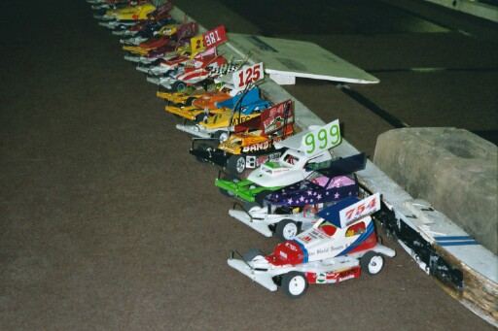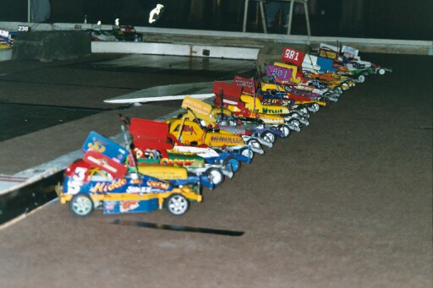

Round 3. Heat one.
Andy Cox leads the way in race one of round three, winning with a respectable 83 laps, then it was Mike Tomkinson with 79, followed by Stuart Smith on 78. Heat two was won with 77 laps by Jon Cutts, some way back in second place was Ryan Cattell on 70, closely followed by Denis Watson with 69. Heat three was a titanic tussle between Ben Harding and Mark Cooper, which was decided on a split time after both had got 79 laps Ben 1st, Mark 2nd, then it was Stoney Stanton promoter himself, Andy Cattell on 74. Heat four. Gary Osbourne records a race win with 74 laps, chased by Basildon’s Craig Summers on 68 and Steve McMullen on 67. Heat five, and Clive Buckler gets back to winning ways in heat five with 79 laps, from a 77 by David Smith, and Alan Crossland on 75. Heat six. Ian Johnson just gets the verdict, after he and Rob Teuke both finished with 78, with previous race winner Paul Jenkinson back in third place on 70. Must mention that although he was not featured Hidde finished in fourth place in his heat with a solid 66 laps.

Round 4. Heat 1.
We had a surprise winner in the shape of Basildon promoter, Alec Quarman (more famous for his exploits with a Banger) winning heat one with 73 laps, next racer across the line was Liskeard racer Andy Wallace on 71, then came Stoney Stanton racer Martin Cattell on 68. Heat two saw Andy Cox lower the colours of Ian Johnson with a race win, all be it on split time after both racers had finished on 79 laps, next racer across the line was Jon Cutts on 77 followed by Alan Crossland with 76. Heat three was won by Gary McMullen on 75, from Ben Harding and Gary Osbourne both on 72, and the out of sorts Mark Cooper on 70. Heat four. Ryan Cattell chalks up another race win with 77 laps, from Rob Teuke on 74 and a 71 from Mike Tomkinson. Heat five was another close race, this time it was between Paul Jenkinson and David Smith, with the latter getting the verdict from the computer after both racers had finished with 79, not far behind these two on 76 was Clive (O.A.P.) Buckler. The last of the heats for the stockcars race six, was won by Stuart Smith with 76, just one lap in front of Pete Ayriss, with local racer Dennis Watson finishing with 72. Hidde de Jong had a score of 65 in this round.
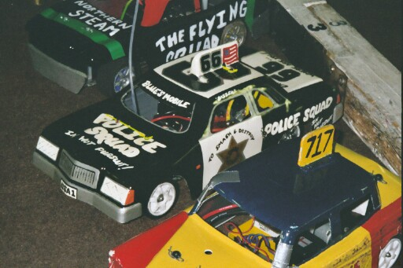

Banger Heats
A sizable turn out for this support formula, which hopefully will have there own official national points championship, with a national set of rules to go with it, for the next year of national racing. Thirty-two racers then, split into four races, top ten straight into the final, then a D/D race comprising of all the racers that want to enter.
Race 1. Martin Cooper see’s off the challenge of Gary (the shake) Osbourn in race one to take the win on 65 to Gary’s 62, then it was Ryan Cattell with 54. Race 2. Was won with a low score of 47 by Stuart Preston, then we had 44’s by Tracy Cooper and Ian (book him) Johnson. Race 3. It’s easy when you hot-rod, just ask Gary McMullen winning with 69, followed by Stoney Stanton youngster Lewis Wheatley on 60, and Urmston racer David Smith with 49. Race 4. More like what a banger race should be like! Victory going to Mike (the chief) Tomkinson with 42, who was closely followed over the finish line, by Jane Wyllie on 41 and Debbie Jackson with 37.

Round 2. Race 1. Win number one for Gary (shake) Osbourne with 57 laps from Tracy Cooper on 53 and just behind her (on the race track!) was Damon (Smudge) Atkins with 52. Race 2. Was another first time winner, this time it was Gary Mansell with 53 laps, chased by Alec (crunch) Quarman on 51, then it was Steven Mansell with 42. Race 3. Hot rod, Gary McMullen secures another win with 62 (boring) laps, to a 49 by Ryan (dad !!!!) Cattell and Richard Atkinson with 40. Race 4. Was won by another new race winner, in the form of Derek (grumpy) Cayzer from the Cambridge club, with 56 laps chased by Clive (old git) Buckler on 54, and some way behind in third was Andy (Ryan !!!!!!) Cattell on 42.

Round 3. Race 1. David (pudding) Smith finds the winners enclosure in race one with 64 laps, just one in front of Martin Cooper, who was followed by Damon (smudge) Atkins. Race two featured nine cars for some reason, which produced a close result, with a win for Martin (navigator) Nash on 53 as was Ian Johnson, these two were just in front of Stuart Preston who finished with 52 followed by Emma Hyde on 49. Race 3. Gary McMullen wins again, but not so convincingly this time, with 57 laps to a 54 by Alec (crunch) Quarman, and 45 laps by Toni-Lou Griffiths. Race 4. Had a win for Gary Mansell on 59, who were chased by Tracy Cooper (she’s good at chasing) on 53 laps.

Round 4. Race 1. Ryan Cattell finds some form to take the win in heat one with 56 laps, and Damon (smudge) Atkins goes one place better this round, by finishing second on 54, then it was Jim Driver on 46. Race 2. A win for Stoney Stanton promoter Andy Cattell with 56 laps, chased by Stuart Preston on 52 and Ian (book him) Johnson on 45.
Race 3.
No surprise here, Hot Rod Gary McMullen does it again, win number four with 64 laps, from (no wonder) Tracy (chasing him) Cooper on 51 and Emma Hyde with 41. Race 4. Was another nine-car heat, won by Martin (in hiding) Cooper with 66, pushed all the way by Clive (granddad) Buckler on 63, and a 58 by Mike Tomkinson.

The end of all the heats, forty races in total, now it’s just a little matter of the working out of the drivers qualifying totals, and who qualified for what, the calculator must have been red hot!

Here are the qualifiers,

Stockcar final Stockcar Consolation Banger Final

Ben Harding Ryan Cattell Gary McMullen

Gary McMullen David Smith Martin Cooper

Jon Cutts Mark Cooper Damon Atkins

Ian Johnson Stuart Smith Gary Osbourne

Andy Cox Rob Teuke Ryan Cattell

Clive Buckler Mike Tomkinson Tracy (Mrs) Cooper

Paul Jenkinson Alan Crossland Clive Buckler

Pete Ayriss Stuart Preston
Gary Mansell

Ian Johnson

The stockcar consolation was a close race, which could have been won by a number
of different drivers, at the end Rob Teuke pulled clear from the chasing pack to win and progress to today’s final, with a winning score of 81 laps, finishing second we had David Smith on 78, third place went to Stuart Smith on 77, fourth finisher was Mike Tomkinson with 76 laps as was Mark Cooper in fifth place, next across the line was Alan Crossland on 73, then it was 70 laps by Pete Ayriss, and the unlucky Ryan Cattell who broke down during the race finished with 47 in last place.

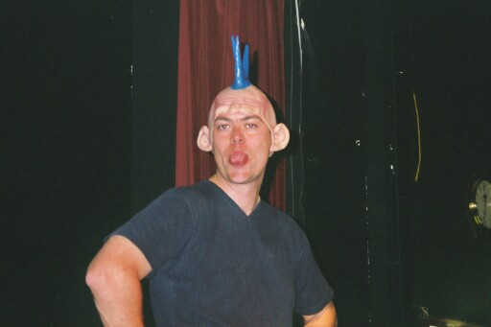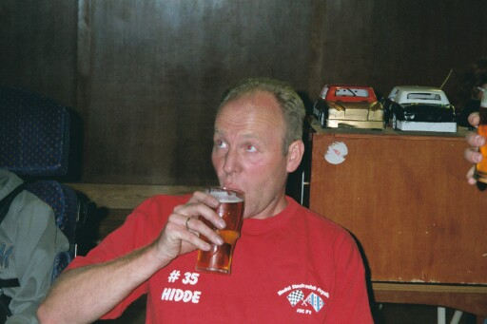

Stuart Preston Hidde de Jong

Banger final.
Gary McMullen starts as red-hot favourite for the final, as he was the only driver to win all of his heats.
Indeed Gary McMullen takes the final, but it was only on a winning split time, as Gary and Martin Cooper both finished with 66 laps, Rugby’s Clive Buckler was third on 61 followed by Ryan Cattell with 57 in fourth place, fifth was Tracy Cooper on 47, sixth place finisher was Gary Osbourne just one lap behind Tracy, seventh finisher was Ian Johnson on 45, eighth went to Stuart Preston with 40, finishing in ninth place we had Gary Mansell, wooden spoon went to Damon Atkins with a meagre 16 laps.

Stockcar final, and National Points decider.
For Ben Harding to win the national points and pinch it from Gary McMullen, he has to win the final, any other result means that he will finish the championship in second place.
So an air of anticipation at the start of the final with so much depending on the result, and oh so close! As Ben just missed out on the win beaten by Ian Johnson who finished with 82 lap in first place followed by Ben Harding with 81 laps in second place, consolation race winner Rob Teuke secured third spot on 80, fourth finisher was Andy Cox from the Urmston club on 79, fifth went to Clive Buckler on 78 sixth place finisher was the new national points winner for 2002, Gary McMullen on 77, seventh finisher was Paul Jenkinson with 74, and finishing eight we had Rugby’s Jon Cutts on 74.

Banger D/D
We had over twenty racers take to the track, for this last, wouldn’t be right to say race, as it is more of an event, as the winner is the last car still moving on the track, as old scores are now settled in full and with a bit of added interest!
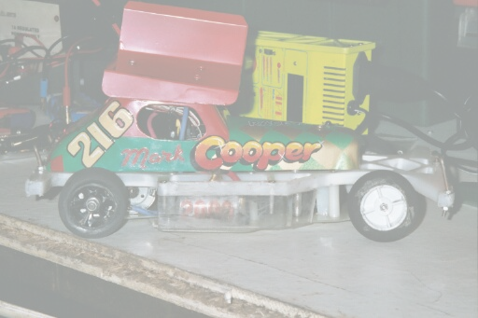
At the end of the survival test Martin Nash from the Liskeard club, based in Cornwall was declared the winner.

The final standings for the stockcar national stockcar championship looked like this,

National Champion 2002 Gary McMullen Best five scores 494
Runner up Ben Harding 493
3rd Andrew Cox 482
4th David Smith 458
5th Karl Spencer 456
6th Ryan Cattell Junior Champion 456
7th Mark Cooper 452
8th Jon Cutts 448
9th Martin Cooper 436
10th Andy Cattell 432

Here are a few surprising facts from the racing year, unfortunately I do not have the information from the Cambridge national meeting, but all the same it makes interesting reading.
At the Rugby national there were eleven different heat winners, the Hathern national produced fourteen different heat winners, at the Urmston national we had fifteen different heat winners, moving on to the Leven national we had ten heat winners, at the new national meeting at Basildon we had eleven heat winners, down in Cornwall at the Liskeard national we had thirteen different winners in the heats, and at the final national meeting at the Stoney Stanton national we had fourteen different heat winners.
Facts from seven national meetings then, a grand total of eighty-eight different race wins, well no, in actual fact there were an outstanding thirty-seven different heat race winners! We had five different final winners from all the national meetings, only Ben Harding achieved the perfect onehundred score. There were a grand total of one hundred and three; different racers take part in the national series. And also as was previously mentioned in this report, we had the first none British racer take part in a national meeting, that distinction goes to the Fryslan 1 club promoter Hidde de Jong. Incredibly Ivan Black travelled down from Scotland to secure a race win at the Liskeard national, someone tell him its cheaper to do it at you’re home club’s national meeting! Some twelve racers were present at all the meetings. At the Cambridge National there were forty-five racers, Rugby we had thirty-six, Hathern attracted forty-two, Urmston was it’s usual good turn out with forty-eight, we had twenty-nine racers at the Scottish national at Leven, at the new venue Basildon we had a disappointing turn out of just twenty-three, Liskeard had thirty-four, at the last national at Stoney Stanton we had forty-two racers in attendance.

The little and large show!

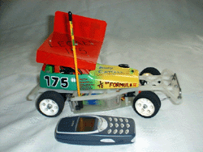
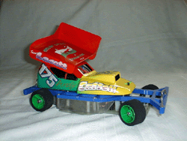

Report by Mark Cooper.

